Speaking Lesson Plan
TITLE | My Own English Fairytales
INSTRUCTOR |  |  |  | Ss’ LEVEL | AGE GROUP | No of Ss | LENGTH
Seulgi(Elly) Jeong |  |  |  | Intermediate | Middle school(13) | 12 | 50 mins

MATERIALS

8 Pictures(4sets)

Vocabulary list for teacher

Story gap-fill worksheet(12)

Copy of story for teacher

Native speaker’s recording

4 Posters

Speaker

White board, board markers
AIMS 1. |  | Students will understand English fairytales through listening native speaker’s recording.
2. |  | Students will learn new vocabulary through the story.
3. |  | Students will do creative thinking when they finish a fairytale.

LANGUAGE SKILLS
Listening |  |  | Native speaker fairytale recording.
Speaking |  |  | Present a story ending.
Reading |  |  | Story gap-fill worksheet.
Writing |  |  | Story gap-fill worksheet, Story ending.
LANGUAGE SYSTEMS
Phonology |  |  | Students will learn how to pronounce words that they did not know through native speaker’s recording.
Lexis |  |  | Students will understand each words meaning through the story.
Grammar |  |  | Students will use past tense in fairytales.
Discourse |  |  | Students will listen and read fairytale then discuss what they imagine is the end of story.
Functions |  |  | Students will understand native speaker and write related story.

ASSUMPTIONS

Students must know about many fairytales. They will know famous fairytales only by posters.

Students can listen and write even they don’t know the new vocabulary.

ANTICIPATED GRAMMATICAL ERRORS AND SOLUTIONS

Verbs must always be simple past tense.

> Do examples together.

REFERENCES

Pictures, Posters > https://www.google.co.kr (key words searched : castle, dragon, princess, wizard, crown, prince, unicorn, Cinderella, Snow white, Red riding hood, Shrek )

Recording file > A native teacher recording for this lesson
Story > I wrote it

NOTES
Plan B > 1. If a lot of students are absent, we don’t need to make groups then we can do activities all together. 2. If recording file is not working, teacher will read to students.
Cut-off plan > If there is not enough time skip the presentation
SOS > If main teacher can’t enter the class, show to students an English fairytale movie then write report. ( The movie must be prepared on school’s computer. )

PRETASK TITLE |  |  | What are these Fairytales?
AIMS |  |  |  | MATERIALS
Introduce fairytales  Eliciting vocabulary. |  |  |  | Famous fairytales’ posters  White board, board markers
TIME | SET UP | STUDENTS |  |  | TEACHER
3mins | Whole class | Students will talk about what fairytales they know |  |  | Show them posters - Cinderella, Snow white, Red riding hood, Shrek
4mins | Whole class | Give vocabulary - travel, wizard, created, rode, escaped, arrived, emerged, roared, ran away |  |  | Eliciting vocabulary

NOTES
Write down these words on the white board.
Don’t focus too much on spelling. Just check students understand meaning

TASK PREPARATION TITLE |  |  | How does the story go?
AIMS |  |  |  | MATERIALS
Listen fairytale with matching pictures |  |  |  | Native speaker’s recording, Speaker  8 pictures(4sets)
TIME | SET UP | STUDENTS |  |  | TEACHER
2mins | 4Groups | Listen to fairytales |  |  | Play recording file
3mins | 4Groups | Discuss what happened in fairytales |  |  | What do you think happened in this fairytales?  Can we talk about it with your partners?  Monitor
3mins | 4Groups | Put the pictures in order |  |  | Give set of pictures
3mins | 4Groups | Show picture to other groups |  |  | Monitor

NOTES

Recording file, pictures are in School homepage or e-mail.
If computer or speaker are not working, you can just read to students.

TASK REALISATION TITLE |  |  | Imagine and Create Your Own Story
AIMS |  |  |  | MATERIALS
Use 4 Language skills. |  |  |  | 8 pictures  Story gap-fill worksheet  Native speaker’s recording, speaker
TIME | SET UP | STUDENTS |  |  | TEACHER
4mins | 4Groups | Dictation  - Listen to Native speaker’s recording and fill up the worksheet.  - Ask students to answer.  - Write answers on white board. |  |  | write answer on the white board
8mins | 4Groups | Discuss and make the end of fairytales |  |  | There are many different types of endings. Happy, sad, what else?  Can u make your own ending with your partners?  Monitor
4mins | 4Groups | Draw last picture |  |  | You have blank picture. Can you draw your ending?  Monitor
8mins | 4Groups | Write what students make on the worksheet |  |  | Can you write your ending on the worksheet?  Monitor

NOTES

Before students make their own story let them know they must share their thinking and discuss with partners.

POST TASK TITLE |  |  | Presentation
AIMS |  |  |  | MATERIALS

Speak English in front of people
TIME | SET UP | STUDENTS |  |  | TEACHER
8mins | 4Groups | Present their end of fairytales for 2mins each in a group |  |  | Listen to other groups’ presentations.  Monitor

NOTES

When students present, they will not read what they wrote. Only use their picture.
.

Worksheets, handouts and lesson materials
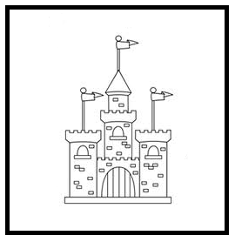
1.8 Pictures(4sets)
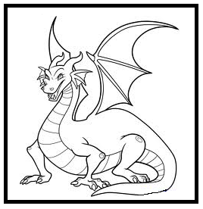
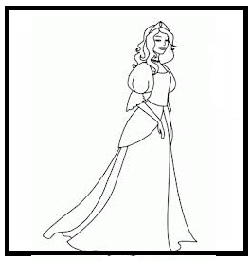
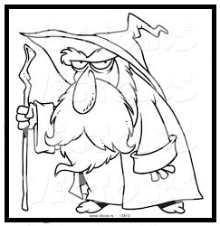

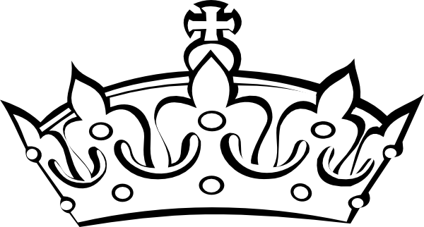
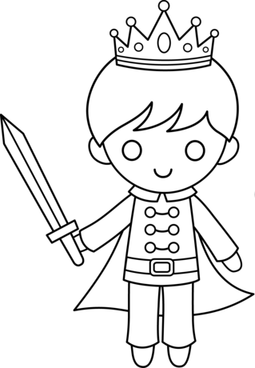
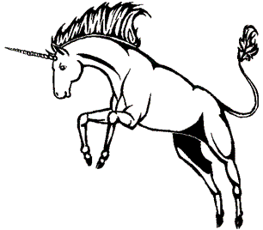

2.Vocabulary list for teacher
- travel, wizard, created, rode, escaped, arrived, emerged, roared, ran away

3.Story gap-fill worksheet(12)
[ Dictation ] Name : a
Once upon a time in a land a beautiful princess lived in a big, old . The princess was very because she wanted to travel and see the world, but her father would not her leave. One day a crazy came to the castle. He he would help the princess if she gave her to him. The princess gave her crown to the wizard. The crazy wizard was and a fast, white unicorn with his magic. He gave the unicorn to the princess. The princess o the unicorn and it was so fast that she the castle and her father.
Eventually, the princess at a tall tower in a forest. At the top of the tower was a young boy, a prince, who was crying for help. , a huge green dragon from the trees. It roared at the princess and she to the ground as her unicorn .

4.Copy of story for teacher
[ Dictation ] Answer for teacher
Once upon a time in a land far away a beautiful princess lived in a big, old castle. The princess was very unhappy because she wanted to travel and see the entire world, but her father would not let her leave. One day a crazy wizard came to the castle. He promised he would help the princess if she gave her crown to him. The princess gave her crown to the wizard. The crazy wizard was pleased and created a fast, white unicorn with his magic. He gave the unicorn to the princess. The princess rode the unicorn and it was so fast that she escaped the castle and her father.
Eventually, the princess arrived at a tall tower in a forest. At the top of the tower was a young boy, a prince, who was crying for help. Suddenly, a huge green dragon emerged from the trees. It roared at the princess and she fell to the ground as her unicorn ran away.

5. Native speaker’s recording
-MP3 file

6. 4 Posters


