TITLE | A newborn baby for a Royal Family
INSTRUCTOR |  |  |  | Ss’ LEVEL | AGE GROUP | No of Ss | LENGTH
Melle |  |  |  | Advanced | 20 | 12 | 50 mins

MATERIALS

-a Picture of “Windsor’s Family Tree”
-Slide projector, computer

-Worksheet #1-1, #1-2, #1-3, #2, #3, #4 (12 copies for each)
-12 Cards of 4 kinds of roles in family
-3 Papers
-Crayons, colored pencils, markers
-Whiteboard and markers
AIMS 1. |  | Students will practice and improve their reading skills by skimming and scanning the text material.
2. |  | Students will practice their speaking skills when they answer the teacher’s questions about what they think about being the royals, discuss what they read with others and do the post-activity presentation.
3. |  | Students will learn vocabulary and expressions through doing pre-taught vocabulary activities or guessing the meaning of new words from the context.

LANGUAGE SKILLS
Listening |  |  | Listening to teacher’s instructions and classmates in group activities
Speaking |  |  | Expressing what students think about being the royals, discuss what they read in pairs or groups, and make a presentation to introduce their family in groups
Reading |  |  | An article named “Britain’s new princess named Charlotte”, worksheets of pre-teaching vocabularies and quizzes on class topic
Writing |  |  | Answers on the worksheets, scripts for short presentation of introducing family in groups
LANGUAGE SYSTEMS
Phonology |  |  | Listen to the teacher, and classmates speaking
Lexis |  |  | Pre-taught vocabularies and expressions
Grammar |  |  | Grammatically correct forms of the pre-taught vocabularies in example sentences
Discourse |  |  | Expressing opinions, introducing a family
Functions |  |  | Giving and receiving opinions, debating, Introducing

ASSUMPTIONS

All of the students have already known what is a royal family and they have heard about the British royal family.

Students already know teacher’s style of teaching and pace in class.

Students are at an advanced level and have already known how to express their opinions in English.

Students are mostly active and familiar working in groups.

ANTICIPATED PROBLEMS AND SOLUTIONS
Students may not understand the teacher’s instructions.
- Give them student-friendly instructions (Speak slowly, be explicit, chunk, CCQs, ICQS, demonstrate)
The main activity finish earlier than expected.
- Review the topic and get feedback from students
- Have SOS activity prepared

REFERENCES

-Breakingnews.com(Breaking News English ESL Lesson Plan on Princess Charlotte)

-Dictionary.com

NOTES
-Plan B
If somebody is absent, the teacher can divide groups into 2 groups of 4 students and one group of 3 students, or etc. instead of 3 groups of 4 students.
If the multimedia (the computer, the projector, or any electrical materials) doesn’t work properly, use the printed picture of “Windsor’s Family Tree”.
-Cut-off plan
The teacher can give students a homework to read and fill in the blanks of Worksheet #4 if the time is not enough.
-SOS activity
The teacher can do an activity for a SOS plan. First, tell students to find out 20 words which are in the classroom. For example, an eraser, a white board, a pencil, a teacher, Melle, Jenn and etc. Next the teacher tells students to make 10 sentences including at least 10 words they found and to write down on a paper. Finally, tell students to present the sentences one by one in front of the class.

PRETASK TITLE |  |  | Warmer
AIMS |  |  |  | MATERIALS
To elicit the words related to the ‘Windsor’s Family Tree’ picture and to get students interested in the main concept of lesson |  |  |  | White board, markers, a picture of ‘Windsor’s Family Tree’, a slide projector and a computer
TIME | SET UP | STUDENTS |  |  | TEACHER
3 min | Whole class | Greetings  Students will guess the words related to the ‘Family Tree’ picture. |  |  | Greetings  Show the ‘Family Tree’ picture to students  Elicit the words related to the picture, for example, royal, family tree, king, queen, princess, prince  CCQs about “the royals”
2 min | 3 Groups of 4 students | Students will discuss what they think about being the royals in groups. |  |  | Set up task  ICQ  Monitor
2 min | Whole class | Some students will present their opinion in front of the whole class and the others will listen. |  |  | Pick up students to present their opinion.

NOTES

If there are any difficulties eliciting words related to the ‘Family Tree’ picture, set up a game of hangman.

TASK PREPARATION TITLE |  |  | Pre-teach vocabularies
AIMS |  |  |  | MATERIALS
To learn pre-taught vocabularies and expressions |  |  |  | Worksheet #1-1, #1-2, 1-3
TIME | SET UP | STUDENTS |  |  | TEACHER
4 mins | 3 Groups of 4 students | Each group of Students will guess the student-friendly definition of one pre-taught vocabulary from the given dictionary definition. |  |  | Set up task  ICQ  Distribute Worksheets #1-1, #1-2, #1-3 to each group  Monitor
3 mins | 3 Groups of 4 students | Each group of students will write the student-friendly definition they guessed on the white board under headings be in line to (the throne), pass away, and tribute. |  |  | Invite students to the whiteboard to write the student-friendly definition they guessed  Monitor  Give students feedback
3 mins | Individual | Students will write the proper student-friendly definitions on the worksheet and fill in the blanks with the appropriate vocabularies. |  |  | Set up task  ICQ  Monitor

NOTES

Make sure students to use black markers when they write the student-friendly definitions they guessed and use colorful markers while giving feedback to students about what they wrote on the whiteboard (e.g. a blue marker for writing correct definitions)

TASK REALISATION TITLE |  |  | Read and check the comprehension
AIMS |  |  |  | MATERIALS
To read the article and write the answers for questions on the worksheet to check the comprehension |  |  |  | Worksheet #2, #3
TIME | SET UP | STUDENTS |  |  | TEACHER
7 mins | Individual | Students will read the article, “Britian’s new princess named Charlotte”. |  |  | Set up task  ICQ  Distribute Worksheet #2  Monitor
5 mins | In pairs | Students will do the worksheet activity. |  |  | Set up task  ICQ  Distribute Worksheet #3  Monitor  Give students feedback
5 mins | In pairs | Students will do the worksheet activity. |  |  | Set up task  ICQ  Distribute Worksheet #4  Monitor  Give students feedback

NOTES

If time is not enough, skip the activity of Worksheet #4 and let students do that for their homework.

POST TASK TITLE |  |  | Presentation
AIMS |  |  |  | MATERIALS
To confirm the comprehension of the main concept and practice writing and speaking skills by doing a presentation |  |  |  | Papers, Crayons, Colored pencils, markers
TIME | SET UP | STUDENTS |  |  | TEACHER
10 mins | 3 Groups of 4 students | Each student will pick up one card of rolls in family.  Each group of 4 students will draw their family tree and make a name for their newborn baby.  Each group of 4 students will prepare a 2-minute presentation to introduce their family and their newborn baby. |  |  | Set up task  ICQ  Distribute papers  Monitor
6 mins | 3 Groups of 4 students | Students will make a presentation of introducing their family tree and their newborn baby. |  |  | Set up task  ICQ  Monitor

NOTES

Make sure students to use the middle names while making their newborn baby’s name

Use the cut-off plan or the SOS plan if the time is not enough or the activity ends up early

Worksheets, handouts and lesson materials
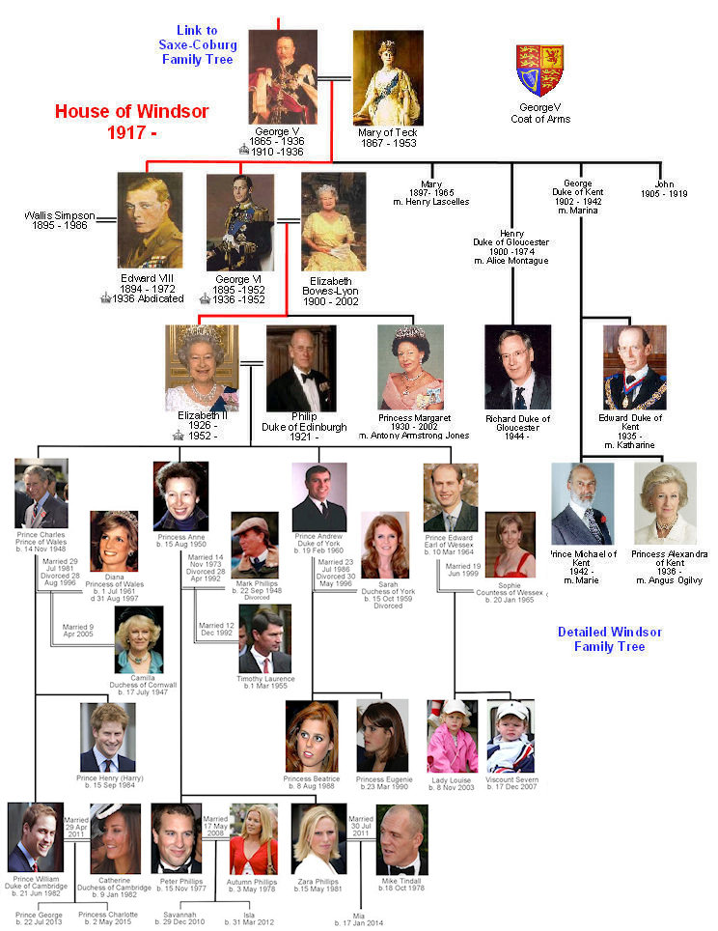

#Worksheet #1-1

Pre-taught vocabularies | Dictionary definition | Student friendly definition
A middle name | The part of a person’s name occurring between the first and family names, as a second given name or a maternal surname. | A person’s middle name is a name between her/his first name and surname. For example,
Be in line to (the throne) | To be the person who will become king or queen after the present ruler.
Pass away | People say pass away to avoid saying die; to disappear
Tribute | A gift, testimonial, compliment, or the like, given as due or in acknowledgment of gratitude or esteem.  A tribute is something that you say, do, or make to show your admiration and respect for someone.

-Examples-
Fill in the blanks with proper vocabularies among middle name, be in line to (the throne, pass away, tribute. Change the form to be grammatically correct.

His mother ______________ by heart attack last year.
Prince Charles is first ________________ the British throne.
Another alumnus, M, agreed to be identified in the article only by this single letter from his ____________.
At her funeral her oldest friend paid ________ to her life and work.
This book is a fitting ________ to the bravery of the pioneers.
My surname is human, my _______________ is Jewish and my private, given, name is Israeli.

Worksheet #1-2

Pre-taught vocabularies | Dictionary definition | Student friendly definition
A middle name | The part of a person’s name occurring between the first and family names, as a second given name or a maternal surname. | A person’s middle name is a name between her/his first name and surname. For example,
Be in line to (the throne) | To be the person who will become king or queen after the present ruler.
Pass away | People say pass away to avoid saying die; to disappear
Tribute | A gift, testimonial, compliment, or the like, given as due or in acknowledgment of gratitude or esteem.  A tribute is something that you say, do, or make to show your admiration and respect for someone.

-Examples-
Fill in the blanks with proper vocabularies among middle name, be in line to (the throne, pass away, tribute. Change the form to be grammatically correct.

His mother ______________ by heart attack last year.
Prince Charles is first ________________ the British throne.
Another alumnus, M, agreed to be identified in the article only by this single letter from his ____________.
At her funeral her oldest friend paid ________ to her life and work.
This book is a fitting ________ to the bravery of the pioneers.
My surname is human, my _______________ is Jewish and my private, given, name is Israeli.

Worksheet #1-3

Pre-taught vocabularies | Dictionary definition | Student friendly definition
A middle name | The part of a person’s name occurring between the first and family names, as a second given name or a maternal surname. | A person’s middle name is a name between her/his first name and surname. For example,
Be in line to (the throne) | To be the person who will become king or queen after the present ruler.
Pass away | People say pass away to avoid saying die; to disappear
Tribute | A gift, testimonial, compliment, or the like, given as due or in acknowledgment of gratitude or esteem.  A tribute is something that you say, do, or make to show your admiration and respect for someone.

-Examples-
Fill in the blanks with proper vocabularies among middle name, be in line to (the throne, pass away, tribute. Change the form to be grammatically correct.

His mother ______________ by heart attack last year.
Prince Charles is first ________________ the British throne.
Another alumnus, M, agreed to be identified in the article only by this single letter from his ____________.
At her funeral her oldest friend paid ________ to her life and work.
This book is a fitting ________ to the bravery of the pioneers.
My surname is human, my _______________ is Jewish and my private, given, name is Israeli.

#Worksheet #2
Britain’s new princess named Charlotte (7th May, 2015)

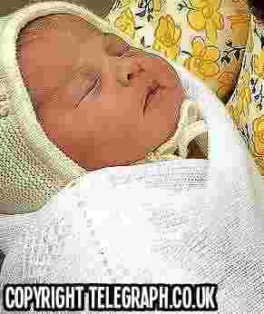
Britain's Duke and Duchess of Cambridge have named their newborn baby daughter Charlotte. She was born on Saturday and since then the world has been waiting to see what she would be called. The parents Prince William and his wife Kate, waited two days to tell the world. Charlotte has two middle names, Elizabeth and Diana. Her official title is Her Royal Highness Princess Charlotte of Cambridge. She is fourth in line to become top of Britain's royal family. If her grandfather (Prince Charles), father, and brother all die, she will be Britain's queen after Queen Elizabeth passes away.

The British public is delighted with the princess' names. People like the fact that they are traditional and linked to members of the royal family. Charlotte is the female version of Charles – Prince Charles is her grandfather. A Queen Charlotte lived in the 18th century. She was married to Britain's King George III. The new princess' middle name, Elizabeth, is the same as her great-grandmother Queen Elizabeth. Finally, her second middle name, Diana, is that of her grandmother, Diana Princess of Wales. Someone tweeted: 'I love that Diana's name is in there. Such a lovely tribute to her."

Worksheet #3

MULTIPLE CHOICES – QUIZ

- Which English city are William and Kate Duke and Duchess of?
- Cambridge
- Manchester
- London
- Oxford
- On what day of the week was Charlotte born?
- Friday
- Sunday
- Saturday
- Tuesday
- How long did the parents wait before announcing the name?
- 3 days
- 2 days
- 4 days
- 5 days
- How many middle names does Charlotte have?
- 5
- 4
- 3
- 2
- How many people are ahead of Charlotte in line to the throne?
- 3
- 4
- 5
- 6
- How do British people feel about the baby’s names?
- Horrified
- Ecstatic
- Indifferent
- delighted
- Charlotte is the woman’s name; what is the man’s name?
- Chester
- Charles
- Brad
- George

- When did Queen Charlotte live?
- In the 1900s
- In the 1600s
- In the 1800s
- In the 1700s
- Who is Princess Charlotte’s great-grandmother?
- Queen Charlotte
- Diana, Princess of Wales
- Queen Elizabeth II
- Queen Victoria
- Who did a tweeter say Charlotte’s middle name was a tribute to?
- A famous writer
- Diana, Princess of Wales
- A nurse
- Kate Middleton

Worksheet #4

Number these lines in the correct order.

( ) | in line to the British throne. This means that if her grandfather (Prince Charles), father,
( ) | version of Charles – Prince Charles is her grandfather. There was a Queen Charlotte in the 18th
( ) | century, who was married to Britain's King George III. The new princess' middle name, Elizabeth, is the same
( ) | fact that the names were traditional, and closely linked to members of the royal family. The name Charlotte is the female
( ) | as her great-grandmother, Britain's Queen Elizabeth. Finally, her second middle
( ) | child. Tweeter Stephanie Clark said: 'I love that Diana's name is in there. Such a lovely tribute to her."
( ) | names, Elizabeth and Diana. Her official title is Her Royal Highness Princess Charlotte of Cambridge. She is fourth
( ) | before they told the world. Their new baby is called Charlotte. She also has two middle
( 1 ) | Britain's Duke and Duchess of Cambridge have named their newborn baby daughter. The two royals are better
( ) | known as Prince William and his wife Kate. Their daughter was born on Saturday and since
( ) | name, Diana, is that of her grandmother, Diana Princess of Wales, who died in 1997 when Prince William was a
( ) | then the world has been waiting to see what the new arrival would be called. The parents waited two days
( ) | The British public is delighted at the choice of names for the new princess. Most people liked the
( ) | and brother (Prince George) all die, she will be Britain's queen after Queen Elizabeth passes away.

