Listening Lesson Plan
Topic: Oprah Winfrey
Instructor | Level | Age | Number of students | Length
Hyemy(Kwak, Hyemi) | Intermediate | Adult | 8 | 50 mins

Materials:
Audio file(article, vocabulary), Computer and Speaker
Picture of Oprah Winfrey
Worksheet: #1 True or false questions, Matching vocabulary & phrase(8 copies)
#2 Gap fill(8 copies)
#3 Language(8 copies)
#4 Quotes of Oprah Winfrey(2 copies)
White board & Marker
2 pieces of Hardboard(A3 size)
Papers and pens

Aims:
1. Ss will improve their listening and speaking skills when they discuss about ‘Oprah Winfrey’.
2. Ss will learn vocabulary by listening to the native speaker sound
3. Ss will enhance reading comprehension skills through reading the article.
4. Ss will practice writing skills when they make wallchart using quotes of Oprah Winfrey.

Language skills:
∙ Speaking: Ss will discuss in pairs and groups.
∙ Listening: Ss will listen to the article and classmate’s opinion.
∙ Reading: Ss will read the article.
∙ Writing: Ss will write some sentences to make wallchart.

Language systems:
∙ Lexis: learn Vocabulary and synonym used in the article.
∙ Discourse: Make free discussion.
∙ Phonology: listen to vocabulary sounds of the native speaker.
∙ Function: access and understand listen English about Oprah Winfrey.
∙ Grammar: complete word class used in the article(#3 Worksheet).

Assumptions:
∙ Students are familiar with the style of teacher.
∙ Students know who Oprah Winfrey is.
∙ Students are at an intermediate level and know how to express their opinion in English.

Anticipated Errors and Solutions:
Students have not enough confidence to express their opinion when they are discussing.
→Encourages him/her so they can participate discussion more actively.
If the audio file does not work.
→Prepare scripts and read it to the students.
Students may not be able to pick up details from listening.
→Play the whole audio file once, and then chunk each sentence for easy listening
Students may finish the activity earlier than expected.
→Make use “bag of tricks” prepared.

References:
www.breakingnewsenglish.com/oprahwinfrey
www.google.com/image/oprahwinfrey
www.dictionary.com/regstoreach
www.google.com/oprahwinfreyquote

Notes:
Students must be monitored during the class.
If the task is completed early, teacher set up SOS activity prepared.

Pre-task
Aims: Warm up |  |  | Materials: Picture of Oprah Winfrey
Time | Set Up | Student |  | Teacher
2mins | Whole Class | Students guess what Today’s topic is, and share their ideas |  | Greeting Students  Guiding questions to elicit Today’s topic  Show picture of Oprah Winfrey
3mins | 2 Groups | Students listen to teacher’s instruction  Discuss about 'Oprah Winfrey' in groups |  | Give instruction and make students to 2 groups  Monitoring/Time management
5mins | Whole  Class | Student will write things about 'Oprah Winfrey' on the white board.  Students watch the whiteboard to know about her briefly |  | Invite students to white board to write things about her under each heading.  Give time to learn about Oprah Winfrey through watching the whiteboard
Notes: Encourage students to engage in ‘Oprah Winfrey’

Task Preparation
Aims: To learn vocabulary used in the article |  |  | Materials: #1 Worksheet, Audio file,  Computer and speaker
Time | Set Up | Student |  | Teacher
1mins | Whole Class | Students listen to the instruction |  | Give instruction  Hand out #1 worksheet to each student
5mins | 4 pairs | Students complete #1 worksheet individually, and confer with partner |  | Make students in pairs  Monitoring  Time management
4mins | Whole Class | Mark #1 worksheet(Matching words) individually  Listen to the native speaker sounds and practice how to pronounce them |  | Give the right answer(Matching words)  Play the native speaker sound  CCQ Vocabulary
Notes: Students can learn vocabulary with listening to the native speaker sound

Task Realization:
Aims: To practice listening and Speaking skills |  |  | Materials: Audio file, Computer & Speaker  #1 worksheet, #2 worksheet
Time | Set Up | Student |  | Teacher
5mins | Whole  Class | Students listen to the instruction  Students listen to the article |  | Give instruction  Play audio file of the article twice
2mins | Whole  Class | Mark #1 worksheet individually |  | Give the right answer of #1 worksheet to students(True/False)
3mins | 4 pairs | Students fill in the spaces of #2worksheet individually, and confer with partner |  | Make students in pairs  Hand out #2worksheet to each student  Monitoring/Time management
3mins | 4 pairs | Students listen to the article again  Mark #2worksheet partner’s #2worksheet |  | Play the article 1 more time.  Give the right answer of #2worksheet to students(Gap fill)
7mins | Whole  Class | Each student read loudly like an anchor and the rest of students listen to pronunciation. |  | Make Each student read the article loudly  (one-person role play)
Notes: Reading comprehension and listen to each student’s pronunciation.
Make error correction if it is needed through monitoring students.

Post Task
Aims: To practice writing skills and make wallchart |  |  | Materials: #3 worksheet
Time | Set Up | Student |  | Teacher
7mins | 2 Groups | Students listen to the instruction  Students write some quotes in papers and paste at hardboard n group |  | Give instruction  Present Demo(wallchart of quotes)  Mnitoring/Time management
3mins | Whole  Class | Present wallchart of each group  Loud applause and say good-bye |  | Give feedback and tell their achievement.  Hand out homework(#3worksheet)  Thanks to the Students and Conclude the class
Notes: Make wallchart to memorize today’s lesson about ‘Oprah Winfrey’

Picture of Oprah Winfrey

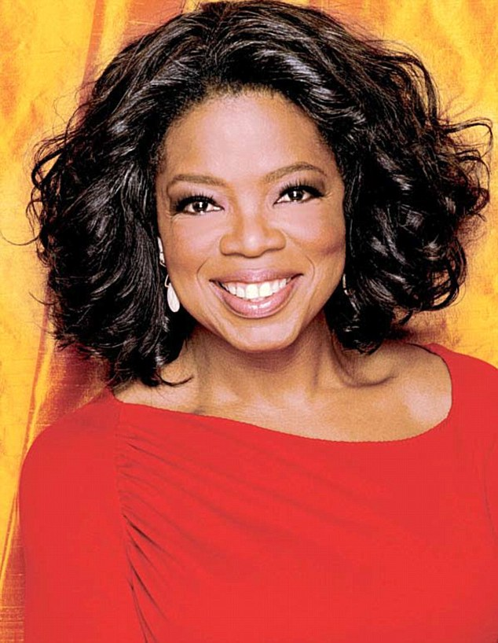

*script

8th December, 2008

THE ARTICLE
Oprah Winfrey has been named the most powerful woman in entertainment. This is according to the entertainment trade publication The Hollywood Reporter. She jumped up from the number six spot, which she occupied in 2007. Her rise to the top may be due to the influence she had on the US Election in November 2008. Analysts reckon her support of Barack Obama brought him over one million votes. The Hollywood Reporter's chief editor Elizabeth Guider explained: "The decision to place Oprah at the top of the list was based on her dizzying array of Oprah-branded media and her immense cultural influence," she said. TIME magazine listed Winfrey as one of the 100 people of the twentieth century.
Oprah Winfrey is a household name in many parts of the world. Her rags-to-riches life is an incredible success story. She is a self-made woman who became the world's first black billionaire in 2004. Winfrey owns her own production company Harpo ('Oprah' spelt backwards), which made $345 million in profit in 2007. She is perhaps most famous for her chat shows. The "Oprah Winfrey Show" began in 1986 and has been one of the world's most-watched programmes ever since. Winfrey's entertainment empire covers TV, magazines, book clubs and online shopping. She is also extremely well known for her charity work. She is set to launch her own TV channel, OWN (Oprah Winfrey Network), which will reach 70 million homes.

#1 Worksheet

1. TRUE / FALSE: Look at the article’s headline and guess whether these sentences are true (T) or false (F):
a. | Oprah Winfrey won a competition testing the strength of celebrities. | T / F
b. | Winfrey had an influence on the 2008 US Election. | T / F
c. | Oprah bought Barack Obama over a million votes in the election. | T / F
d. | TIME magazine said Oprah was one of the 20th century’s top people. | T / F
e. | Oprah was born into a very rich family. | T / F
f. | Oprah reversed the letters of her given name for her company name. | T / F
g. | The Oprah Winfrey Show is the most successful show in TV history. | T / F
h. | Oprah may soon be in 70 million living rooms via her own TV network. | T / F

2. SYNONYM MATCH: Match the following synonyms from the article:
1. | trade | a. | get to
2 | rise | b. | believe
3. | reckon | c. | huge
4. | array | d. | started
5. | immense | e. | variety
6. | incredible | f. | very
7. | began | g. | industry
8. | empire | h. | amazing
9. | extremely | i. | organization
10. | reach | j. | elevation

3. PHRASE MATCH: Match the following phrases from the article (sometimes more than one. combination is possible):
1. | the most powerful woman | a. | for her chat shows
2 | the influence she had on the | b. | influence
3. | She jumped up from the | c. | watched programmes
4. | her immense cultural | d. | household name
5. | the 100 people of | e. | in entertainment
6. | Oprah Winfrey is a | f. | number six spot
7. | ’Oprah’ spelt | g. | her own TV channel
8. | She is perhaps most famous | h. | the twentieth century
9. | one of the world’s most- | i. | backwards
10. | She is set to launch | j. | US Election

#2 Worksheet

GAP FILL: Put the words into the gaps in the text.
Oprah Winfrey has been __________ the most powerful woman in entertainment. This is __________ to the entertainment trade publication The Hollywood Reporter. She jumped up from the __________ six spot, which she occupied in 2007. Her rise to the top may be __________ to the influence she had on the US Election in November 2008. Analysts __________ her support of Barack Obama brought him over one million votes. The Hollywood Reporter's chief editor Elizabeth Guider explained: "The __________ to place Oprah at the top of the list was based on her dizzying array of Oprah-branded __________ and her immense cultural influence," she said. TIME magazine __________ Winfrey as one of the 100 people of the twentieth century. |  | due  listed  number  decision  reckon  named  media  according
Oprah Winfrey is a __________ name in many parts of the world. Her rags-to-riches life is an incredible success __________. She is a self-made woman who became the world’s first black billionaire in 2004. Winfrey __________ her own production company Harpo (’Oprah’ spelt backwards), which __________ $345 million in profit in 2007. She is perhaps most __________ for her chat shows. The "Oprah Winfrey Show" began in 1986 and has been one of the world’s most-watched programmes ever __________. Winfrey's entertainment empire covers TV, magazines, book clubs and online shopping. She is also extremely well known for her __________ work. She is set to launch her own TV channel, OWN (Oprah Winfrey Network), which will __________ 70 million homes. |  | famous  owns  reach  charity  household  story  made

#3 Worksheet (LANGUAGE)

Oprah Winfrey has been named the most (1) ____ woman in entertainment. This is according to the entertainment trade publication The Hollywood Reporter. She (2) ____ up from the number six spot, which she occupied in 2007. Her rise to the top may be due (3) ____ the influence she had on the US Election in November 2008. Analysts reckon her support of Barack Obama brought him (4) ____ one million votes. The Hollywood Reporter's chief editor Elizabeth Guider explained: "The decision to (5) ____ Oprah at the top of the list was based on her dizzying array of Oprah-branded media and her immense cultural influence," she said. TIME magazine listed Winfrey (6) ____ one of the 100 people of the twentieth century.
Oprah Winfrey is a household name in many parts of the world. Her rags-to-riches life is an incredible success story. She is a self-(7) ____ woman who became the world’s first black billionaire in 2004. Winfrey owns her (8) ____ production company Harpo (’Oprah’ spelt backwards), which made $345 million (9) ____ profit in 2007. She is perhaps most famous for her chat shows. The "Oprah Winfrey Show" began in 1986 and has been one of the world’s most-watched programmes (10) ____ since. Winfrey's entertainment empire covers TV, magazines, book clubs and online shopping. She is also (11) ____ well known for her charity work. She is (12) ____ to launch her own TV channel, OWN (Oprah Winfrey Network), which will reach 70 million homes.
Put the correct words from the table below in the above article.
1. | (a) | powerful | (b) | powerfully | (c) | power | (d) | powers
2. | (a) | jumps | (b) | jumper | (c) | jumped | (d) | jump
3. | (a) | for | (b) | to | (c) | on | (d) | at
4. | (a) | up | (b) | one | (c) | more | (d) | over
5. | (a) | placing | (b) | placement | (c) | place | (d) | placed
6. | (a) | as | (b) | for | (c) | by | (d) | from
7. | (a) | makes | (b) | making | (c) | make | (d) | made
8. | (a) | owns | (b) | own | (c) | ownership | (d) | owner
9. | (a) | if | (b) | at | (c) | in | (d) | from
10. | (a) | ever | (b) | even | (c) | never | (d) | every
11. | (a) | extremity | (b) | extremely | (c) | extremes | (d) | extreme
12. | (a) | seat | (b) | sit | (c) | sat | (d) | set

#4 Quotes of Oprah Winfrey

The more you praise and celebrate your life, the more there is in life to celebrate. | Think like a queen. A queen is not afraid to fail. Failure is another steppingstone to greatness. | The biggest adventure you can take is to live the life of your dreams. | Be thankful for what you have; you'll end up having more. If you concentrate on what you don't have, you will never, ever have enough.
Lots of people want to ride with you in the limo, but what you want is someone who will take the bus with you when the limo breaks down. | What God intended for you goes far beyond anything you can imagine. | Real integrity is doing the right thing, knowing that nobody's going to know whether you did it or not. | Do the one thing you think you cannot do. Fail at it. Try again. Do better the second time. The only people who never tumble are those who never mount the high wire. This is your moment. Own it.
Where there is no struggle, there is no strength. | Surround yourself with only people who are going to lift you higher. | I still have my feet on the ground, I just wear better shoes. | I don't think of myself as a poor deprived ghetto girl who made good. I think of myself as somebody who from an early age knew I was responsible for myself, and I had to make good.
I was raised to believe that excellence is the best deterrent to racism or sexism. And that's how I operate my life. | The greatest discovery of all time is that a person can change his future by merely changing his attitude. | Passion is energy. Feel the power that comes from focusing on what excites you. | When I look into the future, it's so bright it burns my eyes.
My idea of heaven is a great big baked potato and someone to share it with. | The whole point of being alive is to evolve into the complete person you were intended to be. | What material success does is provide you with the ability to concentrate on other things that really matter. And that is being able to make a difference, not only in your own life, but in other people's lives. | Doing the best at this moment puts you in the best place for the next moment.

