Speaking Lesson Plan
Topic: Job Interview : Preparing for unexpected questions
Instructor | Level | Age | Number of students | Length
Hyemy(Kwak, Hyemi) | Intermediate | Adult | 7 | 50 mins

Materials:
Computer and Speaker, Beam Projector, PPT file
Worksheet: #1 Job interview questions(A sheet 4 copies, B sheet 4 copies)
#2 Starbucks job interview role card(A sheet 4 copies, B sheet 4 copies)
#3 To do or not to do, that is the difference
White board & Marker
8 pieces of blank paper and pens

Aims:
- To improve speaking skills by discussing about offbeat questions
- To create great answers for successful interviews through discussion about unexpected questions
- To learn vocabulary about job interview when they use them by role playing
- To practice writing skills through making interview questions and introduction about themselves

Language skills:
∙ Speaking: discussing and role-play in pairs and groups
∙ Listening: listening to the interview questions and answers
∙ Writing: writing about themselves and expected questions
∙ Reading: reading an article about job

Language systems:
∙ Lexis: Learn vocabulary used in the job interview
∙ Discourse: Discussion and role play
∙ Phonology: Listen to pronunciation of the native speaker
∙ Function: Conversation through question and answer, role play
∙ Grammar: Use the correct verb tense

Assumptions:
∙ Students are University Students and they needs to prepare job interview for getting a job.
∙ Students are at an intermediate level and know how to express their opinion in English.

Anticipated Errors and Solutions:
Students might have lots of opinions for this topic which could exceed the class time.
→Give time warning
If the audio file does not work.
→Prepare scripts and read it to the students.
Students may finish the activity earlier than expected.
→Make use SOS activity prepared.
Students have not enough confidence to express their opinion when they are discussing.
→Encourages him/her so they can participate discussion more actively.

References:
www.google.co.kr/jobinterview
http://iteslj.org/Lessons/Blake-JobInterview.html
https://en.islcollective.com/resources/printables/worksheets_doc
http://bogglesworldesl.com/adultesl2.htm
https://quizlet.com/12970929/job-interview-vocabulary-flash-cards/

Notes:
If the task is completed early, teacher set up Plan B activity prepared.

Presentation
Aim: To learn vocabulary about job interview and improve speaking skills by discussing about unexpected questions
Materials: PPT, Beam Projector, Computer and Speaker
Time | Set Up | Student | Teacher
1mins | Whole Class | Students listen to the guiding questions  Then students notice class topic. | Greeting  Elicit the topic through showing first page of PPT.  Give guiding questions
2mins | Whole  Class | Student listen to teacher talk  Students answer the questions | Teacher motivate to students by showing second page of PPT and share their opinions what company do they want to apply and the reason why  Then ask what students have to prepare  ‘answer is job interview’
4mins | Whole  Class | Students listen to the pronunciations of some words  Students take notes and memorize them | Teacher shows third page of PPT and explain vocabulary  Play sounds of vocabulary on the website  CCQ ‘Offbeat’
3mins | Whole  Class | Student listen to teacher talk | Teacher explain briefly how to prepare themselves for the offbeat questions
Notes: Make sure the PPT is working.
Prepare print out PPT in advance, in case the PPT is not working.
Vocabulary website: https://quizlet.com/12970929/job-interview-vocabulary-flash-cards/

Practice
Aim To improve their speaking skills by making up unexpected questions and answers by themselves
Materials: white board and marker, blank paper(A4 size)
Time | Set Up | Student | Teacher
5mins | 2 Groups | Student listen to teacher talk  Students are brainstorming in groups | Teacher give instruction  Arrange students in groups  ICQ  Write ‘group1’ and ‘group2’ on the white board  Monitoring
2mins | 2 Groups | Students write their opinions on the white board in groups | Invite students to the white board and write unexpected questions
2mins | Whole Class | Students make up their answers for 3 questions  Students listen to the instruction | Teacher and students share student’s ideas, and choose 3 of creative questions  Give instruction  Then give time to think what they will answer for 3 questions
5mins | 4 pairs | Student listen to the teacher’s instruction  Student do a role play  (A will be an ‘employer’ and B will be an ‘applicant’)  Then switch their role and do again | Arrange students in pairs  Demonstration with a student  ICQ  Monitoring
Notes: If they need blank paper to write down, hand out prepared blank paper to students

Product
Aim: To practice speaking skills by doing an job interview role play activity
Materials: Worksheet#1(A sheet 4 pieces, B sheet 4 pieces)
Worksheet#2(A sheet 4 pieces, B sheet 4 pieces)
Time | Set Up | Student | Teacher
3mins | 4 pairs | Students listen to the instruction  Students fill in the blank of A or B sheet | Arrange students in pairs  Hand out Worksheet #1 to students  (A,B one set to a pair)  Give time to fill in 5 more questions of Worksheet #1
7mins | 4 pairs | One of student act as an ‘employer’ and another student act as an ‘applicant’ in pairs  After giving 5 questions to their partner, they switch their role | Give instruction  Hand out Worksheet#2 to students  (A,B one set to a pair)  Demonstration with a student  Monitoring
10mins | 4 pairs | One of pairs do role play as an ‘employer’ and ‘applicant’ in front of their classmates  They can only give 5 questions to other student | Invite all pairs to do role play in front of the other students  One of role play finished, other students can give feedback to the pair
Notes:
Worksheet #1, Worksheet#2 consist of A sheet and B sheet. Hand out 1 set to a pair
Monitoring is very essential, so walk around the classroom, and listen to each student’s pronunciation and make error correction when they give questions to their pair or role play.

Post Activity
Aim: To improve their speaking skills by discussing about ‘to do or not to do’ on the job interview
Materials: Worksheet#3
Time | Set Up | Student | Teacher
5mins | Whole  Class | Students read Worksheet#3  Students express their opinions to other students | Hand out Worksheet#3  Give time to read it briefly  Free talk about Worksheet#3
1mins | Whole  Class | Students listen to the instruction  Say good-bye | Give feedback and tell their achievement.  Thanks to the Students and Conclude the class
Notes: If time is up, give Worksheet#3 for reference

Worksheet#1 (A Sheet)
In Partners, take turns interviewing each other. First, write five additional questions that you would like to ask. Then interview your partner and record their answer.

(1)

(2)

(3)

(4)

(5)

(6) How much do you want to be paid?

(7) What kind of experience do you have?

(8) What are your good and bad points?

(9) What are your long-term plans?

(10) What do you do in your free time?

Worksheet#1 (B Sheet)
In Partners, take turns interviewing each other. First, write five additional questions that you would like to ask. Then interview your partner and record their answer.

(1)

(2)

(3)

(4)

(5)

(6) What did you study at university?

(7) What kind of experience do you have?

(8) How can you help our company?

(9) What are your long-term plans?

(10) What are your interests?

Worksheet#2 (A Sheet)
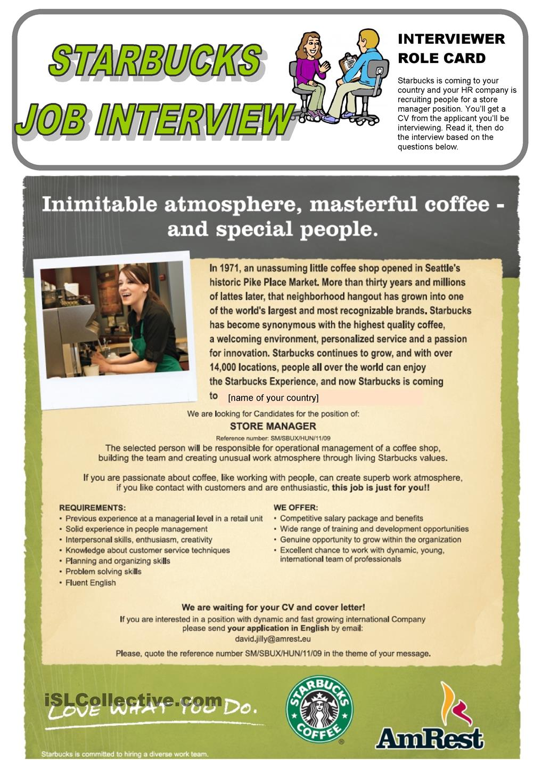

Worksheet#2 (B Sheet)
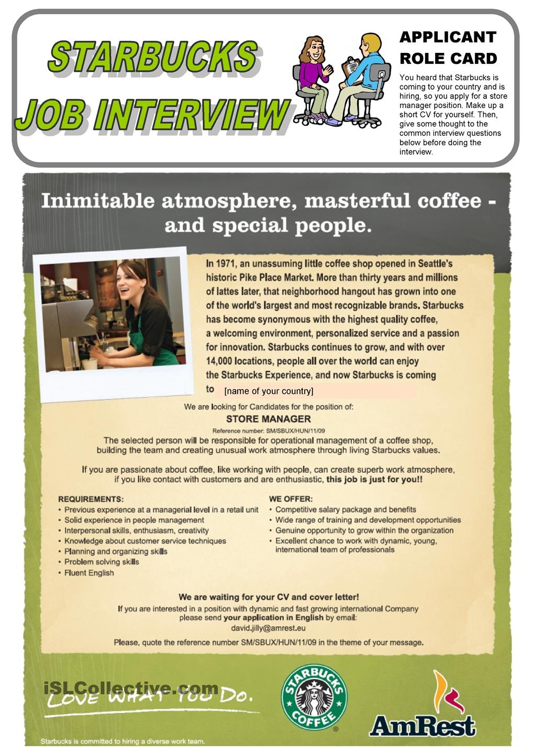

worksheet#3

To Do Or Not To Do, That is The Difference

Do
- Prepare a complete, attractive resume that stresses your qualifications in a positive manner.
- Get permission from people you plan to use as references.
- Write an effective cover letter that really sells “You”.
- Fill out the application completely, accurately, and legibly.
- Use the completed resume as a reference for filling out the application.
- Arrive for the interview a few minutes early.
- Dress appropriately for the interview.
- Go to the interview alone.
- Bring resume, social security card, work permits and licenses to the interview.
- Present yourself with confidence.
- Research the company.
- Be prepared to answer questions about yourself and your qualifications.
- Be prepared to ask questions about the company.
- Smile.
- Follow the interview with a thank-you letter

Do Not
- Do not present a resume that was hastily put together or has typographical errors and smudges.
- Do not use a general, all-purpose resume.
- Do not give inaccurate information.
- Do not present an application that is unreadable or incomplete.
- Do not arrive late for an interview.
- Do not wear jeans, wrinkled clothing, or outrageous jewelry to an interview.
- Do not overdo perfume or aftershave.
- Do not take friends or family to an interview.
- Do not act as if the receptionist and interview are doing themselves a favour by seeing you.
- Do not forget your manners.

*Plan B
In pairs, Student A is an employer Student B is applying for a job but there is a reason they should not get the job. Example: a pilot that is afraid of heights
Student A must ask questions in the job interview until he/she is able to determine why they should NOT hire Student B.