TITLE | What is my sound?
INSTRUCTOR |  |  |  | Ss’ LEVEL | AGE GROUP | No of Ss | LENGTH
Mirae Kim |  |  |  | Beginner | 3-4 years old | 8 students | 50mins

MATERIALS

A4 papers, colored pencils, rubber bands, stickers, mp3 file, animal’s pictures, a computer, a projector and Worksheet.
AIMS 1. |  | Students can compare animals’ name and sound.
2. |  | Students can express each animals.
3. |  | Students can make own mask and develop their physical skills.

LANGUAGE SKILLS
Listening |  |  | Students will be listening about animal song.
Speaking |  |  | Students will be talking about animal’s names and sound.
Reading |  |  | Students will be reading animals name card.
Writing |  |  | Students will be writing animal’s name on the work sheets.
LANGUAGE SYSTEMS
Phonology |  |  | Distinguish /sh/ and /s/. Eg. /sh/ for Sheep, shine, she and /s/ for sun, super, snake.
Lexis |  |  | Faster, Mice, Farm, Here, There.
Grammar |  |  | A past tense. Students listen to the song, especially ‘had’ and study about past tense.
Discourse |  |  | How can we express animals?
Functions |  |  | Describing and Studying animal’s characteristics.

ASSUMPTIONS

Students can already know some animals sound like dog, cat and so on.
Students can already know ‘Old macdonald had a farm’ song.
Students can role playing trough using animals mask.

ANTICIPATED GRAMMATICAL ERRORS AND SOLUTIONS
Students may not know about the past tense. Students will study past tense in the song and sentences.
Students can confuse ‘here’ and ‘there’. Indicate two products which are located different distance for students.
Students may not be able to know some word from the song. Repeat the song.

REFERENCES

https://www.youtube.com/watch?v=nffX3kbt520

http://www.mrprintables.com/printable-animal-masks.html

http://www.kidkids.net/ddoran/myfile_bbs.htm?skind=subject&uid=176995&skeyword

NOTES
1. Plan B : If the computer and the projector are not working, Teacher sing the song by her/himself.
2. Cut-off plan : If teacher have not enough time, teacher can skip the matching game.
3. SOS plan : ‘

PRETASK TITLE |  |  | Talk about animals that we can see
AIMS |  |  |  | MATERIALS
Talk about each students experience about animals. For example, when, where they saw some animals and how their feeling. |  |  |  | X
TIME | SET UP | STUDENTS |  |  | TEACHER
5 | Whole class | Students can talk their feeling, when they touch animals. |  |  | Ask some guiding question  pay attention for speaking students.
 |  | Students can express what they saw animals.
 |  | Students can ask for another student about their experience.

NOTES

Checking the time and consider that all students can talk.

TASK PREPARATION TITLE |  |  | Moo~ Who am I?
AIMS |  |  |  | MATERIALS
Students study animals name and sound by listening to a song.  Students can know each animals name. |  |  |  | mp3 file, animal’s pictures, a computer, a projector
TIME | SET UP | STUDENTS |  |  | TEACHER
10 | Whole class | Students will listen to the ‘old macdonald had a farm’ |  |  | Play the music several times.  Show animal’s picture cards.
 |  | Students will talk each animal name.

NOTES

Checking computer system and volume of song.

Checking the animal’s picture cards.
Note what students already know and doesn’t know.

TASK REALISATION TITLE |  |  | I can be animals!
AIMS |  |  |  | MATERIALS
Students practice pronouncing /sh/ and /s/ through some words.  Students can match animals name and sounds.  Students can make their own animal mask. |  |  |  | A4 papers, colored pencils, rubber bands, stickers
TIME | SET UP | STUDENTS |  |  | TEACHER
10 | Whole class | Students will study pronunciation /sh/ and /s/. |  |  | Explain different pronunciation between two letters.
15 | individual | Students will make their own animal mask. |  |  | Help some students who need help.

NOTES

Note students understand different of letters.
Note students making speed, when they make mask.

POST TASK TITLE |  |  | I know who is sound.
AIMS |  |  |  | MATERIALS
Students can explain own mask’s feature.  Students can |  |  |  | X
TIME | SET UP | STUDENTS |  |  | TEACHER
10 | Whole class | Student will talk about their own mask. |  |  | Ask guiding questions.
 |  | Student will talk about animal’s sounds and names.

NOTES

X

Paste worksheets, handouts and lesson materials here
Song of ‘Old macdonald had farm’
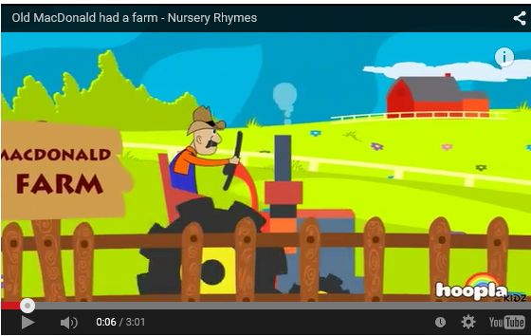

Animal’s picture cards

Animal’s mask
