Reading Lesson Plan
Topic: Body Language & Culture
Instructor | Level | Age | Number of students | Length
Jessie Hwang | Advanced | Adults (age 20 +) | 7 | 50 minutes

Materials:
- Whiteboard, markers
- Printed photos
- Work sheet #01. (7 copies), Work sheet #02. (7 copies), Work sheet #03. (7 copies), Work sheet #04. (7 copies)

Aims:
- Students will improve their reading skills by reading about the article ‘Body language.’
- Students will find out the different cultures may vary in viewing personal facial expression, hand gestures, postures and eye contacts when reading article and through discussion.
- Students will identify various body languages in various cultures through group discussion.

Language skills:
- Reading: Reading article and comprehension about body language.
- Speaking: Verbally sharing their opinions of body languages and cultures.
- Listening: Listening to teacher’s instruction and classmates’ opinions about body language.
- Writing: Writing an essay given as homework to specify their opinion and give concrete examples related to body language.

Language systems:
- Phonology: Listen to teacher and classmates speaking.
- Function: To understand the information and meaning of reading materials given.
- Discourse: Difference interpretation of body language in different cultures.
- Lexis: Students focus on key vocabulary and meanings interpreted on body languages.
- Grammar: Students will learn the difference between written and spoken language.

Assumptions:
- Students already know teacher’s style of teaching and pace in class.
- Students are very active and familiar working in pairs or groups.
- Students are interested with body languages interpreted differently in different cultures.
- Students like to get information in English.

Anticipated Errors and Solutions:
- The main activity finish earlier than expected,
→ Review the topic and get feedback from students.
→ Have SOS activity prepared.

References:
- Extensive Reading for Academic Success Advanced A by Jeff Zeter (Compass Publishing)
- http://westsidetoastmasters.com/resources/book_of_body_language/chap5.html
- http://www.theaustralian.com.au/life/weekend-australian-magazine/questions-body-language-expert-david-alssema/story-e6frg8h6-1226030896495

Notes:
- Give clear instruction before starting each activity.
- Ensure students to read and understand clearly about today’s topic.
- Ensure worksheets are prepared well.

Presentation: Warm-up
Aims:  To elicit today’s topic “Body Language.” |  |  | Materials:  Appendix 1 – 2 photos
Time | Set Up | Student |  | Teacher
2 mins | Whole class | - Students will guess today’s topic “Body Language.” |  | - Greeting.  - Elicit today’s topic by;  * showing the photos  * guiding questions
Notes:
- Show 2 photos when eliciting today’s topic.
- Write down today’s topic “Body Language” on the white board.

Practice: Reading comprehension of body language
Aims:  To have students read the article and do reading comprehension to understand about body language and its functions. |  |  | Materials:  Worksheet #01 – 7 copies  Worksheet #02 – 7 copies
Time | Set Up | Student |  | Teacher
5 mins | Pairs | - Students will read the worksheet #01 to adapt the questions and discuss the answers in pairs. |  | - Provide Worksheet #01.  - I.C.Q.  - Monitor.
17 mins | Pairs | - Students will read the worksheet #02 and check their answers. |  | - Provide Worksheet #02.  - I.C.Q  - Monitor.
2 mins | Whole class | - Students will check the correct answers. |  | - Provide correct answers.
Notes:
- Time warning.
- Worksheet #01 Answers:
1. (D) / 2. (B) / 3. (C) / 4. (A) / 5. (A),(D),(F)

Production: Discussing body language in different cultures/countries
Aims:  To have students understand the differences of body language meanings in different cultures through discussion and feedback. |  |  | Materials:  Worksheet #03 – 7 copies
Time | Set Up | Student |  | Teacher
20 mins | 2 Groups | - Students discuss their opinions base on questions on worksheet #03. |  | - Move students for new grouping.  - Provide worksheet #03.  - I.C.Q.  - Monitor.
2 mins | Whole class | - Students share their opinions for today’s class and give feedback. |  | - Elicit feedback.
Notes:
- Time warning.
- Encourage students to share their opinions and experiences and ensure the speaking responsibility equally during their discussion.
- When grouping, group students depart from their partner worked in previous activity.

Post Activity: Feedback and assigning homework
Aims:  To confirm students has understood today’s topic and to review it themselves. |  |  | Materials:  Worksheet #04 – 7 copies (homework)
Time | Set Up | Student |  | Teacher
2 mins | Whole class | - Students will write their opinion specifically with concrete examples about the topic given. |  | - Assigning essay homework.
Notes:
- If class finishes earlier than expected, use Appendix 5 as a Plan B/SOS activity.
- Assign essay homework.
* Topic: Have you Some people believe that body language shows more about people’s true feelings than spoken language. Body language includes people’s facial expressions, hand gestures, and posture. Do you believe we can tell more from body language than from what people say? Be specific and give concrete examples in your response.
* Word count: 1000 words (font size 11 with double spaces)
* Due date: July 04th before 1pm – hard copy.

Appendix 1. - Eliciting ‘Body Language’
Photo 1.

Photo 2.

Appendix 2. - Worksheet #01
Body Language Reading Comprehensions

- Which of the sentences below best expresses the essential information in the highlighted sentence in the passage? Incorrect choices change the meaning in important ways or leave out essential information.

- People are not always aware of how they are communicating with their bodies.
- All cultures use body language.
- Some people do not understand that body language is an important way to communicate.
- Its unconscious nature may or may not contribute to the power of body language.

- According to the information in paragraph 2, if a person is not sure what another person said, then the person is likely

- to ask the person to repeat the statement
- to look to the person’s body language for confirmation of what was said
- to compare the spoken words to written words.
- to be reluctant to trust the person.

- In paragraph 4, the writer describes the practice of bowing in Japan

- to contrast it with the ways people greet each other in other cultures.
- to show how the meaning of gestures can vary by gender.
- to illustrate how social relations between people can influence body language.
- to explain how body language can add emphasis to a person’s speech.

- What can be inferred from paragraph 5 about body language?

- Body language can be learned.
- People cannot effectively use another culture’s body language.
- The importance of body language in everyday communication is exaggerated.
- People prefer written communication because it does not involve body language.

- An introductory sentence for a brief summary of the passage is provided below. Complete the summary by selecting the THREE answer choices that express the most important ideas in the passage. Some sentences do not belong in the summary because they express ideas that are not presented in the passage or are minor ideas in the passage.

The nonverbal means of communication known as body language is found in every culture.
- The meaning of body language can depend on various factors such as culture.
- Some researchers believe body language is responsible for more than half of what people communicate.
- A simple thing like better posture can improve a person’s mood.
- A person’s body language provides important clues to the meaning of a person’s words and emotions.
- Latin Americans and United States citizens do not share a similar sense of space.
- While people are often unaware of messages they are sending through their body language, they can also
- consciously use body language to communicate.

Appendix 3. - Worksheet #02

Body Language

Body language is a nonverbal form of communication involving gestures, body postures, body movements, facial expressions, use of time and space, and the like. Body language often accompanies speech, but even when a person is not talking, his or her body language is sending out signals to the people nearby, often without realizing communication is taking place. Even though people may be unconscious of how they are holding their body or of the movements they are making with their legs, arms, and or head, or perhaps partly due to this lack of awareness, body language is an important part of communication used in every culture.

Body language is sometimes more important than speech in conveying the content of a message. It provides clues for interpreting what is being said and can reinforce the content or contradict it. Often it is easier to express feelings through body language than with spoken language, especially if the feelings are negative. Clues to relationships can be discovered by studying how closely two people stand to each other, whether they look each other in the eye, or how often and in what ways they touch during a conversation.

Because it is usually unconscious, body language tends to reveal a person’s true state of mind. In any communication, spoken words, tone of voice, and general body language are all important. Ideally, there will be alignment between words, voice, and body, but much communication is revealed by nonverbal signals. People sometimes end double messages, where their words say one thing but their body language says the opposite. In such situations, when people are unsure about someone’s words or do not necessarily trust the person, they tend to put more stock in what they see in the person’s body language rather than accepting the words at face value. Nonverbal clues facilitate the understanding of a person’s words. Consequently, there is more chance of an email message being misunderstood than part of a conversation that happens face-to-face.

Body language has different meanings in different cultures. Interpretation of body language, even within a culture, depends on factors such as the situation, the relationship between the people involved, and a person’s gender. A gesture or body position can have multiple meanings, so that a person whose arms are folded across the chest could be relaxing, could be cold, or could be signaling an unwillingness to interact with another person. In Japan, bowing used in social interactions depends on the social status of the people involved. In the United States, females tend to look directly at each other when they talk, but males are less likely to make eye contact, especially with another man. In Madagascar, people point with their lips, while those in the United States point their fingers. In fact, rarely does a signal transcend culture or carry the same meaning throughout the world. For instance, in the United States, as well as in most other countries, shaking the head side to side indicates “no” and nods up and down indicate “yes.” In India and Greece, however, the meanings are reversed, with a side to side shake meaning “yes” and an up and down nod meaning “no.”

Body language can express a broad array of emotions and attitudes. It can communicate defensiveness or a sense of power. It can signal aggression or submission. Sometimes, the former is expressed by how close a person stands in relation to another. A citizen of the United States can misinterpret as aggressive a Latin American who is maintaining what is considered a comfortable interpersonal distance in the Latin culture. Body language can emphasized what a person is saying. In fact, much of what people attribute to intuition actually results from their unconscious reading of another person’s body language. People can use body language consciously as well. For instance, a person can show interest in and respect for another person by deliberately turning toward that person or can illustrate boredom through a feigned yawn. Body posture is usually an unconscious reflection of how a person feels, but a person can also intentionally use it to affect mood. For instance, a person’s depression may be reflected in sagging shoulders and little eye contact, but if the person purposefully straightens the posture, walks upright, and looks around, better feeling ensue.
Appendix 4. - Worksheet #03

GROUP DISCUSSION

Non-verbal communication or body language is an important part of how people communicate and there are differences from culture to culture. Hand and arm gestures, touch, and eye contact (or its lack) are a few of the aspects of non-verbal communication that may vary significantly depending upon cultural background.

For instance, shaking the head side to side indicates “NO” and nods up and down indicate “YES” in most of the countries. However, in India and Greece, the meanings are reversed.

In Brazil, Germany, Russia, and many other countries around the world, the OK sign is a very offensive gesture because it is used to depict a private bodily orifice. The OK sign actually does mean "okay" in the United States, however in Japan it means "money," and it is commonly used to signify "zero" in France. Clearly the OK sign isn't offensive everywhere; however, it is not OK to use in many parts of the world, nor does it necessarily mean "okay"!

- Please discuss how body language (gestures, facial expression or body postures) is interpreted in different countries with examples. Did you faced a problem or trouble of using wrong body language or misinterpreted the meaning with people of different cultural background? Please share.

- Research from Harvard University suggests that when reading expressions and decoding situations, women were correct 87% of the time while men scored only 42%. Women are much better at reading emotion. So do you agree women are better at reading body language than men?

Appendix 5. - Worksheet #04

Essay Assignment

* Topic:
Some people believe that body language shows more about people’s true feelings than spoken language. Body language includes people’s facial expressions, hand gestures, and posture. Do you believe we can tell more from body language than from what people say? Be specific and give concrete examples in your response.

* Word count: 1000 words (font size 11 with double spaces)

* Due date: July 4th(Sat) before 1pm – Hard copy

Appendix 6. - SOS activity
Hand Signals in Different Cultures

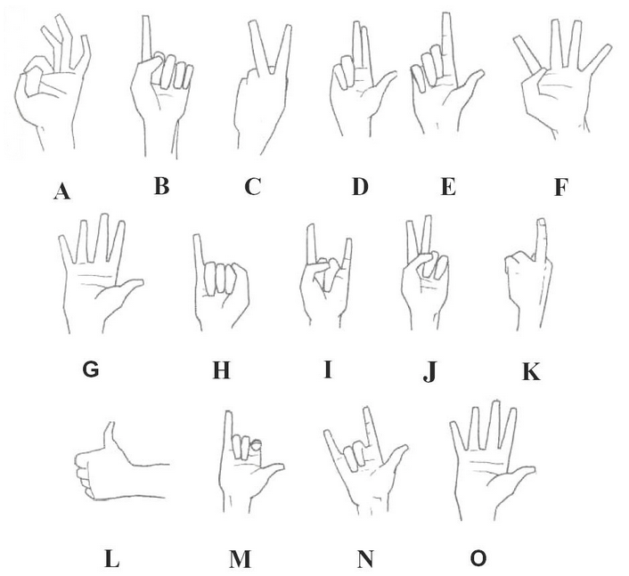

Explanations
 | Country | Meaning
A | Europe and North America | OK
 | Mediterranean region, Russia, Brazil, Turkey | An orifice signal; sexual insult; gay man
 | Tunisia, France, Belgium | Zero; worthless
 | Japan | Money; coin
B | Western countries | Excuse me!; As God is my witness; No!(to children)
C | Britain, Australia, New Zealand, Malta | Up yours!
 | USA | Two
 | Germany | Victory
 | France | Peace
 | Ancient Rome | Julius Caesar ordering five beers
D | Europe | Three
 | Catholic countries | A blessing
E | Europe | Two
 | Britain, Australia, New Zealand | One
 | USA | Waiter!
 | Japan | An insult
F | Western countries | Four
 | Japan | An insult
G | Western countries | Number 5
 | Everywhere | Stop!
 | Greece and Turkey | Go to hell!
H | Mediterranean | Small penis
 | Bali | Bad
 | Japan | Woman
 | South America | Thin
 | France | You can’t fool me!
I | Mediterranean | Your wife is being unfaithful.
 | Malta and Italy | Protection against the Evil Eye (when pointed)
 | South America | Protection against bad luck (when rotated)
 | USA | Texas University Logo. Texas Longhorn Football Team.
J | Greece | Go to Hell!
 | The West | Two
K | Ancient Rome | Up yours!
 | USA | Sit on this! Screw you!
L | Europe | One
 | Australia | Sit on this! (upward jerk)
 | Widespread | Hitchhike; Good; OK.
 | Greece | Up yours! (thrust forward)
 | Japan | Five
M | Hawaii | Hang loose
 | Holland | Do you want a drink?
N | USA | I love you.
O | The West | Ten; I surrendered.
 | Greece | Up yours – twice!
 | Widespread | I’m telling the truth.

