Reading Lesson Plan ( PPP model)
6/26/2015
Topic: Job interview
Instructor | Level | Age | Number of students | Length
Jeonghyun (Sally) Seo | Intermediate | Middle school(12~15) | 7 | 50 minutes

Materials:
Whiteboard, markers, pens
8 copies of worksheet #1~3
8 copies of SOS activity

Aims:
- Understand article through reading and discussion
- Improve speaking skills by discussing and debating
- Practice listening skills by listening to classmates
- Practice writing skills when writing Christmas cards

Language skills:

Reading : reading article
Speaking: Verbally sharing opinions and debate
Listening: Listening to classmates and teacher’s instruction
Writing: Writing down about positive and negative points of Christmas. Writing Christmas message

Language systems:

Lexis : vocabulary and expressions about Christmas
Phonology: students focus on accurate pronunciation to ensure successful communication during discussion
Function: To understand the article and follow up questions in the worksheets
Discourse: communication with classmates

Assumptions:

Students are middle school student and familiar with Christmas.

Anticipated Errors and Solutions:
-The main activity may finish earlier than expected
=> review the topic and get feedback from students
=>have SOS activity prepared

References: http://Google.com/search

Notes:

Students must be monitored during activities.
Teacher to involve in the process so that students can complete practice and production in time
Encourage student to make fun roll play

Presentation : Warmer
Aims: To brainstorm about Christmas |  |  | Materials: Pictures, and markers
Time | Set Up | Student |  | Teacher
1min | Whole class | Students will guess the topic |  | Greetings  Elicit through pictures about Christmas
2 min | 3 groups | Students will discuss words connected with Christmas |  | Give instruction. ICQ.  monitor
2 min | Whole class | Each group will write down the words on the white board |  | Invite students to whiteboard to write downs words connected with Christmas  Encourage students to share their ideas
Notes:

Practice : Reading article and discussion
Aims : To understand article and discuss their opinions |  |  | Materials: Worksheet 1, 2, Paper and Pencil
Time | Set Up | Student |  | Teacher
2 min | Whole class | Students guess the meaning of 5 Vocabularies |  | Write down 5 vocabularies to pre teach and elicit  Give instruction and Monitor
7 min | 3 groups | Students in pair match the words ( worksheet 1) and make sentences using the vocabularies to confirm understanding |  | Handout worksheet 1  Give instruction  ICQ  Monitor
12 min | 3 groups | Students read article and make pair to discuss follow up questions (worksheet 2).  They will discuss words they do not know each other and teach each other |  | Give instruction  ICQ  Monitor
2min | Whole class | Students question about words or meaning if they are not clear |  | Ask feedback to confirm understanding
Notes: If students find too many new words, students can use dictionary.

Production: Debate
Aims: To have student debate over Christmas |  |  | Materials :Worksheet 3, pencils
Time | Set Up | Student |  | Teacher
5 min | 2groups | Divide into 2 groups and each group will brain storm and make list about positive things and negative things related to Christmas |  | Set up task,  Give instruction,  ICQ,  Monitor
10 min | 2groups | Each group will read the instruction in the worksheet and debate over Christmas |  | Give instruction  Monitor
Notes:

Post activity : writing Christmas message and feedback
Aims: To confirm understanding of interview situation |  |  | Materials: Christmas card, pencil
Time | Set Up | Student |  | Teacher
5 min | Whole class | Student write Christmas message to their parents or friends |  | Give instruction  ICQ  Monitor
2min | Whole class | Students give feedback about usefulness of class |  | Elicit feedback
Notes: Christmas card for writing messages will be prepared by teacher this time considering time constraints . If there is enough time, student will draw and make Christmas cards.

WORK SHEET 1

Match the works within their meaning used in the article
- feast (noun)  - Hymn  - pilgrim  - solstice  - sleigh (noun) | - a vehicle that slides over snow (sometimes pulled by horses)  - a person who travels on a journey to a holy place  - a large and special meal  - a song about (the goodness of) God  - either of the two times a year when the sun reaches its highest/lowest point

Make sentences using the words
feast (noun)
hymn
pilgrim
solstice
sleigh (noun)

WORKSHEET 2 – READING ARTICLE

Christmas Traditions Around the World
The Philippines: Christmas season begins in September with the feast of Saint Pio and ends in January, meaning nearly half the year is Christmas in the Philippines. The event closest to December 25th is a nine-day mass called Simbang Gabi, which includes hymns and Filipino foods. Christmas Eve is celebrated all night and then followed by a day of family talks and gift giving. Maligayang pasko (Merry Christmas)!

Mexico: In the nine days before Christmas, children and adults dress up as Mary and Joseph and visit different neighborhoods. These “pilgrims” sing songs at houses in request of shelter. The host replies in song and offers drink and food. Children try to break a star-shaped piñata and do not receive gifts until January 4th. Feliz Navidad!

Finland: Finns believe that the Winter Solstice brings out the spirits of the dead. On Christmas Eve, celebrated at roughly the same time, Finns place candles around the graves of relatives. Hyvää Joulua!

Vietnam: Christmas was only recently reintroduced to largely Buddhist Vietnam after a relaxation of restrictions in the early 1980s. It is a mainly a Jesus-free event. Santa is sometimes shown on a scooter instead of a sleigh and Vietnamese Catholics gather in churches that look like temples. Citizens visit crowded city centers and later eat Christmas chicken soup. Chúc Giáng Sinh Vui Vẻ!

After reading above article, please discuss with your classmates.

- Which country has the longest Christmas holiday season?

- In Mexico, what should you do if Mary and Joseph show up at your door?

- Your opinion: Which celebration sounds most interesting to you?

WORKSHEET 3

1) Divide the class into two groups. Group 1 should make a list of negative things related to Christmas. Group 2 should make a list of the positive things related to Christmas. Spend 1-2 minutes on this.
2) Read the following: The council in your town has received several complaints about Christmas. As a result, an official town meeting has been called to discuss the future of the holiday. Read your roles below and then participate in the meeting

Group 1 | Present your arguments to the town. Suggest either cancelling Christmas or changing the holiday in some major ways. Take 1-2 minutes to prepare. Go first when ready.
Group 2 | Take 1-2 minutes to think of your pro-Christmas arguments. After Group 1 has presented, present your arguments and defend the holiday against their criticisms.

SOS ACTIVITY Role play related to Christmas

Role-play 1
Student A | You gave a sweater to your friend (Student B) for Christmas. You bought it from a nice old lady when you were on a recent holiday. Now you are having coffee with your friend. You notice that he/she is not wearing the sweater. Make a comment about this.
Student B | For Christmas, your friend, Student A, gave you a sweater. It is ugly and it also has a strange smell. You know you’ll never wear it. Ask your friend if you can have the receipt so you can return it.

Role-play 2
Student A | You are at home. Despite the bad economy, you were able to buy presents for everyone in your family this year. You are about to eat Christmas dinner. Soon, someone will knock on your door.
Student B | You are raising money for a charity (think of a charity name). You are visiting houses in a rich area to get donations. Knock on Student A’s door and try to get money.

Eliciting material (pictures)

Photos to help explaining vocabularies
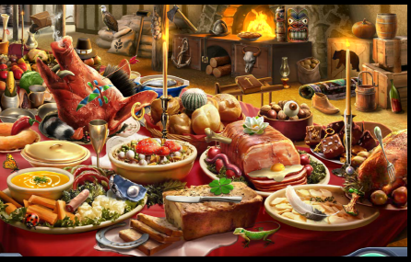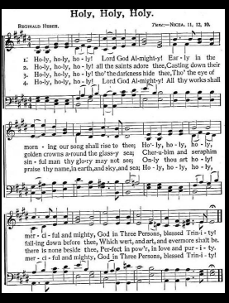
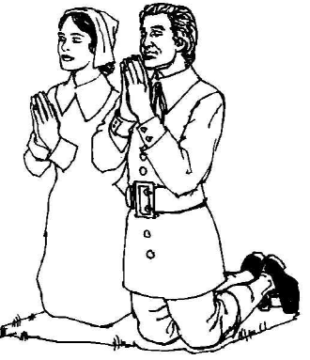

Examples of Christmas cards

