Speaking lesson plan
TITLE | Enjoy making story
INSTRUCTOR |  |  |  | Ss’ LEVEL | AGE GROUP | No of Ss | LENGTH
Solee Hwang |  |  |  | Elementary | 10-11 age | 9 | 50mins

MATERIALS

Whiteboard, markers, Pictures, DVD, Vocabulary work sheets
AIMS 1. |  | Students will practice speaking about making story by using picture cards.
2. |  | Students will learn new vocabulary about name of animals by the story.
3. |  | Students will study listening about story of Alice by looking DVD

LANGUAGE SKILLS
Listening |  |  | Looking for DVD
Speaking |  |  | Conversation with students
Reading |  |  | Read a Vocabulary sheet
Writing |  |  | Writing students worksheet
LANGUAGE SYSTEMS
Phonology |  |  | Students will learn how to pronounce words that they did not know through DVD.
Lexis |  |  | Students will understand each words meaning through the story.
Grammar |  |  | Students will use past tense in story of Alice.
Discourse |  |  | Students will listen story of Alice then discuss what they imagine is the end of story.
Functions |  |  | Students will understand story of Alice and write related story.

ASSUMPTIONS

Students can listen and write even they don’t know the new vocabulary.

ANTICIPATED GRAMMATICAL ERRORS AND SOLUTIONS

How can speak vocabulary
get students to mimic the teacher's pronunciation

REFERENCES

http://blog.naver.com/ckh3lad?Redirect=Log&logNo=40131675401

NOTES

Students learned speaking, writing and listening. Make short simple story and conversation by small group.

TASK PREPARATION TITLE |  |  | Studiyng vocab
AIMS |  |  |  | MATERIALS
Introduce pictures, Eliciting vocabulary |  |  |  | Give picture cards to students
TIME | SET UP | STUDENTS |  |  | TEACHER
2mins | Individual | Students will look for pictures |  |  | Giving pictures papers
5mins | Individual | Students will learn about new vocabulary. |  |  | Teaching new vocabulary
3mins | Individual | Students will think of story |  |  | Waiting for Students

NOTES

Give picture papers and teaching new vocabulary.

TASK PREPARATION TITLE |  |  | Making a story
AIMS |  |  |  | MATERIALS
improve writing and conversation skill with each others |  |  |  | Looking around for students
TIME | SET UP | STUDENTS |  |  | TEACHER
10mins | Individual | Students think and write story |  |  | Looking for students
5mins | Group of 3 | Conversation with each other and make one story |  |  | Looking for students
10mins | Group of 3 | Announce story each group |  |  | Listen

NOTES

Give a paper and looking for students

TASK PREPARATION TITLE |  |  | Looking for DVD
AIMS |  |  |  | MATERIALS
improve listening skill |  |  |  | Play DVD
TIME | SET UP | STUDENTS |  |  | TEACHER
8mins | Individual | Students whatching DVD |  |  | Using a DVD
7mins | Individual | Students will talk about looking for DVD |  |  | Looking for students

NOTES

Play DVD

Paste worksheets, handouts and lesson materials here
<Student work sheet 1.>
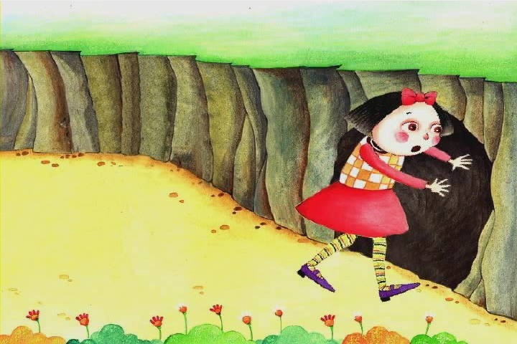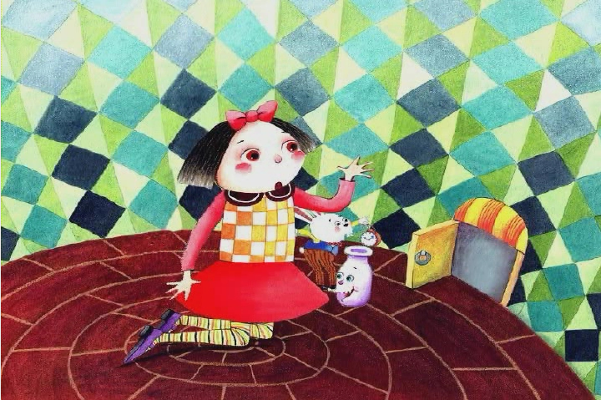

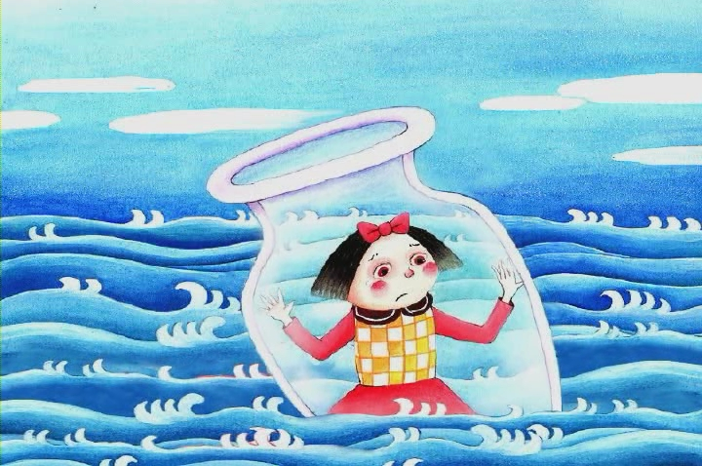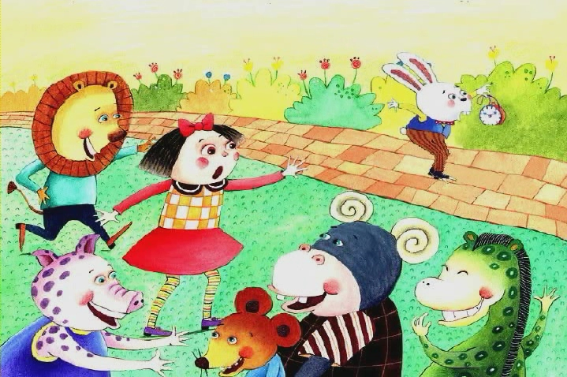

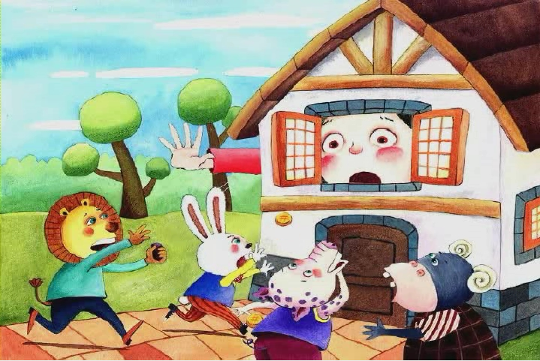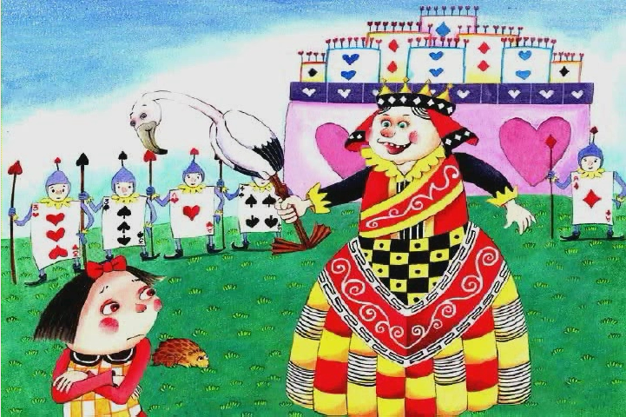

+vocabulary+
- Lion, rat, rabbit, pig, giraffes, hippos
- Cards soldiers, Queen
- Cave, Glass bottle, palace

