TEMPLATE FOR READING LESSON PLAN

TASK-BASED LEARNING (TBL)
TITLE | Coffee v smoothies: Which is better for you?
INSTRUCTOR |  |  |  | Ss’ LEVEL | AGE GROUP | No of Ss | LENGTH
SOPHIE KIM |  |  |  | HIGH INTERMEDIATE | 25 | 9 | 50 mins

MATERIALS

8 pieces of a passage, to distribute it for adult learners (authentic materials)
- 8 pieces of a comprehension sheet, to give the learners a worksheet for homework
- 8 pieces of a worksheet, to review the grammar rule & have a clear understanding the article
- Whiteboard
- 3 different colors of a marker, to reorganize the text.
- Flash cards, to present new vocabularies.
AIMS 1. |  | By the end of the lesson, the learners will be better able to predict the text by practicing skimming/looking through the gist of a passage. (top-down skills)
2. |  | By the end of the lesson, the learners will be better able to comprehend the text of a passage to get detailed information by practicing scanning skills through doing an activity (top-down skills)
3. |  | By the end of the lesson, the learners will be better able to use the certain words relevant to a passage properly (function) by presenting vocabularies (lexis and phonology) and understand the text accurately through reviewing the grammar rule based on the previous lesson, partitive (grammar). (Supporting above 1 and 2 aims)

LANGUAGE SKILLS
Listening |  |  | The learners will be listening to other group’s presentation.
Speaking |  |  | The learners will be talking about the healthy knowledge of drinking a cup of coffee.
Reading |  |  | The learners will be reading a passage with skimming and scanning skills.
Writing |  |  | The learners will be writing their own passage that are related to the headline.
LANGUAGE SYSTEMS
Phonology |  |  | The pronunciation between /b/ and /v/ sounds will be concentrated for the lesson (e.g. blank and vegetable).
Lexis |  |  | The vocabulary will be concentrated for the lesson by presenting the certain words, synonym and antonym, from the text.
Grammar |  |  | The key grammar points of the lesson, partitive will be concentrated on for reviewing previous lesson.
Discourse |  |  | The main topic discussion will be concentrated on for the lesson while brainstorming.
Functions |  |  | The language relevant to the puropose which is about coffee will be concentrated on in the lesson

ASSUMPTIONS
The learners already know the grammar rules, partitive, which will help the teacher during lesson.

The learners already have common knowledge of drinking a cup of coffee that are relate to health, which will help the teacher during lesson.

The learners already have basic reading skills unconsciously, skimming and scanning, which will help the teacher during lesson.

ANTICIPATED GRAMMATICAL ERRORS AND SOLUTIONS
- The learners might forget the grammar rule that were handled in the previous lesson.
Reviewing the rule, solving the questionnaire and providing genuine feedback in an efficient way if necessary.

- The learners might not know how to pronounce between /b/ and /v/ sounds accurately.
Presenting the examples of vocabularies, blank and vegetable, accurately.

- The leaners, individually, might have different speed in reading a book.
Be tolerant and patience would be the best solution.

REFERENCES

Diane Lasen-Freeman and Marti Anderson. 2011. Communicative Language Teaching in Techniques & Principles in Language Teaching (3rd edition). Oxford: Oxford University Press.
- http://www.bbc.com/news/magazine-24621394 (Magazine: relevant to previous class)
- http://www.oxforddictionaries.com/definition/english/partitive (grammar)

- http://indianexpress.com/tag/drink/ (drink)
- http://datedaily.mate1.com/dating-tips-2/dating-tips-for-men/the-psychology-of-first-date-locations/attachment/man-giving-woman-surprise-gift#.VZunybAViYk (surprise)
- https://www.vmguru.com/2012/09/new-enterprise-hypervisor-comparison-2/ (compare)
- http://gainesvillescene.com/2015/02/26/study-edge-meets-tinder-gainesville-knack-new-business/ (study)

- http://www.thesweeterthejuice.com/blockage-disease-detoxing/ (disease)
- http://123beautysolution.in/?p=2210 (vegetable)
- https://en.wikipedia.org/wiki/Black_Standard (black)

NOTES
The teacher would provide any video clip that the learners are recently interested in and summarize what they listened and saw and present it in front of other learners.
It helps them to have good relationship with other learners (student-student interaction) by listening and sharing it. (SOS)

PRETASK TITLE |  |  | Having a conversation
AIMS |  |  |  | MATERIALS

Sharing the basic knowledge of drinking a cup of coffee that is relevant to heath.
TIME | SET UP | STUDENTS |  |  | TEACHER
2 mins. | The whole class | The students will greet each other. |  |  | The teacher has a greeting time with his/her students.
3 mins. | The whole class | The students will share basic knowledge of drinking a cup of coffee that is relevant to health.  (some of students would be pointed) |  |  | The teacher introduce a topic to his/her students.  -eliciting

NOTES
Some of students would be pointed and answered the questions from the teacher.

TASK PREPARATION TITLE |  |  | Presenting & Reviewing
AIMS |  |  |  | MATERIALS
Presenting new vocabularies with visual aids and reviewing the rule of grammar to have a clear understating the text. |  |  |  | Flash cards for presenting vocabularies.  Whiteboard  3 different colors of marker.
TIME | SET UP | STUDENTS |  |  | TEACHER
5 mins. | The whole class | Student will learn the certain words from the text through presenting vocabularies. |  |  | Teacher teach the certain vocabularies by visual aid.
5 mins. | The whole class | Student will review the rule of grammar, partitive, by listening to teacher’s lesson and doing a worksheet. |  |  | Teacher review the two rules of grammar, axillary and partitives.
5 mins. | The whole class | Students will pronounce /b/ and /v/ sounds by repetition and distinguish the difference of sounds between them. |  |  | Teacher pronounce the words, black and vegetable accurately and loudly for his/her student.

NOTES

TASK REALISATION TITLE |  |  | Skimming
AIMS |  |  |  | MATERIALS
Predicting the content of a passage by skimming the headline. |  |  |  | 8 pieces of a passage  8 pieces of a worksheet, for reviewing the grammar
TIME | SET UP | STUDENTS |  |  | TEACHER
3 | The whole class | The students will predict the content of a passage by skimming the headline as a group |  |  | Teacher introduce the aim and hand out an article to students.
5 | Three in a group | The each groups will brainstorm the ideas what content would be involved in the text and make their own article according to skimming the headline. |  |  | Teacher provide the instructions clearly.
7 | Three in a group | The each group will present it in front of the class. |  |  | Teacher monitor his/her students during presentation.

NOTES

Teacher would act as being an involver while the students discuss about the gist, if necessary.

POST TASK TITLE |  |  | Scanning
AIMS |  |  |  | MATERIALS
Scanning the passage when students do an activity like filling in the blanks. |  |  |  | 8 pieces of passage sheets  8 pieces of comprehension sheets.
TIME | SET UP | STUDENTS |  |  | TEACHER
5 mins. | There in a group | Students will fill in the blanks by guessing the words as a group. |  |  | The teacher provide clear instructions about an activity.
8 mins. | The whole class. | Students will share the answers they write and make them correct with the teacher |  |  | The teacher act as being an involver.
2 mins | The whole class | Students will read the passage together by using skimming and scanning skills. |  |  | The teacher leads the students to read the passage.

NOTES

Students will be given the comprehension sheet for homework.
(Since there must be some sections they didn’t understand fully after the class, the students should do the comprehension sheet by themselves without using Internet or dictionary. It is one of effective ways to teach and help the students to give genuine feedback about the parts they have difficulty in.)

Magazine

Coffee v smoothies: Which is better for you?
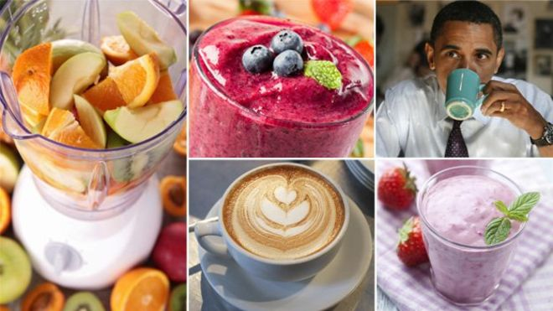

One is made of fruit. The other is caffeinated. So a smoothie is a healthier option than a coffee, right? Don't be so sure, says Michael Mosley, as he weighs the evidence.
Which is healthier - coffee or smoothies?
It seems obvious that the answer must be a smoothie. After all, drinking coffee is a necessary evil while having a smoothie, made from fruit, is part of your five-a-day. But when you look into the scientific studies they reveal something much more surprising. Let's start with coffee.
There have been numerous claims down the years that drinking coffee will increase your risk of a whole range of terrible things from heart disease to cancer.
These claims have been largely based on case control studies, where you take a group of people who drink coffee and compare them with another matched group who don't.
Coffee: The good and bad
The problem with this approach is that coffee drinkers are more likely than non-coffee drinkers to have other "bad" habits, like drinking alcohol or smoking, so it is hard to tease apart what is really doing the harm.
A more reliable way to get at the truth is to do what is called a prospective cohort study. You take a group of disease-free individuals, collect data about them, then follow them for a large number of years to see what happens.
When scientists collected data on the coffee drinking habits of 130,000 men and women and then followed them for over 20 years they found that coffee is rather a good thing (The Relationship of Coffee Consumption with Mortality, Annals of Internal Medicine, June 2008).
They crunched the numbers and concluded that "regular coffee consumption was not associated with an increased mortality rate in either men or women".
In fact, data from this study suggests that moderate coffee consumption is mildly protective, leading to slightly lower all-cause mortality in coffee drinkers than non-coffee drinkers. Based on this and other studies the most effective "dose" is two to five cups a day. More than that and any benefits drop off. There are hundreds of different substances in coffee, including many different flavonoids (compounds widely found in plants that have antioxidant effects). Which of these ingredients is beneficial, we simply don't know.
…
When it comes to the brain, however, the answer seems to be "caffeine". In research recently published in the World Journal of Biological Psychiatry (July 2013) they found that people who drank two to four cups of caffeinated coffee a day were half as likely to commit suicide as those who either drank decaff or fewer than two cups a day. This research pulled together data from three studies that had followed more than 200,000 people for more than 14 years, so it's pretty reliable. It is also supported by a number of other studies, which makes this claim even more plausible.
….
More bad news for fruit juice drinkers comes from a case-controlled study done in Western Australia that examined the daily diets of more than 2,000 people. They found that eating some types of fruit and vegetables (cabbage, broccoli, cauliflower and apples) cuts your risk of colorectal cancer, while drinking fruit juice was associated with an increased risk of rectal cancer. Sugary drinks lead to raised levels of the hormone insulin and persistently high levels of insulin are associated with increased risk of some cancers.
…
Drinking a home-made vegetable smoothie is going to be a lot better for you than a commercial fruit smoothie.

*Fill in the blanks using the words below.

Men, women, drinking, having, drinking, eating, caffeinated, decaff, supported, plausible, crunched, home-made, commercial, alcohol, smoking
Men, women, drinking, having, drinking, eating, caffeinated, decaff, supported, plausible, crunched, home-made, commercial

Coffee v smoothies: Which is better for you?

One is made of fruit. The other is caffeinated. So a smoothie is a healthier option than a coffee, right? Don't be so sure, says Michael Mosley, as he weighs the evidence.
Which is healthier - coffee or smoothies?
It seems obvious that the answer must be a smoothie. After all, drinking coffee is a necessary evil while having a smoothie, made from fruit, is part of your five-a-day. But when you look into the scientific studies they reveal something much more surprising. Let's start with coffee.
There have been numerous claims down the years that drinking coffee will increase your risk of a whole range of terrible things from heart disease to cancer.
These claims have been largely based on case control studies, where you take a group of people who drink coffee and compare them with another matched group who don't.
Coffee: The good and bad
The problem with this approach is that coffee drinkers are more likely than non-coffee drinkers to have other "bad" habits, like drinking alcohol or smoking, so it is hard to tease apart what is really doing the harm.
A more reliable way to get at the truth is to do what is called a prospective cohort study. You take a group of disease-free individuals, collect data about them, then follow them for a large number of years to see what happens.
When scientists collected data on the coffee drinking habits of 130,000 men and women and then followed them for over 20 years they found that coffee is rather a good thing (The Relationship of Coffee Consumption with Mortality, Annals of Internal Medicine, June 2008).
They crunched the numbers and concluded that "regular coffee consumption was not associated with an increased mortality rate in either men or women".
In fact, data from this study suggests that moderate coffee consumption is mildly protective, leading to slightly lower all-cause mortality in coffee drinkers than non-coffee drinkers. Based on this and other studies the most effective "dose" is two to five cups a day. More than that and any benefits drop off. There are hundreds of different substances in coffee, including many different flavonoids (compounds widely found in plants that have antioxidant effects). Which of these ingredients is beneficial, we simply don't know.
…
When it comes to the brain, however, the answer seems to be "caffeine". In research recently published in the World Journal of Biological Psychiatry (July 2013) they found that people who drank two to four cups of caffeinated coffee a day were half as likely to commit suicide as those who either drank decaff or fewer than two cups a day. This research pulled together data from three studies that had followed more than 200,000 people for more than 14 years, so it's pretty reliable. It is also supported by a number of other studies, which makes this claim even more plausible.
….
More bad news for fruit juice drinkers comes from a case-controlled study done in Western Australia that examined the daily diets of more than 2,000 people. They found that eating some types of fruit and vegetables (cabbage, broccoli, cauliflower and apples) cuts your risk of colorectal cancer, while drinking fruit juice was associated with an increased risk of rectal cancer. Sugary drinks lead to raised levels of the hormone insulin and persistently high levels of insulin are associated with increased risk of some cancers.
…
Drinking a home-made vegetable smoothie is going to be a lot better for you than a commercial fruit smoothie.

Comprehension Sheet

Q: Which drinkers have “bad” habits, like drinking alcohol or smoking?

Q: Was regular coffee consumption associated with an increased mortality rate in either men or women?

Q: What fruits cut the risk of colorectal cancer?
(The answer would be found out according to an article.)

Q: Is a commercial fruit smoothie better for your health than drinking a home-make vegetable smoothie?

Q: Is those who drank decaff or fewer than two cups a day likely to commit suicide?

Worksheet for reviewing grammar (partitive)
http://www.esltower.com/GRAMMARQUIZ/elementary/partitives/index.html

Drink

Surprise

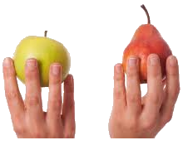
Compare
disease
Study

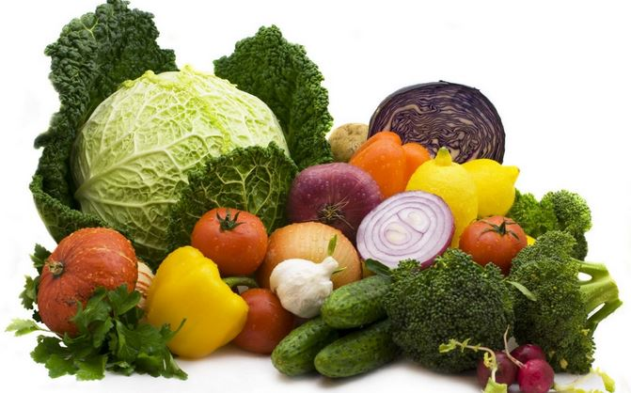
Vegetable
black

