TITLE | Present Perfect
INSTRUCTOR |  |  |  | Ss’ LEVEL | AGE GROUP | No of Ss | LENGTH
Eunji Lee |  |  |  |  | 13~14years old | 9 | 50 mins

MATERIALS

White board, Marker, Worksheets, pencils
AIMS 1. |  | Students will practice asking and answering questions by using Present Perfect.
2. |  | Students will be encouraged to use correct verb forms in questions and statements.
3. |  | Students will also be provided an opportunity for speaking, writing and listening by doing worksheets.

LANGUAGE SKILLS
Listening |  |  | Listen to other students’ questions.
Speaking |  |  | Ask some questions by using Present Perfect.
Reading |  |  | Read some questions in the worksheets.
Writing |  |  | Write other students’ answer in the worksheets.
LANGUAGE SYSTEMS
Phonology |  |  | Students will focus on pronunciation. e.g. /v/, /s/
Lexis |  |  | Students will focus on some words. e.g. been and taught..
Grammar |  |  | Students will focus on grammar. e.g. have been, has gone…
Discourse |  |  | Students will practice Present Perfect sentences.
Functions |  |  | Students express their sentences by using Present Perfect.

ASSUMPTIONS

They will already know some words. e.g. taught or never.. It will make them enjoy the class easily.

ANTICIPATED GRAMMATICAL ERRORS AND SOLUTIONS
Students might confuse about the Past Participle verbs.
I will let them practice with several sentences as many Past Participle verbs as possible

REFERENCES

http://www.teach-this.com/images/resources/just-say-yes.pdf

NOTES

If there is not enough time for activity, give them worksheet as homework.

If there is a little time left, do the SOS activity.

It is called ‘Tell me what am I doing?’ game. You need to think some action verbs. Divide two teams and give them a minute to do the game. One team should stand in a row seeing the wall. After that, you show one action verb to only one student, then the student will explain what that word is to second person. And second person will do that to third person and so on. When one team do that, the other team has to sit and watch how many words they get.

PRETASK TITLE |  |  | The concept of Present Perfect
AIMS |  |  |  | MATERIALS
To understand the exact concept of Present Perfect |  |  |  | Whiteboard, Marker
TIME | SET UP | STUDENTS |  |  | TEACHER
3 mins |  | Students will listen to the teacher about the concept of Present Perfect. |  |  | A teacher explains about Present Perfect by drawing time line.
1 min |  | Students will listen to teacher about differences between Past and Past Perfect. |  |  | A teacher explains about Past by drawing time line.

NOTES

Make sure they understand the concept of Present Perfect and Past.
For example, She has studied English for 2hours.
She studied English 2 hours ago.

TASK PREPARATION TITLE |  |  | Find someone who~
AIMS |  |  |  | MATERIALS
To practice making sentences by using Present Perfect. |  |  |  | Worksheet, Pencils
TIME | SET UP | STUDENTS |  |  | TEACHER
2 mins |  | Students will listen to the instruction to enjoy the activity. |  |  | Explain how it works.
10 mins |  | Students will walk aroud to find someone who matches the sentence, write their name and make sentences |  |  | Observe the students and help them if they need help.
5 mins |  | Students will make presentation about their work to share their answers. |  |  | If there is an error, make correction.

NOTES

Make sure everyone participates in the activities.

TASK REALISATION TITLE |  |  | Just say ‘yes’
AIMS |  |  |  | MATERIALS
To encourage students to distinguish when to use Past and Present Perfect |  |  |  | Worksheet
TIME | SET UP | STUDENTS |  |  | TEACHER
3 mins |  | Students will listen to what teacher says. |  |  | Explain how to do it with an example.
10mins |  | A student will come out, pick a note and ask a question on the note. Before ask a question, guess someone who has that experience. |  |  | Observe and give a compliment not to make a mistake.

NOTES

Before you start the activity, cut the worksheet first and fold them not to see.

The basic rule -
First, pick someone who asks a question on the note.
One student comes out, picks a note and thinks how to make a sentence with key words on the note by using Present Perfect.
Next, let her guess who will say the truth about the sentence on the note and ask questions to someone.
If someone is picked, she has to say only ‘yes’ with correct sentence even if she doesn’t have that experience.

POST TASK TITLE |  |  | Make stories by using Present Perfect.
AIMS |  |  |  | MATERIALS
To apply the concept of Present Perfect to their experience |  |  |  | Sheets of paper, Pencils.
TIME | SET UP | STUDENTS |  |  | TEACHER
10mins |  | Students will write their experience or story by using Present Perfect. |  |  | Help them and make sure write at least 10 sentences.
6mins |  | Students will make a presentation about their story. |  |  | If there are mistakes, correct them.

NOTES

Make sure everyone writes the story.
If there is no time, give them as homework.

Paste worksheets, handouts and lesson materials here
Find a someone who~
Find a someone who~ | Name | Sentence
- has never been to Australia.
2. has taught someone new skills.
3. has always been interested in extreme sports.
4. has seen a shooting star.
5. has recently returned from a trip.
6. has eaten something very unusual.
7. has never liked adventure.
8. has ridden a roller coaster.
9. has visited another country alone.
10. has had an unusual accident.
11. has never done anything dangerous.
12. has decided to try something adventurous this year.
13. has never had a pet.
14. has come here by bus.
15. has eaten breakfast for cereal.

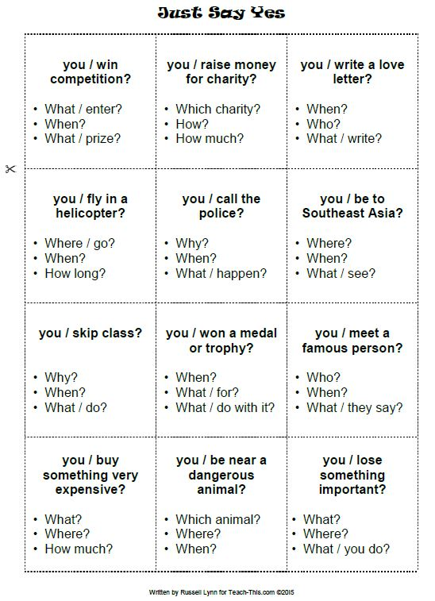

Make your story about what you learned today. At least 10 sentences.

