GRAMMAR LESSON PLAN
TITLE | Enjoy studying grammar
INSTRUCTOR |  |  |  | Ss’ LEVEL | AGE GROUP | No of Ss | LENGTH
Solee Hwang(Amy) |  |  |  | Elementary | 8 | 9 | 50 mins

MATERIALS

Whiteboard, markers, Student & Vocabulary work sheets
AIMS 1. |  | Students will study grammar about basic grammar by writing students work sheet.
2. |  | Students will practice speaking about making short answer by conversation with partner.
3. |  | Students will study new vocabulary about general words by the text.

LANGUAGE SKILLS
Listening |  |  | Listen to teacher's pronunciation
Speaking |  |  | Conversation with students
Reading |  |  | Read a student sheet
Writing |  |  | Writing student worksheet
LANGUAGE SYSTEMS
Phonology |  |  | Students will learn how to pronounce words that they did not know through Ss papers.
Lexis |  |  | Students will understand each words meaning through the Ss papers.
Grammar |  |  | Students will use simple tense in Ss papers.
Discourse |  |  | Students will listen partners opinion then discuss what they imagine is the future tense.
Functions |  |  | Students will understand simple tense and write related future.

ASSUMPTIONS

Students can use simple tense and write even they don’t know the new vocabulary.

ANTICIPATED GRAMMATICAL ERRORS AND SOLUTIONS

How can use simple tense and imagine cap fill.
get students to mimic easy to understand the writing skill.

REFERENCES

Teacher's note 1

NOTES

Students learned using simple tense grammar, writing and speaking. Make short answers and conversation by small group.

PRETASK TITLE |  |  | Enjoy grammar
AIMS |  |  |  | MATERIALS
Introduce simple tense, Eliciting vocabulary |  |  |  | Give student papers
TIME | SET UP | STUDENTS |  |  | TEACHER
3 mins | Individual | student will listen about what is simple tense and when we use this |  |  | Explain what is and when use
5 mins | Individual | student will make simple sentences for diary. |  |  | Looking alound student
3 mins | Pairs | Student will check answer sheet with patner. |  |  | Explain answers
2 mins | Pairs | Student will talk each other about their writing. |  |  | Listening conversation

NOTES

Give student papers and teaching new vocabulary. Check answer and understanding.

TASK PREPARATION TITLE |  |  | Making story by using past simple.
AIMS |  |  |  | MATERIALS
improve writing and conversation skill with each others |  |  |  | Looking around for students
TIME | SET UP | STUDENTS |  |  | TEACHER
7 mins | Individual | Students will write and use past simple tense about making story |  |  | Give paper
5 mins | Pairs | Students will talk about thier story |  |  | Listen students conversation

NOTES

Give student papers and teaching new vocabulary. Check answer and understanding.

TASK REALISATION TITLE |  |  | Making story by using present simple.
AIMS |  |  |  | MATERIALS
improve writing and conversation skill with each others |  |  |  | Looking around for students
TIME | SET UP | STUDENTS |  |  | TEACHER
7 mins | Individual | Students will write and use present simple tense about making story |  |  | Give paper
5 mins | Pairs | Students will talk about thier story |  |  | Listen students conversation

NOTES

Give student papers and teaching new vocabulary. Check answer and understanding.

POST TASK TITLE |  | Making full story
AIMS |  |  | MATERIALS
improve writing and conversation skill with each others |  |  | Looking around for students and check all work sheet
TIME | SET UP | STUDENTS |  | TEACHER
3 mins | Pairs | Students will make full story |  | Give paper
5 mins | Whole class | Student will role play infront of desk |  | Listen students and check grammar mistake
5 mins | Individual | Student will listen to teacher feedback. |  | Expain about student grammar mistake

NOTES

Give student papers, check answer and understanding.

Paste worksheets, handouts and lesson materials here
Student worl sheet 1.

Using past simple tense

- What did you do yester day?

- Where did you go last summer vacation?

Make 2questions using past!!

Using present simple tense

- What do you do?

- What do you study?

Make 2questions using persent!!

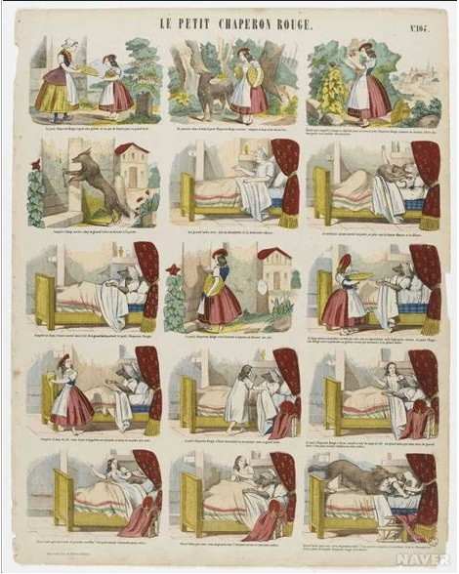
Making a full story

