TITLE | Fantastic Mr.Fox
INSTRUCTOR |  |  |  | Ss’ LEVEL | AGE GROUP | No of Ss | LENGTH
Joon |  |  |  | Intermediate | 10-11 | 6 | 60

MATERIALS

Fantastic Mr.Fox (by Roald Dahl) book, board, markers, computer(connected with Internet), worksheets, visual aids if needed (flash card, realia, etc. to explain vocabulary)
AIMS 1. |  | Students will improve listening comprehension skill by listening a story
2. |  | Students will study vocabulary, expression, and grammar through the story
3. |  | Student will practice speaking skills by discussing in a small group and presenting in front of the class

LANGUAGE SKILLS
Listening |  |  | Students will be listening to teachers reading “Fantastic Mr.Fox” book and audio clip
Speaking |  |  | Students will be talking about their understanding of story
Reading |  |  | Students will be reading a script on worksheet
Writing |  |  | Students will be filling out the vocabulary and important expressions on a worksheet
LANGUAGE SYSTEMS
Phonology |  |  | Students will focus on practicing accurate pronunciation  ex) One fat, one short, one lean. These horrible crooks, so different in looks.
Lexis |  |  | Students will focus on learning new words and expressions  ex) cocky, twitched, whooshing, gulp, tommy-rot, came along
Grammar |  |  | Students will learn basic grammar by audio-lingual method  ex) the cleverest the + ~est for the superlative degree
Discourse |  |  | Students understand the story and share their own thoughts about the story
Functions |  |  | Student can listen and create own conversation

ASSUMPTIONS

Student have enough ability to understand the intermediate level of story book

ANTICIPATED GRAMMATICAL ERRORS AND SOLUTIONS

Students can miss the grammar error since class does not run by the grammar translation method

REFERENCES

Book “Fantastic Mr.Fox”, Roalddahl.com, Youtube “Popular Roald Dahl &Audiobooks Video”

NOTES

Before start to reading a story go to Roalddahl.com and explain the main characters of the book

PRETASK TITLE |  |  | Open Arm
AIMS |  |  |  | MATERIALS
Get students’ interest and attention by asking guiding questions which make them to participate in the class |  |  |  | Board, markers
TIME | SET UP | STUDENTS |  |  | TEACHER
7min | Whole Class | Answer to teacher’s question |  |  | Ask some everyday life, broad questions that lead to story of “Fantastic Mr.Fox”

NOTES

If student does not give answers to teacher, make the small group and ask them to share their everyday life (Teacher must go around the class group by group to supervise and lead the conversation)

TASK PREPARATION TITLE |  |  | Hard Ball
AIMS |  |  |  | MATERIALS
Students study new vocabulary/expression/grammar by teacher’s explanation |  |  |  | Board, markers, visual aids (all kinds of visual aid to help student to understand better)
TIME | SET UP | STUDENTS |  |  | TEACHER
13 | Whole Class | Assume and answer the meaning of the new vocabulary/expression/grammar |  |  | Teach new vocabulary/expression/grammar

NOTES

Prepare some example sentences to explain new vocabulary/ expression/grammar in case students have difficulties to understand

TASK REALISATION TITLE |  |  | Show Time
AIMS |  |  |  | MATERIALS
Student listen to the story and understand the context by discussing within a group |  |  |  | Book “Fantastic Mr.Fox”, Computer(connected to internet), Worksheet
TIME | SET UP | STUDENTS |  |  | TEACHER
3 | Whole Class | Listen to teacher |  |  | Explain the character using Roalddahl.com
13 | Group by 2-3 | Student listen to the story by passage and discuss about what they have understand within a group |  |  | Teacher 1-2 page of the book and ask group to discuss about what they have listen
3 | Whole Class | Listen to audio clip and fill out the worksheet |  |  | Play audio clips of the day and ask student to fill out the worksheet
3 | Whole Class | Read worksheet together correctly |  |  | Ask student to read the worksheet to check their pronunciation and make sure all the students wrote correct answers
8 | Group by 2-3 | Prepare summary and ready to present to the class by group |  |  | Ask student to write and present summary of the day by group
7 | Whole Class | By group present in front of the class |  |  | Listen to presentation and give comments

NOTES

Adjust the time of each activities as class continues (some activities might take more time than it planned)

POST TASK TITLE |  |  | Dream
AIMS |  |  |  | MATERIALS
Assign homework by hand out the worksheet |  |  |  | Worksheet
TIME | SET UP | STUDENTS |  |  | TEACHER
3 | Whole Class | Understand the homework/assignment |  |  | Ask student to predict what will happen next to today’s story and complete the worksheet by next class

NOTES

Get students attention until the end of the class, so students does not miss next class assignment
* Next class, start pretask, open arm questions by asking student about their prediction of the story

Fantastic Mr. Fox class worksheet
- Fill out the blank as listen to the audio clip
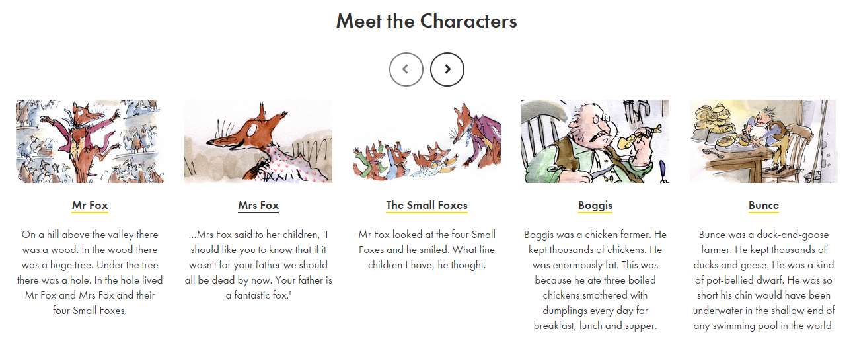
The Three Farmers
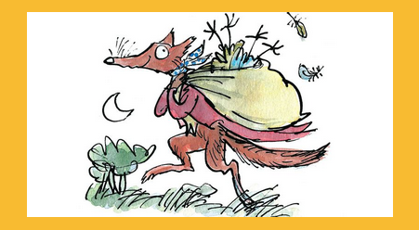
Down in the valley there were three farms. The ______of these farms had dome well. They were rich men. They were also _____ men. All three of them were about as _____ and mean as any men you could meet. Their names were Farmer Boggies, Farmer Bunce and Farmer ____.
Boggies was a chicken farmer. He kept ________ of chickens. He was __________ fat. This was because he ate three _______ chickens _________ with dumplings every day for breakfast, lunch and _______.
Bunce was a duck-and-goose farmer. He kept _________ of ducks and geese. He was a kind of _________ ______. He was so short his chin would have been under water in the ______ end of any swimming-pool in the world. His food was doughnuts and goose livers. He ______ the livers into the doughnuts. This diet gave him a _______-ache and a ________ temper.

Assignment worksheet
- Please predict what will happen next to the story and write in several sentences

