TITLE | Enormous Crocodile
INSTRUCTOR |  |  |  | Ss’ LEVEL | AGE GROUP | No of Ss | LENGTH
Joon |  |  |  | Intermediate | 10 | 6-8 | 50

MATERIALS

Enormous Crocodile (by Roald Dahl) book, board, markers, computer(connected with Internet), worksheets, visual aids if needed (flash card, realia, etc. to explain vocabulary)
AIMS 1. |  | Practice reading aloud skills by reading a story
2. |  | Study vocabulary, expression, and grammar through the story
3. |  | Practice speaking skills by discussing in a small group and presenting in front of the class

LANGUAGE SKILLS
Listening |  |  | Teachers reading “Enormous Crocodile” book and audio clip
Speaking |  |  | Understanding and prediction of story
Reading |  |  | Part of “Enormous Crocodile” book
Writing |  |  | Prediction of next story
LANGUAGE SYSTEMS
Phonology |  |  | Practice accurate pronunciation  ex) biggest brownest muddies, gulp in one gollop, tommy-rot, etc.
Lexis |  |  | Learn new vocabulary and expressions  ex) enormous, grinned, paddling, etc.
Grammar |  |  | Acquire basic grammar by audio-lingual method  ex) the cleverest the + ~est for the superlative degree
Discourse |  |  | Story and discussion
Functions |  |  | Sharing and discussing story and thoughts

ASSUMPTIONS

Student have enough ability to understand the intermediate level of story book

ANTICIPATED GRAMMATICAL ERRORS AND SOLUTIONS

Students can miss the grammar error since class does not run by the grammar translation method
Help students to understand the grammar through comprehension checking questions

REFERENCES

Book “Enormous Crocodile”, Roalddahl.com link below :
http://www.roalddahl.com/roald-dahl/stories/1970s/the-enormous-crocodile
https://soundcloud.com/penguin-books/the-enormous-crocodile
Youtube link below : https://www.youtube.com/watch?v=eJTnGkQonI0&index=41&list=PLrRxiQvX_JCuWg-3CWVs7nR45jQPAdrgP

NOTES

Only Question Activity – who answers lose

Chair Activity - one person seat on the chair in front of the class and guess right vocabulary

Tale Activity – Say work with last person’s last letter

Letter Activity – Give Ss 6 letters to make 5 vocabulary words and 2 sentences and present

PRETASK TITLE |  |  | Hello, everyone
AIMS |  |  |  | MATERIALS
Get students’ interest and attention by asking guiding questions which make them to participate in the class |  |  |  | Board, markers
TIME | SET UP | STUDENTS |  |  | TEACHER
1min | Whole Class | Say hi to teacher and each other |  |  | Greeting
3min | Whole Class | Answer to teacher’s questions about everyday life that lead to the story of “Enormous Crocodile” |  |  | Ask guiding question

NOTES

If student does not give answers to teacher, make the small group and ask them to share their everyday life (Teacher must go around the class group by group to supervise and lead the conversation)

TASK PREPARATION TITLE |  |  | New Words!
AIMS |  |  |  | MATERIALS
Study new vocabulary/expression/grammar by teacher’s explanation |  |  |  | Board, markers, visual aids (if needed to explain vocabulary)
TIME | SET UP | STUDENTS |  |  | TEACHER
1min | Whole Class | Understand today’s activity is the reading a “Enormous crocodile” story |  |  | Introduce Activity
7min | Whole Class | Study new vocabulary by learning the meaning or synonyms/antonyms |  |  | Introduce new vocabulary/expression/grammar

NOTES

Prepare some example sentences to explain new vocabulary/ expression/grammar in case students have difficulties to understand

TASK REALISATION TITLE |  |  | Enormous Crocodile
AIMS |  |  |  | MATERIALS
Understand the story by reading a book and share the thoughts by discussion |  |  |  | “Enormous Crocodile” book, Computer(connected to internet), “Meet the characters” “Script” “Make your own story” “Story 1,2” worksheet
TIME | SET UP | STUDENTS |  |  | TEACHER
5min | Whole Class | Read aloud characteristics of “Meet the characters” worksheet together |  |  | Explain characters
1min | Whole Class | Skim the text for main ideas |  |  | Ask for skimming
2min | Whole Class | Student listen to the audio clip and try to understand the story |  |  | Play audio clips
3min | Whole Class | Read after teacher aloud and answer the questions that teacher is asking or ask questions to teacher while reading |  |  | Read “Script” worksheet aloud with checking questions
10min | Group by 2 | Make own story by drawings with group and present to the class |  |  | Hand out “Make your own story” worksheet
7min | Whole Class | Read after teacher aloud and answer the questions that teacher is asking or ask questions to teacher while reading |  |  | Read “Story1,2” worksheet
7min | Group by 2 | Within group, take a role and read aloud  - one student read narration and another student read word “ ” for practicing reading |  |  | Instruct script role play

NOTES

Adjust the time of each activities as class continues (some activities might take more time than it planned)

POST TASK TITLE |  |  | Lesson Learned
AIMS |  |  |  | MATERIALS

Share thoughts and assign homework
TIME | SET UP | STUDENTS |  |  | TEACHER
2min | Whole Class | Share the thoughts and ideas that have learned by reading a story |  |  | Ask about the story
1min | Whole Class | By next reading class bring the book want to read and present why |  |  | Assign homework

NOTES

Get students attention until the end of the class, so students does not miss next class assignment
* Next class, start pre-task activity by presenting the books Ss want to read

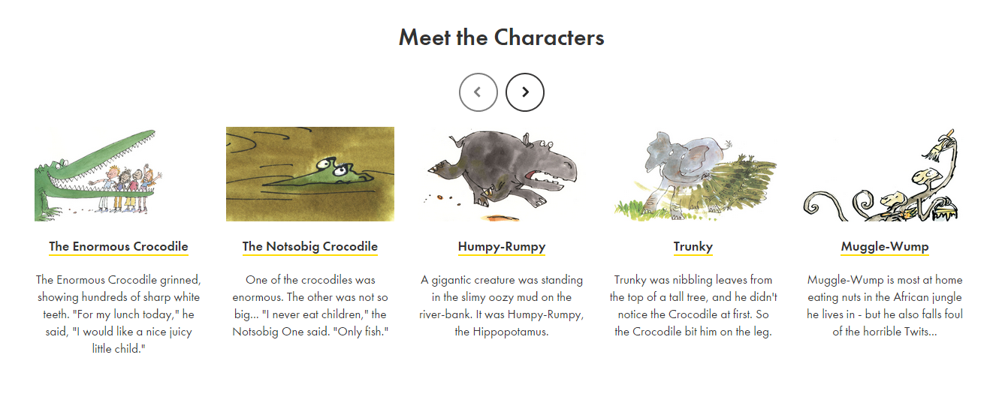
Script

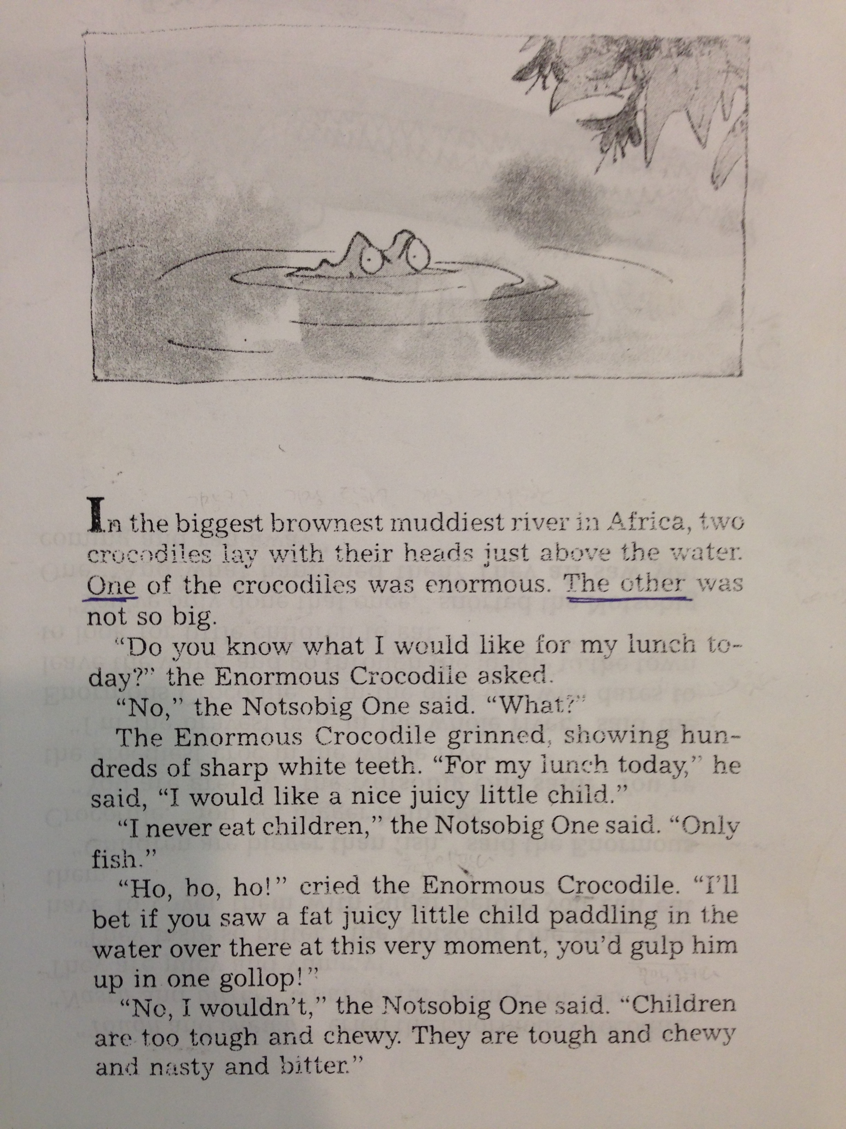

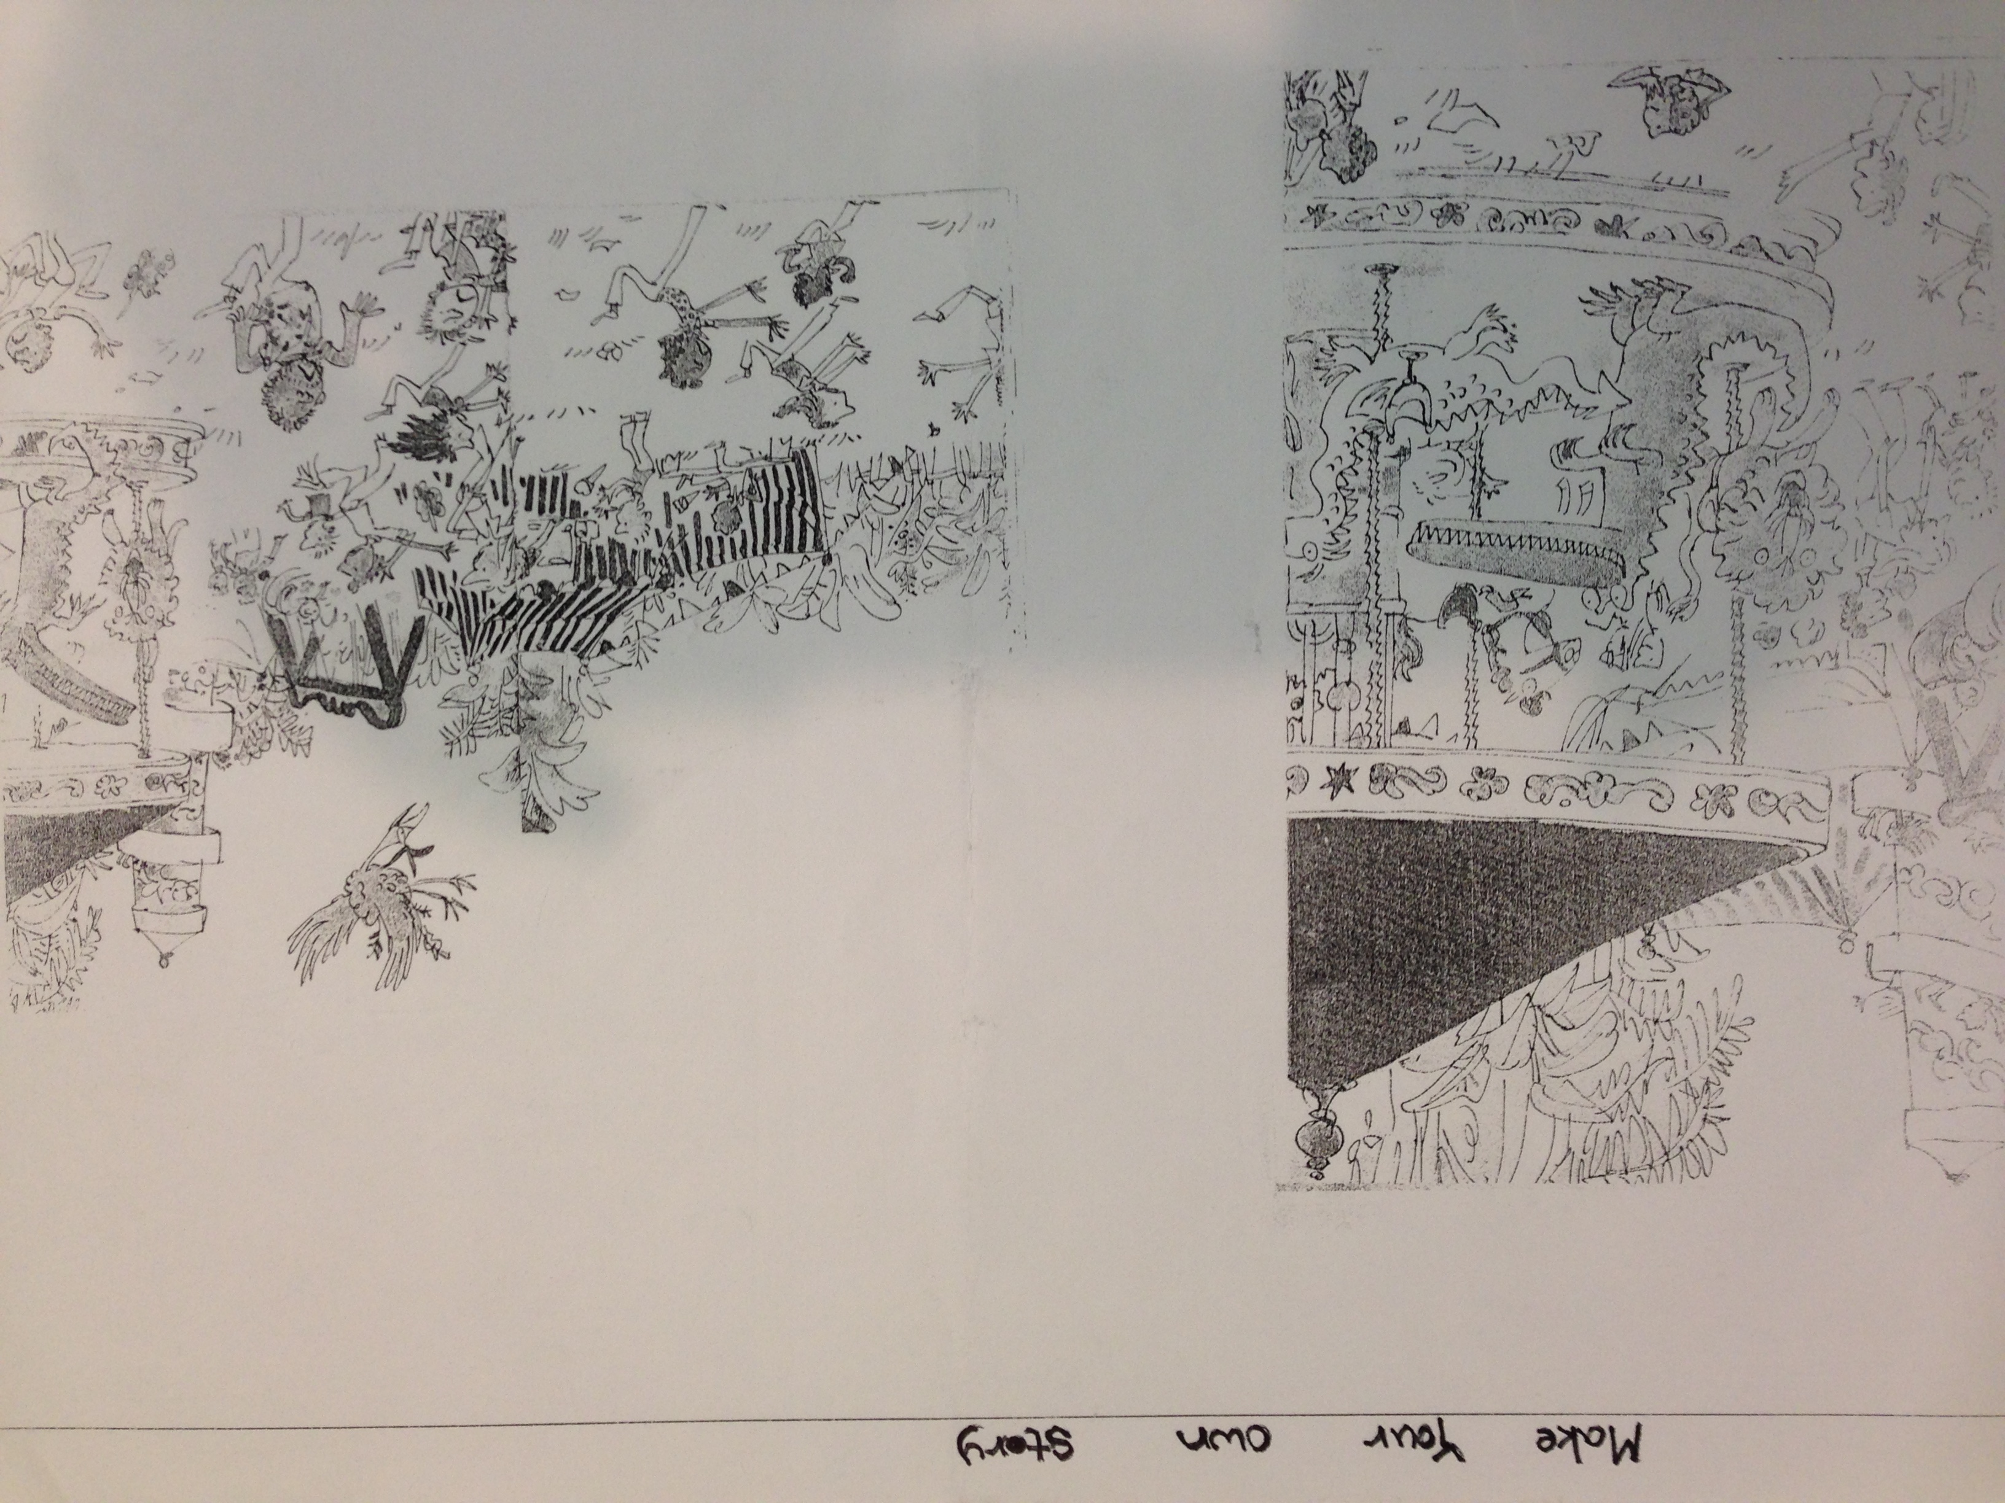

Story 1

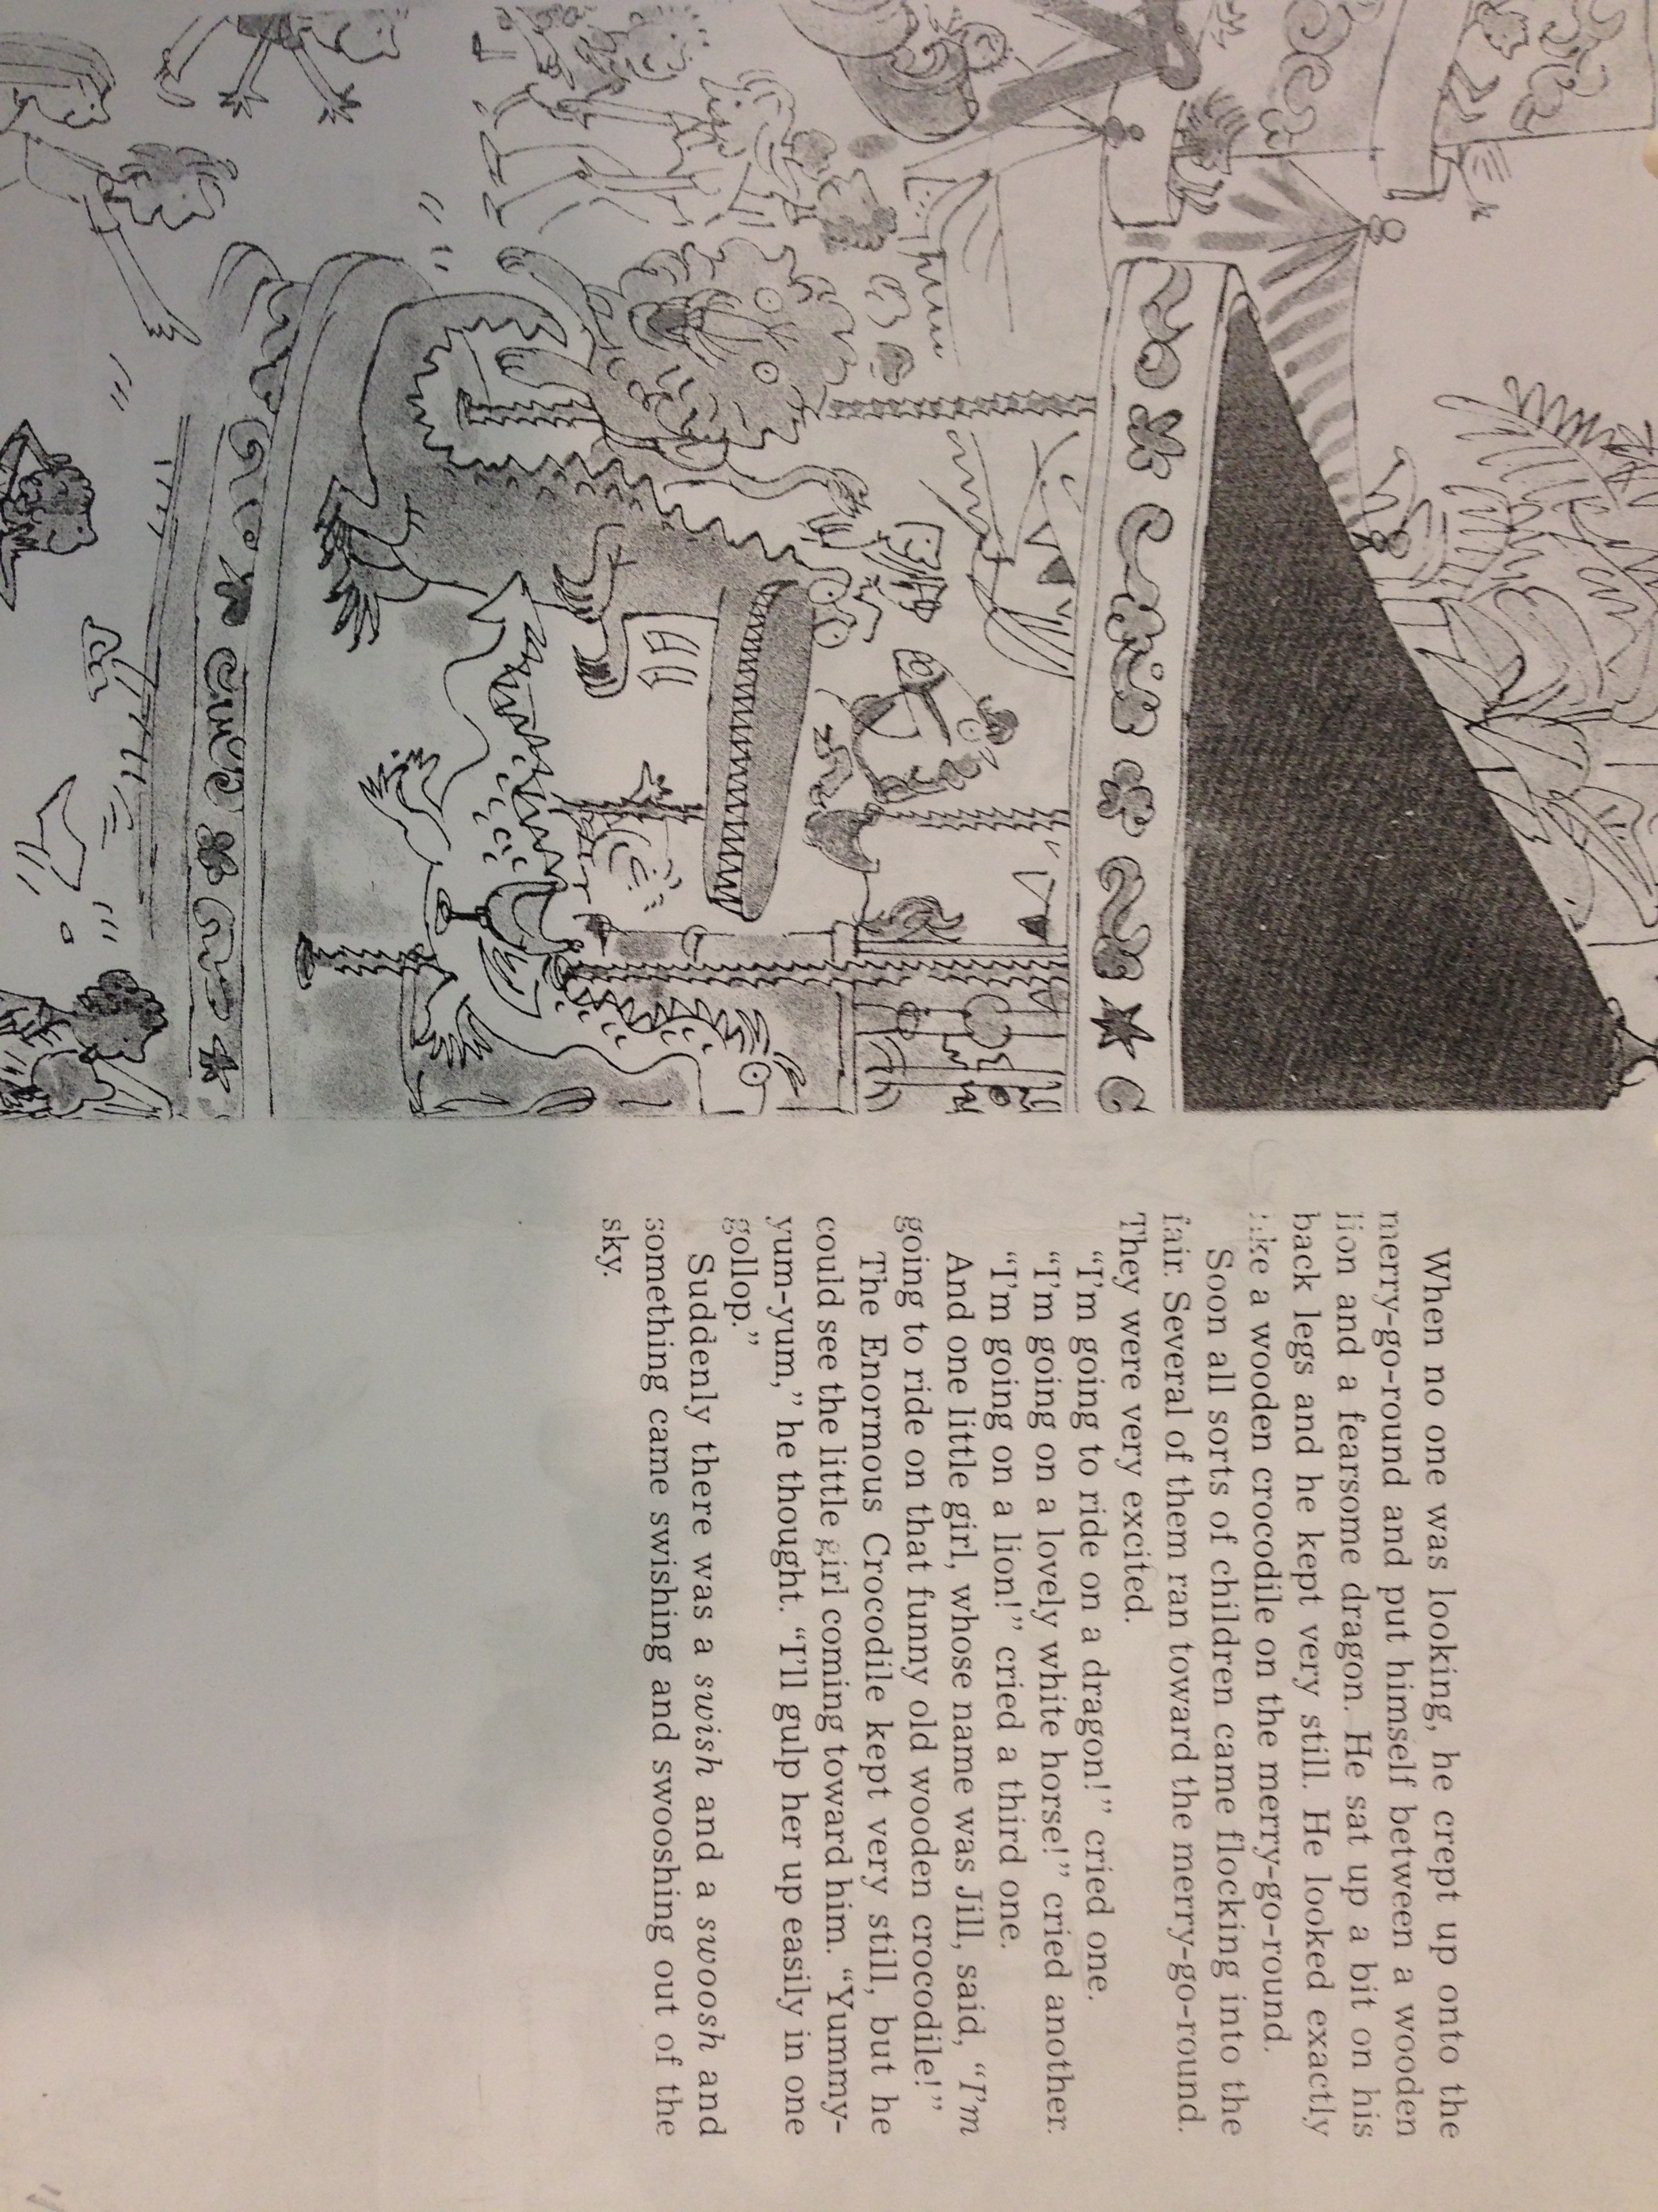

Story2

