|  |  |  |  |  |  |  |  |
| --- | --- | --- | --- | --- | --- | --- | --- |
| Reading Lesson Plan | | | | | | | |
| TITLE | The Traditional Baths of Turkey | | | | | | |
| INSTRUCTOR | | | | Ss’ LEVEL | AGE GROUP | No of Ss | LENGTH |
| Eun Hye Lee (Grace) | | | | Advanced | 18~19 | 6 | 50 Minutes |
| MATERIALS | | | | | | | |
| * White board/board markers * Audio/CD/Computer/Projector * “The Traditional Baths of Turkey” Reading passage  “The Traditional Baths of Turkey” Vocabulary – Worksheet #1 (hand out) 7 copies (+1 Extra)  * “The Traditional Baths of Turkey” Comprehension questions – Worksheet#2 (hand out) 7 copies (+1 Extra) * “The Traditional Baths of Turkey” Vocabulary Review – Worksheet #3 (Homework) (hand out) 7 copies (+1 Extra) | | | | | | | |
| AIMS1. | | Students will study meaning of the paragraph by answering the comprehension questions. | | | | | |
| **2.** | | Students will practice writing the summary in their own languages using the vocabularies that they learn in the class by completing their homework assignment. | | | | | |
| 3. | | Students will study the new vocabularies from the reading passages by completing worksheet. | | | | | |
| LANGUAGE SKILLS | | | | | | | |
| Listening | | | Students will listen to teacher’s explanations of new vocabularies, instructions, and other students talk. | | | | |
| Speaking | | | Students will answer the teacher’s questions and talk with other students in groups. | | | | |
| Reading | | | Students will read the reading passage and completing worksheets. | | | | |
| Writing | | | Students will write the vocabularies and summarize in their own language (complete the worksheets). | | | | |
| **LANGUAGE SYSTEMS** | | | | | | | |
| Phonology | | | Monitoring the students speak, say the word “Turkish”, “cleanliness” sounds | | | | |
| Lexis | | | Vocabularies with adverb form (regularly, particularly, quickly) and bath(noun)-bathe(verb). | | | | |
| Grammar | | | When the sentence start with “However”, “These days”, As a result” put the comma (,).eg.) However, ~~~. / These days, ~~~. / As a result, ~~~. | | | | |
| Discourse | | | The passage is about Turkish people’s traditional baths.The students are going to share their thought and opinions about the reading with group. | | | | |
| Functions | | | Give information of Turkey’s traditional baths. | | | | |
| ASSUMPTIONS | | | | | | | |
| - The students already know each other.- The students already know when the teacher read the passage or read their work, should read it loud. | | | | | | | |
| ANTICIPATED GRAMMATICAL ERRORS AND SOLUTIONS | | | | | | | |
| - Some students might make errors to say bath(noun)-bathe(verb)   * Monitoring the students and correct them when and make students practice the words   - Some students might difficult say the word “adverb form (regularly, particularly, quickly)”   * Monitoring the students and make students say the word correctly. | | | | | | | |
| REFERENCES | | | | | | | |
| - Reading passage: Reading Planet 1 Student Book (e-future): Unit 5 Lesson 2. The Traditional Baths of Turkey - Worksheet: http://www.efuture.co.kr/book/book_view.asp?bookkey=836&catkey=104&serieskey=#tab001  - Video clip: <https://www.youtube.com/watch?v=BpMxxcBx1J0>  -Pictures: [in-cyprus.com](http://in-cyprus.com/hamam-omerye-nicosia/) / [www.telegraph.co.uk](http://www.telegraph.co.uk/news/uknews/law-and-order/9038534/Youll-never-enjoy-a-spa-again-after-reading-this.html) / [www.wallstreetbath.com](http://www.wallstreetbath.com/index.php?page=bath&cat=old_american_shvitz) / [www.cyberbohemia.com](http://www.cyberbohemia.com/Pages/hotrock.htm) / [zzimzilbang.com](http://zzimzilbang.com/minihome/index.html?zzidx=1764) / blog.daum.net / lifelog.blog.naver.com | | | | | | | |
| NOTES | | | | | | | |
| Plan B: If the video clip is not working, techer can show the pictures of Hamam.Cut-off plan: If there isn't enough time to complete the worksheet, assigned as homework.SOS activity :Sentence writingStudents can write sentences using the vocabularies that they learned in the class.  * Students can read their sentences out loud.  1. Write a summary  * Students can write the summary of the reading passage using their own word. * Share their summary with groups | | | | | | | |
|  | | | | | | | |

|  |  |  |  |  |  |
| --- | --- | --- | --- | --- | --- |
| PRETASK TITLE | | | - Warmers / Guiding questions / Eliciting | | |
| AIMS | | | | MATERIALS | |
| Students will get some ideas about the reading passage by watching the video clip. | | | | A white board / board markers Video clip / Computer / Projector | |
| TIME | SET UP | STUDENTS | | | TEACHER |
| 3 min | Whole class | Students will answer the questions.  Q1. When you are tired what do you like to do the end of the day?  Q2. Have you been to the public bath?  Q3. Do you think the other countries have public bath? | | | Give students guide questions. |
| 3 min | Whole class | Students will watch the pictures of the different countries traditional bath style.  Q1. What are the pictures about?  Q2. Which countries bath styles do you prefer? | | | Show the students different kinds of pictures of bath style. |
| 4 min | Individual/  Whole class | Students will watch the video clip about Turkey’s traditional bath.  Students will answer the questions.  Q1.What is the video clip about?  Q2. Is the bath style interesting to you? (Do you like the style of the bath?) | | | Show the video clip about Turkey’s traditional bath.  Ask students about the video clip. |
|  |  |  | | |  |
| NOTES | | | | | |
| If the video clip is not being able to use, just show the pictures of different countries’ bath. If need to ask more question, can add more questions. | | | | | |

|  |  |  |  |  |  |
| --- | --- | --- | --- | --- | --- |
| TASK PREPARATION TITLE | | | - Guiding questions / Eliciting / Vocabularies | | |
| AIMS | | | | MATERIALS | |
| Students will think about the reading passage. Students will practice new vocabularies by completing the worksheet | | | | - A white board / board makers -“The Traditional Baths of Turkey” Reading passage  - “The Traditional Baths of Turkey” Vocabulary – Worksheet #1 | |
| TIME | SET UP | STUDENTS | | | TEACHER |
| 2 min | Whole class | Students will listen to the teacher’s instructions and answer the ICQ.  Q1. What do you need to do first? | | | Give instructions that they need to do.  Ask questions(ICQ)to check they understood well |
| 4 min | Individual  /pair | Students will find the words next to its definition from the reading passage by completing the worksheet individually first and then do with pairs. | | | Monitoring students, help the students if they need. |
| 4 min | Whole class | Students will check the vocabulary worksheet by reading it loud. | | | Monitoring students that they answer correctly. |
|  |  |  | | |  |
| NOTES | | | | | |
| If some students have difficulty to complete the vocabulary worksheet, help them.When they read the vocabulary worksheet loud, if they make error to say vocabularies help them to say correctly. | | | | | |

|  |  |  |  |  |  |
| --- | --- | --- | --- | --- | --- |
| TASK REALISATION TITLE | | | - Reading the passage / worksheet | | |
| AIMS | | | | MATERIALS | |
| - Students will read the reading passage- Students will complete the worksheet | | | | A white board / board makers  “The Traditional Baths of Turkey” Comprehension questions – Worksheet#2 | |
| TIME | SET UP | STUDENTS | | | TEACHER |
| 5 min | Individual | Students will read the reading passage. | | | Make students read the reading passage. |
| 2 min | Whole class | Students will read the comprehension questions loud (Worksheet #2) | | | Monitoring all the students read out loud. |
| 10 min | Individual/  Group | Students will answer and discuss about the comprehension questions with group. | | | Monitoring students are answering and discussing about the comprehension questions.  If some students have a difficulty answering the questions, help them. |
| 5 min | Whole class | Each group will answer and share the comprehensions together. | | | Monitoring students are answering the questions. If the answer is wrong, give hints by asking CCQ. |
| NOTES | | | | | |
| If some students are quiet encourage them to speak.When students read the comprehension questions loud, make sure all students read. | | | | | |

|  |  |  |  |  |  |
| --- | --- | --- | --- | --- | --- |
| POST TASK TITLE | | | Review and assign the homework | | |
| AIMS | | | | MATERIALS | |
| Students will discuss about the questions | | | | A white board / board markers “The Traditional Baths of Turkey” Vocabulary Review – Worksheet #3 | |
| TIME | SET UP | STUDENTS | | | TEACHER |
| 5 min | Whole class | Students will discuss about the questions.  Q1. How is different Korean bath style with Turkey’s traditional bath?  Q2. If you own one of the traditional baths of Turkey, how can you make people come to your bath? | | | Monitoring students discuss the idea. |
| 3 min | Whole class | Students will listen to the teacher’s instruction, answer the ICQ.  Q1. What is first question?  Q2. What are “Synonyms and Antonyms”? | | | Give the homework (worksheet#3) and   give instructions about the homework (ICQ) |
|  |  |  | | |  |
|  |  |  | | |  |
| NOTES | | | | | |
| -If the time limited, discuss the bout questions can skip. -If the time left, teacher can ask more questions related to the reading passage. | | | | | |

**Reading Passage**

**The Traditional Bath of Turkey**

Hamams, or bath houses, are a traditional part of Turkish culture. They **represent** an important piece of Turkey’s long history and serve as a window into the past. However, these bath houses are quickly disappearing because of the changing habits of the Turkish people.

Hamams hold a strong place in the history of Turkey and many date back hundreds of years. Traditionally, all kinds of people went to hamams because Islam has **strict** laws for **cleanliness**. Believers must wash themselves regularly, particularly before their **daily** prayers. As most people in Turkey didn’t have access to running water in their homes, the Hamam was the perfect place to get clean, relax, and catch up with friends.

Today, however, the tradition of going to the hamam is quickly **dying out** for many young people. Now almost everyone has running water in their bathrooms, so they prefer to **bathe** at home. As a result, Turkish people are not going to hamams as often as they used to. These days, instead of relying on locals, many hamams are trying to attract **foreign** tourists.

Some of the best hamams in Turkey are located in Istanbul, the country’s largest city. The Cağaloğlu hamam is a great example. It was a gift to the people from the Sultan in 1741 and is one of the last old hamams to be built during the Ottoman Empire. Many visitors are impressed by the high domed ceilings, marble floors, and marble walls used throughout.

A typical **session** at a human can last well over an hour. Visitors will be welcomed into *camekan*, or entrance hall. There they will be able to relax with friends and chat over a cup of tea. They will also be able to change into the **customary** *pestemal*, or Turkish towel, which wraps around the **waist** like a skirt. When ready, visitors will head into the *hararet*, or hot room. There they will lie on the hot floor and be **scrubbed** clean and massaged by one of the in-house masseurs of masseuses. Men and women always bathe **separately**, but their experiences are very similar.

Although many hamams are in danger of closing, they will always remain a part of Turkish culture. An experience in one of Istabul’s famous bath houses is not to be missed on any visit to Turkey. It will certainly leave you refreshed, relaxed, and squeaky clean for tour next adventure.

**“The Traditional Baths of Turkey” Exercise Key Vocabulary – Worksheet #1**

* **Look at the words in bold type in the following passage. Write each word next to its definition.**

1. every day
2. the condition of being clean
3. to be a symbol or a sign of something
4. to wash in water
5. slowly disappearing
6. following the rules very closely
7. someone or something from another country
8. individually; to do something at different times or places
9. traditional; something that people usually do
10. an area of the body between the hips and the chest
11. episode; a particular period of activity
12. to rub something hard, usually with a brush, in order to clean it

**“The Traditional Baths of Turkey” Comprehension questions –Worksheet #2**

* Answer the questions and discuss with your group.

1. Why are hamamas disappearing?
2. Why ere hamams important places for Islamic people?
3. According to the passage, where are some of the best hamams located?

* Organizing Information: Compare and Contrast – complete the chart

|  |  |
| --- | --- |
| Before | Now |
| Most people running water in their bathrooms. | Almost everyone has in their homes. |
| People went to to get clean, relax, and catch up with friends. | People prefer to bathe at . |

The tradition of goring to the hamam is

quickly  for many

.

**“The Traditional Baths of Turkey” Vocabulary Review – Worksheet #3 (Homework)**

**A. Sentence Completion** Fill in the blanks.

|  |  |  |  |  |
| --- | --- | --- | --- | --- |
| Cleanliness | religious | daily | separated | waist |
| immigrated | foreign | ruins | strict | concern |
| session | separately | strengthen | squeaky clean | die out |
| standard | customary | bathe | approve | scrub |

1. Many Irish people ______________ to America to start a new life.

2. Christians, Buddhists and Muslims are some of the different _______________ groups.

3. After the cleaner cleaned the bathroom, it was _________________________.

4. Some families are _________________ because of the war and they still can’t be together.

5. We should take turns to clean our office to maintain the ___________________.

6. The committee members have to _______________ the plan before we start the work.

7. The training ________________ is for 2 hours and it will start at 10 am tomorrow.

8. Some animals may ________________ soon because of habitat loss.

9. The jacket and the pants cannot be sold _________________. They come as a set.

10. The company maintains a high ________________ of quality.

**B. Synonyms and Antonyms**

- Fill in the blanks using the words in the box above. ( = synonym, antonym)

1. period = 2. every day =

3. traditional = 4. together

4. disappearing = 6. native

**C. Writing Practice –** Write your opinion.

I (want / don’t want) to visit a hamam because

Pictures – Pretask

Hammam, Turkey

[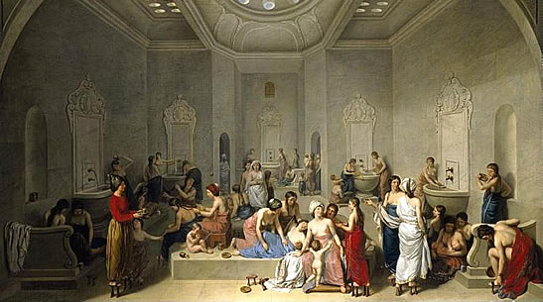](http://www.google.co.kr/url?sa=i&rct=j&q=&esrc=s&source=images&cd=&cad=rja&uact=8&ved=0CAcQjRxqFQoTCLWI8IPPo8cCFYGLlAodbYMBhw&url=http://www.sultanhamamberlin.de/site/en/angebot/baden/was-ist-ein-hamam&ei=tkXLVbXVHoGX0gTthoa4CA&bvm=bv.99804247,d.dGY&psig=AFQjCNGSDmzVJWMjY7t4bexkhunrVQmtZg&ust=1439465894606502)[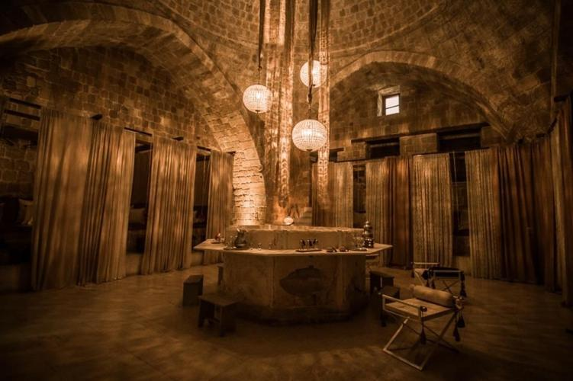](http://www.google.co.kr/url?sa=i&rct=j&q=&esrc=s&source=images&cd=&cad=rja&uact=8&ved=0CAcQjRxqFQoTCMbNoPvPo8cCFUOjlAodrQAHQQ&url=http://in-cyprus.com/hamam-omerye-nicosia/&ei=sEbLVca1NMPG0gStgZyIBA&bvm=bv.99804247,d.dGY&psig=AFQjCNGSDmzVJWMjY7t4bexkhunrVQmtZg&ust=1439465894606502)

Banya, Russia

[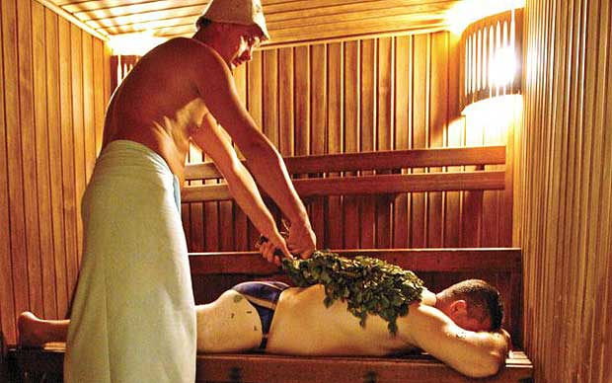](http://www.google.co.kr/url?sa=i&rct=j&q=&esrc=s&source=images&cd=&cad=rja&uact=8&ved=0CAcQjRxqFQoTCJW--pXRo8cCFcydlAodEsUFvg&url=http://www.telegraph.co.uk/news/uknews/law-and-order/9038534/Youll-never-enjoy-a-spa-again-after-reading-this.html&ei=9UfLVdXvEcy70gSSipfwCw&bvm=bv.99804247,d.dGY&psig=AFQjCNGK35nW6toD_wp3VOeeNZr5jeC37g&ust=1439471794925362)

Shvitz, Jewish

[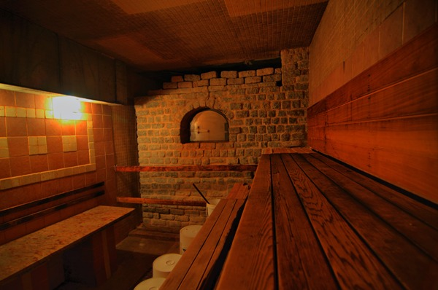](http://www.google.co.kr/url?sa=i&rct=j&q=&esrc=s&source=images&cd=&cad=rja&uact=8&ved=0CAcQjRxqFQoTCLuN7vbRo8cCFUiNlAodO2MOOA&url=http://www.wallstreetbath.com/index.php?page=bath&cat=old_american_shvitz&ei=wEjLVbutH8ia0gS7xrnAAw&bvm=bv.99804247,d.dGY&psig=AFQjCNGupzxcEW5f0vwiZ_uLX6HDGWX4xg&ust=1439472067713407)

Sweat lodge, Native American

[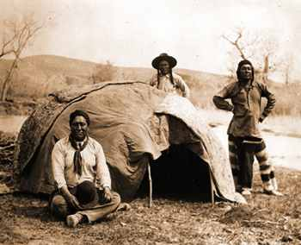](http://www.google.co.kr/url?sa=i&rct=j&q=&esrc=s&source=images&cd=&cad=rja&uact=8&ved=0CAcQjRxqFQoTCIL1mbvTo8cCFUoolAodEZ8IvA&url=http://www.cyberbohemia.com/Pages/hotrock.htm&ei=XErLVYLXEMrQ0ASRvqLgCw&bvm=bv.99804247,d.dGY&psig=AFQjCNFUitBP-UfdgZ8myEAat8hoXAX6Zg&ust=1439472395195568)

JJimjilbang, Korea

[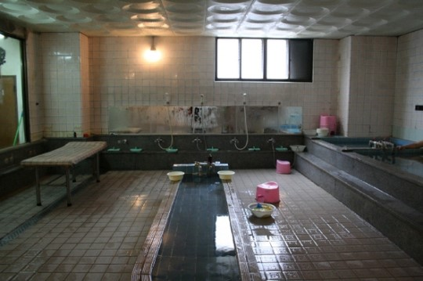](http://www.google.co.kr/url?sa=i&rct=j&q=&esrc=s&source=images&cd=&cad=rja&uact=8&ved=0CAcQjRxqFQoTCKHN0KSOpscCFcyhlAod22oKGA&url=http://blog.daum.net/mansei2000/6002243&ei=epTMVaGoBszD0gTb1anAAQ&bvm=bv.99804247,d.dGo&psig=AFQjCNFzTMOgJbj41hJIHjYGGQr8AZwJKw&ust=1439557093914404) [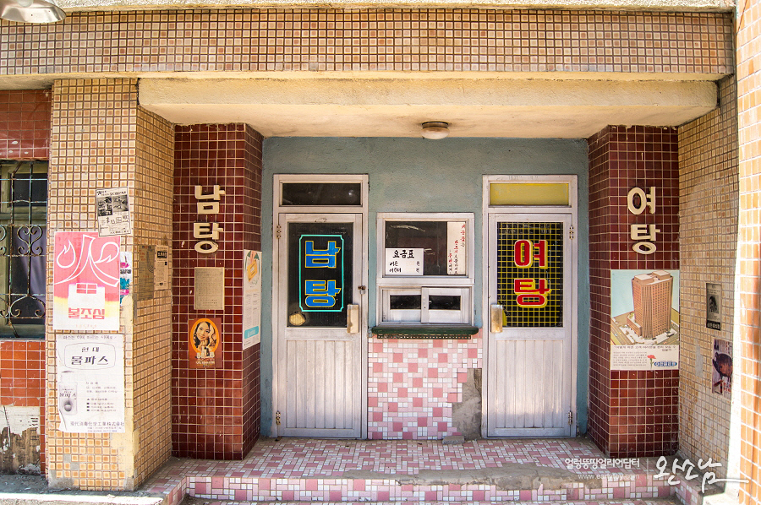](http://www.google.co.kr/url?sa=i&rct=j&q=&esrc=s&source=images&cd=&cad=rja&uact=8&ved=0CAcQjRxqFQoTCOXT0cKPpscCFUiUlAodkAMEEw&url=http://lifelog.blog.naver.com/PostView.nhn?blogId=59hjh&logNo=40159644230&parentCategoryNo=38&categoryNo=&viewDate=&isShowPopularPosts=false&from=postView&ei=xZXMVaXdHMio0gSQh5CYAQ&psig=AFQjCNG0N6aFWvGSE9SSA7XUoTOaGSSwCw&ust=1439557234400716)

[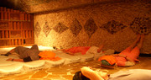](http://fiancee.tistory.com/411) [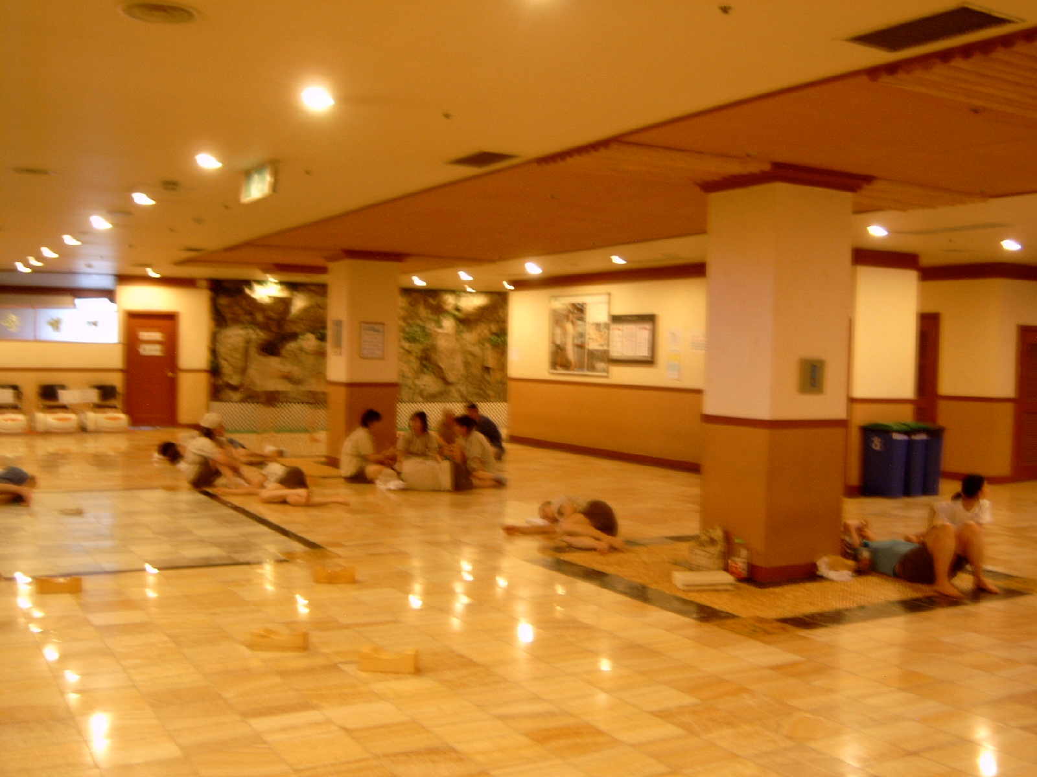](http://www.google.co.kr/url?sa=i&rct=j&q=&esrc=s&source=images&cd=&cad=rja&uact=8&ved=0CAcQjRxqFQoTCJrimuLWo8cCFQG4lAodSzUN1w&url=http://zzimzilbang.com/minihome/index.html?zzidx=1764&ei=003LVdqsF4Hw0gTL6rS4DQ&bvm=bv.99804247,d.dGo&psig=AFQjCNFVdeM13VIyvJy3DKLyzXFL4RivzQ&ust=1439473490083372)