Reading Lesson Plan
TITLE | Personification
INSTRUCTOR |  |  |  | Ss’ LEVEL | AGE GROUP | No of Ss | LENGTH
Hye in kim (Helen) |  |  |  | Advance | 18 | 6 | 50 min

MATERIALS
2 chairs, vocabulary boads. Computer, projector, board, color markers. Personification in the literature worksheets(6copies)

AIMS 1. |  | Ss will be able to practice to find personification by reading some literatures.
2. |  | Ss will study about personification by reading and common example sentences
3. |  | Ss will be able to demonstrate and study personification while they are doing personification describing activity

LANGUAGE SKILLS
Listening |  |  | T’s instruction, describing activity. Other Ss’ explanation of personification in the literatures.
Speaking |  |  | Describing activity, discussion about personification in the literatures in pairs, explanation of personification in the literatures.
Reading |  |  | Common example of personification, L. M. Montgomery’s “The Green Gables Letters”, A.H. Houseman’s poem “Loveliest of Trees the Cherry Now”, Emily Elizabeth Dickinson’s poem “Have You Got A Brook In Your Little Heart”, Katherine Mansfield’s short story “How Pearl Button Was Kidnapped”,
Writing |  |  | The personifications that Ss found in the literatures.
LANGUAGE SYSTEMS
Phonology |  |  | Correct pronunciation of personification
Lexis |  |  | Personification, Literature devices,
Grammar |  |  | Present tense
Discourse |  |  | Shapes song, rolling a dice of the shapes, coloring the shapes
Functions |  |  | Seeking, reading, and speaking of personification.

ASSUMPTIONS

Ss know the vocabularies in the literatures that T provides for exercise

ANTICIPATED GRAMMATICAL ERRORS AND SOLUTIONS
When projector is not working, print out the exercises.

When T cannot print out worksheets, write down the common examples on the board. For literature exercise, read those to Ss and work with them not pairs, but whole class together (use the board. While T reads, T should write down key points on the board)

REFERENCES

http://literarydevices.net/personification/

NOTES

Let Ss discuss what objects people usually personification for. What movies are based on personification.

PRETASK TITLE |  |  | Personification describing activity
AIMS |  |  |  | MATERIALS
Ss will be able to demonstrate and study personification while they are doing personification describing activity. |  |  |  | 2 chairs, vocabulary boads.
TIME | SET UP | STUDENTS |  |  | TEACHER
1min | Wholeclass | Ss listen to T’s instruction |  |  | T tells Ss instruction about personification describing activity without saying the word “personification”.
4 min | pairs | Ss do personification describing activity (please read the Notes section) |  |  | Monitoring while Ss do the activity

NOTES
Let Ss pair with other student and both seat on the chairs.
They seat as looking at each other. Let them have decide who will describe and who will guess the answer.
In other pair, one student come out as helper and hold the vocabulary cards above on the head of guessing student.
For 1 min (time is flexible. T can change the amount of time), describing Student have to describe the vocabulary that is above on the guessing students head by using he or she only. (cannot say “it” “this”)
Describing students have to describe characteristic of the vocabulary (cannot say “she is a flower, animal, robot.” Cannot say category of vocabulary is in.)
The helper has to show other vocabulary when guessing student gets the right answer.
After 1min, teacher counts how many they got right. Write down the score on the board.
Other pairs do same activity.

*T must not say anything about personification or literature devices.

TASK PREPARATION TITLE |  |  | Common example
AIMS |  |  |  | MATERIALS
Ss will study about personification by reading and common example sentences |  |  |  | Computer, projector, board, color markers.
TIME | SET UP | STUDENTS |  |  | TEACHER
5 min | Whole class | Ss tells T about the activity and answer the guiding question. Let students be the groups and have discussion to figure out about the personification. Tell T what they discussed about and listen to T’s explanation. |  |  | Ask Ss about the activity and ask guiding question about personification.  Ex)Was there any vocabularies that a person was the answer?  Monitor them while they discuss, after that, if they have an idea of personification, explain literature device and give them some of literature devices.(ex.climax,mood,symbolism) After that, ask Ss about discussion they had and write down key points from Ss’ idea. Then explain about personification based by Ss’ idea.
7 min | Whole class | Listen to T’s instruction and read out loud the sentences on the projector. Try to find expression about personification in the sentences |  |  | Make Ss read out loud the sentences on the projector, and explain for first one, but after that let Ss do the work. Let them speak out loud the answer and ask why they think it is the answer.

NOTES

Personification Definition
Personification is a figure of speech in which a thing, an idea or an animal is given human attributes. The non-human objects are portrayed in such a way that we feel they have the ability to act like human beings. For example, when we say, “The sky weeps” we are giving the sky the ability to cry, which is a human quality. Thus, we can say that the sky has been personified in the given sentence.

Common Examples of Personification
- Look at my car. She is a beauty, isn’t it so?
- The wind whispered through dry grass.
- The flowers danced in the gentle breeze.
- Time and tide waits for none.
- The fire swallowed the entire forest.
We see from the above examples of personification that this literary device helps us relate actions of inanimate objects to our own emotions.

If Ss struggle to find the personification expression, give them hint and lead them to the answer.

TASK REALISATION TITLE |  |  | Personification in the literature
AIMS |  |  |  | MATERIALS
Ss will be able to practice to find personification by reading some literatures, which is more complicate to find the answer. |  |  |  | Computer, projector, board, marker. Personification in the literature worksheets.
TIME | SET UP | STUDENTS |  |  | TEACHER
3 min | Whole class | Ss read out loud the example and try to find expression about personification in the literature. |  |  | Show them example, and lead them to answer not give them the answer. Ask why they think like that
15 min | individual | Ss do personification in the literature exercises. Ss underline the key points(answers) and write down key points that supporting the answer. |  |  | Tell them to find personification in the exercises. Tell Ss underline the key points (answers) and write down key points that supporting the answer. Monitor Ss while they are doing it.

NOTES
Katherine Mansfield wrote in her short story “How Pearl Button Was Kidnapped”,
“Pearl Button swung on the little gate in front of the House of Boxes. It was the early afternoon of a sunshiny day with little winds playing hide-and-seek in it.”
It personifies wind by saying that it is as playful as little children playing hide-and-seek on a shiny day.

Monitor Ss and if there is anyone that having hard time with personification in the literature exercise, help them. (But do not just give them answer. Lead them to answer. )

POST TASK TITLE |  |  | Concept check
AIMS |  |  |  | MATERIALS
Concept check for the personification by discussion and demonstrate (explain) for each pairs for one exercise |  |  |  | Board. Color markers
TIME | SET UP | STUDENTS |  |  | TEACHER
6min | pairs | Discuss with the partner about the exercises and discuss about demonstration. |  |  | Monitor Ss while they have discussion about the exercise and assign them one exercise for each pairs, and tell them to demonstrate it.
9 min | pairs | Demonstrate the assigned exercise. |  |  | Monitor Ss during the each demonstration and give some feedback after they demonstrate

NOTES

Ss might struggle for demonstration, wait until they finished and lead them to find errors

Paste worksheets, handouts and lesson materials here
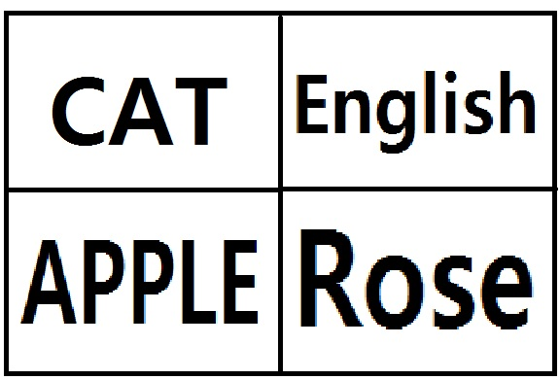
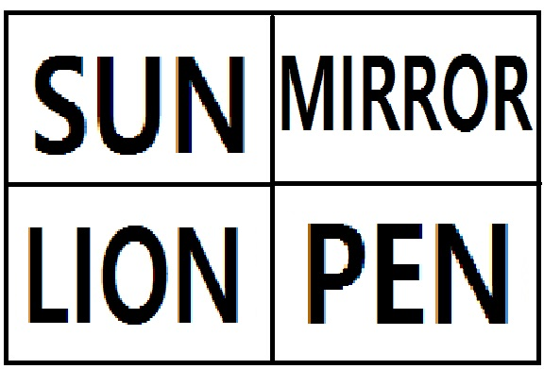
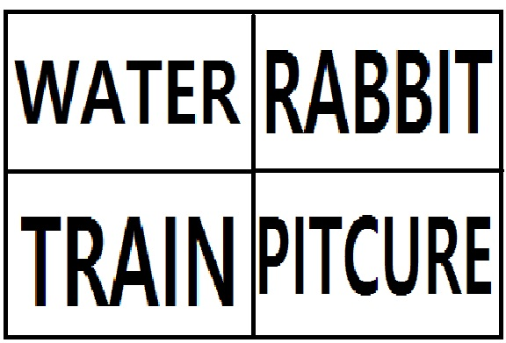
Power point 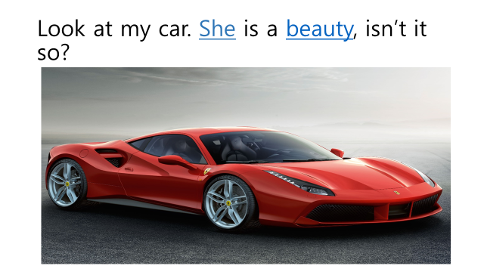 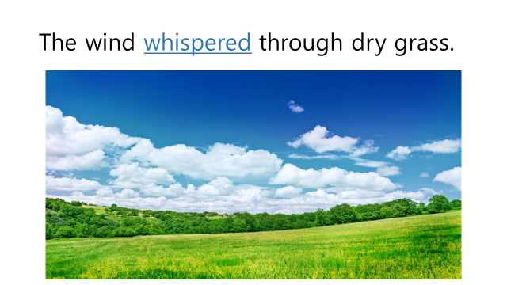 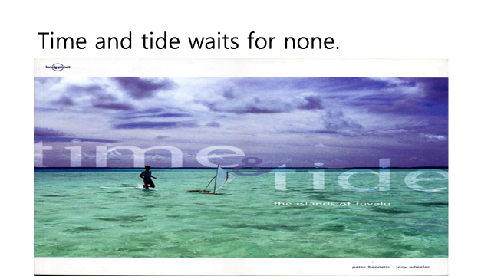 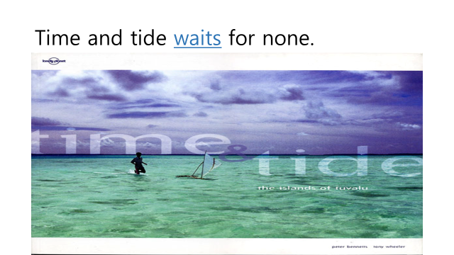 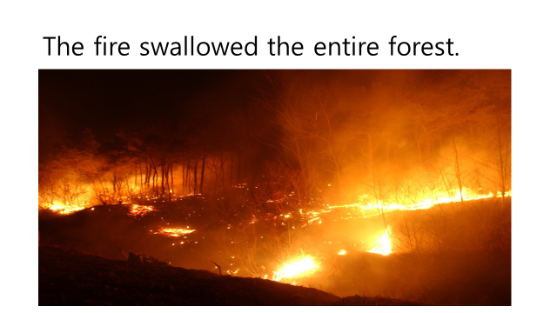 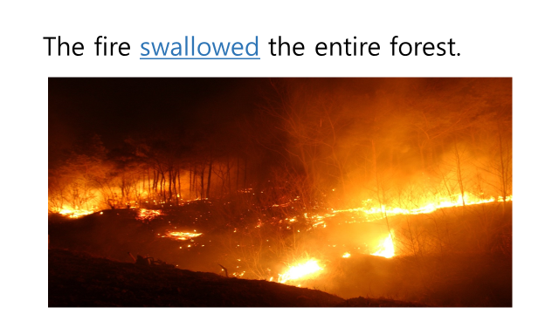

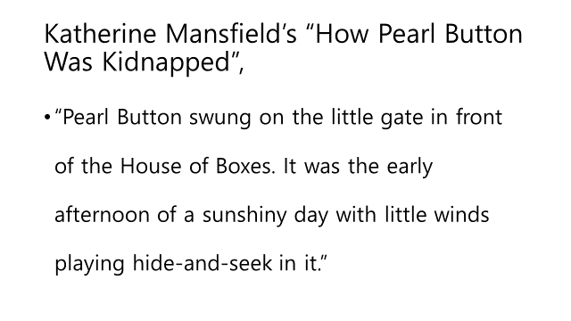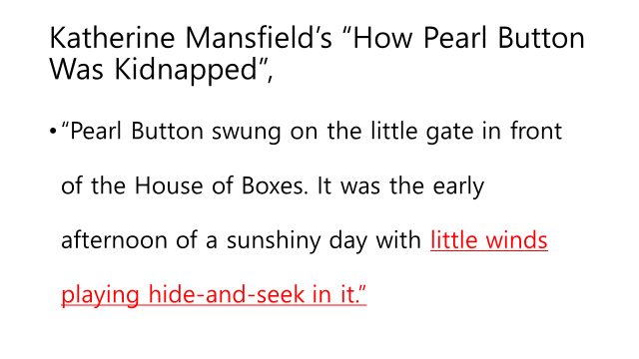

Personification in the literature worksheet
NAME: DATE:
1. Taken from L. M. Montgomery’s “The Green Gables Letters”,
“I hied me away to the woods—away back into the sun-washed alleys carpeted with fallen gold and glades where the moss is green and vivid yet. The woods are getting ready to sleep—they are not yet asleep but they are disrobing and are having all sorts of little bed-time conferences and whisperings and good-nights.”

2. A.H. Houseman in his poem “Loveliest of Trees the Cherry Now” personifies the cherry tree,
“Loveliest of trees, the cherry now
Is hung with bloom along the bough,
And stands about the woodland ride
Wearing white for Eastertide.”

3. Emily Elizabeth Dickinson employs personification in her poem “Have You Got A Brook In Your Little Heart”.
“Have you got a brook in your little heart,
Where bashful flowers blow,
And blushing birds go down to drink,
And shadows tremble so?”

4. William Blake personifies Sunflowers in his poem “Two Sunflowers Move in a Yellow Room”.
“Two Sunflowers
Move in the Yellow Room.
‘Ah, William, we’re weary of weather,
said the sunflowers, shining with dew.
Our traveling habits have tired us.
Can you give us a room with a view?”
Teacher’s Note for personification in the literature

Example #1
Taken from L. M. Montgomery’s “The Green Gables Letters”,
“I hied me away to the woods—away back into the sun-washed alleys carpeted with fallen gold and glades where the moss is green and vivid yet. The woods are getting ready to sleep—they are not yet asleep but they are disrobing and are having all sorts of little bed-time conferences and whisperings and good-nights.”
The lack of activity in the forest has been beautifully personified as the forest getting ready to sleep, busy in bed-time chatting and wishing good-nights, all of which are human customs.

Example #2
A.H. Houseman in his poem “Loveliest of Trees the Cherry Now” personifies the cherry tree,
“Loveliest of trees, the cherry now
Is hung with bloom along the bough,
And stands about the woodland ride
Wearing white for Eastertide.”
He sees a cherry tree covered with beautiful white flowers in the forest and says that the cherry tree wears white clothes to celebrate Easter. He gives human attributes to a tree in order to describe it in human terms.

Example #3
Emily Elizabeth Dickinson employs personification in her poem “Have You Got A Brook In Your Little Heart”.
“Have you got a brook in your little heart,
Where bashful flowers blow,
And blushing birds go down to drink,
And shadows tremble so?”
The bashful flowers, blushing birds and trembling shadows are examples of personification.

Example #4
William Blake personifies Sunflowers in his poem “Two Sunflowers Move in a Yellow Room”.
“Two Sunflowers
Move in the Yellow Room.
‘Ah, William, we’re weary of weather,
said the sunflowers, shining with dew.
Our traveling habits have tired us.
Can you give us a room with a view?”
The flowers are depicting a human characteristic of weariness caused by the weather. In a human way, they make a request to the poet to put them in a room with a window with plenty of sunshine.

Function of Personification
Personification is not merely a decorative device but it serves the purpose of giving deeper meanings to literary texts. It adds vividness to expressions as we always look at the world from a human perspective. Writers and poets rely on personification to bring inanimate things to life, so that their nature and actions are understood in a better way. Because it is easier for us to relate to something that is human or that possesses human traits. Its use encourages us to develop a perspective that is new as well as creative.

