TITLE | Reading a text related to birth order
INSTRUCTOR |  |  |  | Ss’ LEVEL | AGE GROUP | No of Ss | LENGTH
Hanna Kim (Hanna) |  |  |  |  | Adult | 6 | 20 min

MATERIALS

Power point presentation, Video-clip, Computer, Projector, White Board & Markers, Worksheet, Dictionary.
AIMS 1. |  | Ss will practice skimming and scanning skills in reading a text.
2. |  | Ss will increase their anticipation skills through word-guessing activity.
3. |  | Ss will practice and use new vocabulary and expression through discussing the idea about the birth order.

LANGUAGE SKILLS
Listening |  |  | Ss will be listening through watching the video clip.
Speaking |  |  | Ss will be speaking in the speaking activity (discussing the idea about the birth order).
Reading |  |  | Ss will be reading a text related to birth order.
Writing |  |  | Ss will be writing some sentences through answering the comprehension questions.
LANGUAGE SYSTEMS
Phonology |  |  | Enter the pronunciation focus for the lesson here plus examples
Lexis |  |  | Enter the vocabulary students will focus on here plus examples
Grammar |  |  | Enter the key grammar points of the lesson here plus examples
Discourse |  |  | Enter the main topic of the text/discussion/lesson here
Functions |  |  | Enter the purpose of the language used in the lesson here

ASSUMPTIONS

Ss already know how to read with skimming and scanning skills

Ss have enough social knowledge and psychological logic to understand a text about birth order.
Ss have enough ability to understand the advanced level of reading.

ANTICIPATED GRAMMATICAL ERRORS AND SOLUTIONS
If Ss do not understand the text, I will let them use dictionaries and mobiles phone.

REFERENCES

Reading text
: http://io9.com/how-your-birth-order-can-influence-who-you-are-1136567036

Video clip

: https://youtu.be/61ruJlQ5S9s
: https://youtu.be/7zw8_SQLZ-A

Lesson Plan
: http://www.tesol.org/connect/tesol-resource-center/search-details/lesson-plans/2013/12/04/reading-lesson-plan

NOTES
Cut-off plan
: If there is not enough time to complete the whole activity, speaking activity might be cancel but give them writing assignment about the same topic.
SOS activity
: In case we have extra time, Ss might discuss the advantages and disadvantages of being “fist-middle and last” born child.

PRETASK TITLE |  |  | Guessing the topic and related words
AIMS |  |  |  | MATERIALS
- Picture makes the abstract topic more concrete and it illustrates it making the topic more meaningful.  - Word guessing activity provides Ss with possible vocabulary items that they can see in the text and it gives them a chance to understand the topic in general without reading it. |  |  |  | Power point presentation, Projector,  Appendix 1(Word-guessing activity), Dictionary.
TIME | SET UP | STUDENTS |  |  | TEACHER
2 min |  | 1. Ss look at the picture and talk about it trying to find out what the text is about.  2. Ss.tell their answer.  3. Ss look at the screen and get the correct answer. |  |  | 1. T shows a picture of family on the screen and asks Ss to guess the topic of the reading that they are going to read.  2. T gets the answers from Ss.  3. T projects the topic of the reading text on the screen.
3 min |  | 1. Ss do the task individually and put a tic if they think the word is going to be in the reading text and put a cross if they think that it is not. |  |  | 1. T distributes a word guessing activity.

NOTES

TASK PREPARATION TITLE |  |  | Introducing video clip for the reading preparation
AIMS |  |  |  | MATERIALS
- It will give them an interesting one before they start doing reading activity.  - Introducing video clip helps activate the vocabulary and idea schemata of the Ss related to the topic and giving them new idea about it. |  |  |  | Projector, Computer.
TIME | SET UP | STUDENTS |  |  | TEACHER
3 min |  | 1. Ss Watch and listen the video clip, while finding the word what Ss found last activity.  2. Ss try to think which character is first born, middle born and last born. |  |  | 1. T opens and plays the video clip “How Birth Order Affects Who You Are”  2. T wants Ss to match the characters in the video with their birth orders.

NOTES

TASK REALISATION TITLE |  |  | Reading text with comprehension question.
AIMS |  |  |  | MATERIALS
It will increases their skimming and scanning skills and increases their awareness about what they need while reading and answering comprehension questions. |  |  |  | Appendix 2(The Reading Text:)  Appendix 3(Comprehension Questions:)
TIME | SET UP | STUDENTS |  |  | TEACHER
3 min |  | 1. Ss read the text using the skimming and scanning skills. |  |  | 1. T distributes the reading text and asks Ss to read it quickly.  ICQ : Before they read the text T asks Ss what they need to be careful about while reading and answering the question.  2. T monitors the Ss while they are reading.
4 min | ->  Whole class | 1. Ss try to answer them.  2. Ss share their answers with the whole class. |  |  | 1. T distributes an activity sheet(Comprehension Questions) and ask to answer it.  2. T asks the comprehension question and gets answer from Ss.

NOTES

POST TASK TITLE |  |  | Share the idea about the topic
AIMS |  |  |  | MATERIALS
- Checking whether Ss have understood the text or not.  - It reinforces their speaking skills on a specific topic using the related vocabulary items from the text. |  |  |  | Board and markers.
TIME | SET UP | STUDENTS |  |  | TEACHER
2 min |  | Ss give out their answers with their reasons. |  |  | CCQ :  1. Who will have more possible to be a president by the birth order theory?  2. Are agree with the writer or not? And why?
3 min |  | Ss give their opinions about it. |  |  | T asks Ss about their status in the family, and whether they agree with the writer or not.

NOTES

Appendix 1.
Word-guessing activity

Task: Put a tick (v) if you think that the word might be in the text, or a cross (X) if you think that is not in the text.

The words will change in tomorrow(sorry)
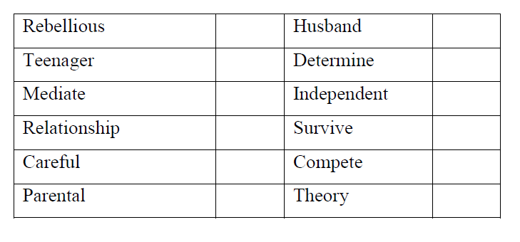

Appendix 2.
The Reading Text

How Your Birth Order Can Influence Who You Are
As many parents can attest, siblings tend to be more different than alike. Some of this may be the result of our birth order, and how we’re subsequently raised. What’s more, birth order may influence our health and sexuality too. Here’s what you need to know about how your birth rank affects your life.
Birth order is an incredibly difficult area to study, and as such, is considered highly controversial.
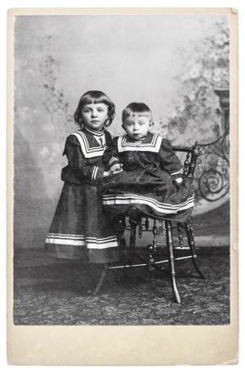
Advertisement
There are so many factors to consider outside of a person’s familial rank by age, including the spacing in years between children, the total number of children in a family, socioeconomic status, the sex of siblings, and environmental circumstances during upbringing. It’s not easy to isolate traits that are dependent on birth order.
And indeed, a 1983 meta-study by Ernst and Angst, which looked at birth order studies done between 1946 and 1980, threw much of this area into question. Many psychologists, to this very day, minimize the role of birth order and its effects on our personalities. And the preponderance of conflicting literature on the matter hasn’t helped, either.
But over the course of the past four decades, psychologists have continued to look into the issue — and they’re discovering that there may in fact be something to it.

Birth Rank and Personality
Alfred Adler, a peer of Freud and Jung, was one of the first theorists to use birth-order position for assessing clients. But the most important modern psychologist to rigorously study the topic was MIT’s Frank Sulloway.

Why Freud Still Matters, When He Was Wrong About Almost Everything Why Freud Still Matters, When He Was Wrong About Almost Everything Why Freud Still Matters, When He Was Wrong About A
He’s been dead for nearly 70 years, but Sigmund Freud’s provocative theories are still a huge part…Read more Read more
In his 1996 book, Born to Rebel, he considered five major personality traits, namely openness, conscientiousness, extraversion, agreeableness, and neuroticism. Birth rank, he argued, has an influence on all of them.
Sulloway showed that firstborns were more conformist, while laterborns were more creative and more likely to reject the status quo. He also made the case that people tend to have more in common with someone of their own birth rank than their own siblings.
This seminal book, while celebrated by many, also kindled a firestorm of controversy. Researchers like Jeremy Freese attacked Sulloway’s methodology, accusing him of manipulating of the data. Since the publication of Born to Rebel, there have been hundreds upon hundreds of studies exploring the topic, with conclusions spanning the gamut.
But back in 2010, in a much-needed update to the Ernst and Angst meta-study, Daniel Eckstein and colleagues decided to do another exhaustive analysis of the existing literature. They looked at the results of 200 birth-order studies to see if any consistency could be found in lifestyle characteristics. They discovered that some personality characteristics were indeed being consistently matched according to birth rank.
First-borns, they learned, tend to experience high success and achievement. Only-borns desire achievement. Middle-borns are highly sociable. And the youngest children have a pronounced desire for a social life.
The authors also put together this tidy chart showing the number of times that research studies were able to match specific personality traits to birth rank:
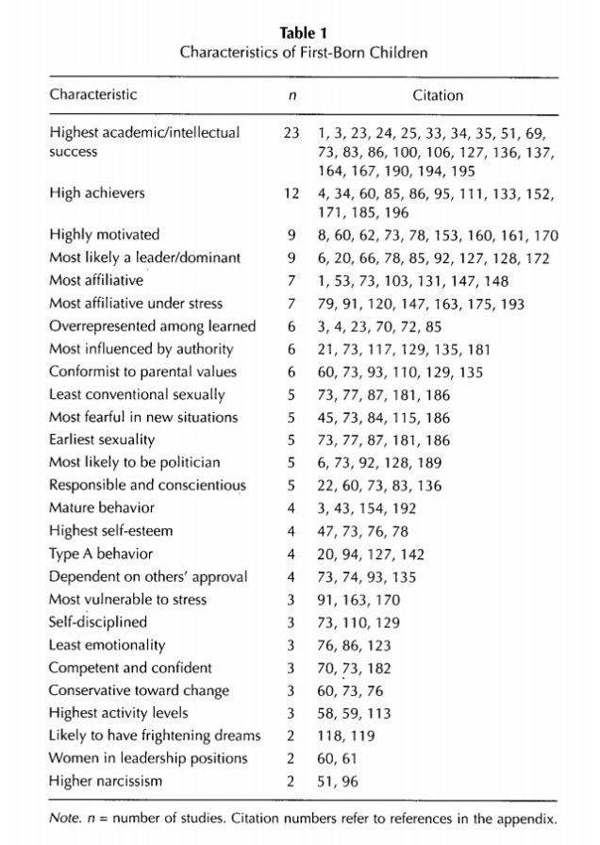
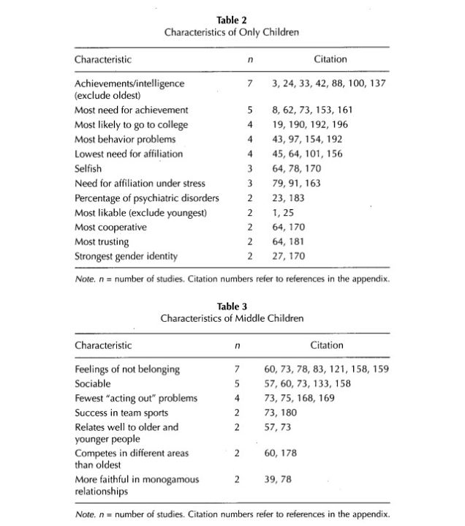
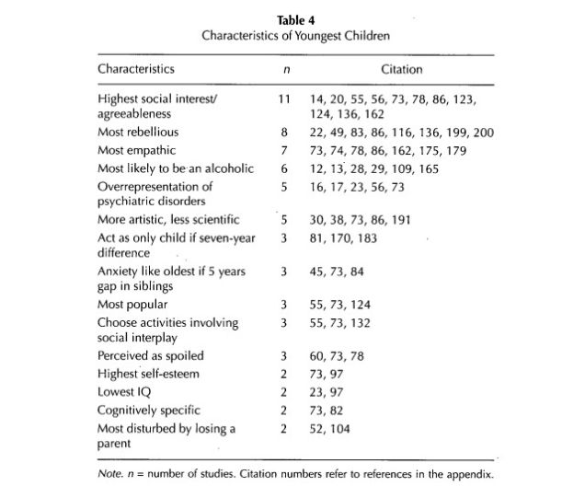
Looking at other studies, there appears to be a connection between birth order and career interests. A 2001 study showed that laterborn children go in the direction of arts and outdoor related careers, while onlyborns, and possibly firstborns, tend to prefer intellectual pursuits. The researchers aren’t saying that it’s an inborn, genetic effect, but rather something that’s enforced by parental guidance.
Relatedly, birth order position also appears to influence our competitiveness. Researchers have found that firstborns pursue “mastery goals,” where competence is determined by others.

Science Fiction’s Fiercest Sibling Rivalries Science Fiction’s Fiercest Sibling Rivalries Science Fiction’s Fiercest Sibling Rivalries
The only creature who could ever make Data truly feel something was his twin brother, the evil,…Read more Read more
Psychologist Bernd Carette writes:
These results are in line with the notion that, presumably due to a differential treatment by their parents during early childhood, firstborns prefer self-referenced standards to evaluate their competence. That is, they approach tasks with the desire to develop knowledge, skills, and task mastery. On the other hand, secondborns tend to evaluate their competence in terms of other-referenced standards. They are more strongly inclined to approach tasks with the desire to demonstrate competence relative to others.
Interestingly, birth rank also affects how dominant and extroverted we are. A recent study showed that firstborns show more of the dominance side of extraversion, while laterborns exhibit more of the sociability aspects of extroversion. Firstborns, it would seem, are actually less dominant or assertive than laterborns. The researchers suspect that strict and overprotective parenting of firstborns may be the reason, which causes them to grow up submissive.

Depends On Who You Ask — And When
A 1998 Canadian study, after looking at 1,022 families, found that firstborns are more conservative, more achieving, and more conscientious. Laterborns were assessed as being more rebellious, liberal, and agreeable. But these results came in from intra-family assessments — and that's a potential problem.
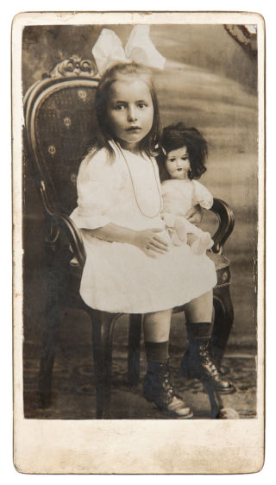
For example, a different study found that people outside the family, such as spouses, friends, and peers, provide different evaluations — which often show none of the expected birth-order differences!
Which is not a complete surprise. It’s possible, if not blazingly obvious, that personality assessments are inherently problematic by virtue of the fact that people behave differently around different people. What’s more, family dynamics will have an impact on both behavior and perception — including characteristics that don’t get seen or expressed outside the family context. So, while birth order has a measurable impact on personalities and the perception of them within a family, it’s an effect that may not often transcend the immediate family environment
What’s more, as Michael E. Lamb and Brian Sutton-Smith have argued, sibling relationships evolve over the course of a lifetime. They’re continually adjusting to changing dynamics and circumstances — adjusting to competing demands of society and inherent biology.

Intelligence
One particularly controversial area of birth order studies is the ongoing debate about intelligence. Firstborns consistently rank higher on intelligence tests. The going theory is that they get more attention and resources from parents.
Indeed, Robert Zajonc says that firstborn children are almost exclusively exposed to adult language, whereas laterborn children experience the less mature, childish speech of their older siblings. This may subsequently explain why firstborns tend to score higher on tests of verbal ability. As for non-firstborns, their older sibling(s) frequently assume the role of parents, answering their questions and offering perspectives, albeit less capably.
Other factors, of course, include socioeconomic status (the smaller the family, the more time and resources that can go around; also, large families tend to fall within lower socioeconomic groups). As well, the age of the mother at the time of birth also appears to be a factor (younger moms tend to be less educated, have lower incomes, and are more capable of producing larger families).

Sexuality
Not surprisingly, birth order can also influence our relationships. In 2009, Timothy Hartshorne and his team showed that, similar to Sulloway, people have a lot in common with people of their own birth ranks. Furthermore, the psychologists found that we’re more likely to form long-term platonic and romantic relationships with other people of the same birth order — an effect the researchers say cannot be explained by other factors, such as family size.
Studies have also shown that sexual orientation correlates with a man’s number of older brothers. And in fact, each additional older brother increases the odds of homosexuality by about 33%.
The going theory is that mothers become increasingly immune to certain antibodies with each subsequent pregnancy. Accordingly, the anti H-Y antibodies produced by the mother during a pregnancy pass through the placental barrier to the fetus, which in turn affects various aspects of sexual orientation in the fetal brain.

Scientists claim that homosexuality is not genetic — but it arises in the womb Scientists claim that homosexuality is not genetic — but it arises in the womb Scientists claim that homosexuality is not genetic
A team of international researchers has completed a study that suggests we will probably never find …Read more Read more
A follow-up study by the same research team noted:
The results indicate that the proportion of homosexual men whose sexual orientation is attributable to fraternal birth order constitutes a minority, but not a negligible minority, of all homosexual men. The fraternal birth order effect may reflect the progressive immunization of some mothers to Y-linked antigens by each succeeding male fetus, and the concomitantly increasing effects of antimale antibodies on the sexual differentiation of the brain in each succeeding male fetus.
Interestingly, only biological older brother’s predict men’s sexual orientation, strongly suggesting a prenatal origin to the fraternal birth-order effect.

Health
Birth order can also have an impact in unexpected areas.
For example, researchers found that firstborn children have a greater difficulty absorbing sugars into the blood and have a higher daytime blood pressure than later born children. Firstborns, therefore, may be at a greater risk of metabolic and cardiovascular diseases in adult life. They surmise that this difference may be attributable to physical changes in the mother's uterus during her first pregnancy.
Japanese researchers have also discovered that first-borns may be more susceptible to food allergies.
First-borns may also be predisposed, for unknown reasons, to high-functioning autism (or what used to be called Asperger’s syndrome). It may have something to do with birth stoppage, obstetric complications, or immunological processes — but scientists aren’t really sure. Relatedly, closely spaced pregnancies have been linked to autism.
Researchers have also found a decreasing risk with increasing birth order for certain childhood cancers (but the opposite for acute myeloid leukemia). In terms of an explanation, the researchers write, "It is possible that firstborn children have higher estrogen exposures that may contribute to greater risk of cancer than later born children. Estrogen levels in maternal and umbilical cord blood samples are somewhat greater in first pregnancies compared with second or third pregnancies."
Also, children with older siblings are more likely to experience respiratory symptoms at four years of age. One possible explanation is that children with older siblings have more exposure to respiratory infections at an early age than oldest or only children.

Additional reporting by Joseph Bennington-Castro.

Appendix 3.
The Questions

Comprehension

1. Find a word or expression in the text which, in context, is similar in meaning to:
a. be good at (par. 3):
b. talented (par. 3):
c. appropriateness (par. 2):
d. privileged (par. 1) :

2. Answer the following questions using your own words.
a. What do children have to do when a place in the family has been taken?
____________________________________________________________________________________________________________________________________________

b. Why does Sulloway believe that a marriage between a typical first-born husband and a later-born wife will probably be successful?
____________________________________________________________________________________________________________________________________________

c. Why do first born children become perfectionist?
____________________________________________________________________________________________________________________________________________

3. Are the following statements true or false?
a. Later-born children usually agree with their family values. (T) (F)
b. Birth order is a good way of knowing whether a relationship will be successful. (T) (F)
c. A last-born child tends to be more creative as s/he has more freedom. (T) (F)

4. Choose a, b, or c, in each question below. Only one choice is correct.
1. The order in which we are born affects
a. both our personality and our relationships.
b. only our personality.
c. neither our personality nor our relationships.

2. The writer’s purpose is to
a. persuade people that birth order is important just for our personality.
b. give information about how birth order affects our personality and relationships.
c. criticize people who don’t believe that birth order has an effect in our lives.

PPT :
