Speaking Lesson Plan

FRIENDSHIP

Students: 8
Level: Low Intermediate
Instructor:
Amy (Song Ji Min)
Length: 25 minutes

Materials:
- Visual aid - picture
- Hand outs with vocabulary, Handouts with fill in the blank, Handouts with questions
- Board and Markers

Aims:

- SWBAT use descriptive adjectives (topic related vocabulary).
- SWBAT share their opinions and give personality description.
- SWBAT discuss their own opinions in a group.
- SWBAT talk about How to make close friends by answering questions.

Language Skills:
- Reading: Read vocabulary and worksheet.
- Writing: fill in the blank and worksheet.
- Listening: listening to teacher’s instructions, discussing with classmates.
- Speaking: Talk about How to make friendship and Share their opinions in pairs or groups.

Language Systems:
- Phonology: Pronunciation related to vocabulary in the topic.
- Function: Fill in the blank, sharing opinions with classmates.
- Lexis: Key vocabulary.
- Grammar: Correct their answers & worksheet.
- Discourse: Expressing opinions.

Assumptions:
Students already know:
- Ss should be already familiar with some of the descriptive adjectives from previous classes.
- The teacher’s style of teaching and the pace of the course.
- Ss should be comfortable sharing their opinions and giving descriptions in pairs.
- Ss know they should speak only English in class.

Anticipated Errors and Solutions:
- Ss finish their task earlier than expected.
-> T prepares extra worksheets.
- Ss take more time to complete their task earlier than expected.
-> Assign as homework.
-Ss may have some difficulties understanding some vocabulary.
-> Give as many synonyms as possible to help their understanding.
- Ss may not be familiar with some of the vocabulary from the list from the fill in the blank worksheet.
-> T will provide students with examples and describe meaning.

References:
http://www.helpguide.org/articles/relationships/how-to-make-friends.htm
http://simpleesl.com/english-worksheets-activities-games-friendship/
http://www.eslflow.com/Describing-colleagues-business-English-lesson.html

Pre-Task

Materials: Board, Markers, Picture
Time  1 min  1min | Set Up  whole class  Whole  class | Procedure:  <Greeting>  “Hello everyone. How are you today?  What did you do last weekend?  (Ss answer variety answers)  I met my best friends last weekend and we talked about our daily life while eating dinner. I was very happy to meet my best friends.  <Eliciting>  T elicits today’s topic from the Ss  T Show Ss picture and T posts the picture on the whiteboard to elicit the topic  T elicits from the Ss by asking questions about FRIENDSHIP.  First, Please take a look at the picture.  What do you see in this picture? (Friend)  Do they look happy in this picture? (Yes, they look happy)  (Each Ss should have chance to answer the questions)  Ok. Today we are going to learn about FRIENDSHIP.  T writes the topic on the whiteboard.

Pre-Preparation
Materials: Whiteboard, Markers, worksheet#1 (vocabulary)
Time  3min  5min | Set Up  T explain  individually  & Pair work | Procedure:  T writes vocabulary related to personality on the board.  T explains and give examples about personality  synonyms and antonyms.  T hands out fill in the blank and synonym, antonym  activity  Ss fill in the blanks with the correct vocabulary below the  picture about synonyms and antonyms.  Ss share and discuss their answers with their partner.  <Instruction vocabulary>  To make a strong friendships we need to consider good  personalities.  So, We will learn about words related to personality.  Look at these vocabularies.  The board looks like this:  Personality  Positive negative  interesting boring  Sociable shy  opposite  Easygoing nervous  honest dishonest  hardworking lazy  T asks Ss each vocabulary’s meaning.  T points to each word.  Do you know?  What does this mean? (Ss answer about it)  After T explains each vocabulary.  T gives Ss some examples using the vocabulary  in a sentence.  I will give you an example.  Ex> I am honest when I talk to my friends.  But I am honestly when I talk to my friends.(x)  When you express someone’s personality, you should use adjective. Honestly is an adverb.  <Eliciting>  T writes some examples using idioms for personality  on the board.  Then, T asks Ss to elicit about it.  I will give additional resources using idioms for personality.  Ex> “ I don’t want my son to be friends with Bobby.  Bobby is a bad egg.  T elicits Ss.  Can you guess? What does this mean?  T explains this idiom.  A bad egg means dishonest.  A bad egg means they cannot be trusted.  One more thing.  Ex> “ The new teacher works all the time-first to arrive  and last to leave- a real eager beaver!”  Eager beaver means hardworking.  T elicits Ss.  Can you guess? What does this mean?  It was fun? (Ss answer)  <Instruction>  I will hand out synonym, antonym activity and fill in the blank worksheet.  I will give you 5 minutes.  Please fill it out the correct vocabulary below to the picture.  After you finish, share the answers and discuss with your partner.  <CCQ>  How much time do you have? (5min)  What are you going to do now?  (Fill in the blank and discuss with partner)  Okay! Here we go~~!!!  <Monitoring & Feedback>  T walks around the class and give Ss feedback whenever necessary and checks Ss’ answers.  Time’s up!  It was fun?  (Ss say the answer)
Main Activity
Materials: Board, Markers, Worksheet#2 (Discuss How to make close friends)
Time  3min  5min  1min | Set Up  Individually  Whole  class  Whole  class | Procedure:  T hands out the worksheet to the students.  Ss write the following three questions on the board  Ss write their opinions and discuss about the questions on the worksheet.  <Instruction>  Now, Time to discuss.  I will give you a three question worksheet  about How to make close friends.  I will give you 3 minutes.  After writing the questions, I will ask each student then please write the following three questions  on the board and discuss your opinions.  <CCQ>  How much time do you have? (3min)  What will you discuss? (How to make close friends)  <Monitoring>  T walks around the class and give Ss feedback whenever necessary.  < Write for questions and Discuss >  Ss write their opinions about the following three questions.  T elicits Ss to share their opinions with classmates.  T asks Ss about the questions and Ss answer it.  What is your answer?  Please write your opinions on the board and discuss  your opinions  <Feedback>  After Ss discuss the answers to the questions individually,  T gives Ss more ideas about the following three questions.  T writes more good ideas below on the board.  I will give you additional resources about the questions.  (T writes about it on the board and explains the ideas.)
Post Activity
Materials: Mini activity worksheet #3
Time  2min  2min  1min  1min | Set Up  Individually  Whole  class  Whole  class  Whole  class | Procedure:  T hands out description worksheet.  Ss write about their own personalities on the worksheet.  T asks Ss to take a look at the description worksheet and describe about their own personalities.  <Instruction>  I will give you a hand out.  Thinking About Your Personality.  And write your personality in the bubble blank.  After you finish it, Please show your picture and  share your personality with each other.  I will give 2 minutes.  Are you ready? Let’s go!!  Time’s up!  <Describing>  Let’s describe your personality individually.  Who wants to go first?  (Ss describe about own personality)  You are very good!!  <Homework>  T gives homework about today’s lesson.  T hands out homework sheets.  I will give you homework. Please prepare your homework and we will present your homework next time.  <Closing & Feedback>  Let’s call it a day!!!  <CCQ>  Is an eager beaver lazy? (no)  Today, we learned about friendship.  Friendships are a part of everyday life.  I hope today’s lesson will useful you  when you make good friendships!  Thanks for today. Have a nice day. Bye!!
Worksheet # 1

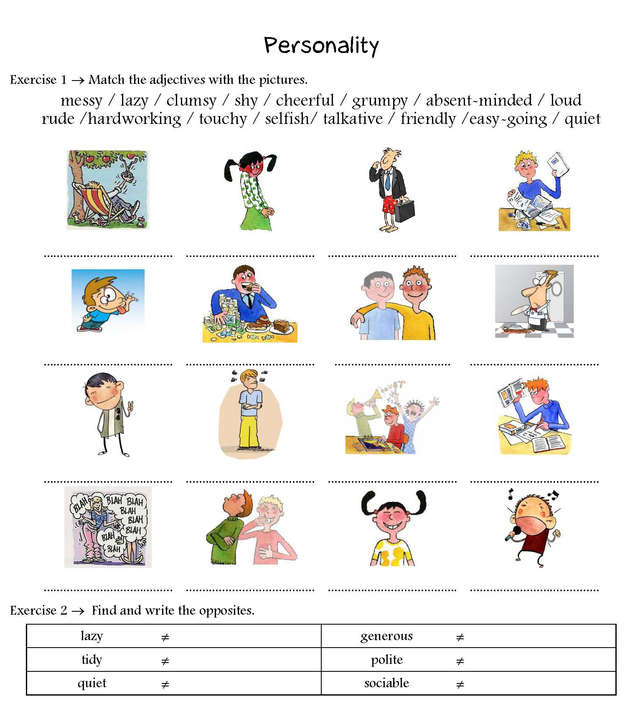

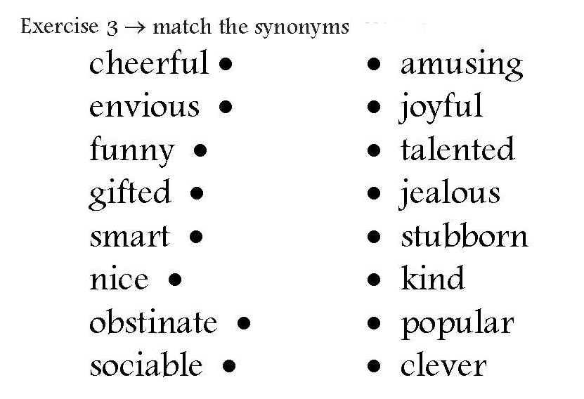

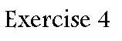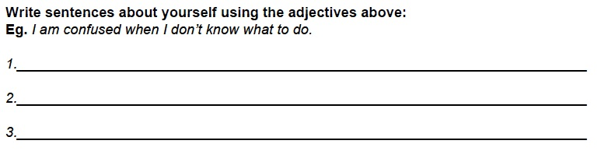

Worksheet # 2

Let’s think and write your opinions about How to make Close Friends

1. What are the benefits of friendship?

2. Why are friends important?

3. How can we improve friendship by being better friends?

Worksheet # 3

Describe about my personality

My
Personality

For example. I am hard-working.
I am friendly.

Homework
