TITLE | Stepping Stone
INSTRUCTOR |  |  |  | Ss’ LEVEL | AGE GROUP | No of Ss | LENGTH
Joon |  |  |  | Beginner | 8 | 6 | 50

MATERIALS

Board, markers, computer, review/assignment worksheets, “Stepping stone” activity tools
(big enough paper with words that people can standing on, timer, etc.)
AIMS 1. |  | Practice “To infinitive” form with substitution table
2. |  | Practice “To infinitive” form with stepping stone game
3. |  | Practice speaking skills by speaking “To infinitive” form examples aloud

LANGUAGE SKILLS
Listening |  |  | Teachers reading “To infinitive” form examples and audio clip
Speaking |  |  | “To infinitive” form examples
Reading |  |  | “To infinitive” form examples and review worksheet
Writing |  |  | Assignment worksheet
LANGUAGE SYSTEMS
Phonology |  |  | Practice accurate pronunciation  ex) like to, love to, English, Korean etc.
Lexis |  |  | Learn new vocabulary and expressions  ex) like to learn, love to learn, etc. .
Grammar |  |  | Acquire grammar by substitution table and activity  ex) I like to learn, He likes to speak, She likes to read, etc.
Discourse |  |  | Substitution table and activity
Functions |  |  | Repeating “To infinitive” form examples

ASSUMPTIONS

Student learned the concept of “singular/pronoun + verb” in previous lesson

ANTICIPATED GRAMMATICAL ERRORS AND SOLUTIONS

Students can make grammar error while doing “stepping stone” activity since it plays fast speed
Help students to understand the grammar by helping each other within group

REFERENCES

Textbook chapter5 “language analysis”, Youtube https://www.youtube.com/watch?v=frN3nvhIHUk

NOTES

Tale Activity – Say a word with last person’s last letter by turns

What do you like Activity – Ask “what do you like?” by turns

PRETASK TITLE |  |  | Review
AIMS |  |  |  | MATERIALS
Review “singular/pronoun + verb” in previous lesson with audio clip and review worksheet |  |  |  | Computer with audio clip, review worksheet, board, markers
TIME | SET UP | STUDENTS |  |  | TEACHER
3min | Whole Class | Listen and follow singing “Do you like song” learned from previous class |  |  | Play audio clip  https://www.youtube.com/watch?v=frN3nvhIHUk
3min | Whole Class | Listen and follow read aloud teacher’s reading review worksheet and remember what have learned from previous class |  |  | Read aloud review worksheet

NOTES

If student does not sing audio clip or read review worksheet take Ss attention to start again.

Whole glass should be participate sing/read aloud together.

TASK PREPARATION TITLE |  |  | Classroom
AIMS |  |  |  | MATERIALS
Students study new vocabulary by teacher’s explanation |  |  |  | Board, markers
TIME | SET UP | STUDENTS |  |  | TEACHER
2min | Whole Class | Answer to teacher’s questions about everyday life that lead to today’s lesson  Ex) What do you like to do? |  |  | Ask guiding question
5min | Whole Class | Assume and answer the meaning of the new vocabulary  Ex) what language do we learning in this classroom right now? |  |  | Teach new vocabulary

NOTES

Prepare some guiding questions that related to today’s lesson

TASK REALISATION TITLE |  |  | Stepping Stone
AIMS |  |  |  | MATERIALS
Students learn how to use “To infinitive” form through activities |  |  |  | Board, markers, “Stepping stone” activity tools (paper, timer)
TIME | SET UP | STUDENTS |  |  | TEACHER
11min | Whole Class | Read substitution table to complete “To infinitive” form from left to right by teacher’s direction aloud. Choose one word from each section and try to make correct sentence. |  |  | Make substitution table
21min | Group by 2-3 | 1) Look at the “stepping stone” big paper  2) Stand on start line  3) Speak aloud correct “To infinitive” form sentence while stepping each word  4) Group come into the finish circle first(start by group) or has short amount of time(start together) wins |  |  | Introduce rules

NOTES

Adjust the time and pay attention on safety issue as activity continues

POST TASK TITLE |  |  | Remember
AIMS |  |  |  | MATERIALS
Review today’s lesson and assign homework |  |  |  | Assignment worksheet
TIME | SET UP | STUDENTS |  |  | TEACHER
3min | Whole Class | Listen and follow read aloud teacher’s reading “To infinitive” form example sentences that have learned today’s lesson |  |  | Read example sentences
2min | Whole Class | Write down one favorite “To infinitive” form sentences using today’s lesson and what they want to learn for next class.  Complete and turn it to teacher by next class. |  |  | Assign homework

NOTES

Get students attention until the end of the class, so students does not miss next class assignment.
* Next class, start pre-task by each students reading assignment aloud.

Review worksheet
- Let’s read out aloud together
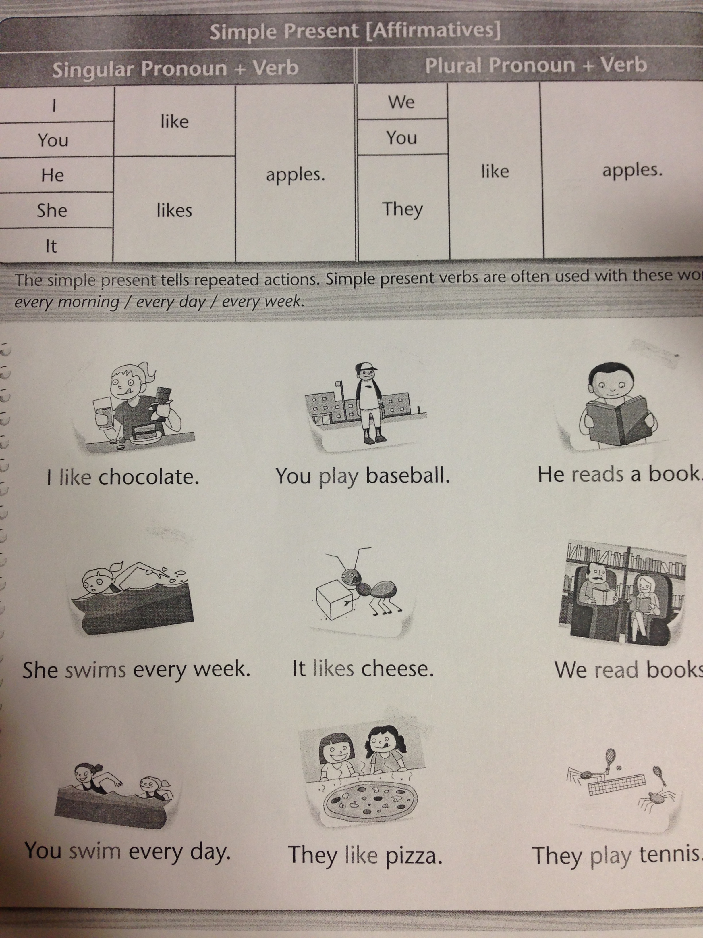

Assignment worksheet

- Write down one favorite “To infinitive” form sentences using today’s lesson

- What do you want to learn for next class

