Speaking Lesson Plan
TITLE | Has been present perfect
INSTRUCTOR |  |  |  | Ss’ LEVEL | AGE GROUP | No of Ss | LENGTH
Hye in kim (Helen) |  |  |  | intermediate | 10 | 6 | 50 min

MATERIALS
Computer, video clip,
Board, fish, octopus, tuna fish, sharks, whale pictures.(laminate)
Fishing rod, Sea pool
Grammar cards (Has been eaten etc)
Fish cards
White board, markers
AIMS 1. |  | Ss will be able to practice to make a sentence with has been p.p. by T’s storytelling
2. |  | Ss will study has been p.p. by singing the slippery fish song
3. |  | Ss will be able to speak fishes name by fishing activity

LANGUAGE SKILLS
Listening |  |  | Slippery fish song, T’s instruction.
Speaking |  |  | Slippery fish song, making has been p.p. sentence, the types of fishes
Reading |  |  | Slippery fish story. Name cards of fishes
Writing |  |  | Has been p.p. sentence
LANGUAGE SYSTEMS
Phonology |  |  | Correct pronunciation of Sliding, Squiggling, Flashing, Lurking, Spouting
Lexis |  |  | Sliding, Squiggling, Flashing, Lurking, Spouting
Grammar |  |  | Has been present perfect
Discourse |  |  | Slippery song, Fishing activity, making has been present perfect sentence
Functions |  |  | Singing, speaking, and making the has been present perfect sentence

ASSUMPTIONS

Ss know the simple time tenses, kinds of fishes

ANTICIPATED GRAMMATICAL ERRORS AND SOLUTIONS

When computer does not working, T needs to sing by herself.

REFERENCES

http://blog.naver.com/rainbowzoo83?Redirect=Log&logNo=220062879311&jumpingVid=07DBC610E0CCDB778791675B389FA5C322ED-video clip

NOTES

Let Ss discuss has been present perfect tense for in other situation

PRETASK TITLE |  |  | Slippery song and Fishes name
AIMS |  |  |  | MATERIALS
Ss will practice to speak has been present perfect tense by slippery song and be familiar with kinds of fishes |  |  |  | Video clips, fishes picture cards, fishes names cards.
TIME | SET UP | STUDENTS |  |  | TEACHER
5min | wholeclass | Students listen, watch and sing the slippery song |  |  | Play the video clip and sing with students
4min | wholeclass | Ss watch and listen to T’s instruction of Fishes. Follow T’s speaking. |  |  | Tell Ss about fish names with the picture cards and name cards. Speak and repeat the fish name.

NOTES
Slippery fish, slippery fish,
Sliding through the water,
Slippery fish, slippery fish,
Gulp, Gulp, Gulp!
Oh, no!
It’s been eaten by an
Octopus, octopus, squiggling in the water,
Octopus, octopus, Gulp, Gulp, Gulp!
Oh, no!
It’s been eaten by a
Tuna fish, tuna fish, flashing in the water,
Tuna fish, tuna fish, Gulp, Gulp, Gulp!
Oh, no!
It’s been eaten by a
Great white shark, great white shark, lurking in the water,
Great white shark, great white shark, Gulp, Gulp, Gulp!
Oh, no!
It’s been eaten by a
Humongous whale, humongous whale,
Spouting in the water,
Humongous whale, humongous whale,
Gulp! Gulp! Gulp! BURP!
Pardon me!

TASK PREPARATION TITLE |  |  | storytelling
AIMS |  |  |  | MATERIALS
Ss will study “Has been eaten” by listening the storytelling |  |  |  | Board  Fish, Octopus, tuna fish, sharks, whale pictures. (Laminate)
TIME | SET UP | STUDENTS |  |  | TEACHER
10mins | Whole class | Students listen what T’ s storytelling |  |  | Tell Ss storytelling

NOTES

Make funny voices for storytelling
Read the slippery fish song

TASK REALISATION TITLE |  |  | Fishing activity
AIMS |  |  |  | MATERIALS  Fishing rod, sea pad
Ss will study “Has been eaten” by fishing activity |  |  |  | Fish, Octopus, tuna fish, sharks, whale pictures. (laminate)
TIME | SET UP | STUDENTS |  |  | TEACHER
12min | Whole class | Students listen what T’ instruction and do Fishing activity.  Students catch fishes and whatever fishes Ss catch, use “has been eaten” grammar and make a sentence |  |  | Give the instruction of the fishing activity and monitor Ss
2 min | pairs | Ss discuss what they think they learned, discuss about key points of today’s lesson |  |  | Give the instruction and monitor Ss

NOTES

Ss might struggle with making a sentence, give a hint.

POST TASK TITLE |  |  | Use other has been pp
AIMS |  |  |  | MATERIALS
CCQ for has been pp by making a sentence with other has been pp examples |  |  |  | Has been pp cards. Board  Markers, white board
TIME | SET UP | STUDENTS |  |  | TEACHER
5 min | Whole class | Listen T’s instruction about has been pp by for other example |  |  | Lecture of examples for other “has been pp by” grammar
5 min | individual | Write other example for” has been pp by” sentences |  |  | T gives instruction and monitor them
2 min | pairs | Discussion with pairs about their has been pp by sentences |  |  | T gives instruction and monitor them
5min | pairs | Write their 3 example sentences on the board |  |  | T gives instruction and monitor them.

NOTES

Ss might struggle with making examples, guide them with asking some question

Paste worksheets, handouts and lesson materials here
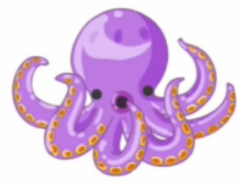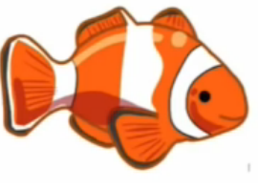

HAS BEEN
EATENBY
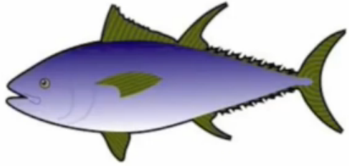

Slippery fish, slippery fish,
Sliding through the water,
Slippery fish, slippery fish,
Gulp, Gulp, Gulp!
Oh, no!
It’s been eaten by an
Octopus, octopus, squiggling in the water,
Octopus, octopus, Gulp, Gulp, Gulp!
Oh, no!
It’s been eaten by a
Tuna fish, tuna fish, flashing in the water,
Tuna fish, tuna fish, Gulp, Gulp, Gulp!
Oh, no!
It’s been eaten by a
Great white shark, great white shark, lurking in the water,
Great white shark, great white shark, Gulp, Gulp, Gulp!
Oh, no!
It’s been eaten by a
Humongous whale, humongous whale,
Spouting in the water,
Humongous whale, humongous whale,
Gulp! Gulp! Gulp! BURP!
Pardon me!
Slippery fish
Octopus
Tuna fish
Great white shark
Humongous whale
Sliding Squiggling
Flashing Lurking
Spouting

