Grammar Lesson Plan
TITLE | Past Perfect (I had done)
INSTRUCTOR |  |  |  | Ss’ LEVEL | AGE GROUP | No ofSs | LENGTH
Su Ah Han (Anna) |  |  |  | Upper Intermediate | 16 | 6 | 50min

MATERIALS

● Computer ● worksheets ●pencils, pens ● projector ● powerpoint
AIMS |  | 1. Ss will study regular verbs used in the past tense completing a handout.  2. Ss will change verbs from present tense into past tense using the suffixes “ed” and “d”.  3. Ss will practice how to use past perfect tense on the worksheet.

LANGUAGE SKILLS
Listening |  |  | Practice irregular past foams
Speaking |  |  | Practice irregular past foams and make a sentence with using past perfect verb.
Reading |  |  | Practice given past perfect examples
Writing |  |  | Practice past perfect sentences.
LANGUAGE SYSTEMS
Phonology |  |  | /e/ is a short sound. First pronounce the sound /I/ then open mouth a little more.
Lexis |  |  | Fur, theater..etc
Grammar |  |  | Past perfect tense form  (1) S+ had + V-ed/V3 + O  (2) S + had not (hadn’t) +V-ed/ V3 +O  (3) Had + S + V-ed/ O3 + O?
Discourse |  |  | Problem solving by giving examples
Functions |  |  | 1. greeting 2. Writing

ASSUMPTIONS
- Students have a prior knowledge of verbs used in the past tense.
- Ss are at the beginning of intermediate language proficiency levels.

ANTICIPATED GRAMMATICAL ERRORS AND SOLUTIONS

If some students have some difficulties to clearly, Let other students, who understand, teach them.
- If the students can’t understand the meaning of the word, they can search words by using their smartphone dictionary.

REFERENCES
Grammar in Use Intermediate p.84-85

NOTES

Enter your Plan B, your Cut-off plan and your SOS activity here
Plan B: If the visual aids like projector, computer, video doesn’t work, then drawing on the white board.

Cut-off plan: If problem solving time is short, teacher should cut the time of student’s solving.
SOS activity: consider lesson plan and process activity.

PRETASK TITLE |  |  | Greetings, Motivation, handout
AIMS |  |  |  | MATERIALS
Ss will study regular verbs used in the past tense completing a handout. |  |  |  | computer  projector
TIME | SET UP | STUDENTS |  |  | TEACHER
1 min | Whole Class | Greeting each other. |  |  | Greetings.
1 min | Whole class | Study past perfect situation |  |  | Explain about example situation about Past perfect sentence.

NOTES

TASK PREPARATION TITLE |  |  | Practice
AIMS |  |  |  | MATERIALS
Ss will study regular verbs used in the past tense completing a handout. |  |  |  | Worksheets, pencils, pen, projector
TIME | SET UP | STUDENTS |  | TEACHER
10 min | Whole Class | practice examples of  past perfect sentences |  | Let students read the examples of past perfect sentences in worksheet.

NOTES

TASK REALISATION TITLE |  |  | Elicit, Lecture, Practice
AIMS |  |  |  | MATERIALS
- Ss will change verbs from present tense into past tense using the suffixes “ed” and “d”. |  |  |  | Worksheets, pencils, pens, projector
TIME | SET UP | STUDENTS |  |  | TEACHER
9min | Whole Class | Students learn past perfect by teacher |  |  | The teacher gives Students past perfect lecture.
6min | Group | Students learn and practice an irregular past participles (worksheet, projector) |  |  | The teacher gives Students an irregular past participles worksheet
6min | Group | Test an irregular past participles |  |  | Test students an irregular past participles
2min | Individual | Complete past perfect sentences using the verbs in parentheses. (worksheet) |  |  | Let Students solve the problem using the verbs in parentheses.  (worksheet)
3min | Individual | Complete past perfect sentences as in example. Use the verb in parentheses. |  |  | Let Students solve the problem using the verbs in parentheses.  (worksheet)
3min | Individual | Make past perfect sentences using the words in parentheses. |  |  | Let Students solve the problem using the verbs in parentheses.  (worksheet)

NOTES

(“Past perfect happened earlier than simple past. right?”

“He had gone home”

“-this is the sentence past perfect is used in.”)

POST TASK TITLE |  |  | Realization, Review
AIMS |  |  |  | MATERIALS
Ss will practice how to use past perfect tense on the worksheet. |  |  |  | Worksheets, pencils, pens
TIME | SET UP | STUDENTS |  |  | TEACHER
2min | Whole class | Review the lesson  Find the correct past perfect verbs and write down in the Blank in past perfect sentences. |  |  | Review the lesson
 | Whole class | End of the Lesson. |  |  | See you next class.

NOTES

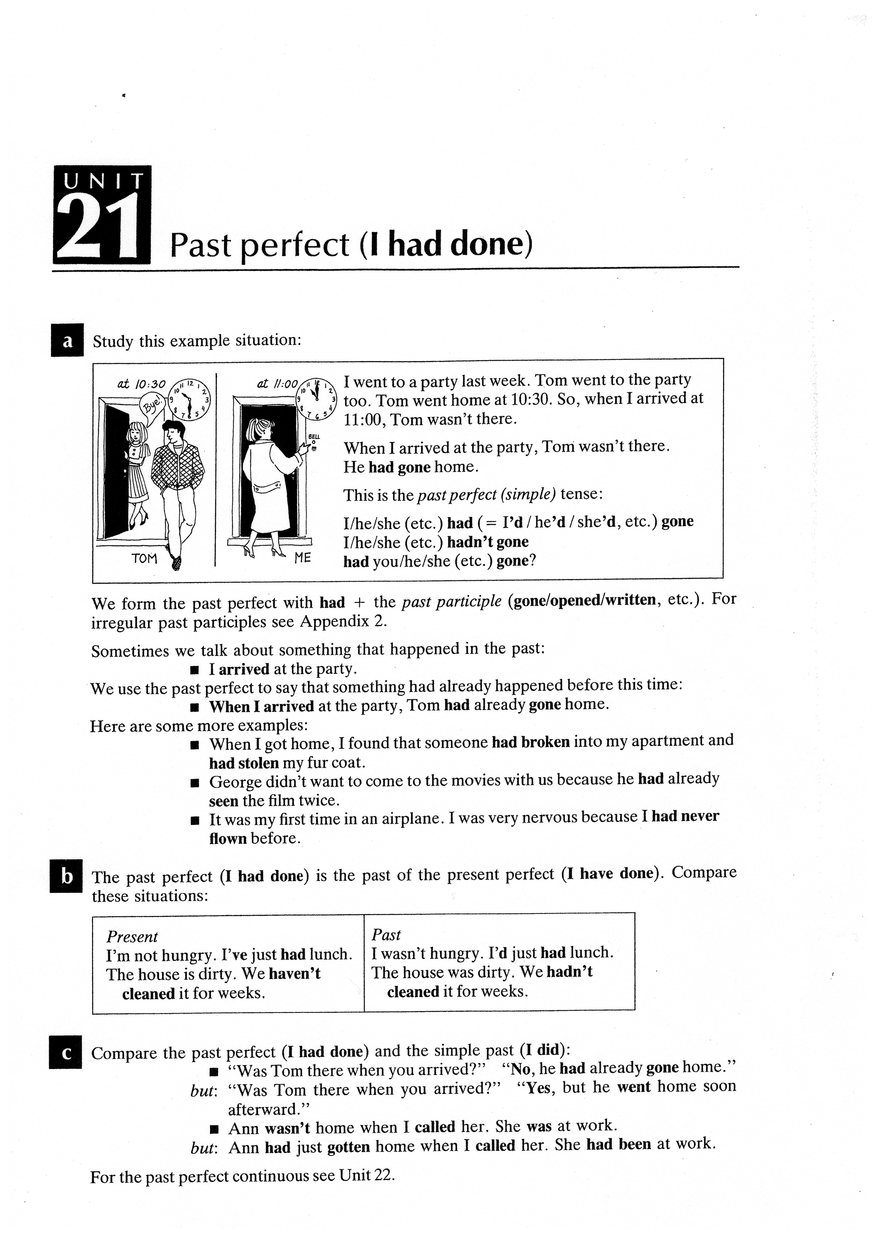
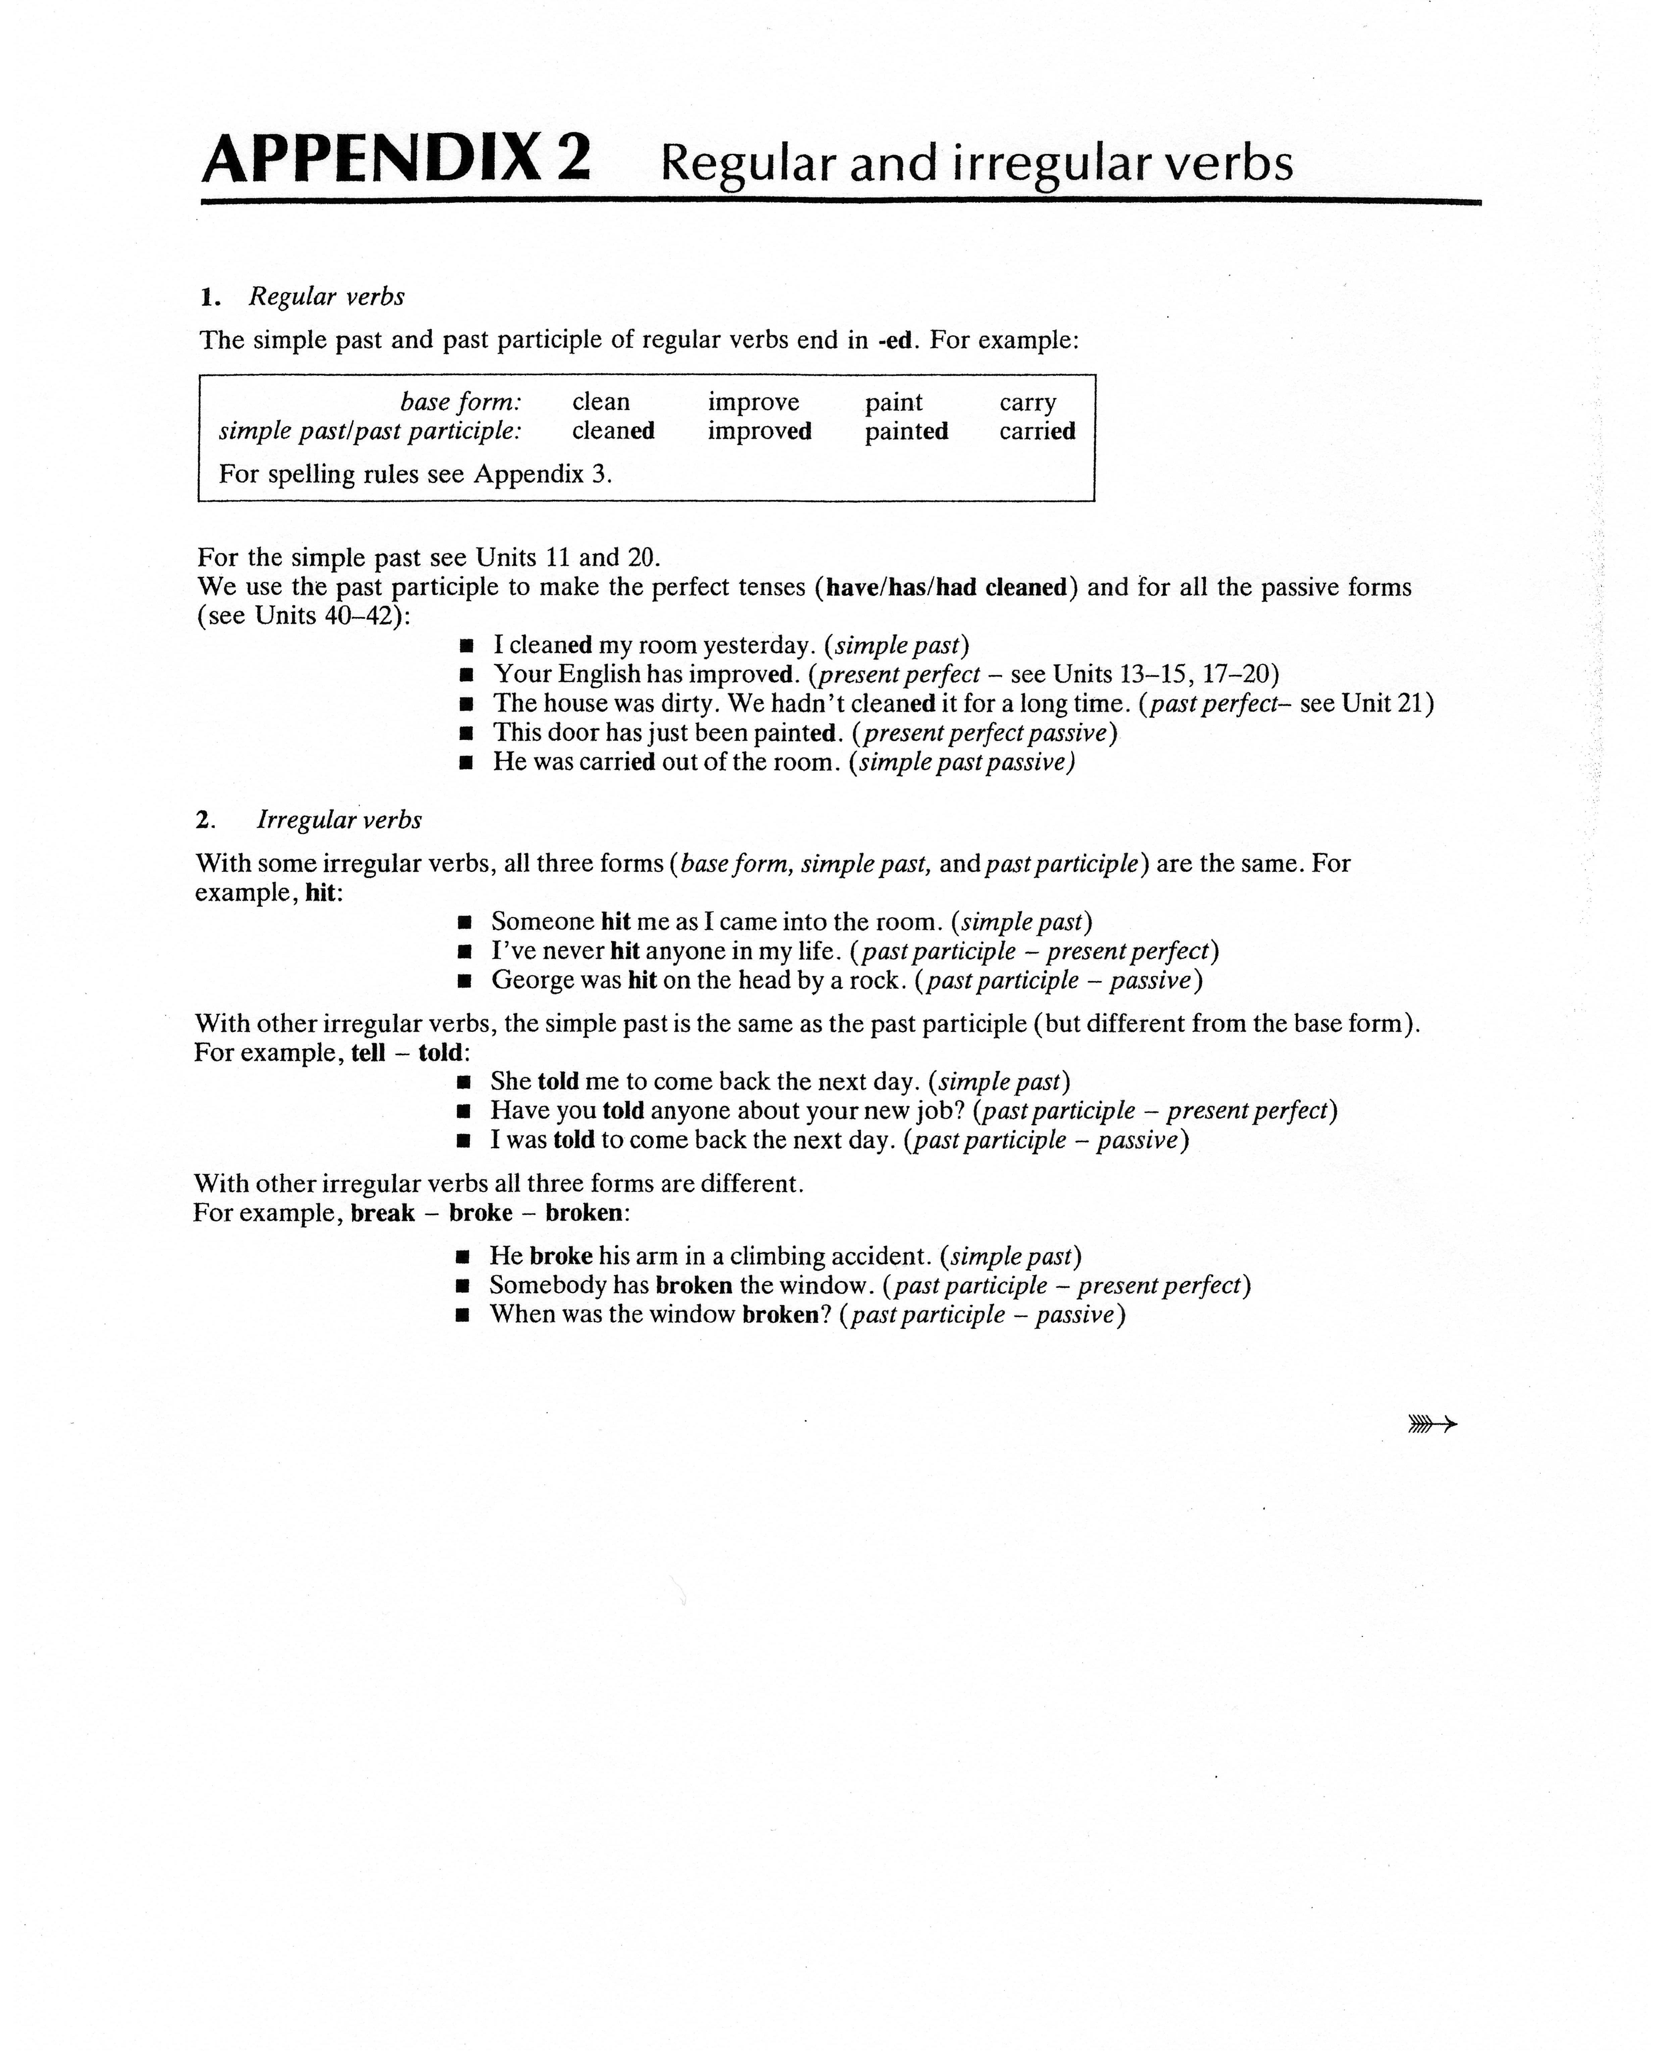

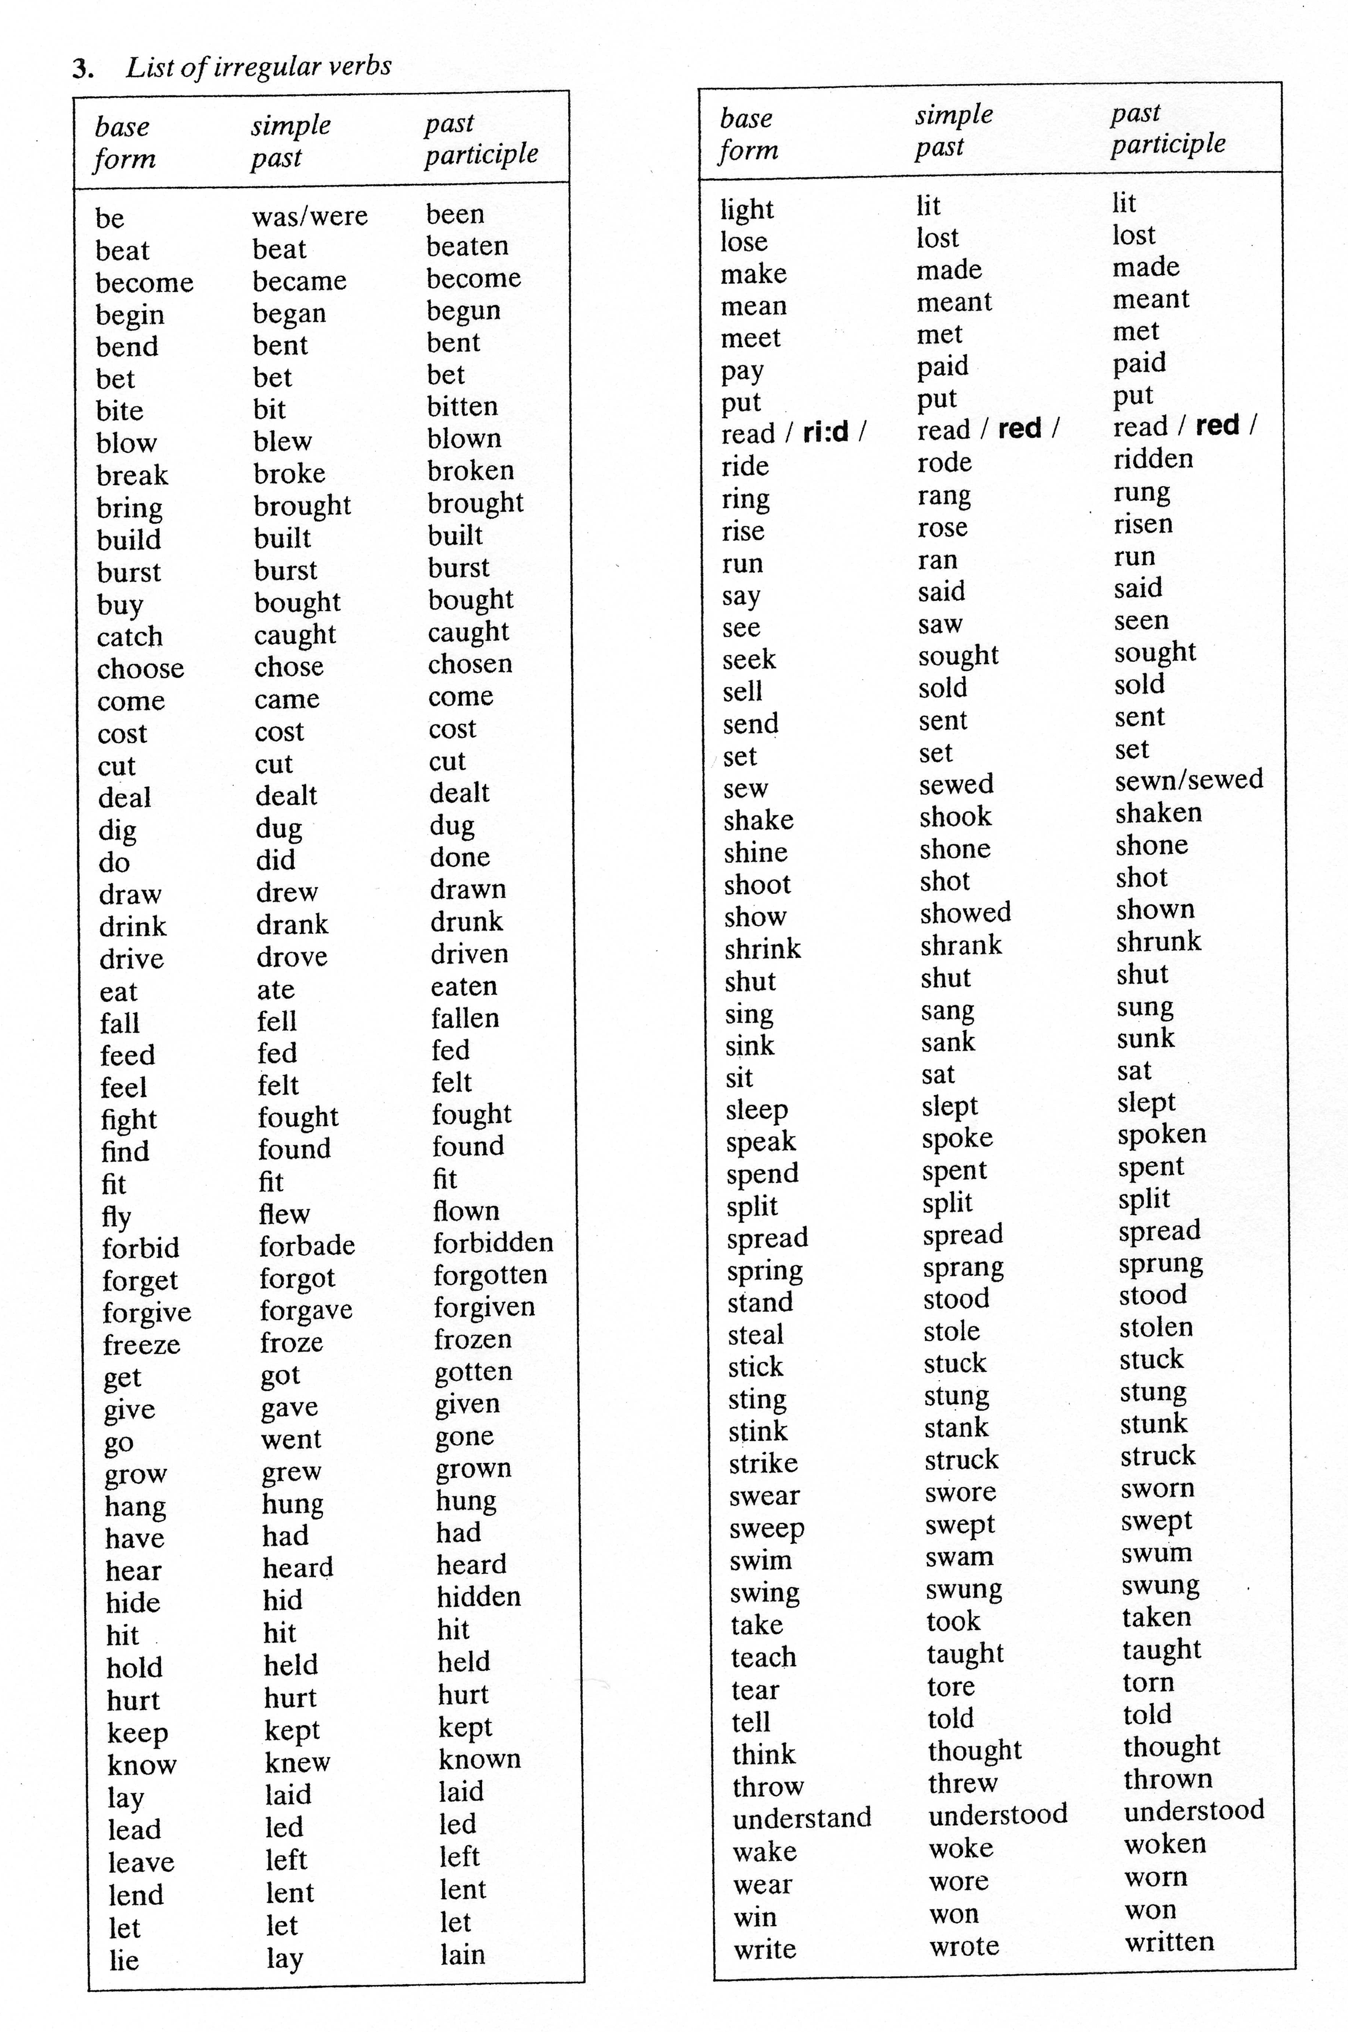

*Using powerpoint , projector

