Grammar Lesson Plan

Where is it? (preposition of place)

Students: 8
Level: Beginner
Instructor:
Amy (Song Ji Min)
Length: 25 minutes

Materials:
- Visual aid – pictures, iPad, video clip - Flash card for CCQ
- Realia –candies, cup - Picture and worksheet for main activity and homework
- White board and Markers

Aims:

- SWBAT guess various usages of prepositions by making sentences.
- SWBAT make correct sentences by using prepositions.
- SWBAT describe examples and images from picture using prepositions of place.

Language Skills:
- Reading: Read vocabularies and sentences.
- Writing: Practice writing sentences using preposition.
- Listening: Listen to teacher’s instructions, Preposition video and song.
- Speaking: Share ideas, Practice speaking through answering questions.

Language Systems:
- Phonology: Pronunciation of preposition.
- Function: Describe prepositions, Finding treasure.
- Lexis: Vocabulary related with proposition.
- Grammar: Use preposition of place in the right situation.
- Discourse: Ask about propositions of place and share ideas.

Assumptions:
Students already know:
-Ss know the teacher’s style of teaching and the pace of the course.
-Ss want to improve grammar for speaking.
-Ss like a activity and they are interested in finding treasure.

Anticipated Errors and Solutions:
-Ss may not understand during teacher’s instructions clearly.
->T will give instructions simple and give some examples.
-If Ss need more time.
->Cut-off activity and give them homework.
-Ss could be confused about where the preposition should be in a sentence.
-> Keep using example sentences on the worksheet.
-Ss may not find treasure.
-> T gives Ss additional clues.

References:
-Pre-preparation activity video : Retrieved Aug.21.2015 from https://www.youtube.com/watch?v=hx8i-Wq_jtc
-Worksheet : Retrieved Aug.20.2015 from http://www.eslpuzzles.com/Worksheets/Prepositions%20of%20Place%20Worksheets/Preposition%20of%20Place%20Worksheets.html

Pre-Task

Materials: Board, Markers, Candy
Time  1 min  2min  1min  2min | Set Up  whole class  Whole  Class  Whole  class  Whole  class | Procedure:  <Greeting>  “Hello class. How are you today?  Did you have lunch?  (Each Ss should have chance to say.)  <Eliciting>  Lead in by playing game about candy hunters game.  T hides some candies in the classroom before Ss come.  As Ss come into the classroom,  explain How to play “ The treasure hunter game”  then let them find the candies.  Ss say “Bingo” when they find a candy and sit their seat.  <Instruction>  The classroom looks like this:  computer  Board  Shelf  Door  T hides three locations.  - The candy is behind the computer.  - The candy is on the shelf.  - The candy is in the cup.  Before we start lesson, Let’s play game.  The game’s name is “The treasure hunter game”.  I hid some candies in the classroom before you came here.  I will give two minutes then let them find the candies.  And say “Bingo” when you find a candy and sit down your seat.  <ICQ>  How much time do you have? (2min)  What are you going to find? (Candy)  Are you ready? Let’s go~!!  Time’s up!!  <Checking >  T asks Ss where they are.  T checks Ss who find the candy.  Let’s see… Who does the candy have?  Where was your candy?  Ss answer T’s questions.  The candy was behind the computer.  The candy was on the shelf.  The candy was in the cup.  Wow! You are lucky!!  T elicits Ss by asking what today’s lesson  Ss guess today’s topic.  Okay! Everyone. It was fun?  Can you guess? What is today’s lesson?  Ss answer “ preposition or preposition of place”  Excellent!! We are going to learn about preposition of place.  T writes the topic on the board.  Then, T explains today’s aims.  Please take a look at today’s aims.  The board looks like this:  Today’s Aims  1) We will describe picture using prepositions of place.  2) We will know how to make correct sentences  by using prepositions.

Pre-Preparation (Presentation part)
Materials: Whiteboard, Markers, pictures, video clip
Time  2min  3min  1min  3min | Set Up  Whole  class  Whole  class  Whole  class  Whole  class | Procedure:  <Instruction & Eliciting>  T explains the meaning of the prepositions  by showing pictures and giving clear examples.  T writes the full sentences below to the pictures.  Ss can understand each vocabulary’s meaning  by showing the pictures.  There are various types of prepositions such as:  time / derection / manner / place.  So, we will learn about prepositions of place.  A prepositions of place is used  with address,street,city,country,location.  We will learn vocabulary related topic.  Please take a look at this. (T points each vocabulary.)  Do you know? What does this mean?  Let’s check these vocabularies. (T explains each vocabulary.)  The board looks like this:  In front of behind  On under  In next to  between  Look at these pictures.  I will give you more examples.  Where is the man? (T points to each picture and ask Ss.)  (Ss answer T’s questions.)  <Checking >  T checks Ss’ comprehension by asking questions.  <CCQ>  Okay! Let’s go over about preposition place.  I will ask you some questions.  Where is your pen? (My pen is………)  Where is your book? (My book is………)  Where is your bag? (My bag is………)  (Ss answer various answers)  Everyone is perfect!!  <Listen & Repeat the preposition>  T shows Ss the video clip related the topic  for three minutes.  Ss check their comprehension by watching video.  Let’s watch video.  I will show you the video for three minutes.  Listen carefully.  It was fun?
Main Activity (Practice to production part)
Materials: Board, Markers, Picture, Paper
Time  2min  ‘  4min  1min | Set Up  Individually  &  Whole class  Whole  class  Whole  class | Procedure:  T posts picture about “In my room” on the board.  T checks Ss’understanding.  T hands out Ss a sheet of paper.  T provides Ss simple picture to illustrate how to use propositions to describe the picture.  Ss make some sentences to describe the picture.  Ss stand at the board and try to write some sentences on the board and describe where they are.  <Instruction>  Please take a look at this picture.  (T points the picture on the board)  The board looks like this:  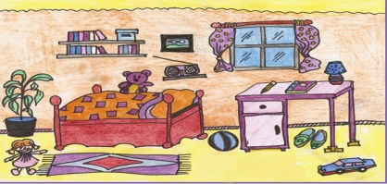  I will give you a sheet of paper.  Make some sentences where they are using propositions like this:  T points over the vocabulary on the board.  I will give you two minutes.  After making some sentences,  I will ask each student then please write the sentences  on the board and describe where they are.  <ICQ>  How much time do you have? (2min)  What are you going to describe?  (where they are or the location of picture)  Okay!! Here we go~!!  <Monitoring>  T walks around the class and give Ss feedback whenever necessary.  Time’s up!  < Describing >  T gives Ss more opportunities to make and describe  some sentences using propositions.  Ss write some sentences on the board.  Ss describe the making sentences to share  with classmates.  Who wants to go first?  Please write one sentences on the board and describe it.  You are very good job!  <Feedback or Correction>  After Ss describe it,  T gives Ss additional sentences about the location of picture.  T writes additional sentences on the board and  explains it.  I will give you additional sentences about it.  For example:  The radio is on the shelf.  The ball is between the desk and the bed.  The shoes are under the desk.  The rug is in front of the bed.  The lame is on the desk.  The book is between the pencil and the lamp.  The lamp is next to the book.  The pencil is next to the book.  The picture is on the wall.  The teddy bear is on the bed.  The books are on the shelves.  The desk is in the bedroom.  The shelves are on the wall.  The doll is next to the rug.  The window is next to the picture..  .  Okay!! Everyone is excellent!!
Post Activity
Materials: Candy, Homework sheet
Time  1min  1min  1min | Set Up  Whole  Class  Whole  Class  Whole  class | Procedure:  <TPR(Total Physical Response) activity & Feedback>  T gives Ss feedback through TPR activity.  T proceeds to the TPR activity with the candy.  Ss follow T’s instructions such as: “Put the candy on your head”.  Ss practice the prepositions by doing command drills.  <Instruction>  I will give you a candy then I will say some instructions.  For example: “Put the candy on your desk”  Please follow my instructions.  Instructions like this:  - Put the candy on your head.  - Put the candy in your hands.  - Put the candy under your book.  - Now, unwrap the candy and put the candy in your mouth. Enjoy!!  <Homework>  T gives homework about today’s lesson.  T hands out homework sheets.  I will give you homework.  Please complete the sentences.  We will check the answers next time.  <Closing & Feedback>  Let’s call it a day!!!  T shows one picture and asks it.  T checks Ss’understanding.  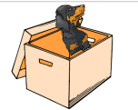  <CCQ>  Is the dog on the box?  Ss answer T’s question correctly. “The dog is in the box.”  Excellent!!!.  I hope you enjoyed this class.  Thanks for today. See you next time. Bye!!
Main activity

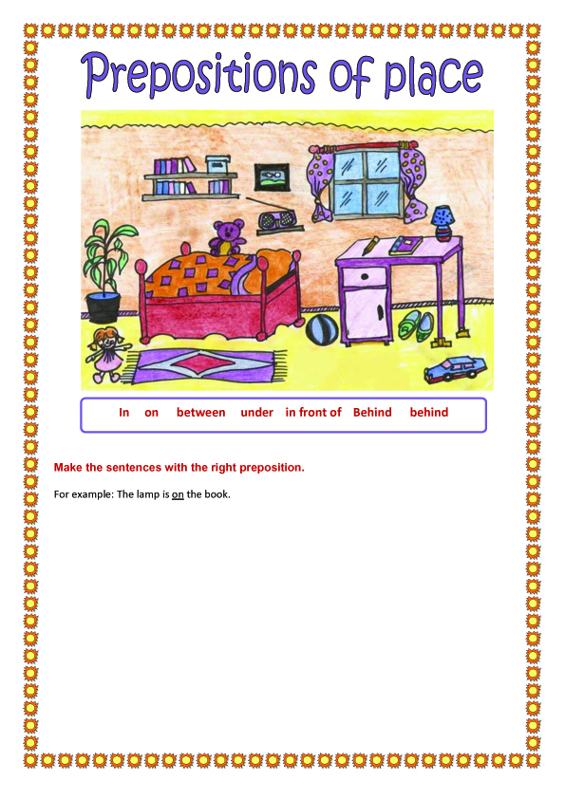
Homework
