Reading Lesson Plan

Do you know about Liberia?

Instructor:  Ashley  (Ye Rim Lee) | Level:  advanced | Students:  9 | Length:  25 minutes

Materials:
- White board, board marker
- Pictures
- Globe
- Reading material
- worksheet
- drawing papers, markers and crayons

Aims:
- Students will be able to identify some culture of Liberia by reading and discussion.
- Students will be able to predict Liberia by pre-reading activity that select True and False.
- Students will able to write the answers and a summary of the text by jigsaw activity.
- Students will able to describe Liberia by jigsaw activity.
- Students will able to express their countries that are people, history and food by interview.

Language Skills:
- Reading: reading the text and worksheet
- Listening: Ts instruction, Ts demonstration, and partner’s idea
- Speaking: discussing pair or group and answering Ts question
- Writing: writing the answer in the worksheet
Language Systems:
- Lexis: Vocabulary in the text
- Function: discussing, guessing, giving and receiving opinions
- Discourse: Observing and answering what it is

Assumptions:
Students already know:
- All students are advanced level.
- The Ts style of teaching and pace of the course.
- Students are able to express slowly their ideas and opinions in English.
- Jigsaw activity.

Anticipated Errors and Solutions:

Error | Solution
If some students have some difficulties to comprehend the word clearly | Let the other students, who understand, teach them.  Allow to find dictionary.
If time is short | Cut the time of sharing the student’s stories.

References:
Carter, Jeanette, and Joyce Mends-Cole. Liberian Women. (1982). Their Role in Food Production and Their Educational and Legal Status.
Bledsoe, Caroline H. (1980). Women and Marriage in Kpelle Society.
McDaniel, Antonio. Swing Low, Sweet Chariot. (1995). The Mortality Cost of Colonizing Liberia in the Nineteenth Century.
Moran, Mary H. Civilized Women. (1990). Gender and Prestige in Southeastern Liberia.
Nunan, David. (2000). Language Teaching Methodology: Pearson Education.
Nunan, David. (2003). Practical English Language Teaching : McGraw Hill.
Pre-task
Materials: Picture, White board and Board markers, computer
Time  2min | Set up  T - S  T – S/ S - T | Procedure:  <Greeting>  Hi, everyone! Welcome to English class.  <Brainstorming>  T (showing the flash game to students)  Have you ever played “travelpod” game?  This flash game is about finding countries in the world.  (showing the globe to students)  If so, let’s find a country through a different way.  Who can find Liberia on this globe?  Today, we are going to learn about country, Liberia.
Task-Preparation
Materials: worksheet1, White board and Board marker, Picture, Globe
Time  2min | Set up  S - S | Procedure:  Task 2_ True and False  T Let’s see how much know about Liberia.  Don’t worry if you are not sure.  You will read what other students wrote about this country later in the lesson.  (Distribute worksheet)  T Please work together and I will give 2 minutes.  .
Task Realization
Materials: White board and Board marker, drawing papers, crayons, markers, worksheet2
17min | S - S | Procedure:  T Please turn to the next page. (worksheet2)  Now, you can learn more about Liberia.  Some of you will learn food, some about people and some the history.  All people already learned about jigsaw activity. Right?  - First, you have to make 3groups. (Divide three groups)  - Each one is given only one section of the reading about Liberia  - (A: People, B: Food, C: History & Geography)  - <read>Each group must work together to find answers and to summary for 4minutes.  - When each group has answered the questions for their section, teacher creates new groups made up of one member from each of the original groups. (ABC, ABC, ABC)  - All new groups come out.  - <share>Students in the new present the information found in their section on People, History or Food by drawing and writing on the paper for 7minutes.  <Demonstration>  I am going to show you, first. (teacher does demonstration)  <ICQ’s>  Is given each group different reading material? (Yes)  A group remains same person. Right? (No)  T Now, go back to the true and false questions to see if your guesses were correct. I will give 4 minutes.
Post-Activity
Materials: White board and Board marker
Time  3min  1min | Set up  S - S  T - S | Procedure:  T Please turn to the next page. (worksheet3)  Now, interview your classmate to learn some things about the history, geography, people, and foods from your countries.  Use the questions you used for the reading activity.  I will give 3 minutes.  Teacher gives feedback/ error correction.  Did you enjoy?  Before we finish, I will give you question.  <CCQ>  What comes from Liberia’s name?  (liberty)  There you go!  See you later!

Worksheet 1
Are these sentences true or false?
Circle true of false.

True | False | Liberian speaks English.
True | False | Liberia is on the east coast of Africa.
True | False | Many people buy and sell food at the market in the countryside.
True | False | Liberia was named by slaves who returned to France.
True | False | Bread is a staple in the diet of many Liberians.

Worksheet 2
Work with your group to find answers to these questions.

Group A people | What kind of the religion in Liberia?  Why allows a husband to claim custody any wife’s children?  Why does some unhappy family exist?
Group B history  & geography | Where is Liberia?  How was it named?  What is the capitol?  What is the main language in Liberia?
Group C food | What do people eat for lunch and dinner?  What foods grow in Liberia?  Why result damage to the natural environment?

<summary> 2~3 lines

Worksheet 3

Interview your classmates

 | People | History  &  Geography | Food
Name

Country
Name

Country
Name

Country

History & Geography

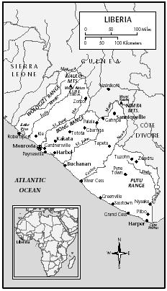
Liberia lies on the west coast of Africa. About half the country is covered by primary tropical rain forest containing valuable hardwoods. A monsoon climate of alternating wet and dry seasons characterizes the weather. The capital, Monrovia, was named for the United States president James Monroe and is situated near the original landing site of the American settlers.
The name comes from the English word "liberty" and refers to the nation's origin as a colony of free blacks repatriated to Africa from the United States in the early nineteenth century. Although the settlers and their descendants, known as Americo-Liberians, defined the boundaries of the nation-state, made English the official language, and dominated the government and economy for almost one hundred fifty years, they have never constituted as much as 5 percent of the population. The remaining people belong to sixteen broadly defined ethnolinguistic groups of the Niger-Congo family.
The official national symbols, such as the official language, reflect the American origin of the nation-state. The flag is a replica of the American flag, but with a single large white star on a blue field representing Liberia's long history as the "Lone Star," the only independent republic in Africa during the colonial period. The Great Seal depicts a sailing ship like that which carried the American settlers to Africa, a palm tree, and a plow and ax with the motto "The Love of Liberty Brought Us Here."
Food

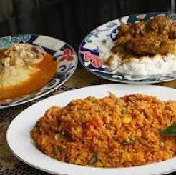
The primary staple is rice. This complex carbohydrate forms the centerpiece of the meal, and savory sauces provide flavor. Meat or fish is used as a garnish or ingredient in the sauce rather than being the focus of the meal. In rural areas, people begin the day with a small meal of leftover rice or boiled cassava dipped in the sauce from the day before. Depending on the time of year and the work schedule, the main meal may be served at midday or in the evening. Snacks of mangoes, bananas, sugarcane, coconut, fried plantain or cassava, and citrus fruits may be consumed throughout the day.
In the countryside, rice is produced by a system of rain-fed swidden (slash and burn) horticulture. Men clear an area of the forest and burn the dried brush, and women and children do most of the planting, weeding, and harvesting. Some areas have been overfarmed, with resulting damage to the tropical forest ecosystem, but the greatest constraint on agriculture is a shortage of labor.
This system is capable of providing for family subsistence but not of producing a large surplus for sale. Urban areas have depended on imported rice, mostly from the United States. Locally produced vegetables, including eggplant, peppers, pumpkins, and greens, are sold in outdoor markets.

People

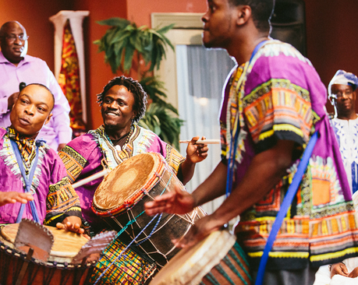
Among the indigenous majority, marriage is ideally polygynous and patrilocal, with the bride moving to her husband's compound to live with his extended family. Probably less than 30 percent of men actually have more than one wife at a time, and those marriages often fail because of conflicts between co-wives. Marriage is a process rather than an event, with bridewealth payments made over many years and solidified by the birth of children. The increasing access of women to cash through the marketing of foodstuffs has resulted in some women freeing themselves from unwanted marriages by paying back the bridewealth. Bridewealth establishes the right of a husband to claim any children born to his wife regardless of their biological father. The great value placed on women as agricultural workers and childbearers ensures that no woman who wants a husband is without one for long. Among the civilized native and Americo-Liberian communities, statutory marriages are limited by the Christian insistence on monogamy.
Pre-coup Liberia often characterized itself as a "Christian nation," but a number of shifting religious identities and practices were and still are available. Active membership in a Christian denomination probably involves less than 20 percent of the population. Twenty to 30 percent of the population is at least nominally Muslim, and the remainder practices indigenous religious systems surrounding ancestor worship and secret society membership.

