TITLE | What is my dog doing?
INSTRUCTOR |  |  |  | Ss’ LEVEL | AGE GROUP | No of Ss | LENGTH
Irene(Yoory Kim) |  |  |  |  | 10-13 | 6 | 40

MATERIALS

Board, marker, computer, projector, sticky memos(post-it),worksheet
AIMS 1. |  | Ss will practice speaking skills by generating and discussing the task
2. |  | Ss will have a chance to express their ideas and feelings to others.
3. |  | Ss will come up with their knowledge of language by describing pictures.

LANGUAGE SKILLS
Listening |  |  | Listen Teacher’s story telling and group members
Speaking |  |  | Discuss as a group and generate language
LANGUAGE SYSTEMS
Lexis |  |  | Action verbs
Grammar |  |  | Present continuous tence
Discourse |  |  | Question and answering, Describe picture by using target verbs

ASSUMPTIONS

Ss know some action verbs and how to make simple sentences.

ANTICIPATED ERRORS AND SOLUTIONS
If projector or doesn’t work
- use smart phone and portable projector

REFERENCES
-worksheet : pinterest
-present continuous video : https://www.youtube.com/watch?v=o4X8PIMs344
-Pictures: google search

NOTES

<Plan B > IF time is remained,
-Making daily life schedule with present continuous tenses
-rush activity – as a team, make verbs into target tense. The fastest team will be the winner

Leed in |  |  | Action verb trees
AIMS- Purpose (Why) |  |  |  | MATERIALS
To be able to recall action verbs |  |  |  | Sticky memos(post it)
TIME | SET UP | Description of Activities
6min |  | ♦ Greeting to the teacher and classmate
 | S-S | ♦ <Action verb tree>  -make Ss into 2 teams by 3 and let Ss choose one who is going to be tree and give Ss papers  - In 2 mins write action verbs and put these on the Ss who is tree.  - The team which has the most action verbs is going to be winner.
2min |  | ♦ Check verbs which Ss come up with

NOTES

If Ss have a difficulty of recall action verbs , Tr can help Ss with eliciting (e.g gesture or motion)

PREPARATION |  |  | Present continuous chart
AIMS- Purpose (Why) |  |  |  | MATERIALS
To have a chance to be familiar with target present continuous tense with chart |  |  |  | Board, maker, smile and angry faces, worksheets
TIME | SET UP | Description of Activities
5min |  | ♦ <Introduce present continuous>  Make a chart with subject and verbs  Smile face check.  -when Ss have right answer – show Ss smiling face, if not, show Ss angry face. |  |  | I You We He/She It They am smiling  are  is

NOTES

If Ss can’t understand pattern of making target form, practice more with smiling face.

Practice |  |  | Answering by target form with worksheets and video
AIMS |  |  |  | MATERIALS
To develop answering grammar form “ present continuous tense” easily |  |  |  | Computer. Projector. worksheet
TIME | SET UP | Description of Activities
5min |  | ♦ Have a chance to be familiar with target verb with worksheet  ♦ after few minutes, Let Ss answer and check  <Question>  - What is he/she/it doing? |  |  | ♦ Make Ss fill the blank with discussing as a team
5 min |  | ♦<watch the video>  https://www.youtube.com/watch?v=o4X8PIMs344  When video ask questions, pause video and let Ss answer first, then check the answer.  -question: What is he/she/it doing?  -answers 1. It is playing the keyboard  2. He is playing basketball.  3. It is dancing  4. He is eating. |  |  | ♦ Make Ss relax and feel free.

NOTES

If Ss want to know more vocabulary in video or worksheet, elicit by gesture or synonym.
Plan B-If computer or projector were not working, show them by Smartphone

Production |  |  | Drawing dog game
AIMS |  |  |  | MATERIALS
To come up with their knowledge about present contiuous form |  |  |  | Picture cards, dice, board, marker
TIME | SET UP | Description of Activities
14min |  | ♦<Instruction and ICQ>  Draw a simple dog on the board and write the numbers  (1 by the head, 2 by eyes, 3 by ears, 4 by body, 5 by legs, 6 by tail)  There are pictures which dogs are doing something.  As a team Ss will describe pictures with present continuous form and roll the dice.  Ss can draw body part of dog according to numbers but Ss should draw head and body first.  The team which draw the dog first will be the winner. |  |  | ♦ introduce the rules of activity  ♦ demonstrate activity
3 min |  | ♦ let Ss play activity.  <feedback and reward>  - Check how to describe pictures with target tense.  ♦ greet to Tr and finish class |  |  | ♦ check and feedback their output and encourage SS

NOTES

Plan B - IF time is remained,
-rush activity – as a team, make verbs into target tense. The fastest team will be the winner

Worksheets, handouts and lesson materials
Worksheet
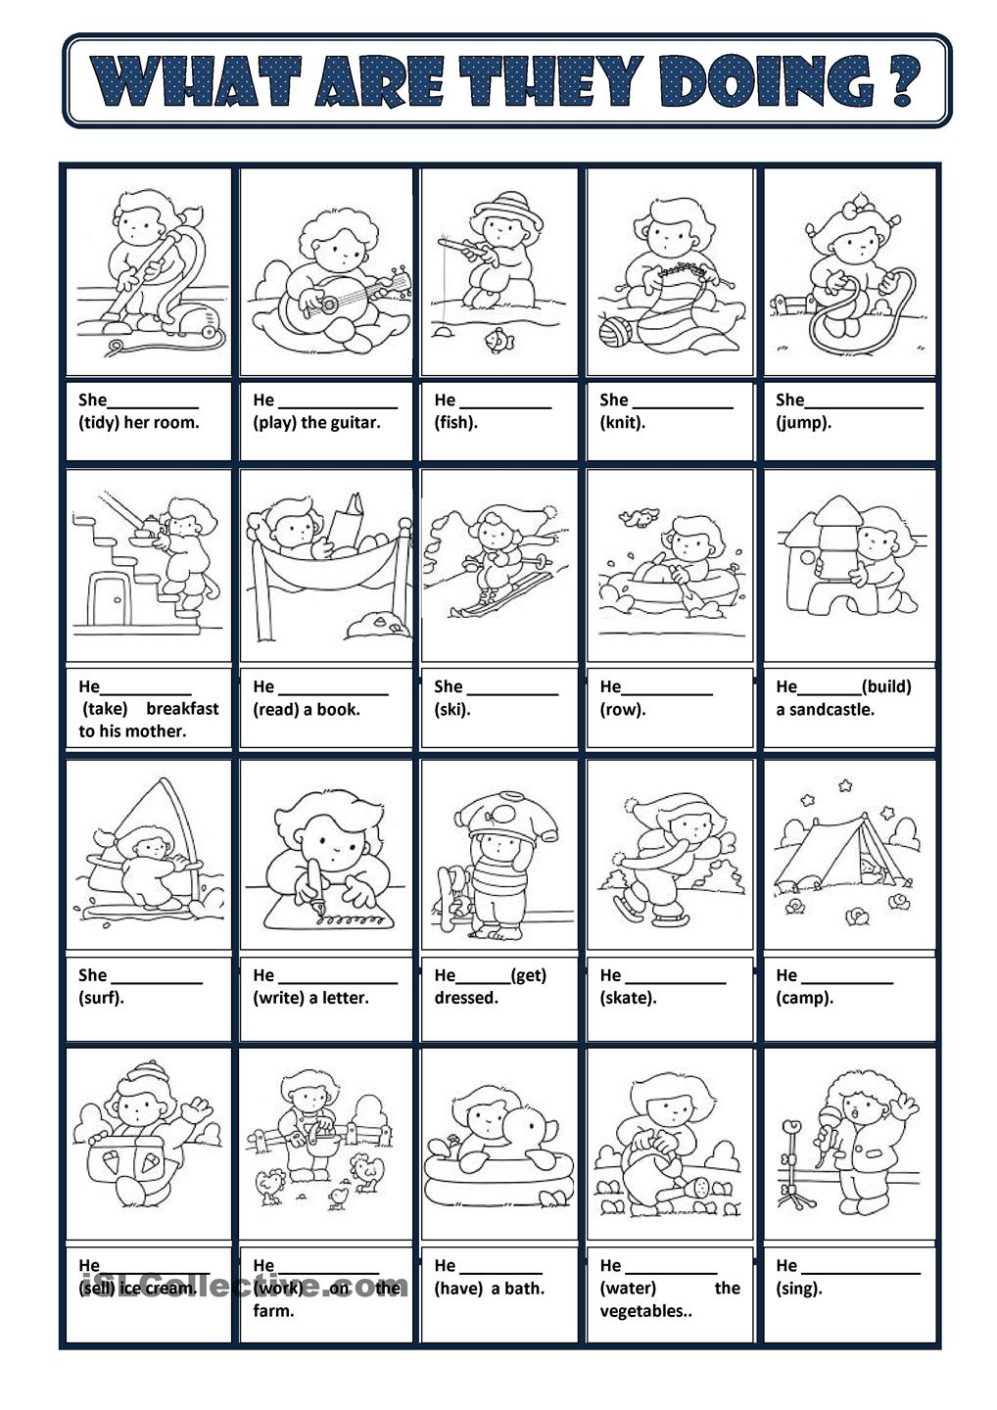
Drawing dog game’ s pictures
- It is cleaning. | - It is cooking
- It is washing his hair. | - It is sleeping.
- It is giving water to plants | - It is reading a book.
- It is driving a car. | - It is playing the guitar.
- It is listening to music | - It is running.
- It is riding a bike | - It is working
- It is drawing | - They are eating

Rush activity
Team A | verbs | Team B
playing(e.g) | play | playing(e.g)
 | make
 | cook
 | clean
 | fix
 | read
 | run
 | ride
 | eat
 | sleep
 | study
 | shop
 | drive

