Lesson Plan 122 TC Claire Hyunah CHOI

Title: Earth day

Instructor:  Claire CHOI | Level:  8 yrs+  Intermediate | Students:  Not more than 10 | Length:  45 min.

Materials:
Slides (Appendix 1)
Flash cards of Recyclable items (Paper/Empty Cans and glass bottles and Plastics) (Appendix 2)
Boxes that materials could fit into (Label the each box)
Color pens and pencils, Glues, Scissors
Activity sheets (Word scramble and Word search (Back up activity) (Appendix 4&5)

Aims:
Ss will brainstorm how to help Earth.
Ss will learn what 3R(Reduce/Reuse/Recycle) means and learn more about recycling. the different types of garbage by listening to teacher's explanation and by participation of the activities.
Ss will be able to say how to help Earth and how they do recycling.

Language Skills:
Writing: Writing down from brainstorming (Activity1)
Reading: Activity 4 (Word Scramble)
Speaking: Repetition of teacher's examples as well as through the activity
Listening: to teacher's examples

Language Systems:
-Lexis: Paper, Can, Glass, Plastic and Compost
- Grammar: I can help the Earth by _________. (Activity 1)
oo collects xx. xx is made of **.
oo puts xx into the recycling bin. (Activity 3)
- Discourse: Reading and filling the blanks of the activity sheets

Assumptions:
The Class is going to be held on April 22.
Students learned how to say and lead to different directions yesterday.
Ss understand basic materials of garbage.

Possible Problems:
Ss might be wondering about things that cannot be recycled.
Ss might want more information about how recycling works.
Solutions: Ask students to focus what we have today and let them know we will come back to their questions at later classes.

References:
Activities:
http://www.thekidzpage.com/celebrationsforkids/earthday/activities/recycle-the-letters-word-scramble.html
http://www.pureplanetrecycling.co.uk/wp-content/uploads/2015/01/Recycling-Wordsearch.pdf
Pictures:
http://mandys-tips-4-teachers.blogspot.kr/2015/04/earth-day-fun.html
http://teacherbitsandbobs.blogspot.kr/2012/04/earth-week-fun-and-another-earth-day.html
http://www.deviantart.com/art/HAPPY-EARTH-DAY-2013-367155346
http://upandforward.recycleforgreatermanchester.com/rubbish-selfie-gallery/abbie-reed-rubbish-selfie-3/
http://www.slu.edu/facilities-services-home/sustainability/campus-operations/recycling-and-waste-reduction/recyclemania/recyclemania-2014-recap
http://blogs.oregonstate.edu/currents/2014/06/23/mixed-compostables-grows-goes/

Time | Interaction | Details | Purpose
3 min. | T-S | - Greeting  Hello everyone. How is everyone doing today? Do you know what day is today? Have Ss guess.  -Introduce 'Earth day' (April 22)  -Ask Ss what 'Earth day' is about.  -Explain | Lead in  Introduce the topic
10 min. | S-S | - Warm-up activity 1: I can help the Earth by ____.  Ask students to brainstorm. (2-3 min)  Ask them "How can you help Earth?"  Form a group of 3 students.  Ask all teams to decide their team name.  Make them to write down their ideas.  Teacher write "We ♥ Earth" on the board then ask each team to take turn make branches of their ideas.  The team survives till the rest teams are out of ideas wins. | Warm up &  Familiarization of today's topic  Recycling: I can help the Earth by ____.
5 min. | T-S | Introduce Today's topic  T introduces 3R (Slides)  Reduce/Reuse/Recycle  Discuss what 'recycle' and 'recyclable' mean.(Make examples of recycling of different types of garbage.)  Explain compost.  (If necessary-hidden slide) | Familiarization of today's topic
5 min. | S-S | Activity 3: Let's make recycle bins for our class  Ask students to work in teams (3 people)  Each team makes two recycle bins with the materials T prepared. (Appendix 2.)  Team 1: Paper, Plastic  Team 2: Can, Glass | Familiarization of today's topic  Arts and Crafts
15 min. | S-S | Activity 2: Blindfold  Teacher gathers all the garbage (flash cards) in a box.  Ask Ss to work in pair.  Ask Ss to create the team names.  T shows how the game works. (Have one volunteer)  One S covers her sight with blindfold.  She picks one garbage (flash card) from the box.  T asks 4 Ss to hold one bin each and to place themselves in different places in the classroom.  Another student in the group guides the blindfolded student to the right recycling bin (box) by calling out instructions.  When the group puts the garbage into the right bin, blindfolded student will have to say "I collected xxx and put it (xxx) into ooo(types) recycling bin. The other student could also try to say my friend (name) collected xxx and I helped him/her put it into ooo recycling bin.  T times each group.  The group that spent the shortest time wins.  Make sure everyone participate. | Practice
5 min. | S  T-S | Final Activity: Word Scramble  Ask Ss to work in pairs to take a guess on the words (hints on the bottom of the paper) | Production  Review
2 min. | T-S | Closing  Homework (Taking picture of Ss recycling)  Make Earth day everyday! | Closing

Appendices
Appendix 1. Slides
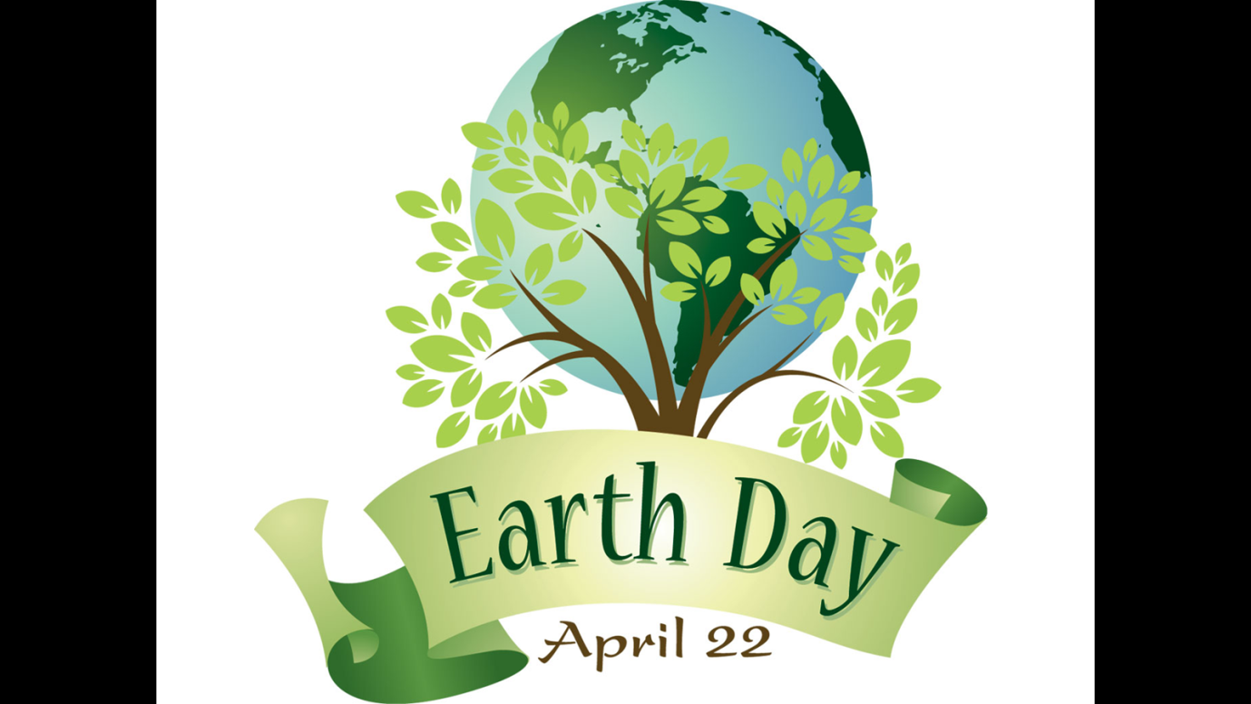
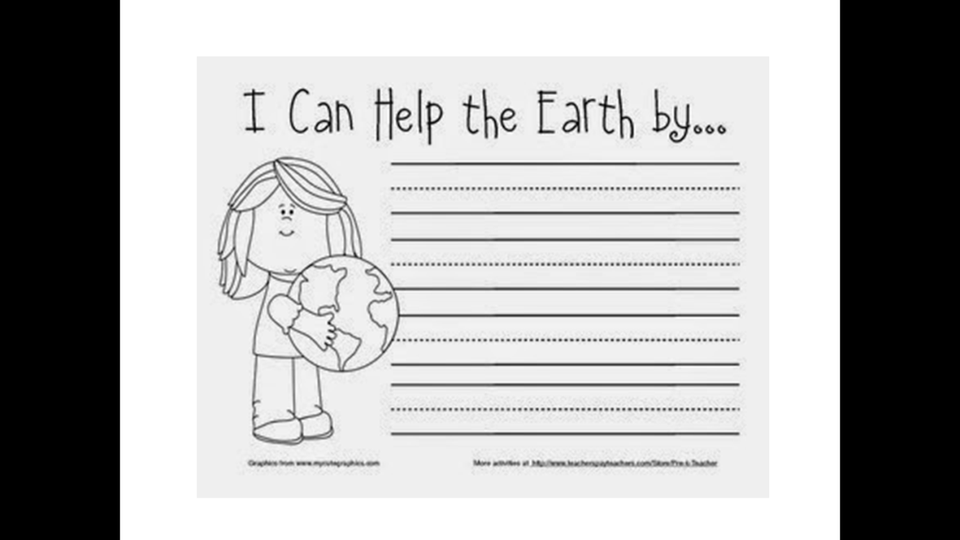
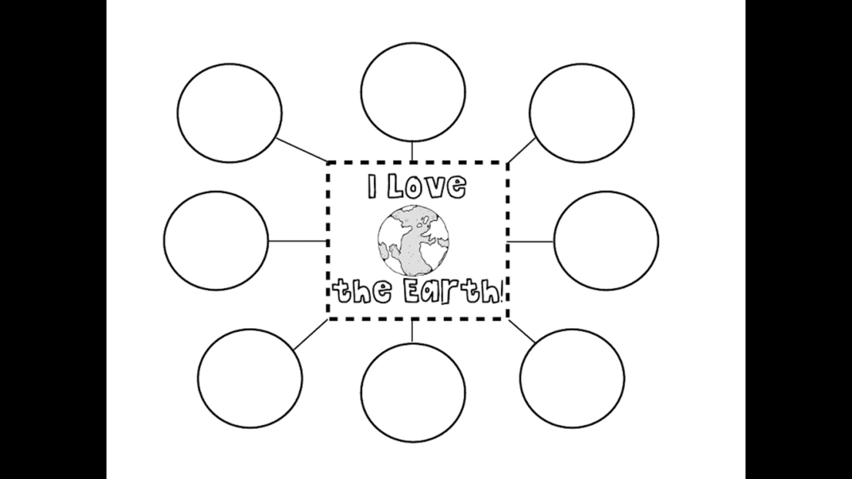
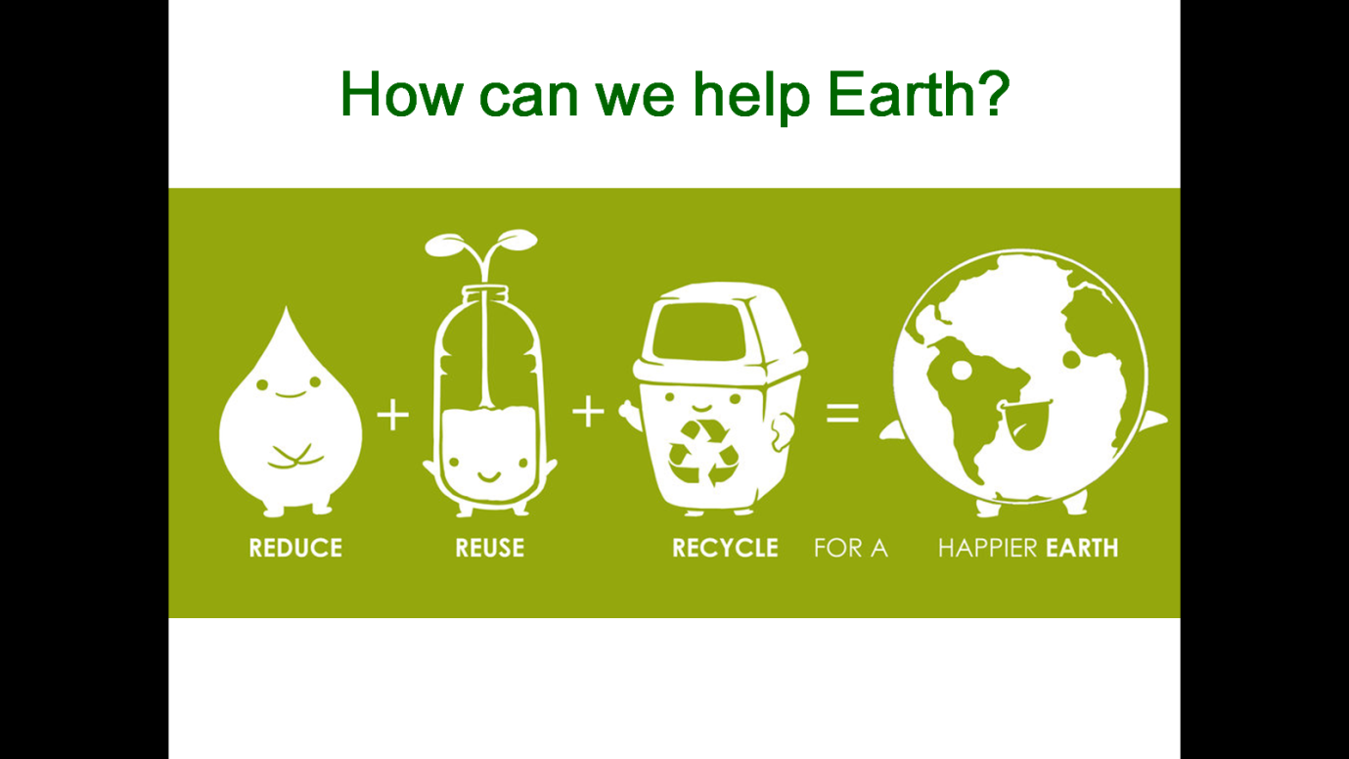
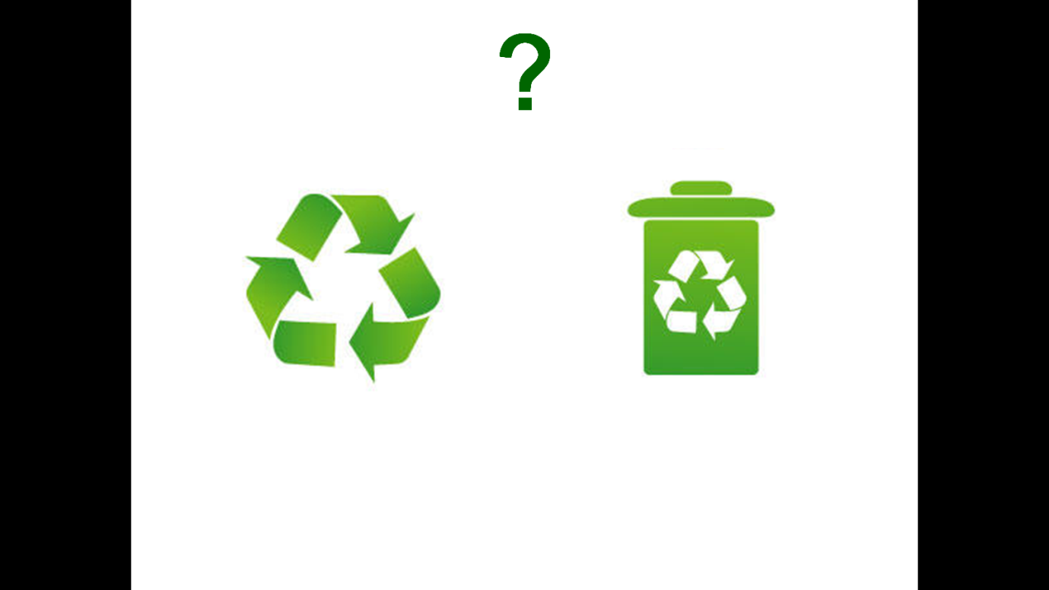
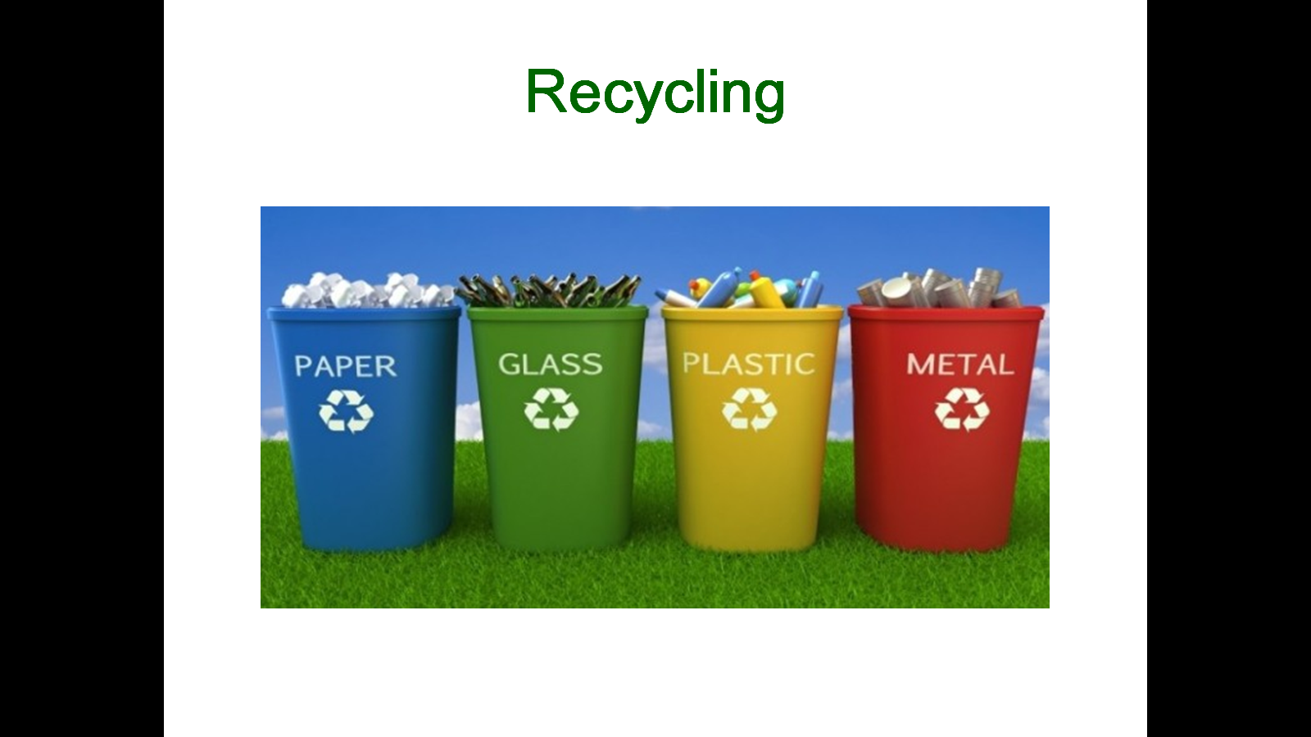
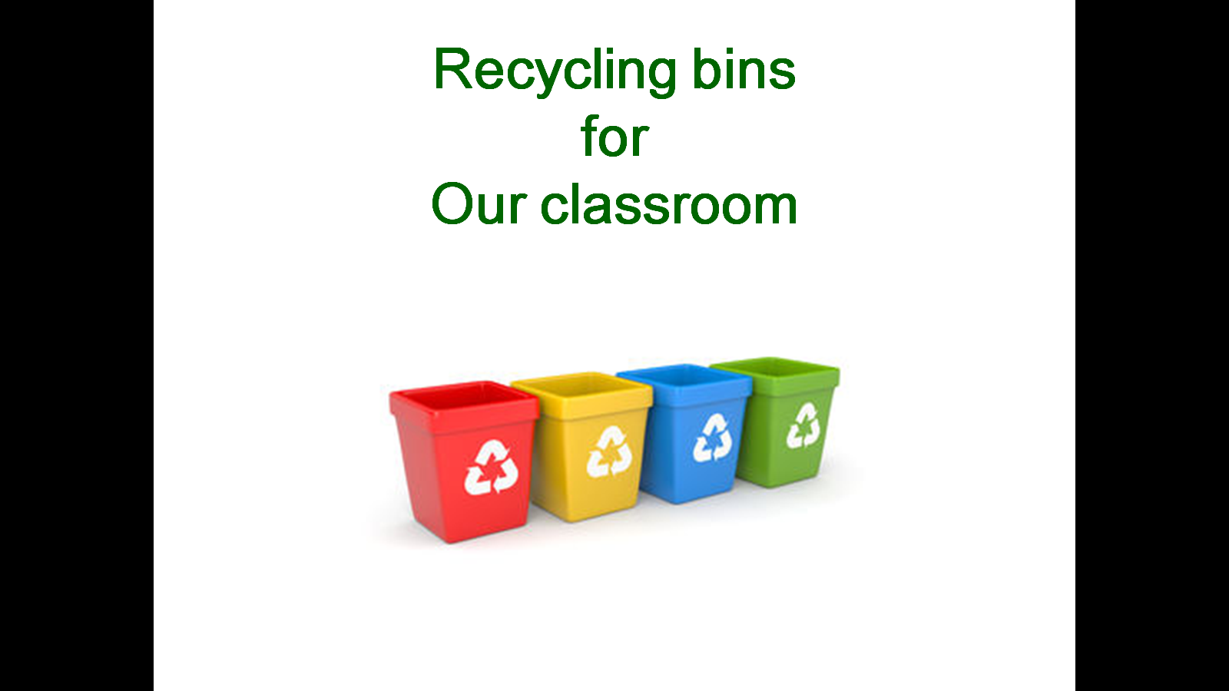
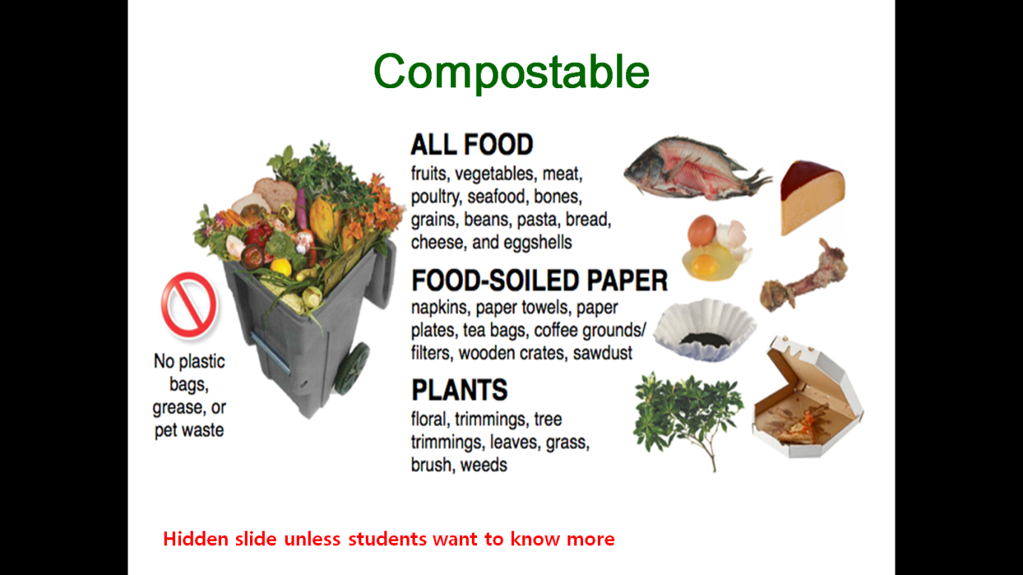
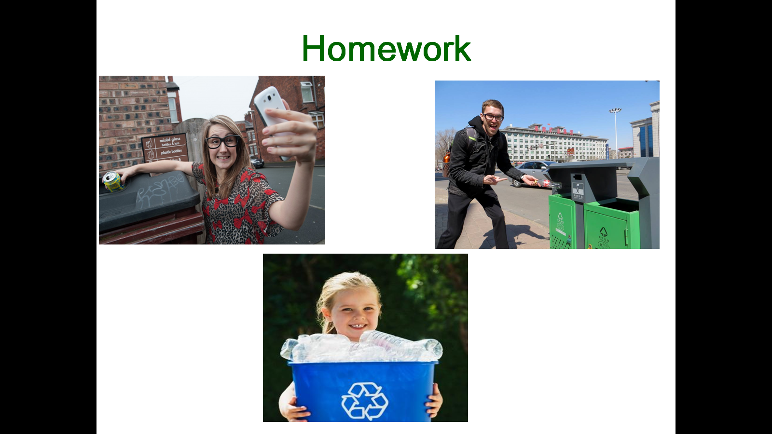

Appendix 2. Flash Cards

Appendix 3. Making recycling bins

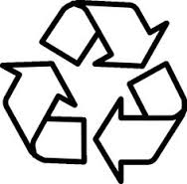

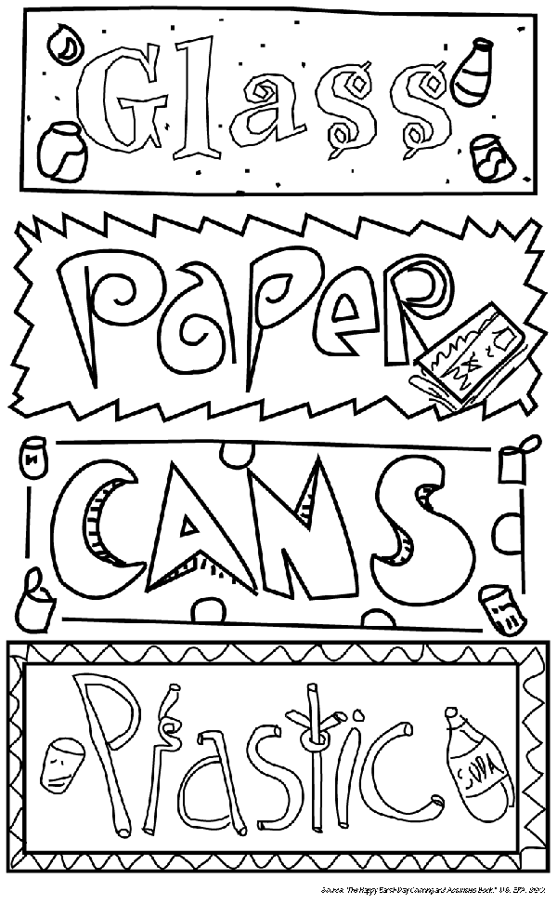

Appendix 4. Word Scramble
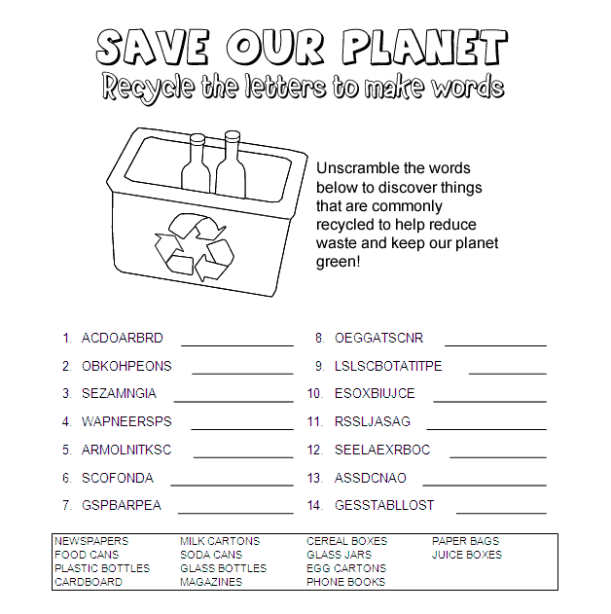

Appendix 5. Word Search (Back up)

