Topic: Describe A Picture
Instructor: | Level: | Age: | Number of Students: | Length:
Jinyong Kim | Intermediate | adults | 12 | 50 minutes
Materials:
- Pictures with expressions
- Expression worksheet(12 copies)
- Listening mp3 file & computer with speaker(Tracks 1,2; about 1.5 min each)
- Listening worksheet with pictures of new vocabulary words(12 copies)
- Blown-up picture of the script
- Paper, colored pens & pencils
- White board, board markers & tape
- Students’ smartphone with pictures in it
Aims:
- SWBAT describe a picture by using the expression that they are taught
- SWBAT practice and use expressions for describing a picture by completing an expression worksheet (e.g., “In the background of the picture~”)
- SWBAT understand present progressive and use this grammar point appropriately through filling out worksheet and using it at the production activity
- SWBAT practice listening to speeches of people with different accents
- SWBAT pick up details from the fast-paced speech by filling out worksheet
Language Skills:
- Reading: expression worksheet
- Listening: speakers’ short speeches about a picture
- Speaking: sharing ideas and discussing within groups
- Writing: writing down details from the listening
Language Systems:
- Lexis: expressions used in describing a picture, new vocabulary words in pictures
- Grammar: present progressive
- Function: describing a picture or a scene
- Phonology: correct pronunciation of vocabulary words
- Discourse: sharing ideas and discussing with group members to draw a picture correctly
Assumptions:
- Students already know:
- the teacher’s style of teaching and the pace of the course
- how the class is set up and run(there will be 4 student groups at each table)
- Students already have learned present progressive
- Some students are familiar with describing a picture through English language tests such as TOEIC speaking test
- Some students are not accustomed to drawing
Anticipated Errors and Solutions:
- Students may have difficulty picking up details from the listening
- Chunk the listening(pause-play-pause-play)
- Let them listen to the tracks again during a drawing activity
- Some students may be not familiar with using the present progressive
- Correct them during practice activity or use the board at production discussion if necessary
- Some groups may struggle to draw a picture
- Guide them during activity
- Some students may not have their smartphone with them or may not have pictures in their phone
- Let them imagine the most memorable moment of scene and describe it
- If time is short,
- Cut the production discussion short and only ask 2~3 students to share their stories
- If students finish their tasks earlier than anticipated,
- Ask as many students as possible about their memorable moments
References:
- Describing a picture. (n.d). In ToLearnEnglish.com. Retrieved November 16, 2015, from
http://www.tolearnenglish.com/exercises/exercise-english-2/exercise-english-91082.php
- Describing pictures in English. (n.d). In english-hilfen.de. Retrieved November 16, 2015 from
http://www.englisch-hilfen.de/en/words/describing_pictures.htm
Notes:

Presentation:
Aims:  -SWBAT practice and use expressions for describing a picture by completing an expression worksheet (e.g., “In the background of the picture~”) |  |  |  | Materials:  White board, board markers & tape,  Pictures with expressions
Time | Set Up | Student | Teacher
2 min  5 min | Whole Class  Whole  Class | Answer the questions  Responds to eliciting  Listen to the instructions carefully  Listen and actively respond to what the teacher is talking about  Answer the CCQs | Before begin the class, write title, aims and attach pictures of vocabulary on the board  Ⅰ. Lead-In  Hello, everyone, how was your yesterday?  Do you like taking a picture? How about being taken a picture? I have lots of pictures and sometimes look through them and share memories with my acquaintances.  (Elicit their experience)  OK, so today, we will listen to two speeches which describe the same picture in slightly different ways. And based on what you hear from the listening, we are going to draw that picture together in groups.  Ⅱ. Expression Practice  Instruction/demonstration  Before doing some activities, we are going to learn some expressions used in describing a picture.  First of all, when we begin to describe a picture, we need to explain a picture roughly like “This is a picture of~” or “This is a picture taken by/in~”  (Show the first picture to students)  I will use this expression on this picture. “This is a picture of three people standing.” Or, I can “this is a picture taken outdoors at a tourist site.”  And there are also some expressions when you want to say what is where. Do you see the guy with a hood? Where is he located in the picture? He is located on the left side of the picture. And for this woman, we can say “she is in the middle of the picture.” Or, “In the middle of the picture, there is a woman with a hat.” Be cautious about preposition.  In the same way, there are several other expressions that you can use.  (Show the other two pictures to students and attach them on the board)  CCQ  -Can you tell me where this clock tower is located in the picture?  -What about this white building?  (As pointing the building in the picture)  -Where is this statue positioned in this picture?
Notes:
Practice:
Aims:  -SWBAT practice and use expressions for describing a picture by completing an expression worksheet (e.g., “In the background of the picture~”)  -SWBAT understand present progressive and use this grammar point appropriately through the activities  -SWBAT practice listening to speeches of people with different accents  -SWBAT pick up details from the fast-paced speech by filling out worksheet |  |  |  | Materials:  Expression worksheet(12 copies)  Listening mp3 file & computer with speaker(Tracks 1,2; about 1.5 min each),  Listening worksheet with pictures of new vocabulary words (12 copies),  Paper, colored pens & pencils,  Blown-up picture of the script  White board, board markers & tape
Time | Set Up | Student | Teacher
7 min  6 min  10 min  5 min | Whole Class  pairs  Whole Class  Individually  Whole Class  Groups  Whole Class | Listen to the instructions carefully  Watch what the teacher is doing  Answer the ICQs  Fill out the worksheet  Listen to the instructions carefully  Remember the guiding questions to answer them after the listening activity  Answer the ICQs and Listen to the 2 speeches and take notes for details individually  Answer the question  Listen to the instructions carefully  Answer the ICQs and draw the picture based on what they hear with group members  Compare the answer picture to their drawings  Give some opinions about the activity and describe the picture by turns using a full sentence  Answer the CCQs | Ⅰ. Expression Worksheet  Instruction  Work in pairs. Read the sentences on the worksheet and put the correct word in the blanks based on what you learned. You can refer to the pictures on the board. You have 3 minutes.  (Hand out the worksheet)  Demonstration  Look at #1 on the worksheet. There are several words next to the blank. Pick the correct word and fill out the blanks from #1 to #5.  ICQ  -Who are you working with?  -How much time do you have?  Let’s get started.  Monitor discreetly. Answer students if they ask questions.  Give time warning: 30 seconds left.  Check answers: let students say the answers  Ⅱ. Listening for details  Instruction  Now, we will listen to the 2 speeches that describe the same picture in slightly different ways. You need to take note details of the picture on the worksheet. Keep in mind that you need to draw a picture based on what you hear. Think about answers of these questions during listening.  Guiding Questions  (Write down on the board)  -How many people are in the picture?  -What kind of furniture is in this place?  ICQ  -What are you supposed to do during listening?  -What activity will you do after this listening?  (Play tracks without stopping)  Do you want to listen again?  - Yes – Have them listen one more time.  - No – Move on the next activity  Answer the guiding questions together.  Ⅲ. Drawing Activity  Instruction  Do you guys have enough information to draw? Now let’s draw the picture together in groups  Like I said before, use the details that you got from listening. You need to share your information with your group members to get a higher quality picture.  Look at your listening worksheet. As you can see, there are two words and their pictures on your worksheet. You can refer to these pictures when you draw a picture. And you can also use these colored pens and pencils if you like.  (Distribute new paper and colored pens and pencils)  When you are done with drawing, send a person up front and attach your drawing on the board with a sticky tape.  I will give you 10 minutes.  ICQ  -Are you working alone?  -How much time do you have?  -What are you supposed to do when you finish drawing?  Monitor discreetly. Answer students if they ask questions.  Give time warning: 2 minutes left.  Ⅳ. Feedback for the Activity  (Put the blown-up picture of the script on the board)  Now compare the answer with your drawings.  (Compliment students)  Share the results together and let them describe the picture. Ask as many students as possible.  Make sure they need to use the present progressive when they describe the people in the picture.  Go through the all features in the picture.  CCQ  -Can you use the simple present when you describe the people in the picture?  -What is the present progressive?
Notes:
Production:
Aims:  -SWBAT understand present progressive and use this grammar point appropriately through the activities  -SWBAT practice speaking by discussing within groups |  |  |  | Materials:  White board, board markers,  Students’ smartphone with pictures in it
Time | Set Up | Student | Teacher
7 min  3 min | Whole class  Pairs  Whole Class | Listen to the instructions carefully  Answer the ICQs and describe their partner’s picture using the expressions that they learned and also share that memorable moment together  Share their moments with the whole class | Ⅰ. Describe your Memorable Moments  Instruction  Work in pairs.  Now, based on what you learned, you will describe your partner’s picture in their smartphone. Show the most memorable picture to your partner and let him/her describe it.  (Write down the written instruction on the board)  Where was the picture taken? What are they doing? What do you see in the picture?  When you finish describing pictures, talk about valuable moments together. You have 7 minutes.  ICQ  -Are you working in groups?  -For how long?  Monitor actively and participate within pairs. Answer students if they ask questions.  Give time warning: 30 seconds left.  Share student’s memorable moments.  Take 2~3 volunteers if running out of time
Notes:
Post Production:
Aims:  -SWBAT describe a picture through the lesson |  |  |  | Materials:  White board, board markers
Time | Set Up | Student | Teacher
5 min | Whole Class | Answer the CCQs | Ⅰ. Conclude Lesson  What did you learn today?  (Elicit today’s expressions for students)  CCQ  -What are the expressions you learned today?  -What I am doing now? Can you describe me?  (And lean against the wall with a wallet in my hands)  Good job today. See you guys tomorrow! Have a nice afternoon!
Notes:

Listening Script
A: This is a picture of three office workers in the copy room.
One woman is standing next to the copier on the left side of the picture. It seems like she has just finished copying some papers. She seems to be talking to the woman with glasses on the right side of the picture. / This woman is leaning against the sink and holding a mug in her hands. She is smiling back at the other woman. / Next to her, there is a man standing in the middle of the picture. He is writing something in the folder. / They are surrounded by wooden furniture and I can see a refrigerator and a stove.
So I think this is a small kitchenette in the office where people can enjoy snacks and take a rest as well as make copies.
B: What I can see in this picture is three people gathered together in the copy room.
On the left side of the picture, there is a big copy machine and a woman has just finished making some copies using it. / On the right side of the picture, there is a man and a woman. The man seems to be working on something as he is looking into the file. However, the woman seems to be taking a break and having some coffee. / In this room, there are many things other than the copy machine, such as a refrigerator, a stove and the wooden kitchen cabinets.
Maybe, this is a place to take a break or enjoy a light snack during the working hours.
Picture of the Script
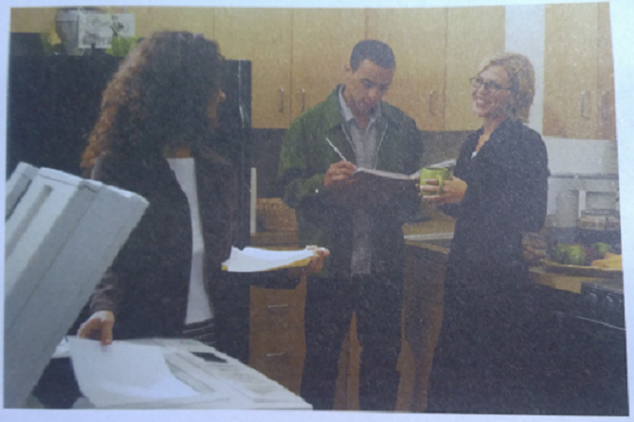Pictures with Expressions
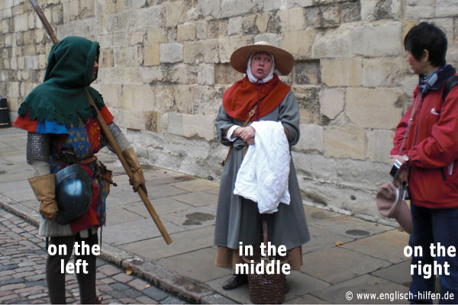
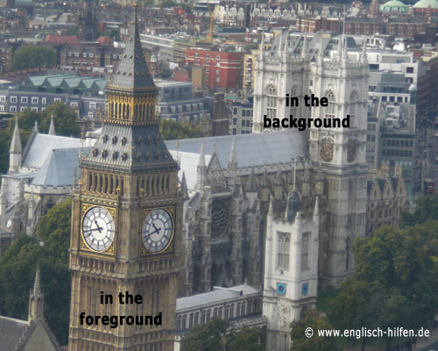
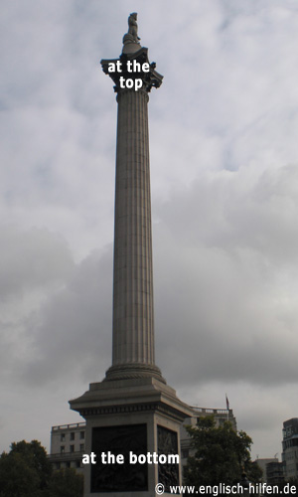
Expression Worksheet
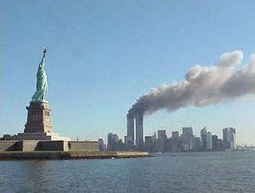

This picture is a photograph. It was taken on Tuesday 11 September 2001, in New York, just after the World Trade Center attacks
The picture is divided into 3 horizontal parts.
1. (In the background/At the top of the picture/In the foreground), you can see water, it's the mouth of the Hudson River.
2. (At the top of the picture/In the middle of the picture/In the foreground of the picture) there is the sky. A blue sky without any clouds.
The scene takes place between these two parts.
3. (In the top left-hand corner/At the bottom/On the left side) of the picture stands, on Liberty Island, the famous statue.
4. (In the middle/On the right/In the bottom right-hand corner)of the picture, the Twin Towers are in flames.
The wind is blowing the smoke towards 5. (the center/the right side/the top right-hand corner)of the picture.
Two hours later, the towers collapsed.
On that day, approximately 3,000 people died.

Listening Worksheet
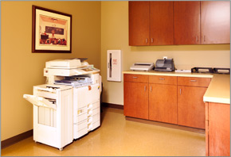
copy room /ˈkäpē ro͞om/
A room in a school or business set aside for the copy machines.

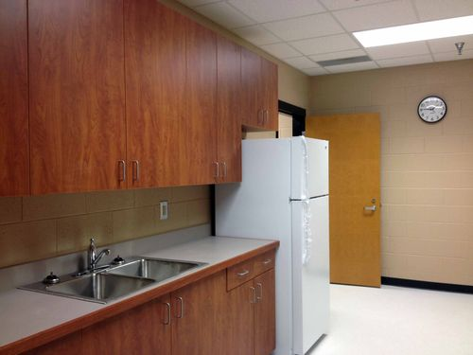
kitch·en·ette /kiCHəˈnet/

a small kitchen or part of a room equipped as a kitchen.

Details of the Picture
On the left side of the picture:

On the right side of the picture:

In the middle of the picture:

In the background of the picture:

