Topic: Expressing Feelings
Instructor: | Level: | Age: | Number of Students: | Length:
Misun & Jisoo | Intermediate | Adults | 12 | 25minutes
Materials:
- Picture for eliciting
- Worksheets for information gap activity and drawing
- Crayons and color pencils
- White board and markers
Aims:
- SWBAT identify proper feeling vocabulary from the context by completing the information gap worksheet.
- SWBAT express a variety of feelings by drawing pictures.
Language Skills:
- Reading: reading vocabulary and worksheet
- Writing: writing feelings on the worksheet
- Speaking: participating in a group activity and sharing ideas with all of the others
- Listening: listening to teacher’s instruction and classmates’ idea
Language Systems:
- Lexis: vocabulary and meanings
- Phonology: listening and speaking to the classmates
- Function: giving and receiving opinions
- Discourse: expressing opinions
- Grammar: using of expressing feelings_ [verb + ed]
Assumptions:
Students already know:
- Ss are possibly familiar with the expressing feelings
- Ss have already known some easy vocabulary for them.
- Ss know how the class is set up and run
Anticipated Errors and Solutions
- If students do not know the movie “Inside Out”
- Just tell them the title of the movie and what the story is about.
- If students finish the worksheet earlier than expectation
- Ask them to make a sentence by using vocabulary.
- If drawing activity may take times longer than expected
- Choose only one group or ask one volunteer to present for the class.
References:
- Learn English Speaking Online (n.d.) In speaking. Retrieved November 23, 2015, from http://www.myenglishpages.com/site_php_files/vocabulary-lesson-feelings.php
- Social emotion skills (n.d.) In do2learn. Retrieved November 23, 2015, from http://do2learn.com/activities/SocialSkills/EmotionAndScenarioCards/ScenarioCards-Level3.pdf
Notes:

Pre-Task:
Aims:  SWBAT guess what they are going to learn by being aware of picture |  |  | Materials:  -Picture for eliciting  -Name cards of the movie characters
Time | Set Up | Student |  | Teacher
3min | Whole class | (Looking at the picture on the board.)  “It is the movie_Inside Out”  “Yes!”  “It was about feelings.”  “Joy, Sadness, Disgust, Fear, and Anger.”  (A student up to the board and put the name cards on the board) |  | < Greeting>  “Good morning! How are you feeling today?”  <Eliciting>  “Look at the picture on the board. “  “What comes to your mind, when you see this picture?”  “Have you ever watched this movie?”  “Do you remember what the story was about?  “Do you know each character’s name?”  “Okay, here I have the cards of each character name, so does anyone who wants to come up here and put the name cards on the right characters? “  “Good! You can find out that their names are all related to feelings.”  “So, today our topic is Expressing Feeling. And we are going to do worksheets, discussion and our main activity is going to be drawing.
Notes:
Task Preparation:
Aims:  SWBAT practice feeling vocabulary by doing worksheet(information gap) in pairs and prepare role play |  |  | Materials:  -Worksheet  -White board and markers
Time | Set Up | Student |  | Teacher
10min | Whole class  Pair work  Whole class | “No, I can’t!”  “We have 3 minutes”.  (Discussing in pairs)  A student reads the sentence.  Student answers.  “Terrified”  “I was terrified when I saw a huge spider.” |  | <Instruction>  “Before we draw, I have worksheets for you to practice some vocabulary about feelings.”  “You can work in pairs and you will get different worksheet from your partner. You will read a scenario for your partner and your partner will think about the feelings of the situation. After that, you will switch the role with your partner and do the same again. Please do not show the answer first to your partner”  (Distribute the worksheet to students)  “Okay. I’ll give you 3 minutes”  <ICQs>  “Can you see your partner’s paper?”  “How much time do you have?”  “Okay, you can start! Off you go!”  (Monitoring)  “Okay, let me have your attention!”  “I think you guys seem to finish your worksheets. Now, let’s talk about one of the situation together.”  “Look at #7. (Student name), can you read the sentence for us?  <Error correction>  “Everyone let’s look at the board now. Can you see the differences?  Which sentence do you think is correct?”  “Yes, Right! Many people make mistakes here. When you express your feelings it must be ‘disappointed’ not ‘disappointing’. When you do your activity, please be careful with that. “  “Can you find another example vocabulary from your worksheet?”  “Can you make a sentence with that?”  “Well done!”
Notes:
Task Realization:
Aims:  SWBAT express their own feelings by drawing pictures. |  |  | Materials:  -6 copies of worksheets #2.  -A vocabulary box  -Crayon and color pencils
Time | Set Up | Student |  | Teacher
10min | Pair work | (Pick up the paper)  “Draw a picture.”  “5 minutes.”  Ss start discussion and drawing  (Ss show their drawing and describe it to the class.) |  | <Instruction>  “Now we are going to draw our feelings. “  “Let’s get in to pairs for this activity”  “Here is a vocabulary box with me. Each pair will pick one paper from the box and you are going to draw a picture of your feelings that you picked. First discuss with your partner what you are going to draw. I will handout worksheet for you to draw and here are some color pencils if you need.  “Finally, after discussion, each group is going to come up here and show your picture that you drew. Describe your picture and feelings.  <Demonstration>  Here is an example for you. You write your name and date on the top of the paper. For target feelings, write down the feeling vocabulary that you picked. I drew a picture of a girl sitting under the tree and reading a book on a sunny day which makes me feel calm.  (T distributes the worksheets and color pencils and goes around with the vocabulary box to pick up one paper.)  “Okay now I’ll give you 5minutes.”  (ICQs)  What are you going to do now?  How much time do you have?  (Monitoring & Note taking)  (Give Ss information they have 1 min left.)  “Have you done your drawing? Who wants to go first?”  (if no one tries first, then use name plates to choose one)  “Okay well done!  “All right! Everyone did very well!”
Notes:
Post Task:
Aims:  Review what they have learned today by asking CCQs and giving homework |  |  | Materials:  White board and markers
Time | Set Up | Student |  | Teacher
2min | Whole  class | (Answer questions)  “No, I feel satisfied.”  “Yes. I get nervous” |  | <SOS/Filler>  If the class runs out of time, only one group will present their role play.  <Feedback>  How many words were new for you?  Which activities were the most difficult for you?”  <CCQs>  “Are you disappointed when you get A+ on your exam?  Do you feel nervous when you do your presentation?  <Homework>  “You have homework to do, please write in a journal about your feelings and experiences of your day.  <Closing>  Today we talked about expressing feelings. Do have any questions about it?  (Dismiss the class if there is no question.)  “Good job, guys. See you tomorrow.”
Notes:

<Picture for eliciting>

<Information gap_worksheet #1>
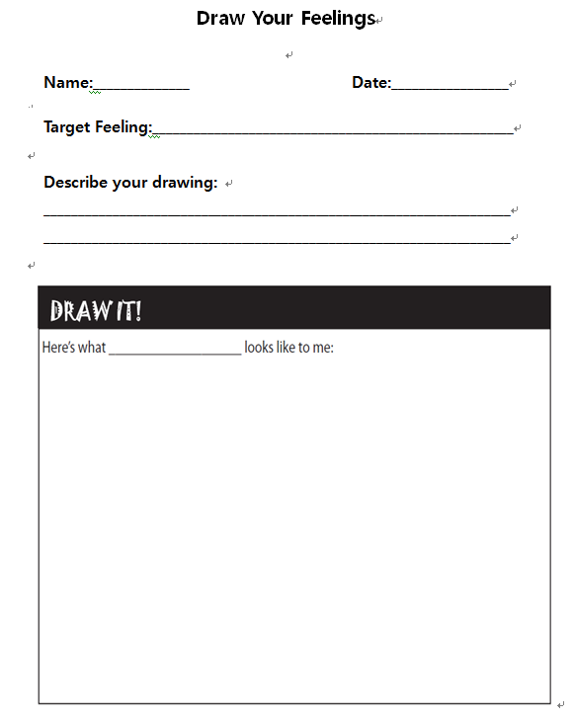
<Drawing activity_Worksheet #2>

