Topic: Later School Start Times
Instructor: | Level: | Age: | Number of Students: | Length:
Misun Kim | Intermediate | Adults | 13 | 25minutes
Materials:
- Picture for eliciting
- The article related to topic
- Worksheets for comprehension check(T/F), key vocabulary and Title contest
- White board and markers
Aims:
- SWBAT find synonyms and definitions for the key vocabulary by quiz questions.
- SWBAT summarize and create a new title in one simple sentence for the text by having a ‘Title Contest’
Language Skills:
- Reading: reading the text “Why you should start work at 10am” and worksheets
- Writing: answering T/F question and key vocabulary quiz and creating a slogan
- Speaking: participating in an activity and sharing ideas in a group
- Listening: listening to teacher’s instruction, demonstration and classmates’ ideas
Language Systems:
- Lexis: vocabulary and meanings
- Phonology: reading the text, listening and speaking to the classmates
- Function: predicting, giving and receiving opinions
- Discourse: expressing opinion
- Grammar: giving advice and express an opinion by using modal verb [S+Should+V]
Assumptions:
Students already know:
- Ss are at an intermediate level and possibly familiar with two-word phrases and vocabulary in the text.
- Ss are able to express their ideas and opinions in English.
- The teacher’s style of teaching and the pace of the class
Anticipated Errors and Solutions
- Students may not know vocabulary words in the text.
- Encourage students to guess from context
- If students finish the worksheet earlier than expectation
- Ask them to find a topic sentence from each paragraph.
- If students finish their task earlier than anticipated (SOS plan)
- Ask as many students as possible about their opinions with staggering starting times
References:
- Why you should start work at 10am (n.d.). In One Stop English. Retrieved December 7, 2015, from http://www.onestopenglish.com/skills/news-lessons/monthly-topical-news-lessons/pdf-content/why-you-should-start-work-at-10am-intermediate/554789.article
Notes:

Pre-Task:
Aims:  SWBAT guess what they are going to read by being aware of picture |  |  | Materials:  -Picture for eliciting
Time | Set Up | Student |  | Teacher
3min | Whole class | Yes!  “No~”  (Looking at the picture)  “No!”  “Because she is yawning”  “No”  “Because she seems so sleepy”  “6am or 7am” |  | < Greeting>  (T begins by smiling and making eye contact and may use an attention getting technique)  “Hi! How are you today?”  “Did you get enough sleep last night?  <Eliciting>  (Showing Ss a picture to elicit the topic)  “Okay now, let’s look at the picture“  “What about this woman in the picture? Do you think she got enough sleep?”  “How to know she didn’t get enough sleep?”  “Right I think so”  “Do you think she can concentrate on her work? “  Why do you think she can’t?  “Yes, I agree with you.”  “What time do you have to wake-up to come to school?”  “Wow! you have to get up early”  “So today, our topic is “Later School Start Times” and we are going to predict first what it is going to talk about, then will do reading comprehension check and do worksheet for key vocabulary. Lastly, we are going to have a Title Contest for our main activity.  <prediction>  “I will tell you the title for your prediction what the text is going to talk about. The title is why you should start work at 10am. Okay. Can you guess what the article is going to talk about?”  (Write their prediction on the board)  (T may ask Ss to come up and write their prediction)
Notes:
Task Preparation:
Aims:  SWBAT identify topic sentences from each paragraph by answering T/F  SWBAT guess and correct the meaning of key vocabulary by quiz questions |  |  | Materials:  -13 copies of comprehension check  -13 copies of key vocabulary quiz  -White board and markers
Time | Set Up | Student |  | Teacher
10min | Whole class  Pair work  Whole class  Pair work | “Yes”  (Discussing)  “No, when it is correct, I will”  (A student comes up and write the answers)  “No”  No I can’t  “3minutes”  “Cognitive”  “No, at the same time” |  | <Guiding questions>  “Now look at the board here are some questions and try to find the information while reading”  - Why should young people start work at 10am?  - At what age is your sleep in tune with your natural rhythms again?  <Instruction>  “Now, I am going to pass the article and the worksheets for answering T/F questions”  “Please scan as quickly as possible and find the information from the article and also answer T/F with your partner”  “Okay let’s work with your partner this time?  “I will give you 3minutes”  (T Distributes the article and worksheets to students)  <ICQs>  “Do you need a partner to do this?”  “Who is your partner?”  “Okay, you can start! Off you go!”  (Monitoring)  (Give information 1minute left)  “Okay, let me have your attention!” “I think you guys seem to finish your worksheet.”  “Let’s check the answers to T/F questions with playing a game together”  “I will ask you to do something if it is correct (T) and if not correct (F), do not react anything.”  <ICQs>  “Are you going to do something that I said when the sentence is incorrect?”  (one by one, T asks one of pairs read the sentence and do as the instruction)  “Okay #1, (ask to read #1 for one of pairs) Please pick up your pencil if the sentence is F”  “Can you read #2 if the sentence is correct?”  “Read #6, please clap 3 times if it is true.  <Checking guiding questions>  “Now Let’s move on to the guiding questions on the board”  “What is the answer for #1 and #2)  “Who is going to come up here and write the answers?”  “Do you have any different answers?  “Very good”  Now, you‘ve read the text and answered all the questions. Let’s compare with your prediction”  (T discusses with Ss the prediction)  <Instruction>  “Now, here I have worksheets for key vocabulary quiz. Please guess the meaning from the text and fill the gaps in the sentences”  “You can work in pairs and you will get different worksheet from your partner. You choose one vocabulary from the list and read full sentence and your partner is going to check the answers if it is correct. After that, you will switch the role with your partner for the next question and do the same way. Please do not show the answer first to your partner”  “I will give you 3 minutes”  (Distribute the worksheet to students)  <ICQs>  “Can you see your partner’s paper?”  “How much time do you have?”  “Okay, you can start!”  (T walks around the room and monitors what they are doing)  (Tell them 1 minute left)  “Did you find the answers correctly?”  <CCQs>  “What is the word meaning is related to recognizing and understanding things?”  “If things are synchronized, they happen at the different time?”  “Well done!”  <Error correction>  “Okay, everyone let’s look at the board now. As you can see there is two-different sentences and which sentence do you think is correct?”  - The 10-year-old and 55-year-old wake and sleep naturally at the same time (O)  - The 10-years-old and 55-years-old wake and sleep naturally at the same time (X)  “Yes, Right! Some people can make mistakes here. Be careful with that. “
Notes:
Task Realization:
Aims:  SWBAT summarize the article and write it in one simple sentence by creating a new title |  |  | Materials:  -6 copies of worksheets.
Time | Set Up | Student |  | Teacher
10min | pair  work | (Read the worksheet)  “create a new title”  “5minutes” |  | “Now we are going to have a title contest for the text.”  <Instruction>  “Let’s get in to pairs for this activity again”  It is quite simple. First summarize the text and create a new title with your partner.  “After the activity, each group is going to share the title you created and each group will write it on the board.”  We are going to vote which one is the best after all.”  “Now, here I am going to hand out the worksheet for this activity.”  (T distributes worksheets to students)  (Make sure each group has the paper)  “Okay now I’ll give you 5minutes.”  <ICQs>  “What are you going to do now?”  “Are you working alone?”  “Okay you can start!”  (Monitoring & Note taking)  (Give Ss information they have 1 min left.)  “Have you done all?  “Okay, each group please come up to the board and write the titles  (T tries to find any errors from their writing and makes it correct)  “Which group is the best do you think? Raise your hands #1,#2,…..#6  (Ask students to raise their hands which one is the best)  “Okay well done!  “All right! Everyone did very well!”
Notes:
Post Task:
Aims:  Review what they have learned today by asking CCQs and giving homework |  |  | Materials:  White board and markers
Time | Set Up | Student |  | Teacher
2min | Whole  class | (Answer to questions)  “No, workers too.”  “Apprentice” |  | <SOS/Filler>  If the class finishes earlier than expectation, ask Ss to read the summary in the task realization time.  <Feedback>  How many words were new for you?  Which activity did you enjoy most?”  <CCQs>  “According to the text, would only students benefit from a later start?  “What is the synonym for trainee from the text?”  <Homework>  “You have homework to do, please write out the text again from memory and use the key vocabulary as many as possible.  <Closing>  Today we talked about “Later School start times”. Do have any questions about it?  (Dismiss the class if there is no question.)  “Good job, guys. See you tomorrow.”
Notes:

<Picture for eliciting>

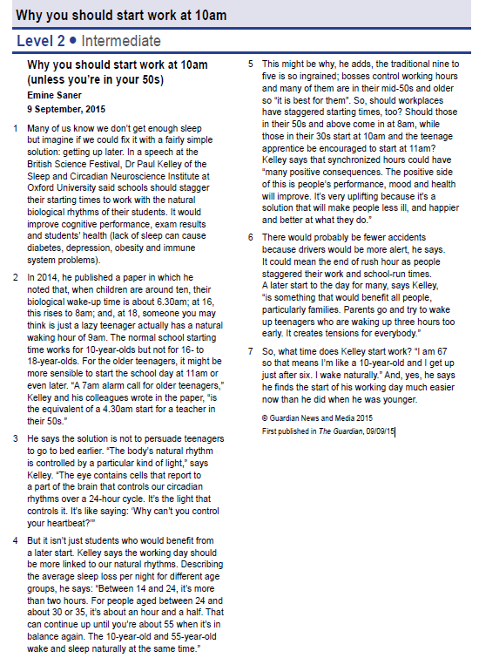

Work with your partner

Comprehension check

Are these statements true (T) or false (F) according to the text?

- Persuading teenagers to go to bed earlier would solve the problem of lack of sleep.

- The body’s natural rhythm is controlled by a particular kind of light.

- Only students would benefit from a later start.

- Bosses keep the traditional nine to five because it’s the best solution for all their workers.

- Staggered hours would lead to more accidents.

- Staggered hours would be of particular benefit to families.

Information gap activity <Student A>

Key vocabulary quiz

Fill the gaps in the sentences using these key words from the text. The paragraph numbers are given to help you.

sensible cognitive stagger synchronized

ingrained apprentice uplifting

1. If you ___stagger__ working hours, you arrange for them to start at different times. (para 1)

2. A __________________ process is related to recognizing and understanding things. (para 1)

3. A ____sensible________ decision is one that is reasonable and practical. (para 2)

4. If an attitude, belief or habit is _____________________, it has existed for a long time and cannot easily be changed. (para 5)

5. An ___apprentice______ is someone who works for a particular company, usually for low wages, in order to learn the type of work they do or acquire a particular skill. (para 5)

6. If things are _____________________, they happen at the same time. (para 5)

7. An ___uplifting_______ experience makes you feel happier or more hopeful. (para 5)

Information gap activity <Student B>

Key vocabulary quiz

Fill the gaps in the sentences using these key words from the text. The paragraph numbers are given to help you.

sensible cognitive stagger synchronized

ingrained apprentice uplifting

1. If you ____________ working hours, you arrange for them to start at different times.
(para 1)

2. A ____cognitive______ process is related to recognizing and understanding things. (para 1)

3. A ______________ decision is one that is reasonable and practical. (para 2)

4. If an attitude, belief or habit is ____ingrained_______, it has existed for a long time and cannot easily be changed. (para 5)

5. An ________ is someone who works for a particular company, usually for low wages, in order to learn the type of work they do or acquire a particular skill. (para 5)

6. If things are _____synchronized________, they happen at the same time. (para 5)

7. An __________ experience makes you feel happier or more hopeful. (para 5)

As what the topic says....a TITLE CONTEST...yes, it’s a contest!! The contest is about creating a new title for the text title “Why you should start at 10am”.
You will work with your partner.
★ What you need to do:
- Summarize the text with your own words (3 or 4 sentences)
- Create a new title
An example of a new title could be as below:
- Science Has the Perfect Reason For Later School Start Times
Title:
Summary:

