125 th WK Apple Yuseon Kim
Speaking Lesson Plan
Title: Cast Away!

Instructor:  Apple Yuseon Kim | Level:  10 yrs+  Intermediate | Students:  Not more than 10 | Length:  25 min

Materials:
board, computer and speaker for video clip, some pictures of movie ‘Cast Away’, pens, camera, photos of students, a coat hanger, a CD, an empty bottle, a plastic bag, some string, some lipstick, some straws etc. (use some everyday objects as realia)

Aims:
Ss will get to know the different uses of everyday objects.
Ss will brainstorm how to use everyday objects in a different way in a difficult situation.
Ss will learn 4 ways to tell the uses of objects using ‘It’s used / They’re used / It could be used, They could be used’.

Language skills:
Writing: Make photo letters with writing sentences using ‘It’s used / They’re used / It could be used, They could be used’.
Speaking: Repeat T’s sentences or speak out Ss’ own sentences through the class
Listening: T and other Ss’ sentences and video clip no.1
Reading: Sentences on the picture card (Appendix 1) and the other Ss’ writing.
Language system:
Lexis: a coat hanger, a CD, an empty bottle, a plastic bag, some string, some lipstick, some straws, everyday object, cast away
Grammar: ‘It’s used for, They’re used for / It could be used for, They could be used for’
Discourse: Ss’ pair work

Assumptions:
Ss have learned about verb ‘use’, auxiliary verb ‘could’.
Ss have learned about singular ‘It’s / It is’, plural ‘They are / They’re’
Ss have learned about the passive form of English.

Possible Problems:
Ss might be wondering what ‘cast away’ means.
Solution: Teacher can explain what ‘cast away’ means watching the video clip together.

References:
Video clip-
https://www.youtube.com/watch?v=0u0Ql2Hnl8I
Picture cards-
Captured from the movie ‘Cast Away’

Time | Interaction | Details / Procedure | Purpose
8 min | T-S | *Greeting and Introduce the Topic  Hello, Everyone. How are you today?  *CCQ*  Can you see this?  -T shows a ball to Ss.  What is it used for? Yes, It’s used for playing volleyball. But it could be used for being my best friend. Let’s watch a video.  -Ss watch the video clip of movie ‘Cast Away’. And T explains about ‘cast away’.  So, what do you think? As you see this movie, the objects which are used for our everyday lives, could be used in a different way especially in a difficult situation.  -T puts the pictures on the board.  (Appendix 1) | Warm up  and  Familiarization  of today’s Topic.
12 min | T-S  S-S | *ICQ*  Let’s imagine you are in that situation like the movie. But you have few things to use. So, please come up with some great ideas and give some advice to Tom hanks. While you think about it, I’ll take a photo of you. And then, you can write a photo letter on that picture to him.  -If needed, T shows modeling.  -T shows some everyday objects telling their names and uses of them with some comments. (This is a coat hanger and it’s used for hanging clothes. But it could be used for some other ways.)  -Let the Ss choose the items. (Each student has an item.)  -T takes a picture of each student. And divide Ss into teams of two Ss. They share the ideas of the objects’ special uses.  -After brainstorming, Ss write letters on their photos using ‘It’s used for, They’re used for / It could be used for, They could be used for’.  -Ss speak out their letters one by one. And put the letters on the Tom hanks’ photo. (Appendix 2) | Perform a task with target language ‘It’s used for, They’re used for / It could be used for, They could be used for’
5 min | T-S | * Closing  -Confirm Ss have the correct acquisition with ‘It’s used for, They’re used for / It could be used for, They could be used for’ asking some more questions.  -Thank you for your good job! And don’t forget your creativity is the best in a difficult situation. | Feedback  and  Review

Appendix 1
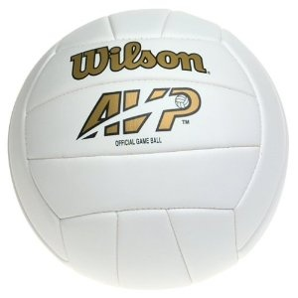
It’s used for (They’re)
playing volleyball.
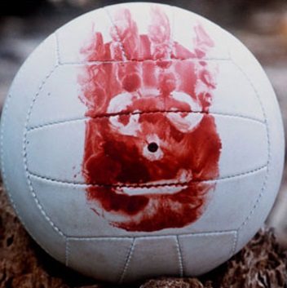
It could be used for (They)
my best friend.

Appendix 2
