█ Listening Speaking Reading Grammar Writing

Topic: Superstition & Jinx

Instructor:  Dian | Level:  Intermediate | Students:  17 | Length:  40 Minutes

Materials:
Audio File (related superstition contents)
Worksheet (attached below)
Examples papers for main & post activity
2-3 Papers per Ss

Aims:
Main Aim – Enabling Ss to improve their listening skills by having Ss discuss their superstition and jinx in a story of superstition to Ss to learn the use of the present perfect tense.
Secondary Aim – Ss will share their superstition and jinx by having Ss do a fill in the blank worksheet, match other’s superstition and jinx, bingo game, be participated in listening dictation of a story of audio file and learning tense.
Personal Aim – I want to adjust my speaking speed and teaching speed to the level of the learner. I want to improve on my explicit ICQ delivery and time management. I want to try to eye contact more.

Language Skills:
Speaking – Ss will talk about the superstitions and the jinxes and why they have those things in their life.
Writing – Ss will practice dictation and tense.
Listening – Ss will listen to other’s personal superstitions and jinxes and the audio file.
Reading – Ss will read worksheet, other’s superstitions and jinxes in activities.

Language Systems:
Lexis – superstition, jinx
Phonology – superstition, jinx
Grammatical – none
Function – none
Discourse – various superstitions and jinxes

Assumptions:
Ss have personal superstitions and jinxes.
There are common superstitions and jinxes.
Ss know someone’s superstitions and jinxes.
Ss know present perfect tense.
Ss have done a dictation activity before.

Anticipated Problems and Solutions:
Ss can hesitate to share their sensitive superstitions and jinxes
- Teacher can example a light superstitions and jinxes what they also can accept. (e.g. I think no. 7 is my lucky no. So when I found no.7 in anywhere, I thought I’ll be lucky on it.)
Ss can confuse present perfect tense.
- Teacher can show the differences and practice Ss several times to use clearly.
Ss have similar superstitions and jinxes in post-activity
- Teacher can confirm the acceptable range before the game with Ss’ agreement

References:
Audio files & Script from English institute.

Lead-In
Materials:
- Loud voice
- Clean and stretched hands
Time | Set Up | Student Activity | Teacher Talk
3min. | T-WC | Greetings and casual discussion  Questions and answer about U.F.O. | Greeting  - Greet Ss and ask about their yesterday after the class and what food they had last night.  Guiding & Follow up Questions  - Show Ss U.F.O. photo.  - Can you tell me what it is?  - Have you ever seen this before?  - What are they looking? Circle, Square?  - Where they come from?  - Then do you believe Alien?  - What are they looking?

Pre-Activity
Materials:
- Audio File
- Visual of movie poster ‘Friday the 13th’
- Worksheet
Time | Set Up | Student Activity | Teacher Talk
12min. | T- Ss  T- WC  T- WC  T- WC  T- WC  Ss- Ss  T- WC  Ss  T- WC | Follow up teacher’s eliciting  Answer the T-question  Check the instructions  Check demo  Listen and complete  Reading the complete sentence and check the correct answer  Ask confusing sentence  Write the examples of present perfect tense | Eliciting  - Show a poster of ‘Friday the 13th’  - What is this? Movie!  - Is it romantic movie? No  - Is it horrible? Yes  - Why did it happen on Friday the 13th?  - Do American think 13th is lucky number? No  - Then they think bad luck number? Yes  - What can we say this kind of believes? Superstition  CCQ  - Write ‘Superstition’ on the board.  - Is there any similar word to ‘superstition’? various answers and Jinx’  - Is superstition a scientific? No  - Is superstition a personal thing? Yes  - Is jinx adapted to everyone? No  - Do we have only one jinx or superstition? No  Instructions  - I’m going to play an audio file and give you worksheets. Then listen it carefully and complete the blank of the worksheet as what you listened individually in 5 minutes.  ICQS  - What are we doing now? Listening and complete sentence  - Do we work in fair? No  - Individually? Yes  - How much time do we have? 5 min.  Explicit Instruction  - To be equal, I want you do not share and compare the completed sentence before match it together.  Explicit ICQs  - Do we share the completed sentence? No.  - Then keep it secretly before we match it? Yes  Demonstration  - Show the worksheet and fill the blank in front the desk  Run  - Hand worksheets out to Ss first  - Play the audio file and make Ss to focus to listen to it  - Let Ss know how much time left. 2 minutes left!! 1 minutes left!!  - Monitor Ss’ writing and play one more depends on their writing condition or asking from Ss  - Angela(student name), would you read the first sentence? Angela speaks  - Then in a counter clock wise, please read next sentence.  - Have you any question about this one? No  - Okay, I have! Write ‘I haven’t slept since then. & he hasn’t slept since then.’ It called present perfect tense.  - Jiyoon(student name), if you could not go to work, how can you make the complete sentence? I haven’t gone to work.  - Leave the sentence on the board and let Ss to write on their notebook

Main Activity
Materials:
- Clean papers
- Materials (Big size of example what they will write on the paper)

Time | Set Up | Student Activity | Teacher Talk
15min. | T- WC  T- WC  Ss  T- WC  T- WC  Ss  Ss- Ss  Ss- Ss  T- WC | Follow up teacher’s eliciting  Check the instructions  Say ‘superstition’ & ‘jinx’  Create 2 groups  Check demo  Check Instructions  Write their superstitions and jinxes  Stand up and come out to the center of classroom  Guess which fact is false  Finish the activity | Eliciting  - Emily(Student name), Do you think no. 7 is lucky no.? Yes or No  - Anne(Student name), Do you any color of lucky? Yes or No.  - What do we call this kind of believes? Superstition and jinx  Instructions  - Okay, from the first on the line, first student say ‘superstition’ then next student say ‘jinx’. Then turn saying ‘ ‘, ‘ ‘ it to Ss to the end of line.  - So, who said ‘superstition’? Hand up! This group will move to the left side of the class.  - Who said ‘jinx’? Hand up! This group will move to the right side of the class.  - Now, we are going to write down our 3 superstitions and jinxes individually in 5 minutes. But one of them must be false.  Demonstration  - Please check the example.(Put the example on the board)  - You can write 3 superstitions or 3 jinxes also. You can mix or choose one category.  - Read 3 items and know which one is false.  ICQS  - What are we doing now? Writing our superstitions and jinxes.  - How many things we can write? 3  - How much time do we have? 5 min.  - Do we write in group? No  - Individually? Yes  - Do we write all true things? No  - One of them must be false? Yes  Explicit Instruction  - To make exciting activity we will put down the paper to the desk direction to keep the secret.  - And I do not want someone start early before I say ‘begin’ after hand papers out.  Explicit ICQs  - So will you show your paper to neighbor? No  - Will keep it secretly? Yes  - Will you start when you received the paper? No.  - When I say ‘begin’? Yes  Run  - Hand papers out to Ss  - Say ‘begin’  - Monitor Ss  - Notice time they have, like ‘2 min left’, ‘1 min left’.  - Say ‘Times Up!!!’ to know the finish.  - Turn the paper to the desk.  - Please stand up and come out to the center of the class(classroom arrangement is horseshoes)  - As a team, first team read a paper (mixed one) then other team will guess which fact is false.  - Calculate the score of choosing false fact and say who is winner team

Post Activity
Materials:
- 3 clean papers
- Materials (example of listed items)

Time | Set Up | Student Activity | Teacher Talk
10min. | T- WC  T- WC  Ss- Ss  T- WC  T- WC  Ss- Ss  Ss  T- Ss  T- WC | Follow up teacher’s eliciting  Check instructions  Create 3 group  Check demo  Check instructions  On Activity  Calculate removed items  Answer the questions  Check error correction | Eliciting  - Write ‘have eaten’, ‘had eaten’ & ‘will be eaten’  - Anyone can explain differences of these 3 sentences? Present perfect tense, past perfect tense, future perfect tense.  - Joanne, do you have any example of these 3 perfect tense? Yes. ~~  Instructions  - From the first on the list, say ‘present’, ‘past’, ‘future’. Say with the list till the end. ‘Present’, ‘past’, ‘future’, ‘present’….  - So, who said ‘present’? Please hand up? Okay this group will move to the left side of the classroom. Next, who said ‘past’? Hand up, please. This group will move to right of the class. Then who said ‘future’? Please hand up! And this group will move to center of the classroom.  - Now, we are playing in group. Each team makes 10 superstitions and jinxes in 3 minutes. You can mix but do not over 10 items. Since we will do line bingo, you should think about it carefully. Each team will read their one items on their turn and remove it. Other team also can remove it if they have same item.  Demonstration  - Show the listed items  - Read first item and remove it by drawing lines on it.  - Pretend other one read their item and if there is similar item on the list, remove it. If there are not similar item, do nothing.  ICQS  - What are we doing now? Writing 10 superstitions and jinxes.  - Do we it individually? No  - Do we it as a group? Yes  - How much time do we have? 3 min  - Can you write 20 items? No  - Can you write 10 items? Yes  - You cannot mix the categories? No  - You can mix? Yes  Explicit Instruction  - To be equal, every team will wait for I say ‘begin’ after give paper.  Explicit ICQs  - Will you start to write once you get the paper? No  - When I say ‘begin’? Yes  Run  - Hand papers out to 3 teams.  - Say ‘begin’ to start  - Monitor Ss  - Notice time they have, like ‘2 min left’, ‘1 min left’.  - Say ‘Times Up!!!’ to know the finish.  - First team says one item on their list.  - Other team can remove if they wrote similar item.  - Every team says one item and removes on their turn.  - After 3 rounds, ask who removes most items.  - Say who is winner.  Close the activity  - What did you find similar and common things on superstitions and jinxes of classmates?  - Alice(student name), will you believe your jinx forever? Maybe Yes.  - Do you have any try to break your superstition or jinx? Not yet, but I will try soon.  - Thank you for your sharing to Ss.  Error Correction  - I found some errors like perfect tense like this. Write some error corrections.

Visual of movie ‘Friday the 13th’
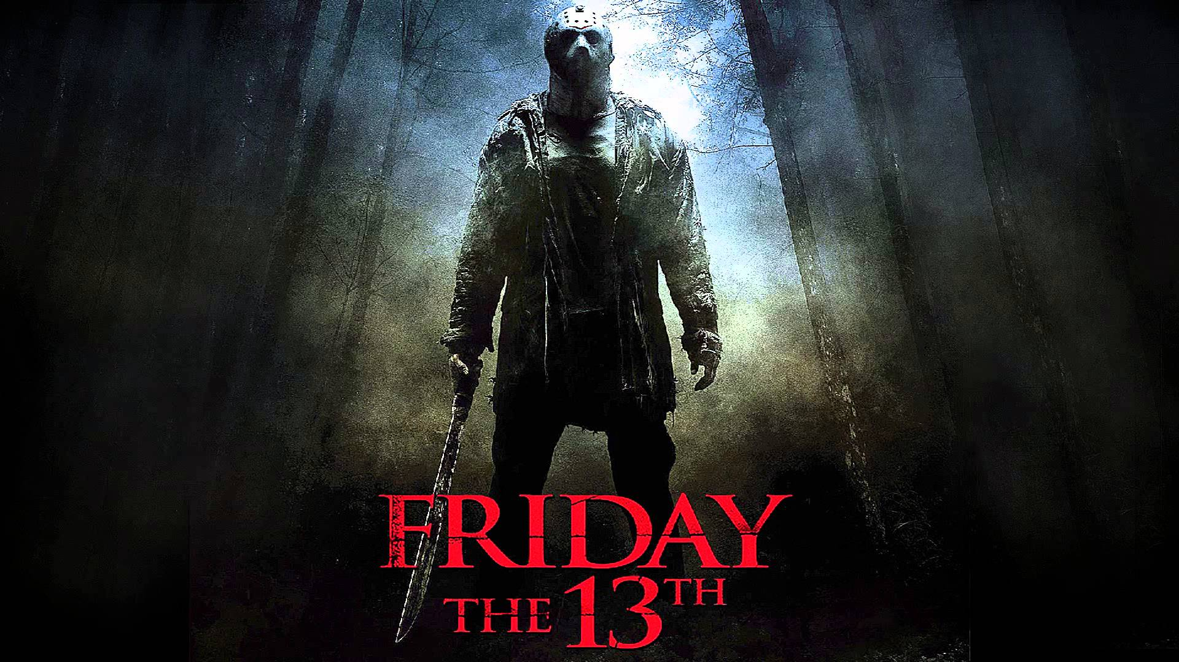
Visual of movie ‘Yes Man’

Worksheet for Pre Activity (filled)
John is very superstitious.
Last Friday was Friday the thirteenth.
On his way home, suddenly a black cat appeared in front of him.
“A black cat? On Friday the thirteenth? Bad things are going to happen.”
Since then, he’s dreamed of big scary black cats every night.
He’s felt very uneasy.
He hasn’t’ slept well.
He hasn’t eaten well.
He’s been afraid of going out.
He hasn’t gone to work.
He hasn’t met his friends.
He’s staying at home day and night.
Even at home, he’s been scared of being alone in the dark.
He’s kept all the lights on.
He’s been very strange all week.
Poor John. What should we do for him?

Worksheet for Pre Activity
John is very .
Last Friday was Friday .
On his way home, suddenly a black cat in front of him.
“A black cat? On Friday the thirteenth? Bad things are .”
Since then, of big scary black cats every night.
He’s felt very .
He well.
He well.
He’s been afraid of going out.
He work.
He his friends.
at home day and night.
Even at home, of in the dark.
.
He’s very all week.
Poor John. What should we do for him?

Examples of superstitions and jinxes (Big size) for Main Activity
I’m avoiding watching live World Cup game when I cheer for my national team because I feel my team will be going to lose if I watch. (True)
I like where black underwear when I have an important appointment because I think it will bring good luck to me. (True)
I wear a sock from left because I believe the day will be a bad day when I didn’t wear from the left. (Faulse)

Examples of superstations and jinxes (A4 size) for Post Activity
1) I’m avoiding watching live World Cup game when I cheer for my national team because I feel my team will be going to lose if I watch. (True)
2) I like where black underwear when I have an important appointment because I think it will bring good luck to me. (True)
3) I wear a sock from left because I believe the day will be a bad day when I didn’t wear from the left. (Faulse)
4) I’m avoiding watching live World Cup game when I cheer for my national team because I feel my team will be going to lose if I watch. (True)
5) I like where black underwear when I have an important appointment because I think it will bring good luck to me. (True)
6) I wear a sock from left because I believe the day will be a bad day when I didn’t wear from the left. (Faulse)
7) I’m avoiding watching live World Cup game when I cheer for my national team because I feel my team will be going to lose if I watch. (True)
8) I like where black underwear when I have an important appointment because I think it will bring good luck to me. (True)
9) I wear a sock from left because I believe the day will be a bad day when I didn’t wear from the left. (Faulse)
10) I’m avoiding watching live World Cup game when I cheer for my national team because I feel my team will be going to lose if I watch. (True)

