127th WK / 2nd Essay (Sung Mi)
Ice-breaker

Title: Fun Card Game to learn the English word with your friends
Title of activity: Go Fish
Age group: 7 (1st grade of Ele.) | Number of Student: 5 | Duration: 15min
Before the lesson
Preparation ‘Go Fish’ board game box.
Grouping 3 people as 2 team with each board game box
Lead in
Good morning kids~ it’s lovely day isn’t it?
What do you usually do in your weekend with your father and mother?
Do you like go shopping to the market with your family? What do you usually buy at the Market? And what does your mother buy? How about father?
Set up
(Eliciting)
Show a visual of the Mart where the place to buy many things.
Hello kids, what do you see in this picture? Do you know where it is?

Tape the visual to the middle of the board and ask the class “When we go to the Mart, what can we buy?” Apply the direct method as I ask each student for an idea. I board everyone’s idea around the Mart picture so that it looks like brain-storming. The direct method activates the student’s schemata. The class is suddenly engulfed and guided by their experiential memories of the Mart. The class starts to say, “Fruits, Milk, Fork, Ice cream, snack, cloth, one student will and might just say ‘just try to eat’
After all students have answered, I’ll go back to the idea on the paper and present my CCQ.

CCQ:
I show the class the board game named ‘Go Fish’ and ask, “Do you know what it is? The class should say yes or no and might even hesitate to answer however student will try to answer whether they know or not.
I then explain my story on my first time experience to do this game with my kids and spend lots of time to play with knowing how many hours passed. Then say “Believe me, this is very fun with smile ”

Demonstration #1:
I get the board game, unwarp the box and show the ‘Reference Book’ to explain how to play the game and let them know this card game is very easy and fun.

Instruction:
Okay class, now I want you to do this game with your four friends to have fun and learn the English word in it. It is the game named ‘Go Fish (Mart for shopping)’ then show them the materials in the box.

- Preparation of game
Well mix and receive 5 cards each student. Hold it tight in your hand not to show other students. All the left of the cards has to be settled to the ground.
Find the same card, then the student who got most earn for the ‘Stars’ on the top of the card.
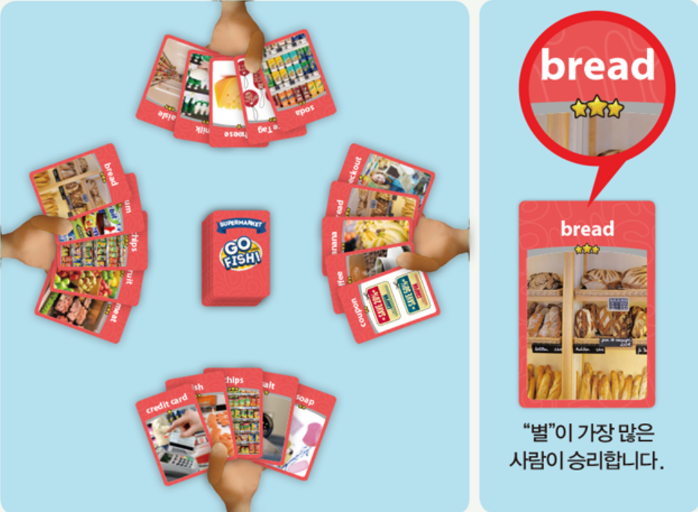

- Progress of the game
Decide who will start first with rock scissors paper
In my tern, direct one person only can ask “Do you have a ‘bread’?”
If the opposite friend has that card, you can receive the card from them.
When you receive the card you can lay down with two same card on the floor.
Keep trying till when you fail.
If the person that I asked don’t have that card then answer ‘Go Fish!’
Then you’re failed and have to get one more card from the center.
Keey rotate this activity from you to one direction that you set at the first time till all the card finished.

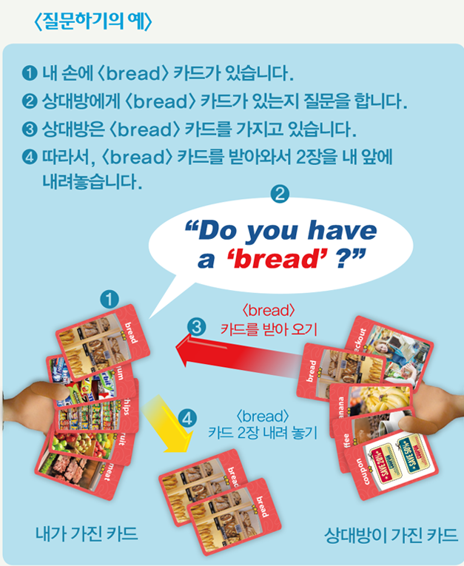

- Finish the game and the winning condition
When anybody run out the card then the game is finishing.
Count the total ‘Stars’ which is located on the top of the card.
The people who got the most many ‘Stars’ will win for this game.

ICQ’s: d
What are you going to do? = do the game
What is the name of this game? = ‘Go Fish!’
AR you working in individual? = No, as group with 4 people.
How much time do you have? = 10 minutes.
Explicit instructions – I don’t want you to sart tearing until I come up to you and say begin.
Explicit ICQ’s = Ar you going to start before I say begin = No
Go around the calss as student do the board game. Confirm with the students by asking how many did each take.
Run
The class now begins talking one thing per sheet. I just monitor making sure I do some variance where students are not presenting down the line. I want to change sides so that students on the other side of the classroom line don’t expect it. If students say they need more time, DO NOT give them, just encourage them by saying that they can do it. “Say anything!” Help out by asking, how about a favorite sport or TV Show… They’ll get into it and they’ll be glad you encouraged them.
Close
For this game, Ss were already presenting in the Run stage however, here is the stage, you can ask student whether this is familier with new word. Pick on two people sitting beside each other whether it is fun and good.
A and B, Did you have fun with this game?
And was it useful as learning the new word?
Post Activity
Error correction: I will correct any of the students oral mistakes that I’ve noted and it there are no mistakes then I will have SS unscramble the sentence.
Any Questions? If there are no further questions, this concludes my ice-breaker and I’ll be followed by Ben.

