Listening Speaking Reading Grammar Writing

Topic: Modal Auxiliary Verbs

Instructor:  Gianna Chung  Angela Kim | Level:  Upper Intermediate | Students:  16 | Length:  30 Minutes

Materials:

- A wall chart for eliciting
- A picture of Kim Hyun-Joong
- A wall chart for pre-activity demonstration
- 16 work sheets for finding appropriate modal auxiliary verbs
- A wall chart for right answers of work sheet
- 16 cards of 4 different colors for grouping
- A wall chart of Kim Hyun-Joong and his scandal for demonstration
- A wall chart of excuse for demonstration
- 4 work sheets of 4 different notorious celebrities and their scandals
- 4 blank worksheets
- Microphone flash card for press conference
- A wall chart of one sentence for post activity demonstration
- A wall chart of lyrics of London Bridge
- Flash card of Dongdaemoon-eul Yeol-ora game
- A wall chart of 16 words for post activity

Aims:

- Main aim: Ss will improve their grammar skills by learning how to use modal auxiliary verbs in sentences.
- Secondary aim: Ss will learn the modal auxiliary verbs by having Ss a worksheet, writing & speaking for a press conference, and making a sentence through the London bridge game.
- Personal aim: We want to improve on time management, staging, and teacher presence.

Language Skills:

Listening: Ss will listen to each other for worksheet and other students’ speeches.
Reading: Ss will read articles of notorious celebrities and their scandals
Writing: Ss will improve writing by writing excuses for press conference
Speaking: Ss will present excuses about the celebrities and make sentences for the London Bridge game.

Language Systems:

Lexis: modal, auxiliary, press conference
Phonology: aux-il-ia-ry
Grammatical: Modal auxiliary verbs
Function: Speech making
Discourse : Ss will make excuse for the celebrities’ scandals by discussing together

Assumptions:

- Most of Ss somehow know how to use modal verbs
- Most of Ss already know about the notorious celebrities’ scandals.
- Most of Ss have their own secret scandals in their lives.
- Most of Ss already know how to play the London Bridge game.

Anticipated Problems and Solutions:

- Students may not know some vocabularies.
Explain them by using easier words and encourage the Ss to guess the meaning
If explanation doesn’t work, tell the meaning of the word to the SS and let them to make examples using it.
- Students may need more time to work on the model verbs worksheet
If it takes longer than 3 minutes, cut answer-checking short by verbally sharing the answers instead.
- Cut main-activity writing short and pick only 1-2 students to present
- If students finish their tasks earlier than anticipated,
Move on to SOS activity.

References:

- http://dictionary.cambridge.org/dictionary/english for vocabularies & idioms
- http://a4esl.org/q/h/0101/ig-modals.html for worksheet
- http://www.englishgrammar.org/modal-auxiliary-verbs-worksheet-2/ for worksheet
- https://www.youtube.com/watch?v=SOd-WaXtsR4&feature=youtu.be for lyrics of London Bridge
- http://puzzlemaker.discoveryeducation.com/WordSearchSetupForm.asp for word finding puzzle

Lead-In
Materials:
No need

Time | Set Up | Student Activity | Teacher Talk
2min | T-WC  T-Ss | Greeting  Answering | Hi everyone! How are you?  Question  Jeny, did you get allowance from your relatives for the new year?  Follow-up  (yes) How are you going to spend it?  (no) I’m sorry to hear that. When was the last time that you got it? How did you spend it?  Question  Jay, have you ever won a lottery?  Follow-up  (yes) How did you spend it?  (no) If you got 5 million won, what would you do with that money?  Thank you for your answer.

Pre-Activity
Materials:
eliciting wall chart, word card of ‘auxiliary verb’, demonstration wall chart, work sheets, answer wall chart, a picture of Kim Hyun-Joong

Time | Set Up | Student Activity | Teacher Talk
2min  3min  2min | T-WC  T-S  T  T-WC  T  T-WC  Ss  S | Set-up  Showing visual material  Finding answers in pairs  Read each sentence with correct auxiliary verb. | Eliciting  Which verbs express permission, ability, obligation or prediction?  It starts with ‘M’. =Modal Auxiliary.  (no answer) Do you know Gianna’s dog’s name? = Momo.  Yes, it starts with ‘Mo-’  (Write this on the board) = Modal  That’s right, it’s ‘Modal auxiliary verb’.  (Put wall chart of Modal auxiliary verbs on the board)  CCQ  (Show Ss a picture of Kim Hyun-Joong)  Do you know who this guy is? = Kim Hyun-Joong  Kim Hyun-Joong says that  I have been studying English very hard. (Show the wall chart) In this context, is the verb ‘have’ used as a modal verb? =No.  He also says that  I really must leave now. (Show the wall chart) In this context, is the verb ‘must’ used as a modal verb? =Yes.  Paring  (Call each student’s name for paring).  Now you two are partners.  Demonstration  (Put a wall chart for a worksheet. Refer to APPENDIX 1)  What do you think fits in this blank? = Can  That’s correct.  (Circle “Can”)  Instruction  First, I will hand out these work sheets to each of you and I want you to circle the correct answer for each sentence with your partners. You will have 3 minutes to do this.  ICQs  What are you going to do?  Are you working individually?  How much time do you have?  Explicit Instruction  Please don’t turn over the paper before I say ‘begin’.  Explicit ICQs  Are you going to turn it over before she says ‘begin’?  (Distributes worksheets. Refer to APPENDIX 2)  Run  Now, Begin.  (monitoring)  Teacher monitors class and answer to Ss when they ask questions  Timing  1 minute, 30 seconds, 10 seconds, time’s up.  From student ‘A’, please read the sentence with the correct answer in turn.  (point the first pair to the right)  (Put the wall chart of the correct answers after all Ss present. Refer to APPENDIX 3)  You can check the right answers on the board.  Let’s move on now.

Main Activity
Materials:
16 cards of 4 different colors for grouping, Kim Hyun-Joong’s scandal wall chart, Excuse letter wall chart for press conference demonstration, 4 scandal cards, 4 blank sheets, Microphone flash card.

Time | Set Up | Student Activity | Teacher Talk
2min  2min  5 min  2 min | T-WC  T  T  T-WC  T  T-WC  Ss  S | Grouping  Regrouping  Writing documents | Grouping  Please pick a card from the basket.  (Have each student pick one picture card.)  Who picked the red card?  Please stand up and move to this side.  Who picked the green card?  Please stand up and move to this side.  Who picked the yellow card?  Please stand up and move to this side.  Who picked the blue card?  Please stand up and move to this side.  (Regrouping )  From A to B will be red team.  From C to D will be green team.  From E to F will be yellow team.  From G to H will be blue team.  Demonstration  (Put the wall chart of Kim Hyun Joong’s scandal. And read the scandals. Refer to APPENDIX 4. Put the excuse wall chart on the board and then read it. Refer to APPENDIX 5)  Instruction  Now, I will hand out these scandal cards to each team. (Refer to APPENDIX 6) What I want you to do is to discuss the celebrity’s situation and write a document for the speech of the press conference just like Angela did. You must use at least 3 modal auxiliary verbs. You can use back side of the scandal cards. And choose a spokesperson for the speech. You will have 5 minutes to do this.  ICQs  What are you going to do?  Are you working in groups?  How much time do you have?  How many modal verbs do you have to use?  Explicit Instruction  Please don’t turn over the scandal cards before I say ‘Begin’.  Explicit ICQ  Are you going to turn over the card before she says begin?  (Distribute the scandal cards.)  Run  Now, begin.  (monitoring)  Answer to Ss’ questions if asks.  Timing  1 minute, 30 seconds, 10 seconds…  Time’s up  (Get 2 or 3 spokespersons from each team to come out and present the celebrity’s excuse. )  From the red team, the spokesperson, please come out and make a speech.  From the blue team, the spokesperson, please come out and present your speech.  Okay. Well done. Please stay where you are.

Post Activity
Materials:
wall chart for demonstration, flash card of Dongdaemoon-eul Yeol-ora, wall chart of 16 words, wall chart of lyrics of London Bridge, word card for scrambling

Time | Set Up | Student Activity | Teacher Talk
3 min  1 min  5 min  30 sec | T-WC-  T-Ss  T  T-WC  Ss  T |  | Grouping  Now, Green & Red teams will be team ‘A’ and Yellow & Blue teams will be team ‘B’.  (Put the wall chart of lyrics of the London Bridge. Refer to APPENDIX 7)  Demonstration  I guess you guys all know this traditional game, “Dongdaemoon-eul Yeol-ora”. (Show the flash card of Dongdaemoon-eul Yeol-ora).  We will sing its English version.  Please listen to our song first.  (Sing the song following 1,2,3)  And now repeat after us.  (Sing the song following 1,2,3)  Dian, Emily, Sarah and Jenny please come out and help us.  Sarah, please hold my hands and the others will follow Gianna.  (Gianna and everyone else is singing the song. When the song finishes, Angela and Sarah will catch Gianna and she will present a sentence using a word from the wall chart and the given auxiliary verb. Refer to APPENDIX 8)  (Put a wall chart for the sentence. Refer to APPENDIX 9)  Thank you for your help. Now you may go back to your group.  Instruction  “Two of the members will make a tunnel and other members will sing the song. The opposite team members will go through the tunnel. When one verse of the song finishes, catch the person who will be under the tunnel. And that person should pick one word from the wall chart and make a sentence using the word an auxiliary verb in 10 seconds.”  ICQs  What are you going to do?  Are you working individually?  How much time do you have to make a sentence?  Do you have to use a word from the wall chart to make a sentence?  Run  Everyone, please stand up and come out. (Ss move forward)  So, team ‘A’, please make a tunnel first. “1,2,3~”  (One verse finishes) Gina, please pick a word and make a sentence.  (One teacher will count the score and write it on the board.)  Let’s switch the team. Now, team B will make the tunnel.  Team ‘A/B’ won the game, congratulations! (Or You got tied. Good job guys!!!)  Please go back to your original seats.  Error Correction  Since, I couldn’t hear error, we will scramble a word.  (Show the class word card)  Can you guess what this word is?  =auxiliary  (Show the class the correct word)  Closing  Do you have any question? If you don’t have any further question, we will end up this lesson. Thank you for your participation.  I hope you enjoyed our lesson.
SOS Activities
Materials:
wall chart for demonstration, 16 word finding worksheets, wall chart of correct answer

Time | Set Up | Student Activity | Teacher Talk
2 min | T  T-WC  T  T-WC  Ss  T-Ss |  | Let’s move on.  Demonstration  (Put the wall chart of word finding puzzle for demo. Refer to APPENDIX 10)  I will find this word from the puzzle.  (Circle the right word)  Instruction  First, I will hand out these work sheets to each of you and find one modal verb and circle it. You will have 30 seconds to do this.  ICQs  What are you going to do?  Are you working individually?  How much time do you have?  Explicit Instruction  Please don’t turn over the paper before I say ‘begin’.  Explicit ICQs  Are you going to turn it over before she says ‘begin’?  (Distributes worksheets. Refer to APPENDIX 11)  Run  Now, Begin.  (monitoring)  Teacher monitors class and answer to Ss when they ask questions  Timing  10 seconds, 5 seconds, and time’s up.  Joanne, what did you find?  (Put wall chart for the right answer. Refer to APPENDIX 11)  You can check the right answers on the board.

APPENDIX 1
(May/ Can/ Have) you speak any foreign language?

APPENDIX 2
Circle an appropriate modal auxiliary verb to complete the following sentences.
- I wish you (would/ will/ should) not drive so fast.
- Liz (has to/ must/ should) get tired of her job. It is boring.
- Where’s Nick? He (might/ mustn’t/ is to) be in his office.
- Take an umbrella. It (has to/ need/ might) rain later.
- Jack (must/ had to/ need) go to hospital yesterday.
- You look tired. You (should/ ought/ are to) go to bed.
- (Must/ May/ Can) it be true?
- (Will/ Would/ Shall) we stay or leave?
- Jane was so tired. She (should/ must/ need) have worked days and nights.
- I don’t think I (will/ can/ would) be able to come.
- (Should/ Would/ Will) I help you?
- He said that I (can/ could/ would) visit his place whenever I wanted.
- (Would/ Should/ Could) you mind moving a bit?
- You (should/ ought/ will) be punctual.
- He (will/ would/ dare) not come unless he is invited.
- (Would/ Should/ Could) you like another cup of coffee?

APPENDIX 3
- would
- must
- might
- might
- had to
- should
- Can
- Shall
- must
- will
- Should
- could
- Would
- should
- will
- Would

APPENDIX 4

Name : Kim Hyun-Joong

Born : June 6, 1986
Job : Singer, Actor, Entertainer
Scandals

- Violently attacking his girlfriend
- Refusing paternity
- Forcing abortion

APPENDIX 5

We are very sorry to cause this problem. However, we must say that it was not Mr. Kim’s intention at all. At first, he just practiced the martial art which he is recently learning. His foot unintentionally hit her stomach by accident. And when he heard that she got pregnant, he should have denied because he knew that she had slept with other guys. Although he was not ready to become a father, he had never suggested abortion. You may blame us. We are willing to stand it.

APPENDIX 6

Name : Kang Yong-Suk

Born : December 3, 1969
Job : Lawyer, Non-partisan politician
Scandals  - Alleged affair  - Adultery | 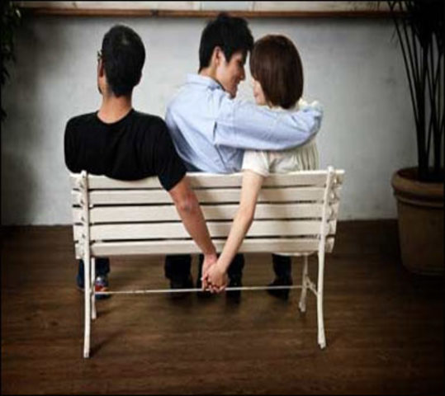
Name : Lee Soo-Geun

Born : February 10, 1975
Job : Comedian
Scandals  - Alleged sports gambling  - Visiting illegal private gambling websites | 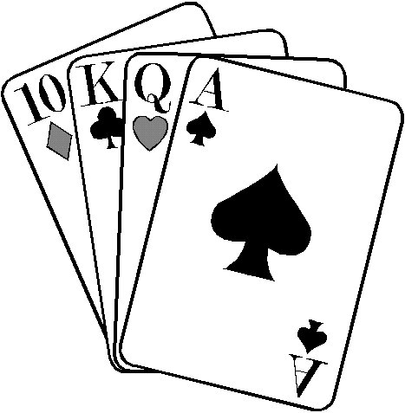
Name : Amy (Lee Yoon-Ji)

Born : 1982
Job : Entertainer
Scandals

- Propofol abuse
- Repeated drug abuse
- Mandatory expulsion

Name : Noh Hong-Chul

Born : March 31, 1979
Job : Entertainer, Entrepreneur
Scandals

- Drunk driving

APPENDIX 7

“London bridge is falling down,
falling down,
falling down.
London bridge is falling down,
my fair lady.”

APPENDIX 8
clothes | snow | winter | English
school | vacation | bank | coffee
motorcycle | restaurant | family | computer
backpack | Starbucks | London | Tesol

APPENDIX 9
I can make puppy clothes.

APPENDIX 10

C L M
T A E
R G N

APPENDIX 11
S K J K T C C S U R
Q P D Q F Y H A J M
H A V E H O D M N A
V E X R U G S X D Y
S Z M L J D Q O O T
K U D O T E V A H T
S A H T C L A A I S
W F V N L E D W T U
T R Z I Z L B K R M
O C W P N V I H Y L

CAN
HAVETO
MAY
MUST
SHOULD
WILL

