Listening Speaking Grammar Reading Writing

Topic: I KWOW WHAT YOU DID LAST SUMMER (Past Tense)

Instructor:  Sung Mi | Level:  Upper-Intermediate | Students:  9 | Length:  30 Minutes

Materials:
- Scramble sentence worksheet for explanation (2 copies)
- Scramble sentence answer sheets (2 copies)
- Visuals (Past tense, Map, Movie poster)
- Dialogue wall chart
- Blank sheet of paper
- White Board, and Board Markers
- My porter sample

Aims:
- Main: To enable students to improve their grammar skills by students making
And utilizing the grammatical sentences with the partner.

- Secondary: Students will learn about past tens by doing worksheet (reorder scramble word) and make Ss’s own sentences to describe their situation.

- Personal: I want to clarify my instruction, try not to lead much by Teacher and let the Ss do by themselves and I’ll focus on to follow the staging exactly and not forget the ICQs and CCQs in the right time.

Language Skills:
- Speaking: Students will have opportunities to talk in pairs.
- Reading: Students will read the written dialogue.
- Writing: Students will be engaged in writing with many activities
- Listening: Students will listen to each other's conversation.

Language Systems:
- Function: asking questions
- Lexis: assumed, vacation, time machine
- Discourse: sharing the experience in last summer
- Phonology: none to discuss
- Grammar: past tense (~ed, was/were)

Assumptions:
- Students have done a dialogue activity.
- Students have done a role play activity before.
- Students know how to express themselves.
- Students can match tense and make the sentences.

Anticipated Problems and Solutions:
- I am planning not to talk too much but students might have too many questions for me when they are doing the reorder the scramble word activity.
- I will tell the students that they will learn about it after. If they still have questions, I will answer them during break time or after class.

- I might need more time to complete my 30 minutes micro-teaching since some class members could be running late
- I will make a free conversation time short and try to reduce any comments.

- For the dialogue activity, I need too much time to write the whole sentences down.
- I will use my wall-chart. All I need to do is to make it clear and big enough to see.

- Students might read to slow when they do the conversational activity which may affect time management.
- I will follow the one-half rule for the main activity which we will only get half the students to present or one-third rule when students present and give the rest of the answers on a wall chart for the pre-activity.

References:
- Simple past tense structure
http://www.grammar-monster.com/glossary/past_tense.htm

- Movie poster named ‘I know what you did last summer poster’
https://www.google.co.kr/search?q=map+image&biw=1225&bih=773&tbm=isch&tbo=u&source=univ&sa=X&sqi=2&ved=0ahUKEwiC3sfW1ZXLAhVlE6YKHTbRBxoQ7AkINA#tbm=isch&q=i+know+what+you+did+last+summer&imgrc=1O96H_WjDQJXUM%3A

- Map picture
https://www.google.co.kr/search?q=map+image&biw=1225&bih=773&tbm=isch&tbo=u&source=univ&sa=X&sqi=2&ved=0ahUKEwiC3sfW1ZXLAhVlE6YKHTbRBxoQ7AkINA#imgrc=kcGegaOdg4ouVM%3A

Lead-In (2 minutes)
Materials: - none

Time | Set Up | Procedure
2min | T-S | Hello everyone. I hope you had a great Friday night yesterday.  Alice, what do you usually do in you free time?  Do you have any reason for that?  Oh, I see. Thanks for sharing.  Isabel, what is your favorite movie?  Why do you like that and any special story for this movie?  Good for them! Thank you for sharing.

Pre-Activity (8 minutes)
Materials:
- Picture of past tense
- Wall chart for worksheet
- Answer sheet
- White Board, and Board Markers

Time | Set Up | Procedure
(Total 8min) | T-WC  Ss-Ss | - Eliciting  So, class!  In grammatical tense, there is the principal function which is to place an action or situation in past time.  Simply the things that have already happened? _Past tense  Good!  - CCQ  (Show the wall chart for past tense)  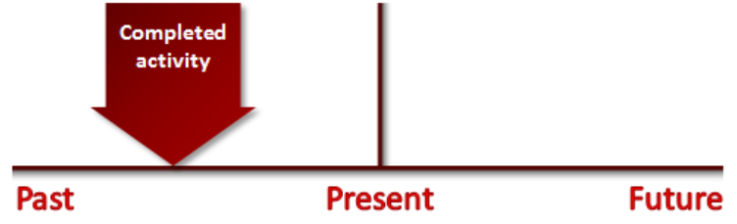  (Point to the future) Is this time a ‘Past Tense’? _ NO  (Point to the future) Now I’m here. Is this time ‘Past Tense’? _ NO  (Then, point to the past) I went to the movie theater last night. Is it a ‘Past Tense’? _Yes  Great!  (Write down ‘Past Tense’ on the board and put the wall chart for pattern (1) and (2) for past tense)  <Grouping – Pairs>  Can you say Past / tense?  Great! who said past? Please come to this side.  Who said tense? Please come to this side.  1 and 2 is one pair, 3~4, 5~6 and 7~8 is one pair.  - Demonstration  (Put the wall chart for example of Past tense on the board)  you yesterday watch did TV?  - I _____ TV yesterday.  - Instruction  Now I am going to give you 3 minutes.  What you have to do is to reorder the scramble sentences to make the question and answer properly. You can make the answer with past tense for the verb which is in the question.  - ICQ  - What are you going to do? _reorder the scrambled sentences to make the question and answer.  - Are you working individually? _NO in pair  - How much time do you have? _ 3 minutes  - Explicit Instruction  - I don’t want you to start before I say begin.  - Explicit ICQ  - Are you going to do it right after you get the paper? _NO  - When I say begin? _YES  Let's begin  - Runs  (Students do their work in groups and I monitor the class and check the time)  (1 minutes, 30 seconds, 0 seconds, times up)  - Close  Ok, who’s the youngest? Please write down your group's answer.  Check the answers.  (no time for checking all the 6 answers, at least together and give them a answer sheet)
  Pattern (2) | Pattern (2)
  Subject + verb + ed | Subject +was/were
  We studied English last night.  She called me this morning. | We were at my grandfather’s house yesterday.  I was 30 years old last year.

Main Activity (12 minutes)
Materials: - Wall chart for conversation
- White Board, and Board Markers
- Blank sheet of paper

Time | Set Up | Procedure
(Total 12min) | T-WC  Ss-Ss  T-WC  Ss - Ss | - Eliciting  So, class!  What do we call the period of free time without work?  In this free time, the people usually take a rest with some fun activity or visit somewhere to make the energy. _Vacation  <Grouping – Pairs>  Can you say Vaca / tion?  Great! who said vaca? Please come to this side.  Who said tion? Please come to this side.  1 and 2 is one pair, 3~4, 5~6 and 7~8 is one pair.  - Demonstration  Put the wall chart on the board  Let's read this dialogue about the last vacation together.  (Wall Chart)  Kirix: Hi Jenny, have you ever seen the movie named ‘Nightmare’?  Jenny: Yes. I like that movie, that kind of horror movie.  Kirix: I don’t like that kind of movie. It followed me around even my dream.  Jenny: Understand! Anyway, Kirix what did you do in your last summer vacation?  Kirix: I visited to Whisler in last summer vacation. It was awesome!  Jenny: Oh Mount Whisler? Great! What did you do there?  Kirix: I walked all the village and skied from the top to the down. It was extremely fun. How about you?  Jenny: I learned English to get the certificate named ‘TESOL’. It was too hard then that I thought.  Kirix: Wow! Did you get the certification?  Jenney: Year I got it ☺  - Instruction  Now, it is time to make your own conversation with your partner based on this wall chart. You can share your experience in your last summer. What did you do in that time? Where and with whom? Also you can describe what was your feeling at there?  I am going to give you 5 minutes.  - ICQ  - What are you going to do? _Making a conversation  - Are you working individually? _No in pairs.  - How much time you have? _5minutes  - Explicit Instruction  - I don't want you to start before I say begin.  - Explicit ICQ  - Can you start before I say begin? _No  - When I say begin? _Yes  (Handing out the paper)  Being!  - Run  (Students will make their own dialogue.)  (1 minute, 30 seconds, 10 seconds, times up)  - Close  ___and ___, can you start your conversation?  (if running out of time, make only 2 pairs present - one-half rule)

Post Activity (7minutes)
Materials: - Pictures (Map, Movie poster named ‘I know what you did in last summer')
- White Board, and Board Markers
- Blank sheet of paper
- My own picture drawing

Time | Set Up | Procedure
(Total  7min) | T-WC  Individual | - Eliciting  So, class!  What do you call that printed picture that shows main theme of the movies to advertisement.  Nobody?  When we’d like to see the movie, we can see this in the web site to grasp the theme of this movie and the main actors and actresses in this picture. _Poster  - CCQ  (Show the picture of a map) Is this a poster? _ NO  (Show the poster) Is this poster? _ YES  Great!  - Demonstration  So, let me show you my own perter.  I tried to show you my image in this poster.  - Instruction  Now, I am going to give you 3minuts to make your own poster that bring you the good memory when you’re young, just like mine.  - ICQ  - What are you going to do? _Make my poster  - Are you working individually? _Yes  - How much time you have? _3 minutes  - Explicit Instruction  - I don’t want you to start before I say begin.  - Explicit ICQ  - Do you start before I say begin? _No  - When I say begin? _Yes  - Begin!  - Run  (Students draw their own poster and I monitor the class and check the time.)  (1 minute, 30 seconds, 10 seconds, times up)  - Close  Great! ____ can you show us your poster and explain about it?  (Ask 2~3 more students) Well done class.  I did not catch any mistakes so can you unscramble this?  (Error correction or unscramble a word “TSAP ENSET”)

SOS Activities
Materials: No needed

Time | Set Up | Procedure
(Total 12min) | T-WC  Ss-Ss | - Eliciting  Now class, What is call the machine in which people can be traveled into the past or the future? _Time machine  Great!  - CCQ  (Show the picture of television) Is this a time machine? _ NO  (Show the time machine) Is this time machine? _ YES  Great!  Let’s imagine that we’re going to travel with the time machine to 10 years before. We can go anywhere that we want and can experience whatever we want.  - Demonstration  10 years ago, I proposed a variety of proposal without day and night.  - Instruction  Now, I will give you 30 seconds to think and talk about what you did when you traveled to 10 years before with the time machine.  - Run  (The class now begins think about your time travel and discuss about it with your pair)  - Close  So, ___ did you find anything interesting from your pair?  (Error correction or unscramble a word " CINHAEM MITE ")

- Wall Chart (Past Tense)

- Visual (Map, Movie poster)
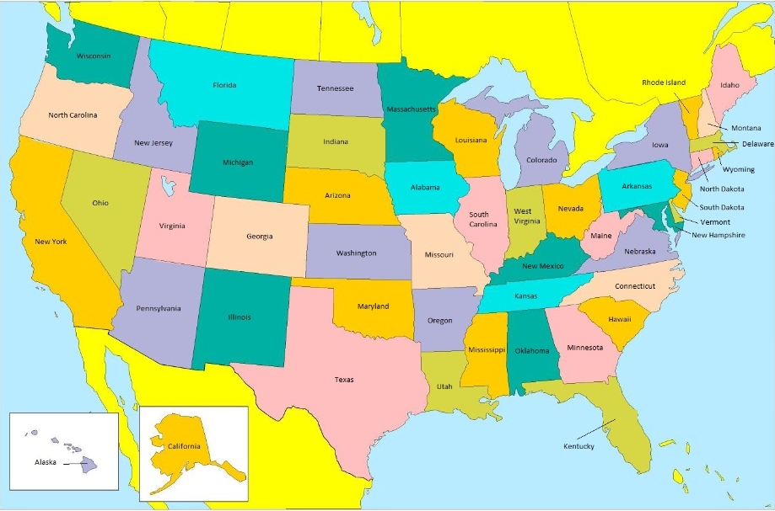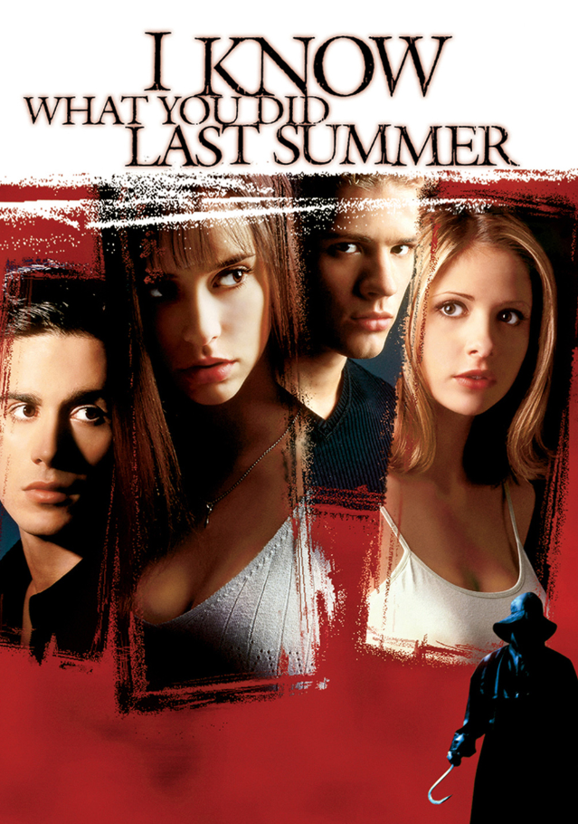

- Work sheet

Reorder the scrambled sentences for the question, and answer with past tense.
Demo | you yesterday watch did TV?  → I ________ TV yesterday
1 | stay did who with you?  → I ________ with my best friend
2 | days Europe you how did many traveled in?  → I ________ Europe for 10 days
3 | Learn to you cook how where did?  → I ________ from my mom
4 | Did him love you much how?  → I ________ him so much!
5 | school high you did where you’re in live high?  → I ________ in Canada when I was in high school.
6 | Last time night raining it did what last?  → It ________ raining from 5 pm

- Wall Chart
Pattern (1) | Pattern (2)
Subject + verb + ed | Subject +was/were
We studied English last night.  She called me this morning. | We were at my grandfather’s house yesterday.  I was 30 years old last year.

- My Own Poster


