Listening Speaking Reading Grammar Writing

Topic: Ordering food at the restaurant

Instructor:  Susan (Jiwon Her) | Level:  Intermediate | Students:  8 | Length:  30 Minutes

Materials:
- White board & Board Markers
- Each students either need to bring their own electronic dictionaries or their cellphone
- Projectors / Internet accessed laptop
- Drill practice sheet (8 copies)
- Dialogues (8 copies)
- Menus (4 copies)
Aims :
- To learn how to order food at the restaurant
- To familiarize students with basic vocabulary items, e.g. starters, main course, dessert, etc.
- To learn the usage of modal verbs, i.e., can and would like, to make requests and/or offers and fillers, e.g., certainly, you’re welcome, the same to you, etc., through dialogue reading and pair work.
Language Skills :
- Listening : Carefully listen to classmates as well as listen to the video clip
- Reading : Reading dialogues to familiarize with the dialogues for practicing
- Speaking : Role-playing / Sharing answers and opinions one another
- Writing : Jot down answers from classmates.
Language systems :
- Lexis : Words both on the menus and dialogues
- Function : Ordering food in a restaurant with modal verbs (“would like” & “can”) – the use of “would like” for making offers and requests in a more polite way and “can” in a more casual way.
- Grammar : Modal verb usage of “would like” and “can”
- Discourse : Sharing answers and opinions one another
Assumptions :
- Students already know :
Instructor’s teaching style and the pace of the course
They will face the real situation to go to the restaurant.
Anticipated Errors and Solutions :
- Students may not familiar with vocabularies.
Solution : Eliciting questions to the students or let them to find the definitions from the dictionaries.
References :
- https://www.youtube.com/watch?v=sIWm5Fi8Z7Q

Pre-task
Materials: White board & marker, Menu sheet
Time | Set Up | Student Activity | Teacher Talk
5 min | T-SS | Answering | (Lead in)  Good morning class! Did you have breakfast? Everyone?  Student answers : (Yes or No)  Do you ever been to any restaurant?  Student answer : Yes  Since everyone has some experiences to go to restaurant. Today, we will going to learn how to order food at the restaurant in English.  (Ask students to name different types of food found in a restaurant. Write the vocabulary items on the board and make sure students also take notes. Teach the vocabulary items on the menu if they are not included on the board.)  What types of food we can eat at the Italian restaurant? Maria?  Maria ; Spagetti? (Write it on the board)  Kelly: Pizza ? (Write it on the board)  June : Soup?  Yes. And there are more things we can eat at the restaurant. (Distribute Menu sheet. )  Now, by using your own electronic dictionaries to find the meanings of the words then write it beside the words on your Menu sheet individually.

Task -Preparation
Materials: White Board, Markers,
Time | Set Up | Student Activity | Teacher Talk
10minutes  (1)  (2)  (3) | T-SS  SS  S-S  T-SS | Answer  Reading  Reading | (Distribute Drill sheets )  Instruction  Find your partner to practice it at least two times. I will give you two minutes.  ICQ : What do you need to now?  Students : Find our partner to practice it.  (Students read drills each other)  All right. (Give out Dialogues) What’s the difference between “would you like”? and “can?”  Sue ?  Sue : “would you like ?” feels more polite and “can?” seems like more casual.  Absolutely right!  Now Let’s suppose one of you named as Kitty. Kitty is going to have lunch in a restaurant. Read the following dialogue carefully with your partner to see how Kitty orders her food. You have 3 minutes to do it.  (Students read the dialogues)  (CCQ)Ok everyone, so what does kitty orders first? Nana?  Nana : she ordered starters as a bowl of chicken soup?  (CCQ)Yes and next? June  June : Then She orders cheese burger as main course.  (CCQ)That’s right and what drink she would like to have? Ilhye?  Ilhye : A glass of coke  Yes Brilliant ! everyone

Task Realization
Materials: Menu sheet , Dialogue sheet.
Time | Set Up | Student Activity | Teacher Talk
10 minutes  (5) | T-S |  | (Pair students up and ask them to use the menu to role play through ordering a meal. Both students should switch roles a number of times)  Instructions  Now with your partner, take roles each other in turn then Let’s do role-playing with menus to change the food name. You may switch roles each other to do it several times.  ICQ  Do you need to switch your roles each other?  Students : Yes  You have 5 minutes do it.  Time is up. Good job ! Now we would like to see yours. Any volunteers?  (Volunteer student will give short role-playing presentation in their seats. Or if there are no volunteers, You can nominate one team as example role-playing presentation)
Post Activity
Materials: Drill sheets
Time | Set Up | Student Activity | Teacher Talk
5 minutes | T-SS | Listen | Fabulous work today, everyone, before ending our class, Let’s review we have learned in today’s class. Let’s practice drills without seeing it.  Let’s suppose I’m a waiter, and you are customer say.  Can I help you?  Students say :I'd like to have the set lunch  Would you like to have a starter?  Students : I'd like to have a bowl of chicken soup, please.  And what would you like to have for the main course?  Students : I'd like to have a grilled cheese sandwich. (food name can be changeable)  Would you like anything to drink?  Students : I'd like to have a glass of Coke. ( it can be changeable)  Excellent ! everyone!  Did you enjoy the class?  Student : Yes !  Can you make an order at the restaurant now?  Student : Yes !

SOS Activity : I can play a short video clip and let them to discuss about it.

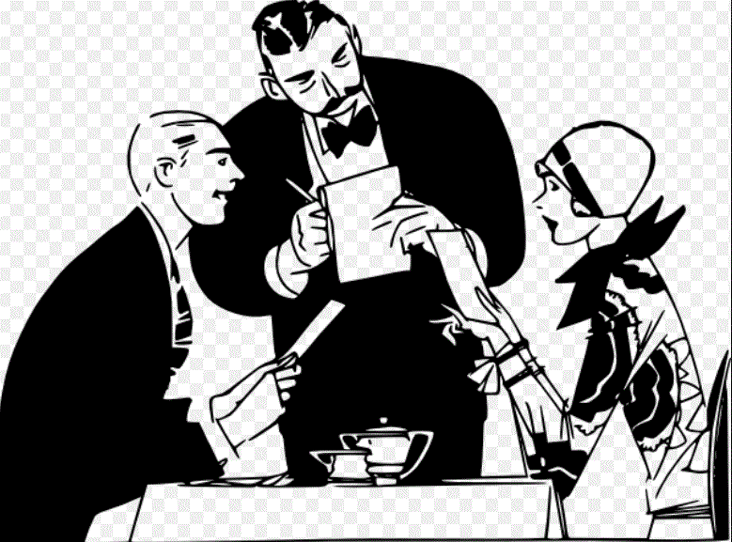

DRILLS
Making offers: (A)
Can I help you?
Would you like to have a starter?
Would you like anything to drink?
Can I bring you anything else?

Making requests: (B)
I'd like to have the set lunch.
I'd like to have a bowl of chicken soup, please.
I'd like to have a glass of Coke
I'd like to have a grilled cheese sandwich.
I’d like to have the bill.

DIALOGUE
Waiter : Hello. Can I help you?
Kitty : Yes. I'd like to have lunch.
Waiter : Would you like to have a starter?
Kitty : Yes, I'd like to have a bowl of chicken soup, please.
Waiter : And what would you like to have for the main course?
Kitty : I'd like to have cheese burger.
Waiter : Would you like anything to drink?
Kitty : Yes, I'd like to have a glass of Coke.
Waiter (After Kitty having her lunch) : Can I bring you anything else? Kitty : No thank you. But I’d like to have the bill, please.
Waiter : Certainly. (After a moment) That's $34.
Kitty : Here you are. Thank you very much.
Waiter : You're welcome. Have a nice day.
Kitty : Thank you, same to you.

