Listening Speaking Reading Grammar Writing

Topic: Being bilingual may delay dementia

Instructor:  Susan (Jiwon Her) | Level:  Upper- Intermediate | Students:  8 | Length:  30 Minutes

Materials:
- White board & Board Markers
- Each students either need to bring their own electronic dictionaries or their cellphone
- Reading Article (8 copies)
- Synonym Match Worksheet (8 copies)
- Comprehension Question Worksheet(8 copies)
- Warm up Worksheets (4 Copies)
Aims :
Main Goal : Students will familiarize with the contents regarding the topic
Secondary Goal : Students will learn a series of vocabulary
Personal Goal : Giving ICQ after the instruction
Language Skills :
- Listening : Need to listen to partner’s opinion
- Reading : Reading materials
- Speaking : Sharing ideas each other
- Writing : Jot down answers from classmates.
Language systems :
- Lexis : New vocabulary as well as synonyms
- Function : Thinking about what will benefit to brain
- Discourse : Sharing answers and opinions one another
Assumptions :
- Students already know :
Instructor’s teaching style and the pace of the course
Anticipated Errors and Solutions :
- Students may not familiar with vocabularies.
Solution : Eliciting questions to the students or let them to find the definitions from the dictionaries.
References :
- www.BreakingNewsEnglish.com

Lead - in
Materials: White board & marker
Time | Set Up | Student Activity | Teacher Talk
5 min | T-SS | Answering | Good morning! Everyone, Did you have a nice sleep ?  Some students may say ; YES  Some will say : No or Not really?  Nice sleep will highly helpful for our brain to work properly. Anyway what other factor will contribute to healthy brain?  Possible answers from the students : Balanced Diet / Nutrition / Exercise …etc  Yes All right answers. But Do you ever think of that learn foreign languages helpful to our brain?  Some student may say with Surprised facial expressions : Yes or NO

Presentation (Top-Down Model)
Materials: White Board, Markers, Projectors, PPT, Synonym worksheet
Time | Set Up | Student Activity | Teacher Talk
10minutes  (1) | T-SS | Answer  Reading  (SS) | Ok Class. Today, before going to read the article, let’s go over some new words.  (Showing the ppt)  Mono (One) + Lingual (Ability to speak language)  = A person who can speak only language  Bi (Two) + Lingual (Ability to speak language)  = A person who can speak two languages  Tri (Three) + Lingual (Ability to speak language)  = A person who can speak three languages.  Multi (Several) +Lingual (Ability to speak language)  = A person who can speak more than three languages  (CCQ) Can he speak two languages?  Students : No. He can only speak one language.  (CCQ) Is he monolingual?  Students : No. He is multilingual.  Good! Next  - Literate = A person who can read and write  - illiterate = A person who Unable to read or write:  (CCQ) Is he literate?  Students : Yes  (CCQ) Is she illiterate?  Students : Yes  Dementia refers to Alzheimer’s disease. A disease that affects our brain to kill brain cells.  (CCQ) Is dementia horrible?  Students : Yes ~!  (Distribute synonym worksheets) Now, by using your own cell phone or dictionary, find the definitions of the words shown in the worksheets. Then match the following synonyms from the article. And sharing answers with your partner. I will give you 5 minutes to do it.  (ICQ) Can you use your cell phone to find the words?  Students : Yes  (Students are doing worksheets)

Practice( Top- down Model)
Materials: Article, Comprehension questions worksheet
Time | Set Up | Student Activity
10 minutes | T-S  S-S |  | Now It’s time to read the article. What’s the topic of the article? Nana?  Nana : Learn foreign language is helpful for maintaining healthy brain?  Yes  (Distribute comprehension question worksheet) Now Read the articles to find answers for comprehension questions. Then share your answers and reasons with your partner. I will give you 7 minutes to do it.  (ICQ) What do you need to do now?  Students : Read the article and find the answers for the questions.  Teacher : And?  Students : Share our answers and reasons with partner.  Teacher : Great  (S-S interaction)  You have 30 seconds.  (Ask answers and clues for questions in turn for each groups)
Post Activity
Materials: Warm up sheets
Time | Set Up | Student Activity | Teacher Talk
5 minutes | T-SS  S-S | Listen | Ok. Did you enjoy the class?  Students : Yes  Now Let’s have a fun ( Distribute warm-up sheets) Rank these and share your rankings with your partner. Put the things that are best for the brain at the top. Change partners often and share your rankings.  (Working with partner)  You have 30 seconds to finish it.  Ok We’ve got to finish our class now. Today’s assignment is to prepare short presentations why something is best for your brains.  (Finish the class)

SYNONYM MATCH
Match the following synonyms from the article.
Name :
Date :

- study a. leading to
2. delay b. proved / proven
3. types c. away
4. contributing to d. analysed
5. at bay e. benefit
6. gender f. postpone
7. evaluated g. for good
8. advantage h. sex
9. confirmed i. report
10. permanently j. kinds

TOPIC : Being bilingual may delay dementia
A new study shows that being bilingual may delay dementia by five or
more years. Researchers from the University of Edinburgh in Scotland discovered that people who spoke two languages did not show any signs of three types of dementia for more than four years longer than those who were monolingual. A co-author of the report, Dr. Thomas Bak, said:
"Bilingualism can be seen as a successful brain training, contributing to cognitive reserve, which can help delay dementia." This means that speaking two languages keeps the brain in better health and helps to
keep diseases like Alzheimer's at bay for longer than if someone spoke just one language.
Dr Bak's research found that bilingualism and the delaying of dementia
had little to do with social status, gender, occupation or educational background. Bak's team evaluated the medical records of 648 people from India who had been diagnosed with dementia. Of these patients, 391 were bilingual or trilingual and many were illiterate. Dr Bak wrote:
"The fact that bilingual advantage is not caused by any differences in education is confirmed by the fact that it was also found in illiterates, who have never attended any school." He suggested that learning a
language later in life could keep the brain healthier. He said language learning was "socially more enjoyable, and it forces your brain to train permanently".
COMPREHENSION QUESTIONS Name :
Date :
Q1 : Which university conducted this research?

Q2 : What did Dr Bak say bilingualism can be seen as?

Q3 : How many of Dr Bak's case studies spoke two or more languages?

Q4 : What had many of the illiterate people never done?

BRAIN
Name :
Date :
Rank these and share your rankings with your partner. Put the things that are best for the brain at the top. Change partners often and share your rankings.

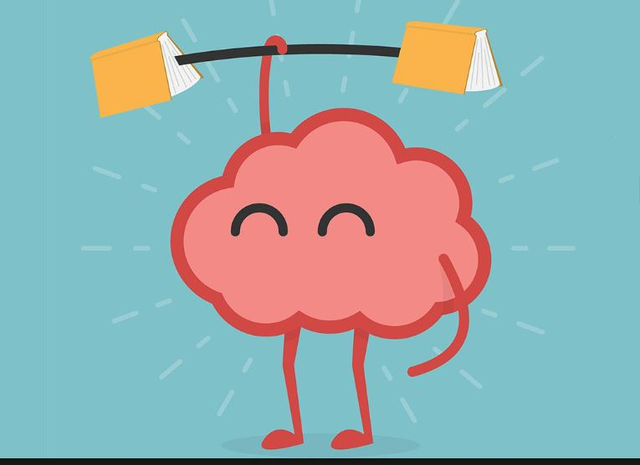
• reading
• crossword puzzles
• using a computer
• sleep
• studying English
• exercise
• good food
• meditation
Reasons for Ranking

