The 'Untouchable' who cycled from India to Sweden ... for love
Charlotte Von Schedvin was a blonde, blue-eyed young woman who hailed from Swedish nobility.
PK Mahanandia was a poor art student from eastern India, seen as an "untouchable" in his country's caste system.
Mahanandia and Charlotte’s love story transcends time and distance.

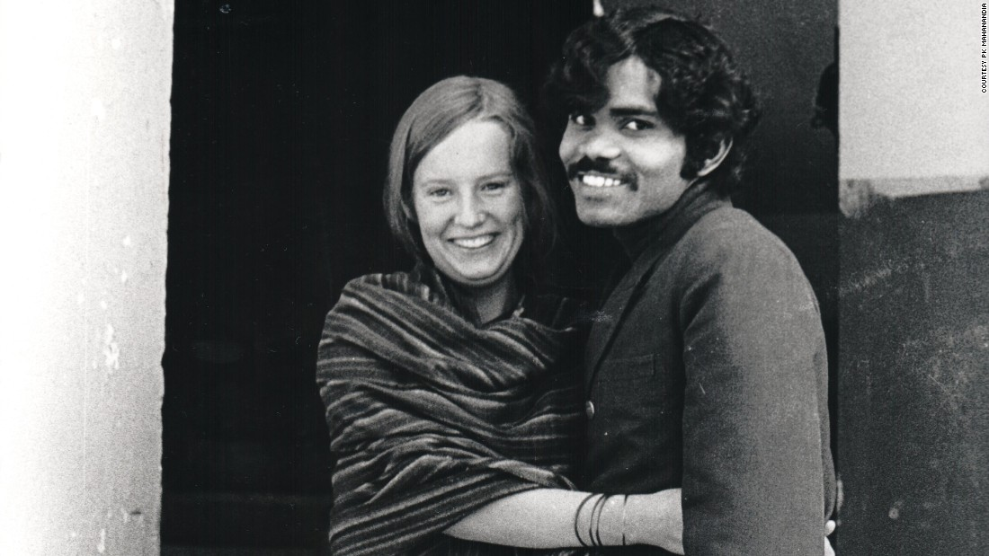

It all began in 1975, when Mahanandia joined the College of Art in New Delhi and became known for his portraits. Chalotte heard about Mahanandia’s work, and travelled to India to get her portrait painted.

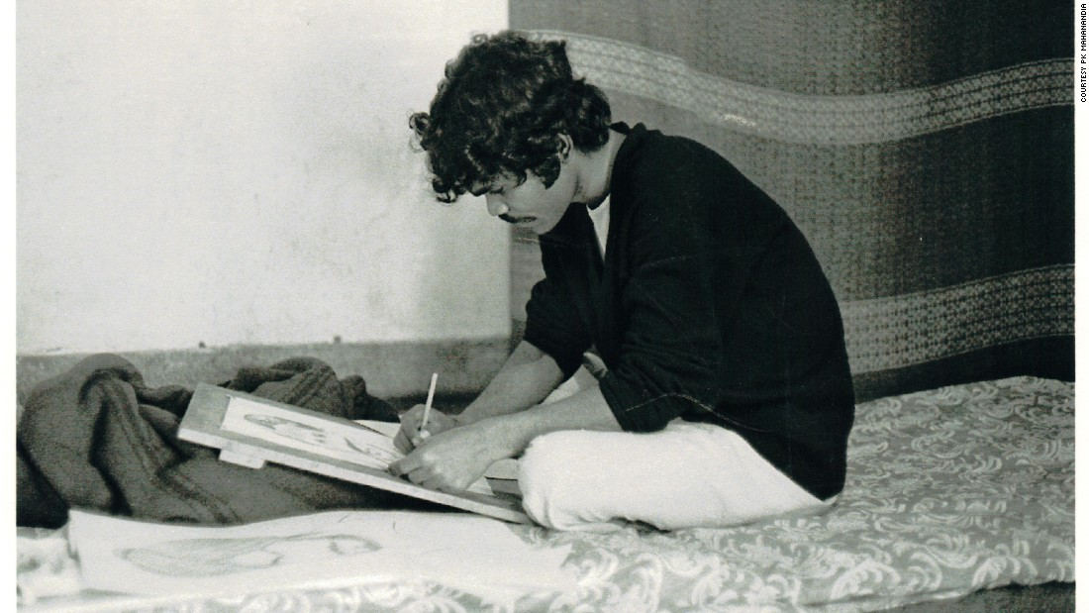

As the days passed, the two fell in love, but Chalotte had to return to Sweden. She asked Mahanandia to come along, but he wanted to finish his studies first. She offered to pay for his plane ticket when he was done school, but Mahanandia refused and said “I would come to meet you on my own.”

The two separated, but kept in touch through letters.

Three years later, Mahanandia sold all his possessions and bought a second-hand bike. He then set out on a journey that would take him through Afghanistan, Iran, Turkey, Bulgaria, Yugoslavia, Germany, Austria and Denmark to reach the love of his life.

His bike broke down many times on the way. Mahanandia also went without food for days. But after four months and three weeks, Mahanandia finally reached Gothenburg, Sweden.
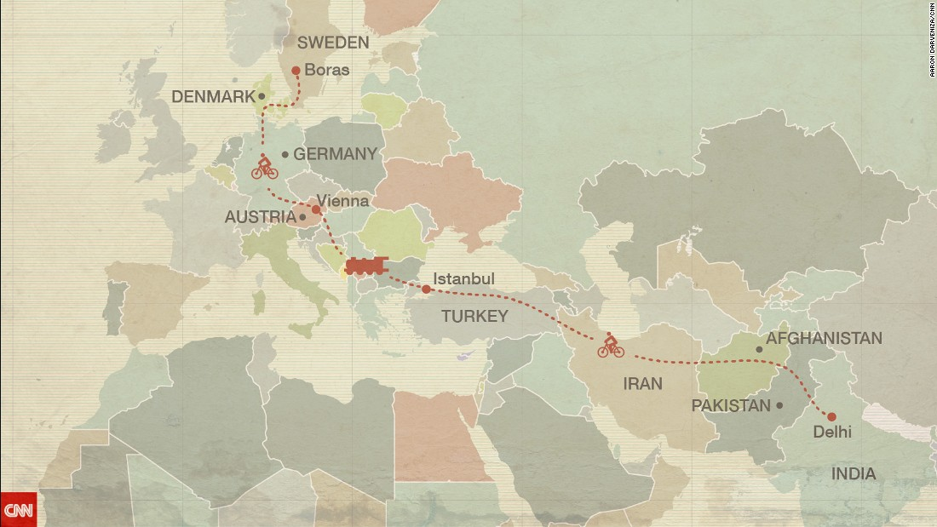

Mahanandia was stopped by Swedish immigration officers, who were surprised to learn he travelled all the way from India by bicycle and that “royal blood from Europe would marry a poor Indian.”

Charlotte drove to Gothenburg after she heard about the incident, and was thrilled to see her love.

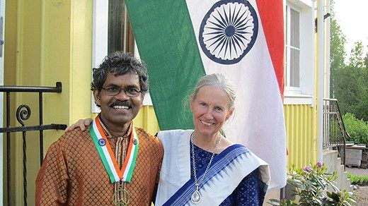

Today, the couple have been happily married for 40 years, living in Sweden with their two children.
