- Appendix 1

Material 1 – Pre-activity

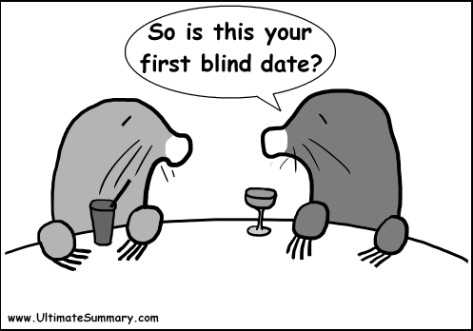

- Appendix 2

For print-out
- Appendix 3

Dialogue 1
A: It's spring! I’d like to set you up with my co-worker. How's that?
B: Yes. What is his personality like?
A: His character is sensitive and caring. He has a strong sense of responsibility.
B: Well..What does he do?
A: He is a lawyer.
B: Oh..What does he look like?
A: Um...He is a little chubby and bald. But he has a nice smile.
Remember! a little chubby.
B: Show me his picture.
A: Here.
B: OOPS! He is so fat!!!
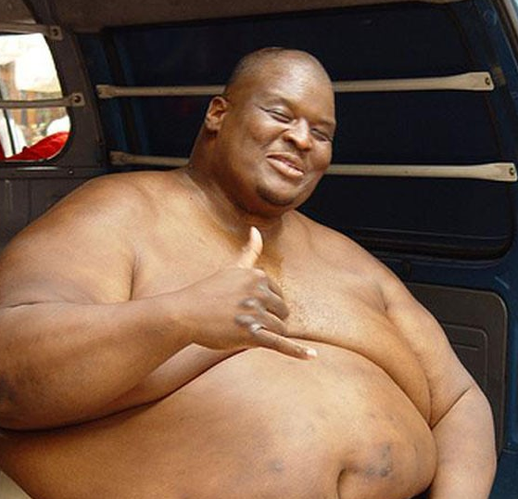

- Appendix 4

Dialogue 1
A: It's spring! I’d like to set you up with my co-worker. How's that?
B: Yes. What is his _______________ like?
A: His character is ________and________. He has a strong ___________________.
B: Well..What does he do?
A: He is a __________.
B: Oh..What does he look like?
A: Um...He is a little __________ and ______. But he has a nice smile.
Remember! a little __________.
B: Show me his picture.
A: Here.
B: OOPS! He is so ________!!!

- Appendix 5

Dialogue 2
A: I know a perfect guy for you. I’m going to set you up with my friend
B: Sure! What does he look like?
A: He looks like Mickey Mouse. He is a smooth talker and he wears glasses.
B: Not good. I don't want to see him.
A: I think you go together very well.
B: Well..What is his personality like?
A: He has a sense of humor, He makes people laugh. He is sociable.
B: What does he do?
A: He is a famous comedian in Korea.
B: I don't know well, comedian. Can I see his picture?
A: Here.
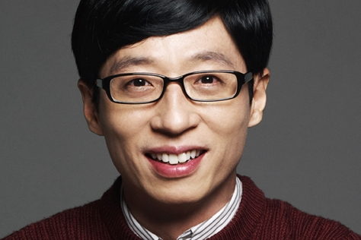

- Appendix 6

Dialogue 2
A: I know a perfect guy for you. I’m going to_________you up with my friend
B: Sure! What does he look like?
A: He looks like Mickey Mouse. He is a _________ and he wears glasses.
B: Not good. I don't want to see him.
A: I think you go together very well.
B: Well..What is his __________ like?
A: He has a ____________, He makes people laugh. He is _______,
B: What does he do?
A: He is a famous __________ in Korea.
B: I don't know well, _________. Can I see his picture?
A: Here.

- Appendix 7

Material 1 – Main activity
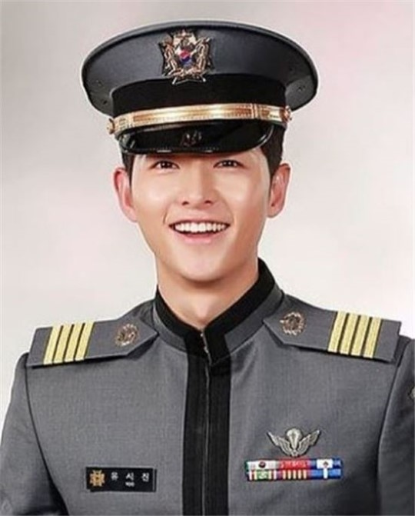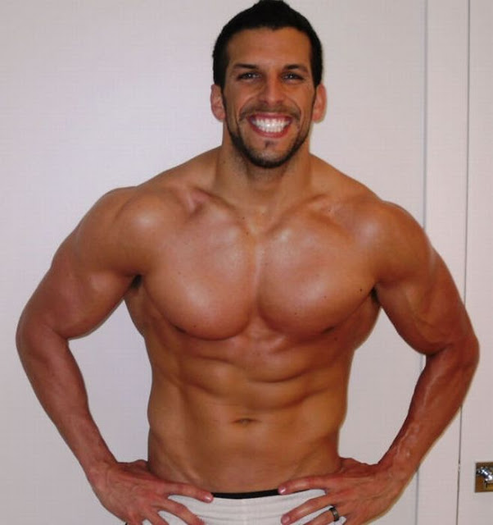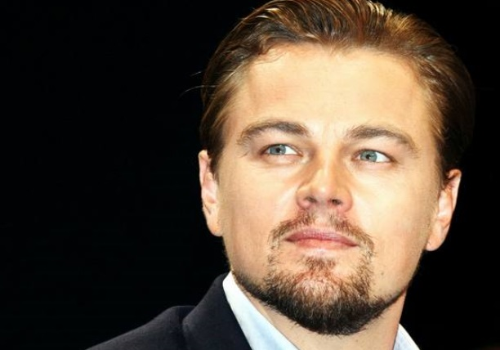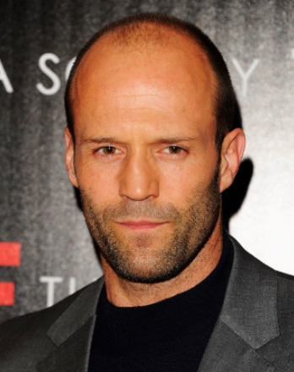

- Appendix 8

Material 2- Main activity

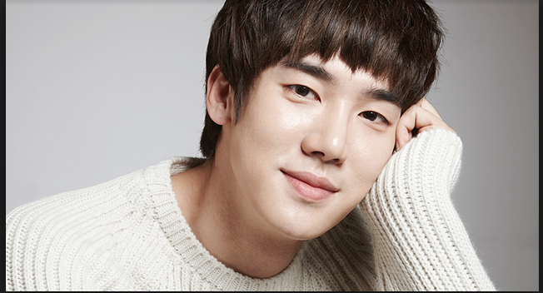
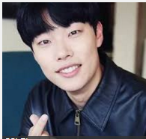
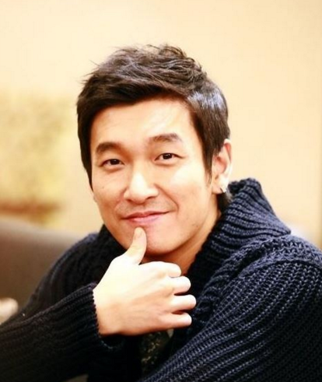
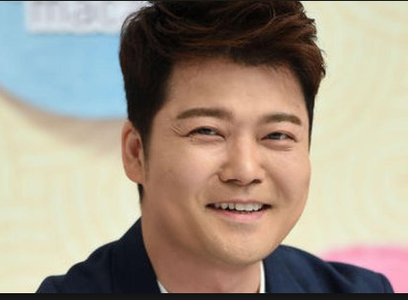
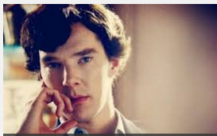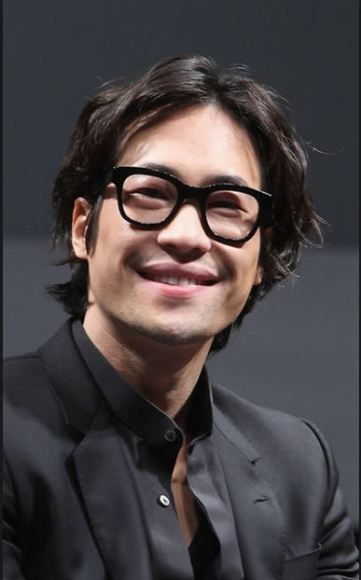

- Appendix9

- Appendix 9

Talking about blind dates and dating

Did you ever arrange a blind date?
Have you ever been on a blind date?
How many blind dates have you been on?
What’s the most embarrassing date you have ever been on?
What is the most thoughtful gift you’ve ever given?
What is the best gift you’ve ever received?
If you were going to go on a blind date, what 3 questions would you like to ask first?
What do you hate most about meeting someone on a first date?
Do you like dressing in casuals or formals?
Who do you speak to when you’re having a hard time in love?
How old were you when you had your first crush?
How long ago was your last relationship?
Do you like blind dates or not? Why?
When was the recent blind date? How was it?
What is your ideal type?

- Appendix 10
Blind dates
Word search
J | C | H | E | Q | S | O | C | I | A | B | L | E | M | V
W | I | W | G | T | Z | C | N | E | T | J | L | T | U | B
A | C | C | O | B | P | H | P | A | N | D | A | D | S | D
A | V | A | R | P | F | P | F | I | Q | Q | R | Y | C | G
P | B | R | G | R | T | V | A | U | T | A | S | T | U | A
T | B | I | E | L | I | L | T | M | E | A | A | A | L | S
H | G | N | O | W | P | V | D | B | U | F | T | X | A | E
O | U | G | U | Z | W | W | H | A | A | M | T | E | R | N
U | H | V | S | K | S | B | A | L | D | S | R | S | C | S
G | I | V | V | Z | T | O | W | G | A | R | A | G | R | I
H | B | N | V | W | U | J | H | F | X | Q | C | O | P | T
T | J | B | Z | Z | B | D | A | Q | W | G | T | P | Q | I
F | C | H | U | B | B | Y | R | G | O | M | I | H | Y | V
U | Q | W | K | X | L | O | X | F | B | E | V | M | V | E
L | R | X | B | Q | E | X | Z | V | J | G | E | L | V | I

ATTRACTIVE
BALD
BEARD
CARING
CHUBBY
GORGEOUS
MUSCULAR
PLAIN
SENSITIVE
SOCIABLE
STUBBLE
THOUGHTFUL

- Appendix 11
Blind dates
Word search Answer
J | C | H | E | Q | S | O | C | I | A | B | L | E | M | V
W | I | W | G | T | Z | C | N | E | T | J | L | T | U | B
A | C | C | O | B | P | H | P | A | N | D | A | D | S | D
A | V | A | R | P | F | P | F | I | Q | Q | R | Y | C | G
P | B | R | G | R | T | V | A | U | T | A | S | T | U | A
T | B | I | E | L | I | L | T | M | E | A | A | A | L | S
H | G | N | O | W | P | V | D | B | U | F | T | X | A | E
O | U | G | U | Z | W | W | H | A | A | M | T | E | R | N
U | H | V | S | K | S | B | A | L | D | S | R | S | C | S
G | I | V | V | Z | T | O | W | G | A | R | A | G | R | I
H | B | N | V | W | U | J | H | F | X | Q | C | O | P | T
T | J | B | Z | Z | B | D | A | Q | W | G | T | P | Q | I
F | C | H | U | B | B | Y | R | G | O | M | I | H | Y | V
U | Q | W | K | X | L | O | X | F | B | E | V | M | V | E
L | R | X | B | Q | E | X | Z | V | J | G | E | L | V | I

ATTRACTIVE
BALD
BEARD
CARING
CHUBBY
GORGEOUS
MUSCULAR
PLAIN
SENSITIVE
SOCIABLE
STUBBLE
THOUGHTFUL

