Listening Speaking Reading Grammar Writing
Topic: Vacation

Instructor:  Miri | Students Competency Level  Pre-intermediate | Number of Students:  12 | Lesson Length:  78 minutes
Materials: (List the Names of all materials used in the lesson. Materials must be shown at the end of this document)
-White Board and Markers
-Mind Map Worksheet
-Situation Cards
Situation 1
Situation 2
Situation 3

Aims: (What students will be able to achieve by participating in the activities of the lesson. (Ss gain or get by doing…)
-Improve speaking skills and discussion with a group and answering teacher.
-Improve listening skills by discussion with a group, responding to teacher.
-Improve interaction and communication skills by having discussion in a group

Language Skills: (Lists what activities language skills students will be using by participating in the activities of the lesson.)
- Reading: (Where did reading occur in the lesson?)
Situation Cards
- Listening: (Where did listening occur in the lesson?)
Teacher talk, discussion
- Speaking: (Where did speaking occur in the lesson?)
Small group discussion, answering teacher
- Writing: (Where did writing occur in the lesson?)
Notes, planning

Language Systems: (Lists what language systems students will be using by participating in the activities of the lesson.)
- Phonology: (sound)
Discussion, teacher talk, group presentation
- Function: (situation)
Trip, emergency situation
- Lexis: (meaning)
Vocabulary about trip, emergency situation
- Grammar: (language structure)
Future tense and description
- Discourse: (communication)
Discussion, responding the teacher, group presentation

Assumptions: (What students must already be able to do and what concepts must already be mastered before the lesson in order to achieve the aims of the lesson.)
- All students have experiences of a vacation.
- All students have been to exciting places and bad places.
- All students can plan where to go, what to do during vacation.
- All students have different tastes about having vacations.
Anticipated Errors and Solutions: (What things might go wrong in the lesson and what the solution will be. An SOS activity should also be included)
- If Students may not have many ideas. -> Solution: T gives them little examples.
- If activity lasts too long. -> Solution: T cuts the unnecessary parts.
- If activity finished too soon. -> Solution: T makes suggestions and shares ideas.
- If Ss may not understand. -> Solution: T shows demonstration.
- If certain Ss are shy. -> Solution: T encourages them, gives positive feedback, and changes roles for them.
References:

Lead-In or Pre-Task Part (Warm-Up Part to activate and create interest in the lesson.)
Materials: (List the Names of all materials used in the Lead-In or Pre-Task Part of the lesson. Materials must be shown at the end of this document)

Time: | Classroom Set Up: | Student Activity and Goals: | Teacher Procedure & Instructions:
1min  5min  10min | Whole  Whole  Ss | Ss greet the teacher.  Ss listen to teacher.  Ss talk their stories | Greeting.  Tell T’s stories about special or embarrassing, dangerous experiences of the vacation.  Elicit the stories from Ss.  Let’s brainstorm about vacation.

Pre-Activity or Task Familiarization Part (Presentation Part Presenting the language structure to be covered in the lesson. Prepares students for the communication activity.)
Materials: (List the Names of all materials used in the Pre-Activity or Task Familiarization Part of the lesson. Materials must be shown at the end of this document)
-White Board and Markers
-Mind Map Worksheet

Time: | Classroom Set Up: | Student Activity and Goals: | Teacher Procedure & Instructions:
2min  2min  2min  5min | Whole  Whole  Whole  Whole | Ss listen what T says.  Ss move into group.  Ss get mind map forms and think about how to do it.  Ss prepare for filling mind map | Introduce mind map forms and how to fill them.  Divide Ss into groups.  Hand out mind map forms.  Make sure that students understand. If not, Teacher describes how to do it.  Transition now it’s time to fill the blanks in mind map forms.

Main Activity or Task Realization Part (Practice to Production Part Teacher lead practice of the language presented and move to communication based more student centered activity)
Materials: (List the Names of all materials used in the Main Activity or Task Realization Part of the lesson. Materials must be shown at the end of this document)
-White Board and Markers
-Mind Map Worksheet

Time: | Classroom Set Up: | Student Activity and Goals: | Teacher Procedure & Instructions:
1min  3X  10min  5min | Whole  Groups  Groups  Whole | Ss get ready for presentations  Everything below happens three times.  Ss present. One student at a time other group watches, listens and enjoys.  Ss listen what T says. Ss applaud other students. | T gives instruction Ss to present happily.  Everything below happens three times.  T monitors each student’s mind map and listens to students’ presentations. And ask students for describing other words in their mind maps.  Give Ss positive feedback and comments. Facilitates class members’ feedback.

Post Activity or Post Task Part (Wrap-Up Part Close the Lesson on a high note to and consolidate language learned in a communication based activity new situation.)
Materials: (List the Names of all materials used in the Post Activity or Post Task Part of the lesson. Materials must be shown at the end of this document)
-White Board and Markers
-Mind Map Worksheet
-Situation Cards
Situation 1
Situation 2
Situation 3

Time: | Classroom Set Up: | Student Activity and Goals: | Teacher Procedure Instructions:
5min  10min  10min | Whole  Whole  Whole | Ss listen to the new situation from teacher.  Ss prepare for presentation  Ss tell about plan for vacation.  Ss listen. | T suggests embarrassing situation during vacation to Ss. Ss discuss in groups.  Give Ss time to prepare group presentation.  T monitors presentations and participates merrily.  Close by giving Ss feedback about their accomplishment and improvement.

Mind Map Worksheet

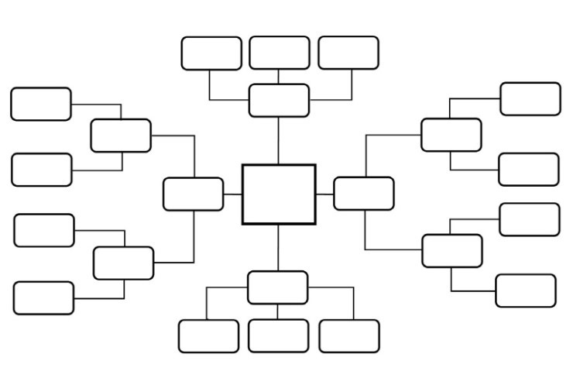

Situation Cards

Situation 1

You are on a vacation in Paris. You bought a Channel bag for your mother. While you’re waiting for the flight to Korea in an airport, You realized you left the Channel bag in a cabinet in a hotel you had stayed at.
What will you do?

Situation 2

You and your family are on a vacation in Amazon. When You are crossing the Amazon River by boat. Suddenly, the boat bumps into something and the boat seems to be sinking. What will you do?

Situation 3

You and your wife/husband are on a vacation. On the last day of your trip, your wife/husband spent all the money that he/she has earned until now on gambling.
What will you do?

