▩ Listening and Speaking Reading Grammar Writing
Topic: Throwing Parties

Instructor:  Terry | Students Competency Level  Pre-intermediate | Number of Students:  13 | Lesson Length:  50 minutes
Materials: (List the Names of all materials used in the lesson. Materials must be shown at the end of this document)
Pictures of Different Parties:
-A Birthday Party
-A Farewell Party
-A Marriage Proposal Event
-A Welcome Party
Aims: (What students will be able to achieve by participating in the activities of the lesson. (Ss gain or get by doing…)
-Improve speaking skills by discussion and making a presentation.
-Activate, increase interest, and participate with joy in an English communication activity by sharing ideas of teacher and students.
-Improve interaction and communication skills by having a discussion in a group.
-overcome fear of public speaking by making a presentation in front of the others.
Language Skills: (Lists what activities language skills students will be using by participating in the activities of the lesson.)
- Reading: (Where did reading occur in the lesson?)
Reading words on the material
- Listening: (Where did listening occur in the lesson?)
Teacher’s talk, discussion, listening to presenters
- Speaking: (Where did speaking occur in the lesson?)
Answering the teacher, small group discussion, making a presentation
- Writing: (Where did writing occur in the lesson?)
Drawing pictures and descriptions

Language Systems: (Lists what language systems students will be using by participating in the activities of the lesson.)
- Phonology: (sound)
Discussion, teacher’s talk
- Function: (situation)
Share own stories and making up a story
- Lexis: (meaning)
Vocabulary about throwing a party
- Grammar: (language structure)
Verbs, nouns and adjectives
- Discourse: (communication)
Discussion, responding the teacher, presentation

Assumptions: (What students must already be able to do and what concepts must already be mastered before the lesson in order to achieve the aims of the lesson.)
All Ss may have experience of many types of parties.

All Ss will enjoy sharing their own parties.

All Ss will enjoy coming up with fun ideas about making their own parties.

Anticipated Errors and Solutions: (What things might go wrong in the lesson and what the solution will be. An SOS activity should also be included)
- If Ss may not have many ideas, ☞ Soultion: T gives them a few examples.
- If activity lasts too long, ☞ Soultion: T cuts the unnecessary parts.
- If a presenter is a shy or makes mistakes, ☞ Soultion: T encourages them, gives positive feedback, and cheer him or her up.
References:

Lead-In or Pre-Task Part (Warm-Up Part to activate and create interest in the lesson.)
Materials: (List the Names of all materials used in the Lead-In or Pre-Task Part of the lesson. Materials must be shown at the end of this document)
Pictures of Different Parties:
-A Birthday Party
-A Farewell Party
-A Marriage Proposal Event
-A Welcome Party
Time: | Classroom Set Up: | Student Activity and Goals: | Teacher Procedure & Instructions:
5 min | Whole | Ss greet the teacher and listen to the teacher | Tell T’s stories about an experience about a special event.
5 min | Whole | Ss share their stories with the class. | T asks some students about their experience of preparing an event for someone special or somebody preparing an event for them.  T responses to each student’s answer and thank them for answering.

Pre-Activity or Task Familiarization Part (Presentation Part Presenting the language structure to be covered in the lesson. Prepares students for the communication activity.)
Materials: (List the Names of all materials used in the Pre-Activity or Task Familiarization Part of the lesson. Materials must be shown at the end of this document)
Pictures of Different Parties:
-A birthday party
-A farewell party
-A marriage proposal event
-A welcome party
Time: | Classroom Set Up: | Student Activity and Goals: | Teacher Procedure & Instructions:
2min | Whole | Ss listen what T says and response to teacher’s talk | T puts Materials on the board and introduce each picture, A birthday party,  A farewell party, A marriage proposal event, A welcome party, to the students.  T makes sure everyone knows about the materials.
3 min | Group | Ss move into group | T Divides Ss into groups of 3 or 4 people
1min | Whole | Each group picks a material to make a plan for a party. | T asks each group to pick up one material on the board by playing rock, scissors, paper.
1 min | whole | Ss Listen to what teacher says. | T hands out a sheet of paper to each group and colored pencils.  T asks Ss to discuss their plan about the material they pick and make them draw their plan on a sheet of paper and write steps to the plan on another sheet of paper.  T makes sure each member should play a role in the steps.
13min | Group | Ss discuss their ideas and make a drawing about the party and writes steps to the party. | T makes sure each member of the groups is assigned to each step so that every member should write and speak.  T walks around and helps if they have any questions and corrects their mistakes while speaking.

Main Activity or Task Realization Part (Practice to Production Part Teacher lead practice of the language presented and move to communication based more student centered activity)
Materials: (List the Names of all materials used in the Main Activity or Task Realization Part of the lesson. Materials must be shown at the end of this document)
Pictures of Different Parties:
-A Birthday Party
-A Farewell Party
-A Marriage Proposal Event
-A Welcome Party
Time: | Classroom Set Up: | Student Activity and Goals: | Teacher Procedure & Instructions:
15min | Whole | Each group presents their ideas in front of the others. | T makes them finish with the pre-activity  T asks each group to come up front in turn and ask each member to present their ideas and explain the drawing.  T gives feedback and thank for the presentations.

Post Activity or Post Task Part (Wrap-Up Part Close the Lesson on a high note to and consolidate language learned in a communication based activity new situation.)
Materials: (List the Names of all materials used in the Post Activity or Post Task Part of the lesson. Materials must be shown at the end of this document)

Time: | Classroom Set Up: | Student Activity and Goals: | Teacher Procedure Instructions:
5 min | Whole | Ss listens what teacher says and vote for the best party. | T appreciates their work.  T summarizes each group’s party and asks the students to vote for the best party by raising hands  T has Ss give the winners a clap.  T dismisses the class.

Pictures about various parties.

- A farewell party. 2. A birthday party.
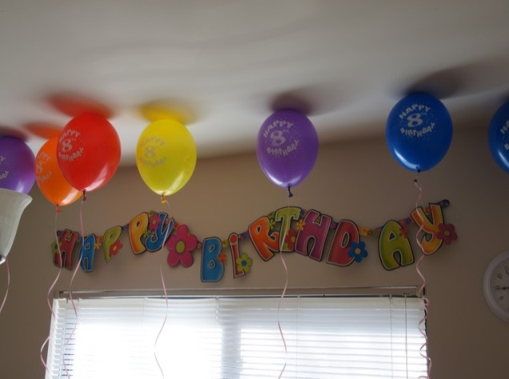

3.A marriage proposal. 4. A welcoming party.

