Listening Speaking Reading Grammar Writing
Topic: Planning a Holiday

Instructor:  Kate | Students Competency Level  Intermediate | Number of Students:  14 | Lesson Length:  65 minutes
Materials:(List the Names of all materials used in the lesson. Materials must be shown at the end of this document)
White Board and Markers
Conversation Sheet
Key Sheet
Cell Phone
Pictures Related To Holidays
Between Calm & Passion Movie Poster
Italy, My First Holiday
Cell Phone_ Between Calm & Passion MP3
Aims:(What students will be able to achieve by participating in the activities of the lesson. (Ss gain or get by doing…)
-Improve speaking skills by role play and discussion with a group and answering teacher
-Activate, increase interest, and participate with fun in an English communication activity by sharing stories and students
- Improve listening skills by role play and discussion with a group, responding to teacher
- Improve writing skills by planning the role play
- Improve interaction and communication skills by having discussion in a group and planning a role play
Language Skills:(Lists what activities language skills students will be using by participating in the activities of the lesson.)
- Reading: (Where did reading occur in the lesson?)
Conversation sheet, note taking
- Listening:(Where did listening occur in the lesson?)
Teacher talk, during the role play, discussion
- Speaking: (Where did speaking occur in the lesson?)
Role play, small group discussion, answering teacher
- Writing: (Where did writing occur in the lesson?)
Note, planning
Language Systems: (Lists what language systems students will be using by participating in the activities of the lesson.)
- Phonology: (sound)
Role play, discussion, teacher talk
- Function:(situation)
Conversation between a Travel Agency and a customer
- Lexis: (meaning)
Vocabulary about planning holiday
- Grammar:(language structure)
Be verbs and description
- Discourse: (communication)
Discussion, responding the teacher, role play

Assumptions :( What students must already be able to do and what concepts must already be mastered before the lesson in order to achieve the aims of the lesson.)
- All Ss understand the basic of role play and will enjoy the conversation related to Holiday as travel and holidays are one of the most popular theme.
- All Ss probably have experienced for having holiday with their friends or family or by their own.
- All Ss have opinion about traveling or having holiday.
- All Ss might have the plan for holiday this year
Anticipated Errors and Solutions:(What things might go wrong in the lesson and what the solution will be. An SOS activity should also be included)
- If Ss may not have many ideas ☞ Solution: T gives them little examples.
- If activity lasts too long ☞ Solution: T cuts the unnecessary parts.
- If activity finished too soon. ☞ Solution: T makes suggestions and shares ideas.
- If Ss may not understand. ☞ Solution: T shows demonstration.
- If certain Ss are shy. ☞ Solution: T encourages them, gives positive feedback, and changes roles for them.
References:

Lead-In or Pre-Task Part (Warm-Up Part to activate and create interest in the lesson.)
Materials: (List the Names of all materials used in the Lead-In or Pre-Task Part of the lesson. Materials must be shown at the end of this document)
White Board and Markers
Cell Phone
Pictures Related To Holidays
Between Calm & Passion Movie Poster
Italy, My First Holiday
Cell Phone_ Between Calm & Passion MP3
Time: | Classroom Set Up: | Student Activity and Goals: | Teacher Procedure &Instructions:
1 min  5 min  7 min | Whole  Whole  Ss | Ss greet the teacher.  Ss listen to teacher.  Ss talk their stories. | Greeting.  Tell T’s stories about the best holiday planned and travelled alone in Italy.  Elicit the stories from Ss about their best ever holiday in their life.  Let’s do a role play about conversation between travel agency and a customer.

Pre-Activity or Task Familiarization Part (Presentation Part Presenting the language structure to be covered in the lesson. Prepares students for the communication activity.)
Materials: (List the Names of all materials used in the Pre-Activity or Task Familiarization Part of the lesson. Materials must be shown at the end of this document)
White Board and Markers
Conversation Sheet
Key Sheet
Time: | Classroom Set Up: | Student Activity and Goals: | Teacher Procedure &Instructions:
3 min  5 min | Whole  Whole | Ss listen what T says.  Ss receive the conversation sheet and prepare for role plays | Introduce the role play and describe setting. Explain that it is a conversation between a Travel Agent and a customer.  Divide class into pairs and hand out the conversation sheet. Explain that the conversation is jumbled and Ss need to put the dialogue in the right order.

Main Activity or Task Realization Part(Practice to Production Part Teacher lead practice of the language presented and move to communication based more student centered activity)
Materials: (List the Names of all materials used in the Main Activity or Task Realization Partof the lesson. Materials must be shown at the end of this document)
White Board and Markers
Conversation sheet
Key sheet
Time: | Classroom Set Up: | Student Activity and Goals: | Teacher Procedure &Instructions:
10 min  2 min  1 min  4 min  10 min | Groups  Whole  Whole  Groups  Groups | Ss make the dialogue in the right order by looking for the links between the ‘speech bubbles.  Other group listen their conversation.  Ss receive the Key Sheet.  Ss do a role-play and take turns with their partners.  The Ss perform the conversation in front of the groups by memorizing the conversation. | T gives instruction for each group to write out the dialogue (or just to make a list of the correct sequence of numbers.)  T askes one of the group to read their restored conversation to each other.  T hands out the Key sheet.  T asks to have role play again with the Key sheet.  Invite several pairs to repeat the conversation in front of the group without the script.

Post Activity or Post Task Part (Wrap-Up Part Close the Lesson on a high note to and consolidate language learned in a communication based activity new situation.)
Materials: (List the Names of all materials used in the Post Activity or Post Task Part of the lesson. Materials must be shown at the end of this document)
White Board and Markers
Pictures Related To Holidays
Time: | Classroom Set Up: | Student Activity and Goals: | Teacher Procedure Instructions:
7 min  10 min | Whole  Whole | Ss make another related conversation that can happen at travel agency while planning holiday  Ss make their own vacation plan for this summer season and share their plan to others.  Ss listen. | T discusses possible new situation with Ss such as some problem occurred because the customer wants some extra service or makes some changes on free of charge etc.  T ask Ss to make their own plan to each student for a short holiday this summer_ where they would like to go and why, what they would like to do there, if they’d like to use travel agent or not, if so, why etc.

Conversation Sheet
Conversation Sheet related to a conversation between a Travel Agent and a customer
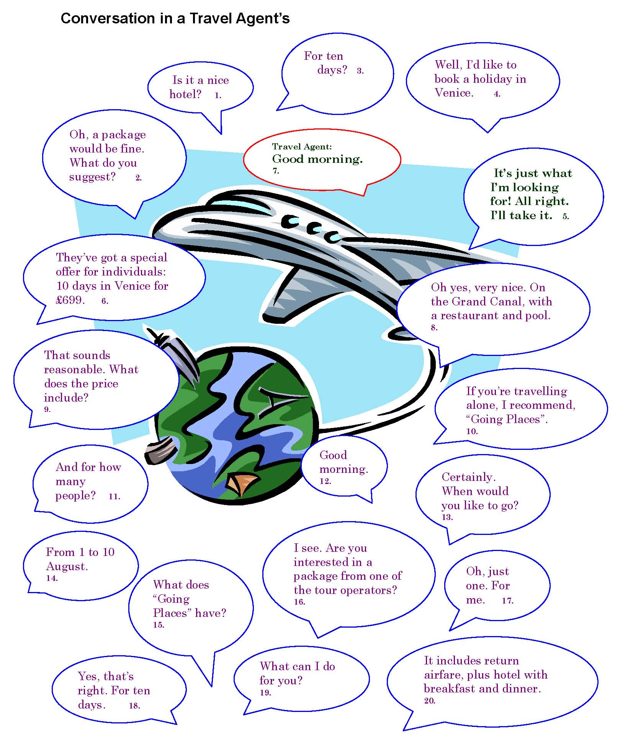

Key Sheet
(Conversation in a Travel Agent)

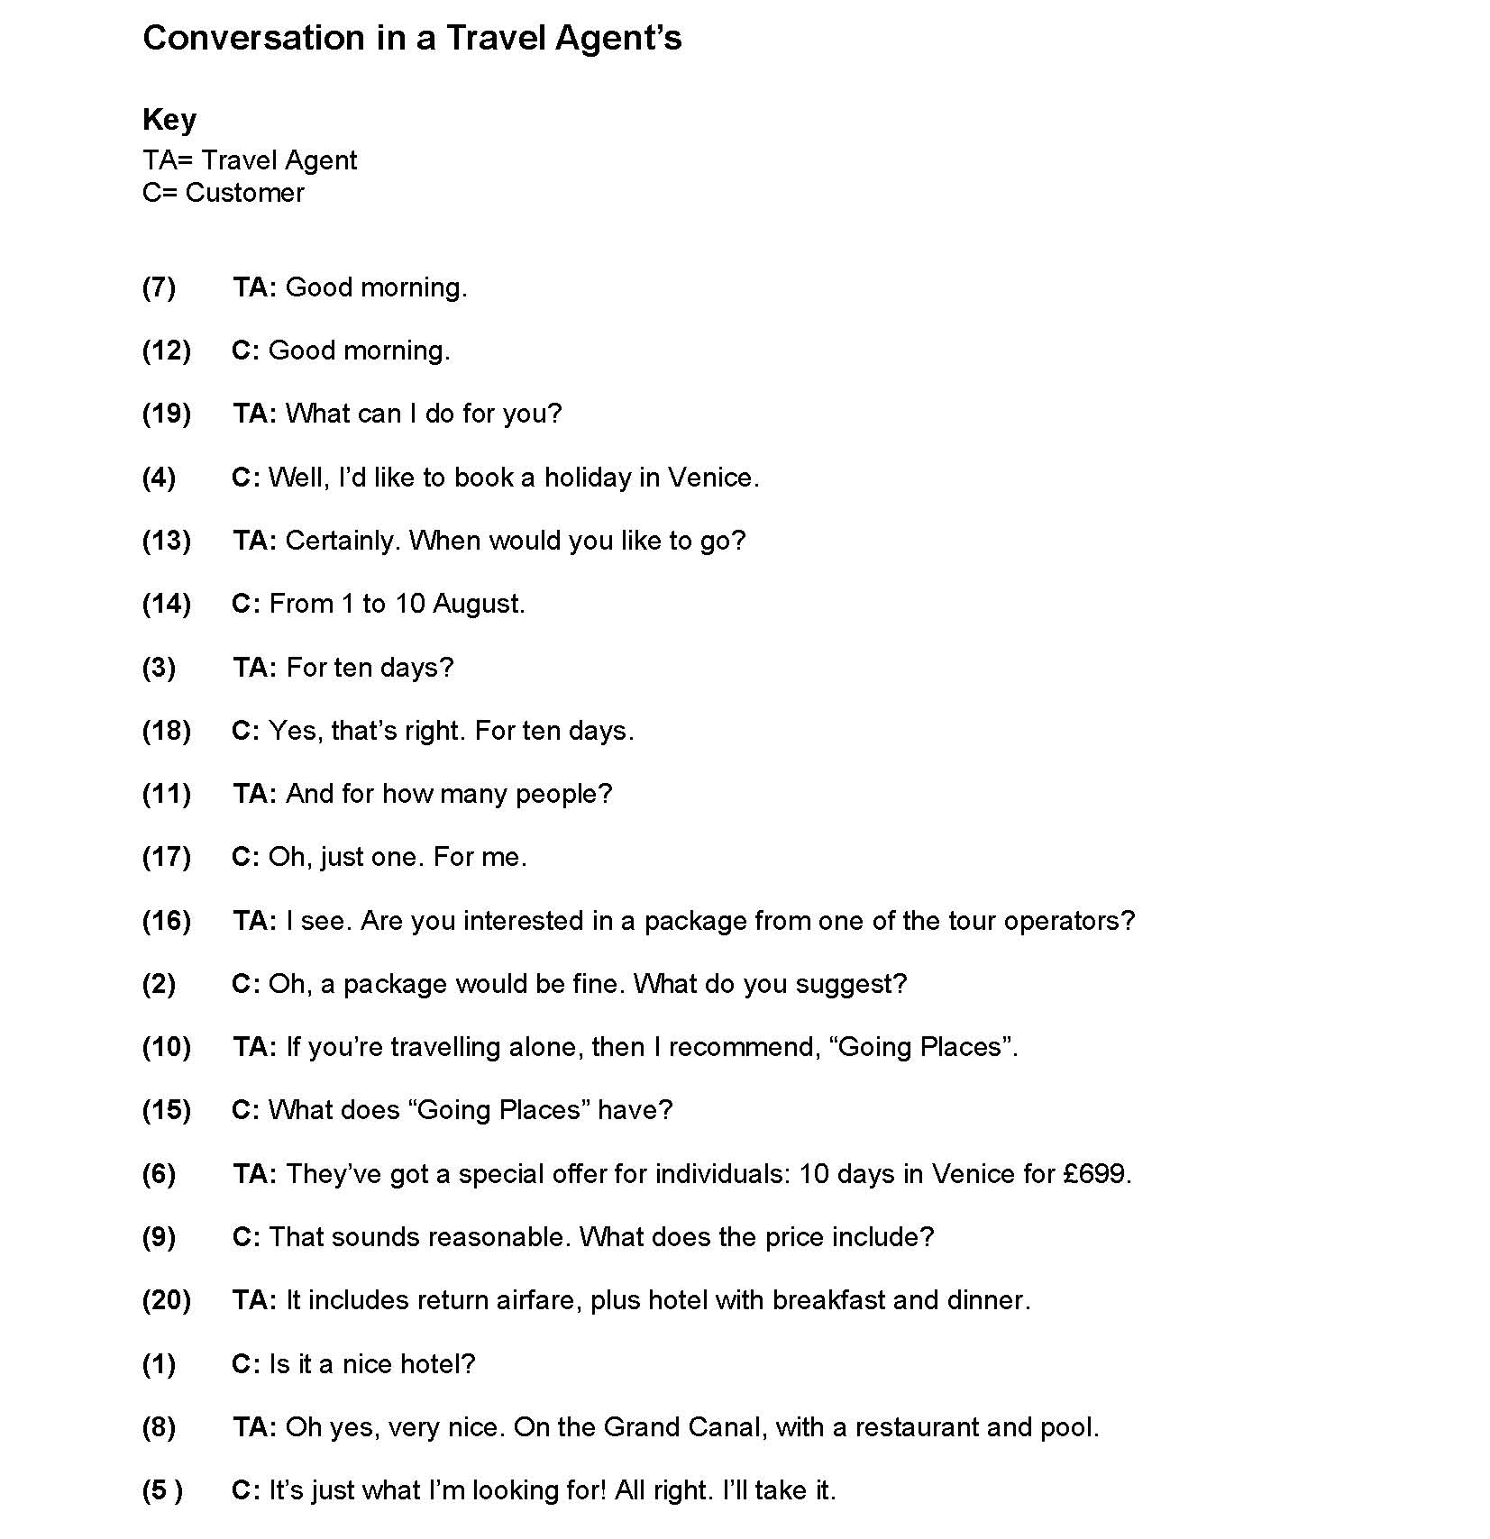

Pictures related to holidays

Between Calm & Passion Movie poster
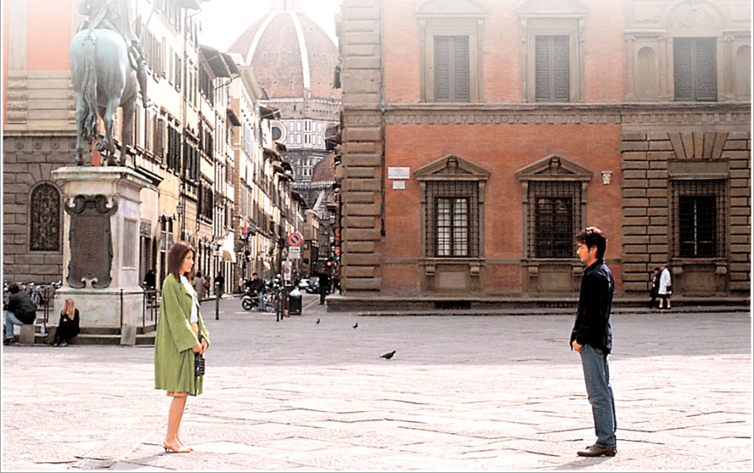

Italy, My First Holiday

