■Listening ■ Speaking Reading Grammar Writing
Topic: Food Recommendation in the World

Instructor:  Jennie | Students Competency Level :Intermediate | Number of Students: 14 | Lesson Length:  50 Minutes
Materials:(List the Names of all materials used in the lesson. Materials must be shown at the end of this document)
Pictures(Food),Computer project for overhead screen.
Map Of Paper
Video( Austrailian Tries American Candy)
Aims:(What students will be able to achieve by participating in the activities of the lesson. (Ss gain or get by doing…)
- Ss gain the ability to think about various international food culture with other students and teacher.

Language Skills:(Lists what activities language skills students will be using by participating in the activities of the lesson.)
- Reading: (Where did reading occur in the lesson?)
Talking their idea.
- Listening:(Where did listening occur in the lesson?)
What other classmates think about the topic. Teacher Talk. Show the short video related to the topic

- Speaking: (Where did speaking occur in the lesson?)
Illustrate what they think about the topic.

- Writing: (Where did writing occur in the lesson?)
Write their idea on the map.
Language Systems: (Lists what language systems students will be using by participating in the activities of the lesson.)
- Phonology: (sound)
T Talks Ss discussion.
- Function:(situation)
- Discussing different foods.
- Lexis: (meaning)
- Vocabulary and food, tastes, and countries.
- Grammar:(language structure)
Have you ever been?

- Discourse: (communication)
Discuss with groups.

Assumptions:(What students must already be able to do and what concepts must already be mastered before the lesson in order to achieve the aims of the lesson.)
--Students already know how to make the sentence to tell the idea.
Anticipated Errors and Solutions:(What things might go wrong in the lesson and what the solution will be. An SOS activity should also be included) Ss may ask ask about teachers’ experience.
--Peer editing by doing group discussion.

References:

Lead-Inor Pre-Task Part (Warm-Up Part to activate and create interest in the lesson.)
Materials: (List the Names of all materials used in the Lead-Inor Pre-Task Partof the lesson. Materials must be shown at the end of this document)

Computer, overhead projector, screen
Time: | Classroom Set Up: | Student Activity and Goals: | Teacher Procedure &Instructions:
1 | W | -Greet T | -Greet Ss
3 | W | -Listen attentively become interested | -Talk to food recommendation all over the world.Show the video.
5 | S-W | -Share opinions | -Asks Ss opinions of travel food and other not satisfied with.
1 | W | -Enjoy class, ready to participate | -Transition

Pre-Activity or Task Familiarization Part (Presentation PartPresenting the language structure to be covered in the lesson. Prepares students for the communication activity.)
Materials: (List the Names of all materials used in the Pre-Activity or Task Familiarization Part of the lesson. Materials must be shown at the end of this document)
Food Pictures, computer, projector, overheaded screen
Time: | Classroom Set Up: | Student Activity and Goals: | Teacher Procedure &Instructions:
3 | W | -Ss pick up nation(Asia, America, Europe) | -Talk about world food.
10 | W | -Actively participate  Share ideas. | -T leads class discussion of world food encourage to present.
2 | G | -Move into 3 group  Discuss about world food experience. | -Encourage to present recommendation  -Transition. Divide into groups.

Main Activity or Task Realization Part(Practice to Production Part Teacher lead practice of the language presented and move to communication based more student centered activity)
Materials: (List the Names of all materials used in the Main Activity or Task Realization Part of the lesson. Materials must be shown at the end of this document)
Map Of Paper
Time: | Classroom Set Up: | Student Activity and Goals: | Teacher Procedure &Instructions:
15 | G | -Write and discuss their part experience | Instructions T first Assign Groups  -Direct and facilitate groups to write on the map of paper and discuss their experience.
10 | G | -Listen and prepare to finalize 3 things | -Thank group  -Summarize Ss’ ideas all together.

Post Activity or Post Task Part (Wrap-Up Part Close the Lesson on a high note to and consolidate language learned in a communication based activity new situation.)
Materials: (List the Names of all materials used in the Post Activity or Post Task Part of the lesson. Materials must be shown at the end of this document)

Time: | Classroom Set Up: | Student Activity and Goals: | Teacher Procedure Instructions:
8 | G | -Share the ideas among groups | -Share each group’s idea  -Vote for the best idea among the groups.
2 | W | -Applaud and respond positively | -Congratulate Ss on a job well done. Give positive feedback.

<Materials>
-Sushi

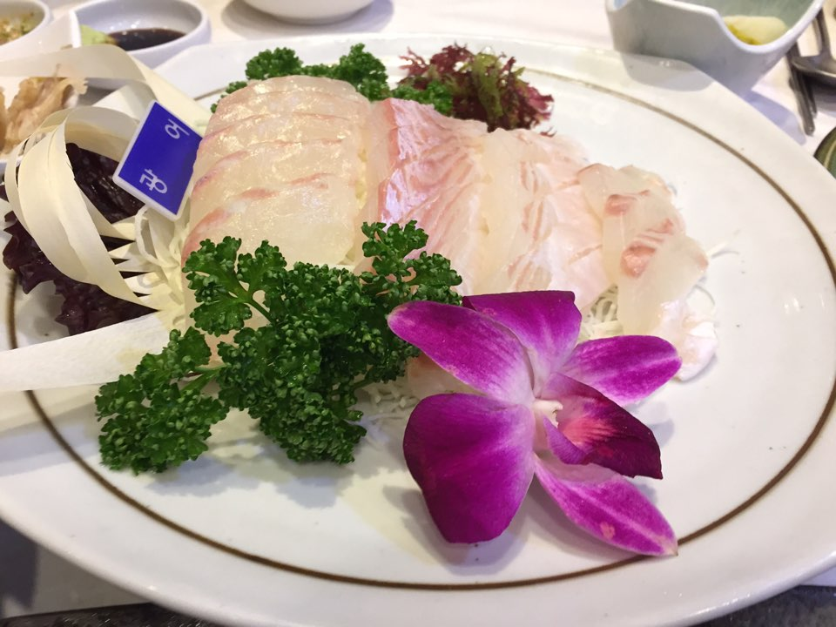

-Bulgogi

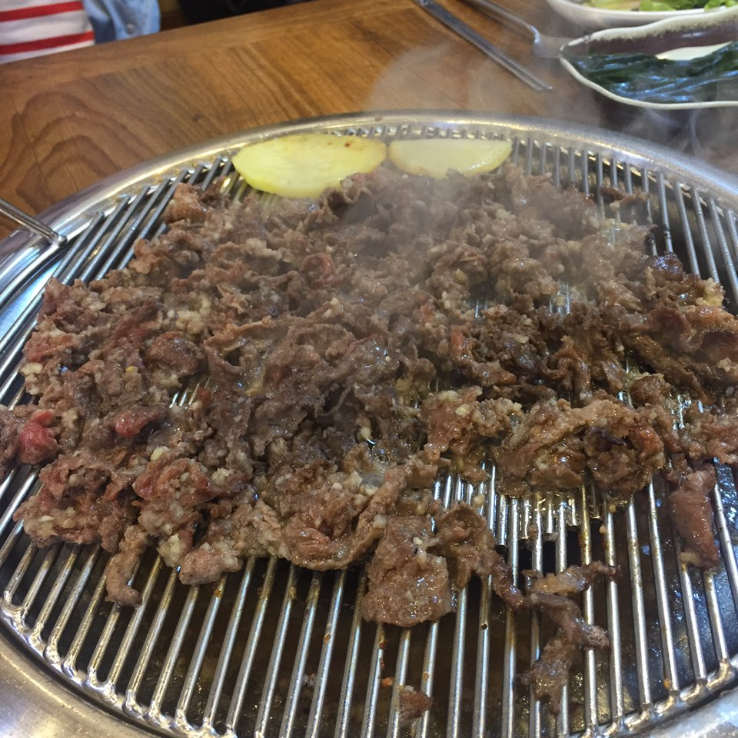

Hodduk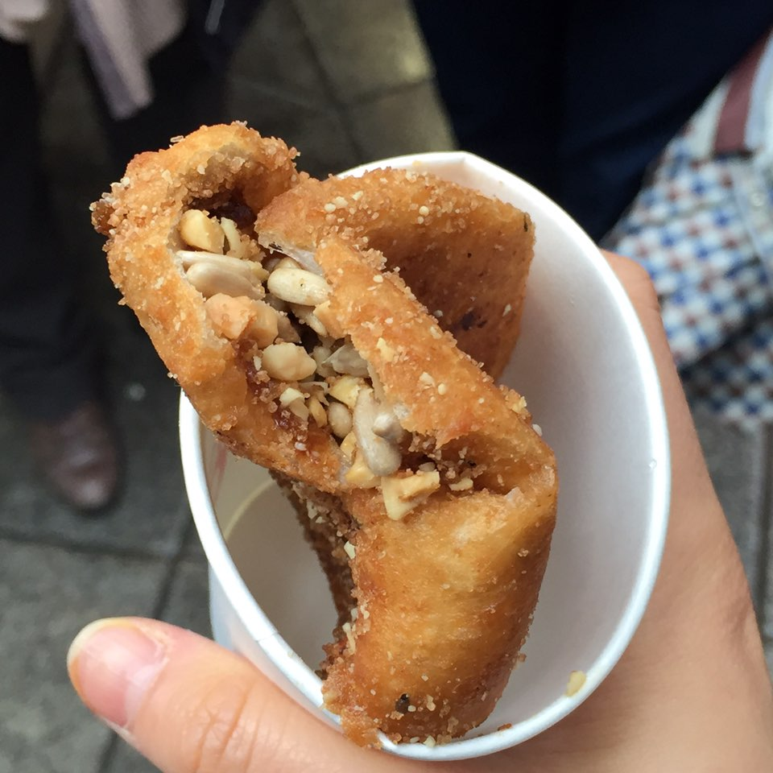

Korean noddles & Pork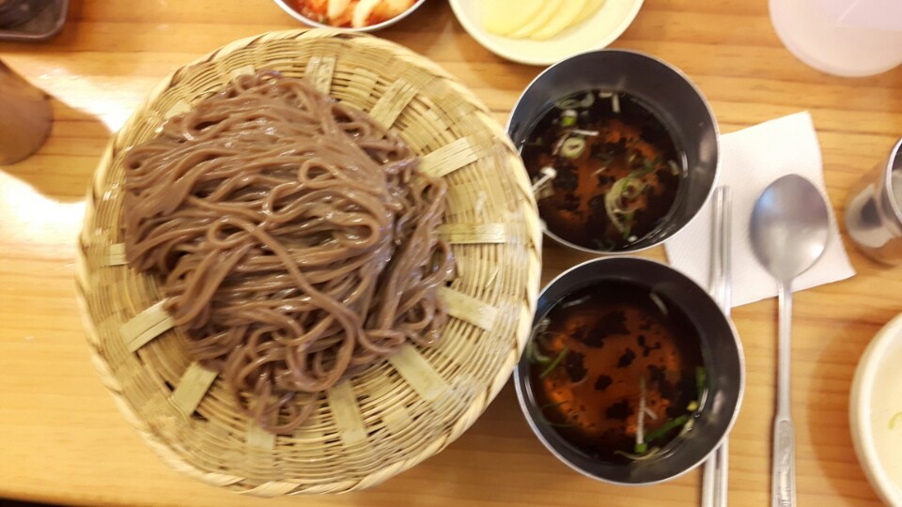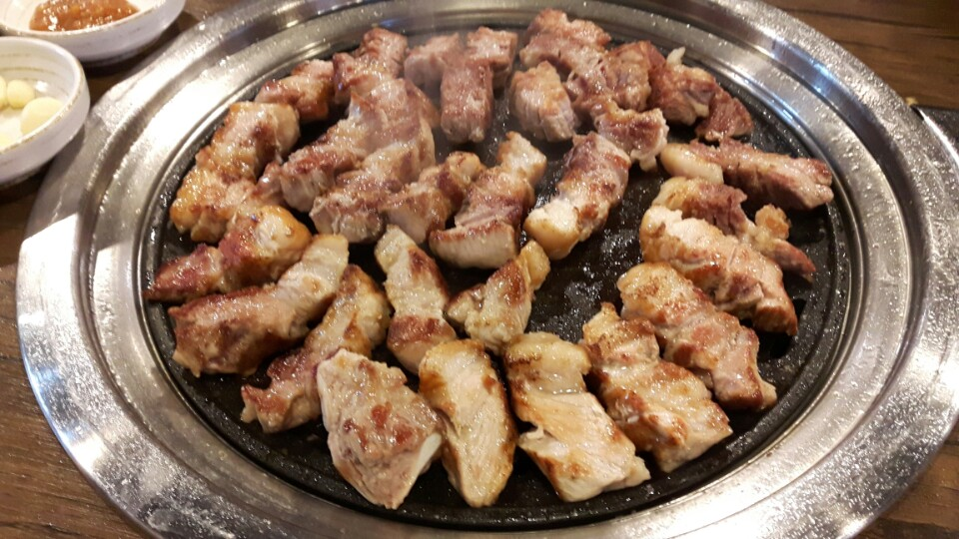

Fried rice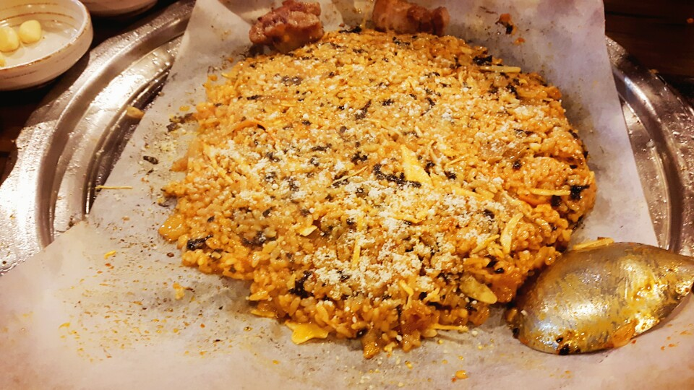

Korean dumpling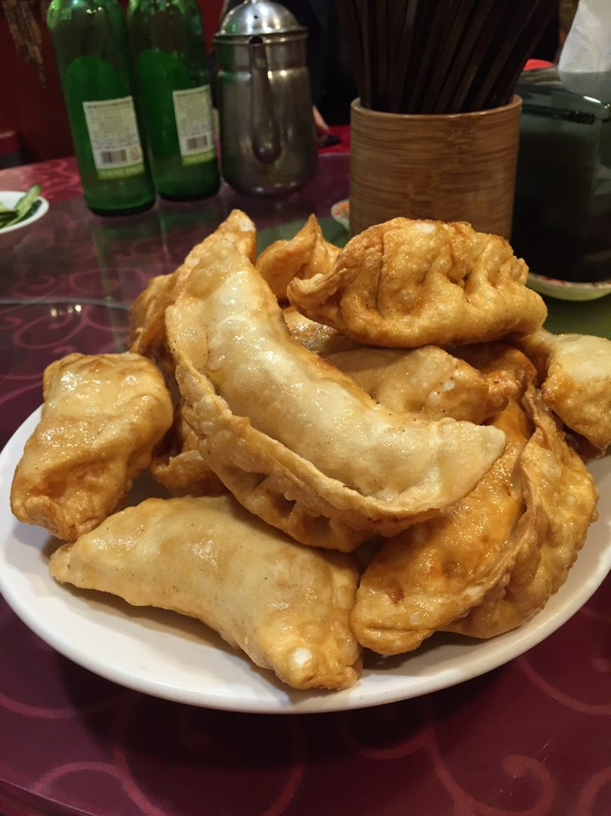

Korean shell

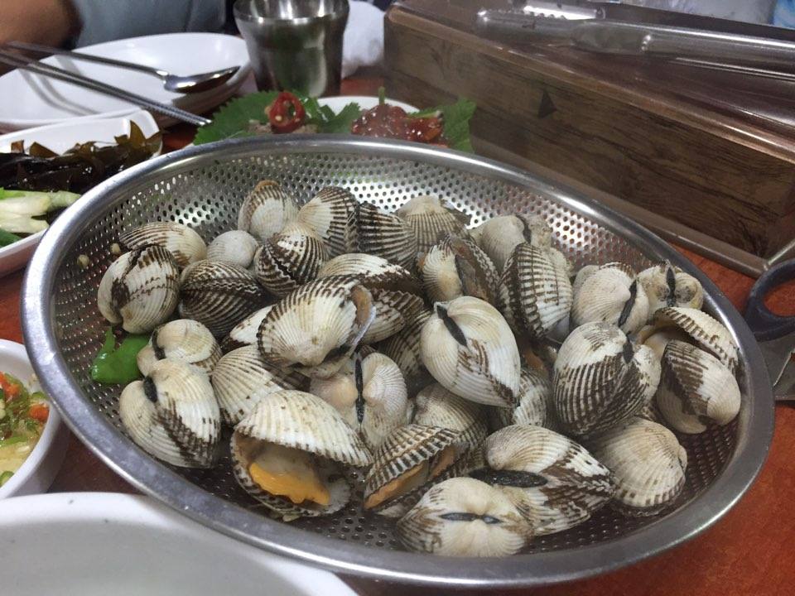

Ddukbbokki&oden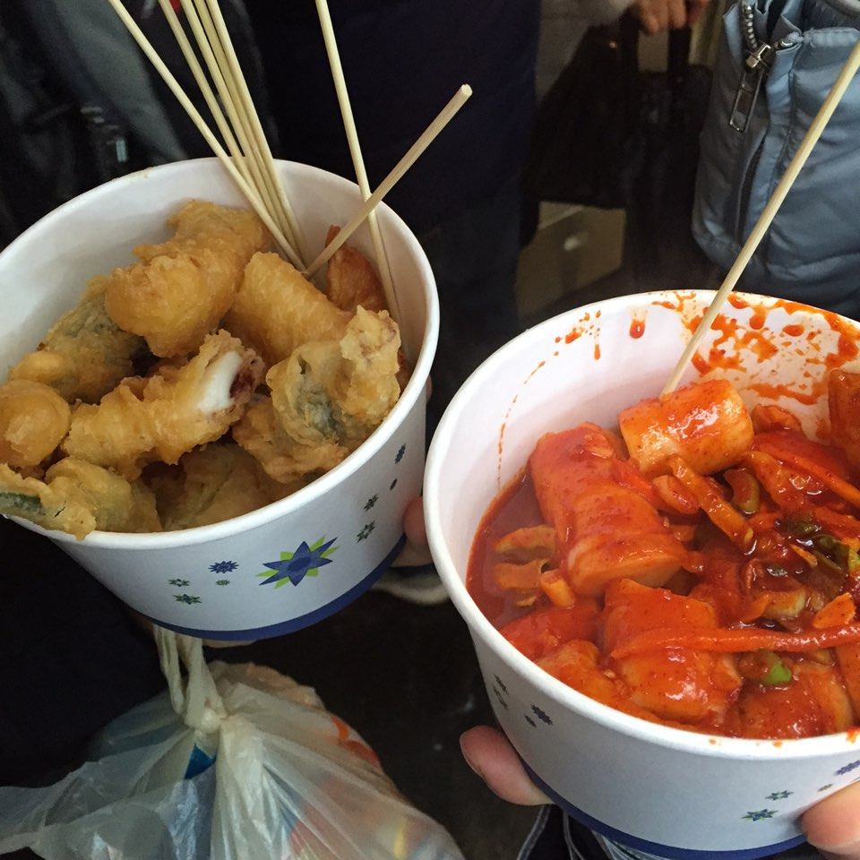

World map

