Listening/Speaking Reading Grammar Writing
Topic: Party for the Happy Memories

Instructor:  SKY | Students Competency Level  Pre-Intermediate | Number of Students:  13 | Lesson Length:  50 minutes
Materials: (List the Names of all materials used in the lesson. Materials must be shown at the end of this document)
- White Board and Markers
- Happy Memory Dialogues Text
- Joyful And Happy Moment Phrase Text
- Memory Cards:
Memory 1
Memory 2
Memory 3

Aims: (What students will be able to achieve by participating in the activities of the lesson. (Ss gain or get by doing…)
- Ss will be improving the speaking skills by telling the happy moment to the other students.
- Ss will be able to learn the expressions to respond actively to their partners by participating in the activity.
- Ss will be improving the interaction and communication skills by having conversations
- Participate with fun in an English communication activity by sharing happy moments of teacher and students

Language Skills: (Lists what activities language skills students will be using by participating in the activities of the lesson.)
- Reading: (Where did reading occur in the lesson?)
Reading a dialogue regarding the active responding
- Listening: (Where did listening occur in the lesson?)
Teacher talk, during the activity,
- Speaking: (Where did speaking occur in the lesson?)
Speaking to a partner, to group members, answering teacher
- Writing: (Where did writing occur in the lesson?)
Writing the happy moments in a card.

Language Systems: (Lists what language systems students will be using by participating in the activities of the lesson.)
- Phonology: (sound)
Repeating after T (phrases), Teacher talk, Activity participation.
- Function: (situation)
Daily conversation, Delivering what a person says to the others.
- Lexis: (meaning)
Vocabulary and phrases about expression and memory
- Grammar: (language structure)
General discussion grammar
- Discourse: (communication)
Responding the teacher, talking to a partner and a class

Assumptions: (What students must already be able to do and what concepts must already be mastered before the lesson in order to achieve the aims of the lesson.)
- Ss have at least 3 joyful and happy memories.
- Ss are able to describe their experience to the other students properly
- Ss are closed enough to share their stories with one another without hesitation.

Anticipated Errors and Solutions: (What things might go wrong in the lesson and what the solution will be. An SOS activity should also be included)
- If activity lasts too long
: Teacher cuts the unnecessary parts.
- Some Ss might not be confident in telling their story
: Teacher shows the very simple demonstration.
- If activity finishes too soon.
: Teacher makes suggestions and shares ideas
(such as the Memory you would like to have in the future.)

References:

Lead-In or Pre-Task Part (Warm-Up Part to activate and create interest in the lesson.)
Materials: (List the Names of all materials used in the Lead-In or Pre-Task Part of the lesson. Materials must be shown at the end of this document)

Time: | Classroom Set Up: | Student Activity and Goals: | Teacher Procedure & Instructions:
1 min  3 min  3min | Whole  Whole  W - S | Ss greet the teacher  Ss listen to teacher  Ss talk their stories and  Listen to teacher | Greeting.  Tell teacher’s stories which are joyful and happy so the teacher hope that it happens again.  Elicit the story from Ss. And explain how important the active response to the teller is in a daily conversation.  Let’s share the happy moment with friends.

Pre-Activity or Task Familiarization Part (Presentation Part Presenting the language structure to be covered in the lesson. Prepares students for the communication activity.)
Materials: (List the Names of all materials used in the Pre-Activity or Task Familiarization Part of the lesson. Materials must be shown at the end of this document)
- Happy Memory Dialogues Text
- Joyful And Happy Moment Phrase Text
Time: | Classroom Set Up: | Student Activity and Goals: | Teacher Procedure & Instructions:
2 min  5 min  7 min | Whole  Pairs  Whole | Ss listen what Teacher says  Ss make pair and read dialogues & phrases  Ss write the memories in the memory card | Before the main activity, teacher demonstrate how to response actively to the partner.  Hand out the dialogue text and phrase text. Practice in pair.  Hand out the memory card and ask Ss to write 3 happy moments.  1. Happiest moment in a month,  2. Happiest moment in a year  3. Happiest moment in life  Transition now time to get in the Daily conversation.

Main Activity or Task Realization Part (Practice to Production Part Teacher lead practice of the language presented and move to communication based more student centered activity)
Materials: (List the Names of all materials used in the Main Activity or Task Realization Part of the lesson. Materials must be shown at the end of this document)

- Memory Cards:
Memory 1
Memory 2
Memory 3

Time: | Classroom Set Up: | Student Activity and Goals: | Teacher Procedure & Instructions:
1 min  5 min  1 min  5 min  1 min  5 min  3 min | Whole  W – S  Whole  W – S  Whole  W –S  Whole | Ss listen what teacher says.  Ss share their #1 memory with partners.  Ss listen what teacher says.  Ss share their #2 memory in a group.  Ss listen what teacher says.  Ss share their #3 memory in a pair or a group.  Ss listen what teacher says. | Teacher gives the situation for the conversation.  First situation is to meet a friend in a bar on Friday night after working  Divide Ss in pairs. Ask Ss to show some active response and reaction to the partners  Teacher gives the situation.  Second situation is to become friends with other couples.  Divide Ss in groups.  Teacher gives the situation.  Third situation is to become friends with all people in a bar.  Ask Ss show some active response and reaction.  Give Ss positive feedback and comments  Facilitates class members’ feedback.

Post Activity or Post Task Part (Wrap-Up Part Close the Lesson on a high note to and consolidate language learned in a communication based activity new situation.)
Materials: (List the Names of all materials used in the Post Activity or Post Task Part of the lesson. Materials must be shown at the end of this document)

Time: | Classroom Set Up: | Student Activity and Goals: | Teacher Procedure Instructions:
3 min  2 min  2 min | Whole  W –S  Whole | Ss listen teacher  Ss tell the moments  Ss listen teacher. | Let Ss think of the happiest moment in the future.  Let several Ss share those moments  Wrap up the class by giving feedback about their accomplishment and improvement

♥Happy Memory Dialogues Text♥

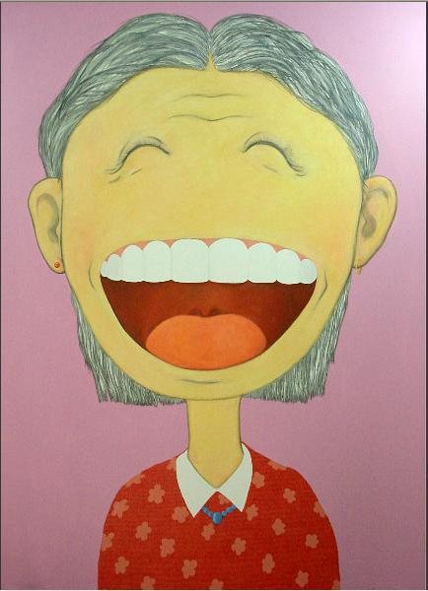
[Dialogue 1]

A: Check this out! I just got accepted to the company.
B: That's fantastic! What a great feeling that must be!
A: That's for sure. I'm walking on air right now.
B: Well, you worked really hard, so you deserve it.

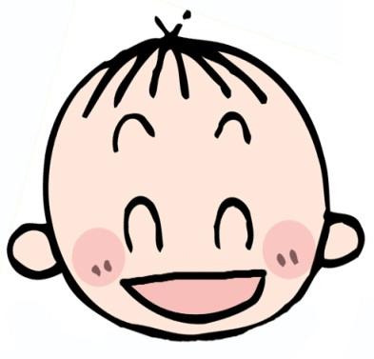
[Dialogue 2]

A: I can't believe it! I'm so happy I got an A.
B: Congratulations, your father will be so proud.

[Dialogue 3]

A: It looks like Johnny's going to recover from
the surgery.
B: Oh, that's great to hear.

[Dialogue 4]

A: Can you tell Denise I found her purse?
B: Of course. She'll be so happy to hear that.

♥Joyful and Happy Moment Phrase Text♥

[Expressions to respond your happy partners]
That’s fantastic news
What wonderful news
I’m really happy for you
That’s music to my ears
I can’t tell you how happy I am to hear that.

[Expressions to describe your happiness]
I’m so happy
I’m overjoyed
I’m flying.
I’m delighted
Could it be any happier than I am right now?
Could it get any better than this?
Does it get any better than this?
I’m so happy, I don’t know what to say
I’m so happy I can hardly contain myself.
MEMORY CARD | #1 MEMORY  ♥ WHEN  ♥ WHERE  ♥ WHOM  ♥ WHAT  ♥ HOW  ♥ WHY
#2 MEMORY  ♥ WHEN  ♥ WHERE  ♥ WHOM  ♥ WHAT  ♥ HOW  ♥ WHY | #3 MEMORY  ♥ WHEN  ♥ WHERE  ♥ WHOM  ♥ WHAT  ♥ HOW  ♥ WHY

