Listening Speaking Reading Grammar Writing
Topic: Do aliens exist?

Instructor:  Casey | Students Competency Level  Intermediate | Number of Students:  13 | Lesson Length:  59 mins
Materials: (List the Names of all materials used in the lesson. Materials must be shown at the end of this document)

- White board and markers
- UFOs Video
- Computer
- Projector
- Screen
- Reading Text
- Question worksheet

Aims: (What students will be able to achieve by participating in the activities of the lesson. (Ss gain or get by doing…)

- Improve Ss listening skill by listening to T introduction, questions and listening to other Ss statements during brain storming and group discussion.
- Improve Ss speaking skills by discussing in groups and responding to teacher questions.
- Improve Ss reading skills by reading the passage.
- Improve interaction, imagination and communication skills by having discussion and doing activity in groups.

Language Skills: (Lists what activities language skills students will be using by participating in the activities of the lesson.)

- Reading: (Where did reading occur in the lesson?)
Text and Worksheets.
- Listening: (Where did listening occur in the lesson?)
T instruction and explanation, discussion
- Speaking: (Where did speaking occur in the lesson?)
Discussing, responding to teacher, questions and presentation
- Writing: (Where did writing occur in the lesson?)
Discussing, taking notes

Language Systems: (Lists what language systems students will be using by participating in the activities of the lesson.)

- Phonology: (sound)
Discussion, teacher talk
- Function: (situation)
Discussing whether aliens exist
- Lexis: (meaning)
Reading skills and using imagination during discussion
- Grammar: (language structure)
Description from texts
- Discourse: (communication)
Discussion, responding teacher, presentation

Assumptions: (What students must already be able to do and what concepts must already be mastered before the lesson in order to achieve the aims of the lesson.)

- All Ss have opinions about topic and what the aliens are.
- All Ss will enjoy discussion and sharing their opinions.
- All Ss enjoy completing their own work sheets
- All Ss enjoy doing activities and using imagination during group discussions.

Anticipated Errors and Solutions: (What things might go wrong in the lesson and what the solution will be. An SOS activity should also be included)

- If Ss may not understand the clear meaning
Solution: Provide more examples.
- If activity lasts too long
Solution: T cuts the unnecessary parts
Give time warning
- If activity finished too soon
Solution: T makes suggestions and shares ideas
Give Ss more time for discussion.
- If students may not understand
Solution: T show demonstration
- If certain Ss are shy
Solution: T encourages them, gives positive feedback, and changes roles for them.

References:

Lead-In or Pre-Task Part (Warm-Up Part to activate and create interest in the lesson.)
Materials: (List the Names of all materials used in the Lead-In or Pre-Task Part of the lesson. Materials must be shown at the end of this document)

- UFOs Video
- Computer
- Projector
- Screen

Time: | Classroom Set Up: | Student Activity and Goals: | Teacher Procedure & Instructions:
1 min  5min  3min | Whole  Whole  Ss | Ss greet, listen and answer the teacher.  Ss watch the video.  Reply to the T | Greeting. Shares thoughts about aliens. Asks Ss to share their thoughts  Show the Ss a short video of UFOs  Ask Ss their opinions about aliens  Let’s read more about UFO

Pre-Activity or Task Familiarization Part (Presentation Part Presenting the language structure to be covered in the lesson. Prepares students for the communication activity.)
Materials: (List the Names of all materials used in the Pre-Activity or Task Familiarization Part of the lesson. Materials must be shown at the end of this document)

- Reading Text
- Question Sheet

Time: | Classroom Set Up: | Student Activity and Goals: | Teacher Procedure & Instructions:
1 min  5 min  1 min  1 min | Whole  Whole  Whole  Pairs | Ss listen to what T says.  Ss read the passage  Ss get the question sheets and listen to what T says  Ss answer and discuss the questions | Hand out the reading text and give the Ss some time read the passage  T waits and answers to any questions from the Ss.  The T hands out the question sheets and demonstrates Ss to answer the questions in pairs.  T waits and answers to any questions from the Ss.

Main Activity or Task Realization Part (Practice to Production Part Teacher lead practice of the language presented and move to communication based more student centered activity)
Materials: (List the Names of all materials used in the Main Activity or Task Realization Part of the lesson. Materials must be shown at the end of this document)

- White board and markers

Time: | Classroom Set Up: | Student Activity and Goals: | Teacher Procedure & Instructions:
2 min  1min  7 min | Whole  Group  Pairs | Ss listen to what T says.  Get in to groups.  Ss do activity. | T demonstrates the class about the next activity. The class will be in groups and they will draw how the aliens would look like, which planet they are from, and imagine that they have special powers, then what it would be. After the discussion, each group will present about their own aliens.  T divide the whole class into 3 groups  T hands the empty sheets and colour pencils.  T monitors the class and see if anyone is in trouble and tries to help them

Post Activity or Post Task Part (Wrap-Up Part Close the Lesson on a high note to and consolidate language learned in a communication based activity new situation.)
Materials: (List the Names of all materials used in the Post Activity or Post Task Part of the lesson. Materials must be shown at the end of this document)

- White board and markers

Time: | Classroom Set Up: | Student Activity and Goals: | Teacher Procedure Instructions:
3X  2min  5 min | Groups  Groups  Whole | The next activity repeats 6 times.  Each group present about their own alien  Ss feedback and give other ideas. | The next activity repeats 3 times.  T monitors presentation. Gives encouragement to each group and facilitates class feed back to the discussion result.  T listens to the students opinions and elicits more answers.  Close by giving Ss feedback about their accomplishment and improvement.

- UFO Reading Text

- The Chiles-Whitted Sighting
When? 24 July 1948
Where? Montgomery, Alabama
What happened? This case was one of the very first UFO sightings reported by commercial pilots. While flying from Houston to Atlanta, pilots Chiles and Whitted saw a large, cigar-shaped object flying close to them. At one point, the object appeared to stop suddenly before disappearing into thin air. The pilots agreed that it was a long, thin craft, with two rows of windows that had a blueish glow. It was moving really fast, leaving a trail of orange/red fog behind them. What makes this sighting more amazing is that this sighting wasn’t only reported by Chiles and Whitted. Several witnesses at an airbase in Georgia claim to have seen an identical object half an hour before the pilots’ experience. Government officials were able to leave out the possibility of it being a military or commercial flight as there were no fitting flights scheduled at that time.
How was it explained? After an investigation, government debunkers wrote the sighting off as an illusion caused by temperature inversions, and later changed their minds and claimed it was a meteor. However, as the description of the object does not at all fit that of a meteor, this sighting is still classed as ‘unexplained’.
- The Battle of Los Angeles
When? 1942
Where? Los Angeles, California
What happened? On the night of 24 February 1942, not too long after the attack on Pearl Harbor, air raid sirens rang out across Los Angeles. Thousands of people witnessed searchlights around Los Angeles fixing on a target hovering over the city, and the Coast Guard Anti-aircraft guns were ready to fire. They assumed it was an attack from Japan – but they were wrong. To this day, the Japanese claim they never attacked and there is no wreckage or other evidence to say that they did. People inland started to report seeing the large craft, or fleet, and Air Raid Wardens put the city into blackout. Some witnesses describe the sighting as a tremendous single object, crawling through the sky, whilst others say it was a group of smaller objects. At 3.16am a barrage of AA shells began, and the firing at the object continued throughout the night until the blackout was lifted at 7.21am. Several buildings were damaged in the firing and six people were killed – three by friendly fire and three from stress caused by the attacks.
How was it explained? The next morning the papers were filled with several different explanations. Some reported that it was Japanese planes that were shot down – though there was no evidence to say that this was the case. The LA Times ran a front-page picture showing an image of an odd object caught in the searchlights. The Government denounced the whole story, calling it a false alarm caused by ‘war nerves’, however many witnesses confirm that they believe what they saw was extra-terrestrial.
- Question worksheets

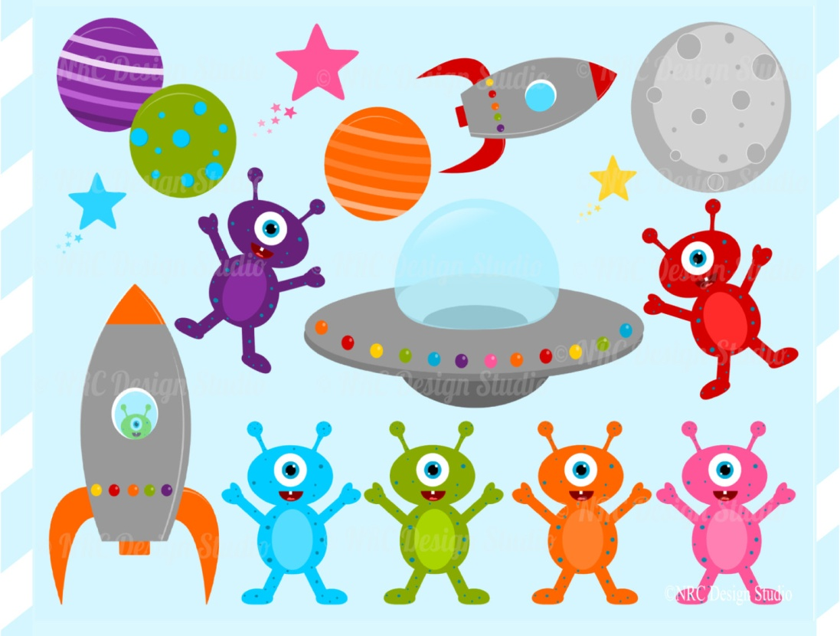

- UFO Video

https://www.youtube.com/watch?v=RjGYSGbAEUM

