Listening Speaking Reading Grammar Writing
Topic: The Benefits of Nature
Instructor:  Sarah | Students Competency Level  Pre Intermediate level | Number of Students: 12 | Lesson Length:  59Mins
Materials: (List the Names of all materials used in the lesson. Materials must be shown at the end of this document)
- Board and Markers
- Pictures of Cherry Blossom Festival,
Flowers in The Park,
Relaxing in Nature.
- Brainstorming of Word ‘Nature’ Work Sheet.
- ‘The Benefits of Nature’ Reading Text
- After Reading Work Sheet
Aims:(what students will be able to achieve by participating in the activities of the lesson.(See gain or get by doing…)
- Improve Ss listening skills by listening T introduction and questions.
- Activate increase interest, and participate with fun in an English communication activity by sharing stories of teacher and students.
- Improve listening skills by discussion with a group, responding to teacher.
- Improve Ss Reading skills by reading work sheet.
- Improve writing skills by completing work sheet.

Language Skills: (Lists what activities language skills students will be using by participating in the activities of the lesson.)
- Reading: (Where did reading occur in the lesson?)
Text and Work Sheets
- Listening: (Where did listening occur in the lesson?)
Teacher talk, T instruction and explanation, discussion.
- Speaking: (Where did speaking occur in the lesson?)
Small group discussion, answering teacher
- Writing: (Where did writing occur in the lesson?)
Notes, Work sheet, homework essay “ What I gained from nature”

Language Systems: (Lists what language systems students will be using by participating in the activities of the lesson.)
- Phonology: (sound)
Small group discussion,T talk, Ss talk
- Function: (situation)
Introduction, Expressing nature
- Lexis: (meaning)
Vocabulary
- Grammar: (language structure)

- Discourse: (communication)
Discussion, responding the teacher

Assumptions: (What students must already be able to do and what concepts must already be mastered before the lesson in order to achieve the aims of the lesson.)
- All Ss have opinion about the topic and how helpful the nature is.
- All Ss enjoy discussion and sharing opinions.
- All Ss enjoy completing their own work sheets.
- All Ss know what the benefits of nature is

Anticipated Errors and Solutions: (What things might go wrong in the lesson and what the solution will be. An SOS activity should also be included)
- If Ss may not have many ideas.
Solution: T gives them little examples.
- If activity finished too soon
Solution: T makes suggestions and shares ideas.
- If Ss may not understand clear the meaning.
Solution: T shows demonstration.
- If certain Ss are shy
Solution: T encourages them, gives positive feedback, and changes roles for them.

References:

Lead-In or Pre-Task Part (Warm-Up Part to activate and create interest in the lesson.)
Materials: (List the Names of all materials used in the Lead-In or Pre-Task Part of the lesson. Materials must be shown at the end of this document)
- Board and Markers
- Pictures of Cherry Blossom Festival,
Flowers in The Park,
Relaxing in Nature.
Time: | Classroom Set Up: | Student Activity and Goals: | Teacher Procedure & Instructions:
1min  3mins  4mins  2mins | W  S - W  S - W  S - W | Ss greet the teacher.  Ss listen carefully  Ss answer about T’s question.  Ss respond | Greet Ss  Start with T’s story about nature  Ex) How I have felt about nature.  Anything interesting reflection about nature during travel.  Ask Ss “When was the last time you were surrounded by a natural environment?”  Ask Ss “How do you feel about nature?  Does it help you in any way?  Transition, Let’s look at how helpful the nature is.

Pre-Activity or Task Familiarization Part (Presentation Part Presenting the language structure to be covered in the lesson. Prepares students for the communication activity.)
Materials: (List the Names of all materials used in the Pre-Activity or Task Familiarization Part of the lesson. Materials must be shown at the end of this document)
- Brainstorming of Word ‘Nature’

Time: | Classroom Set Up: | Student Activity and Goals: | Teacher Procedure & Instructions:
2mins  2mins  3mins  10mins | W  G  W  G | Ss listen instruction carefully.  Ss move into group.  Ss receive worksheet and now begin.  Ss talk about nature and share with group members. Groups share thoughts of members. | Introduce work sheet and hand out work sheet. Show how to complete.  Divide Ss into 4 groups of 4 members.  Ask Ss to read and complete the worksheet. One work sheet per group.  Ask Ss to discuss with others. Let’s talk about what nature is and discuss it after then share with other groups.

Main Activity or Task Realization Part (Practice to Production Part Teacher lead practice of the language presented and move to communication based more student centered activity)
Materials: (List the Names of all materials used in the Main Activity or Task Realization Part of the lesson. Materials must be shown at the end of this document)
- ‘The Benefits of Nature’ Reading Text
- After Reading Work Sheet
Time: | Classroom Set Up: | Student Activity and Goals: | Teacher Procedure & Instructions:
5mins  5mins  3mins  6mins  5mins | W  G  Individual  S – W  S - W | Ss listen to T. Receive text and read it carefully.  Ss share their thoughts with class  Ss get the work sheet and complete the work sheet.  Check the answers each other. Groups share thoughts and respond feedback to other groups.  Each group share their thoughts with class. | Introduce The Benefits of Nature Reading Text and hand out text. Ask Ss to read the text carefully and use question to increase interest in the reading.  Ask Ss to share their thoughts about the text and facilitate classroom discussion and feedback.  Hand out work sheet. Complete work sheet individually.  Put Ss in groups to share their thoughts with others. Help S’s activity and give hint as needed.  Ask each group to share their thoughts with class. Facilitate class feedback.

Post Activity or Post Task Part (Wrap-Up Part Close the Lesson on a high note to and consolidate language learned in a communication based activity new situation.)
Materials: (List the Names of all materials used in the Post Activity or Post Task Part of the lesson. Materials must be shown at the end of this document)
- Board and Markers
Time: | Classroom Set Up: | Student Activity and Goals: | Teacher Procedure Instructions:
2mins  4mins  1min  1min | W  S - W  W  W | Ss listen what T says, respond to teacher  Ss respond  Listen and take note. Write assignments on notebooks  Ss say good bye | Give Ss positive feedback about their opinion.  Ask Ss to have the time to think of a future nature. Elicit response in class discussion.  Write Homework Assignment on board: Assign Essay: “ Hello! Future Nature”  T dismisses Ss and thinks Ss for their active participation.

Pictures for Eliciting Nature
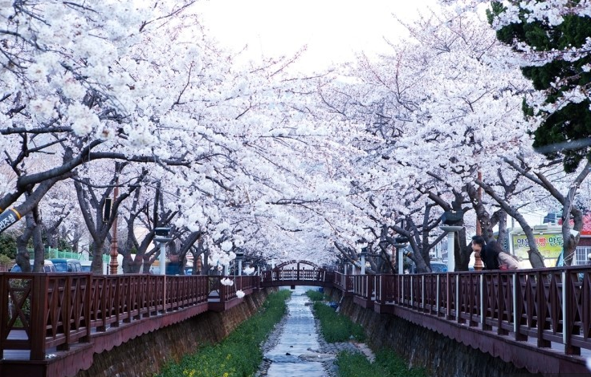
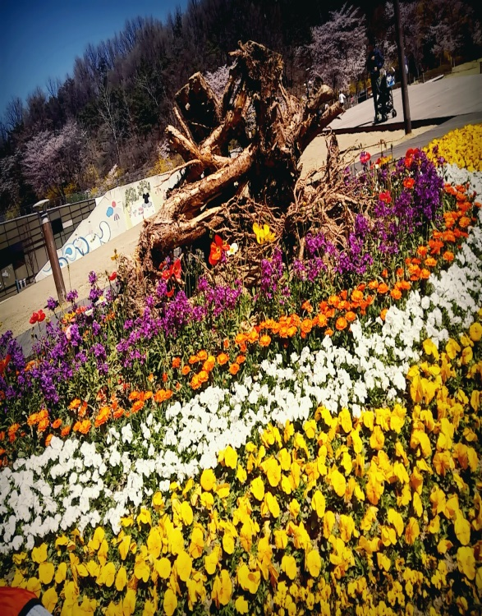

Flowers in the park Cherry Blossom Festival

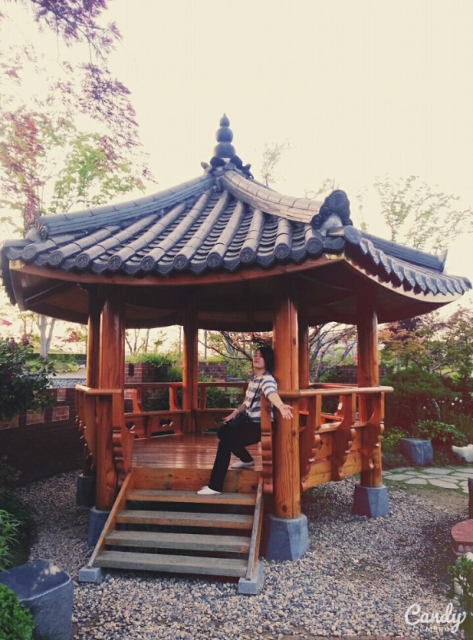

Relaxing in Nature

Brainstorming of Word ‘Nature’ Work Sheet

Nature

‘The Benefits of Nature’ Reading Text
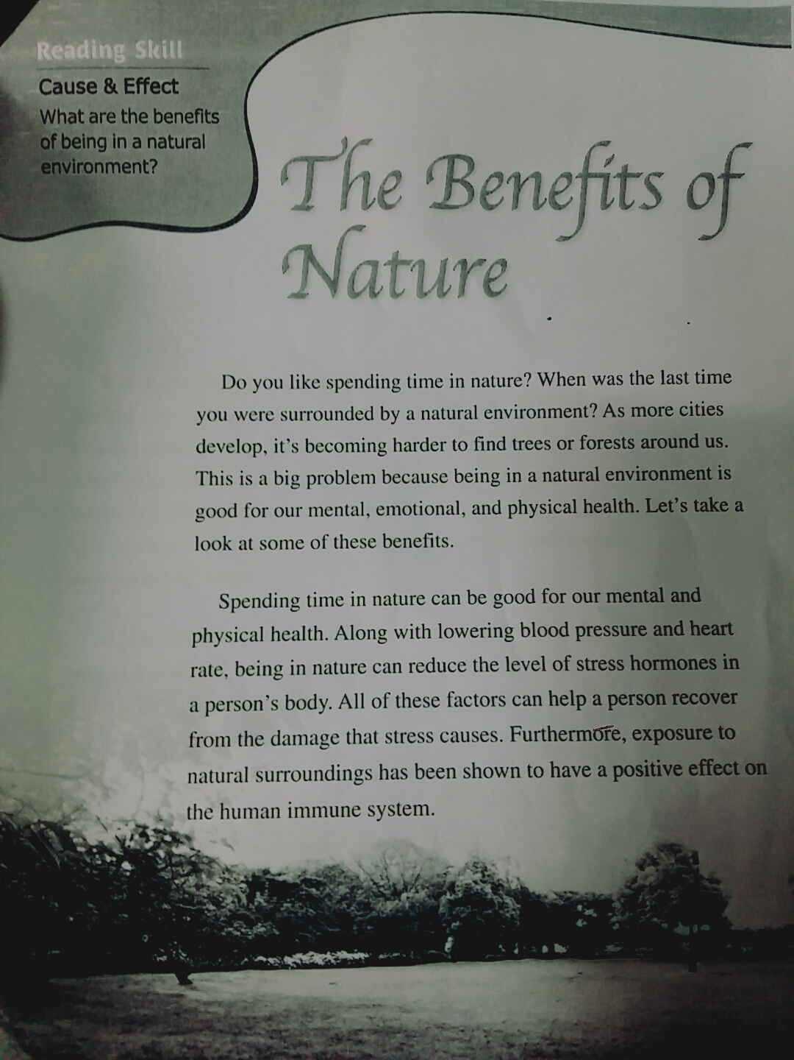
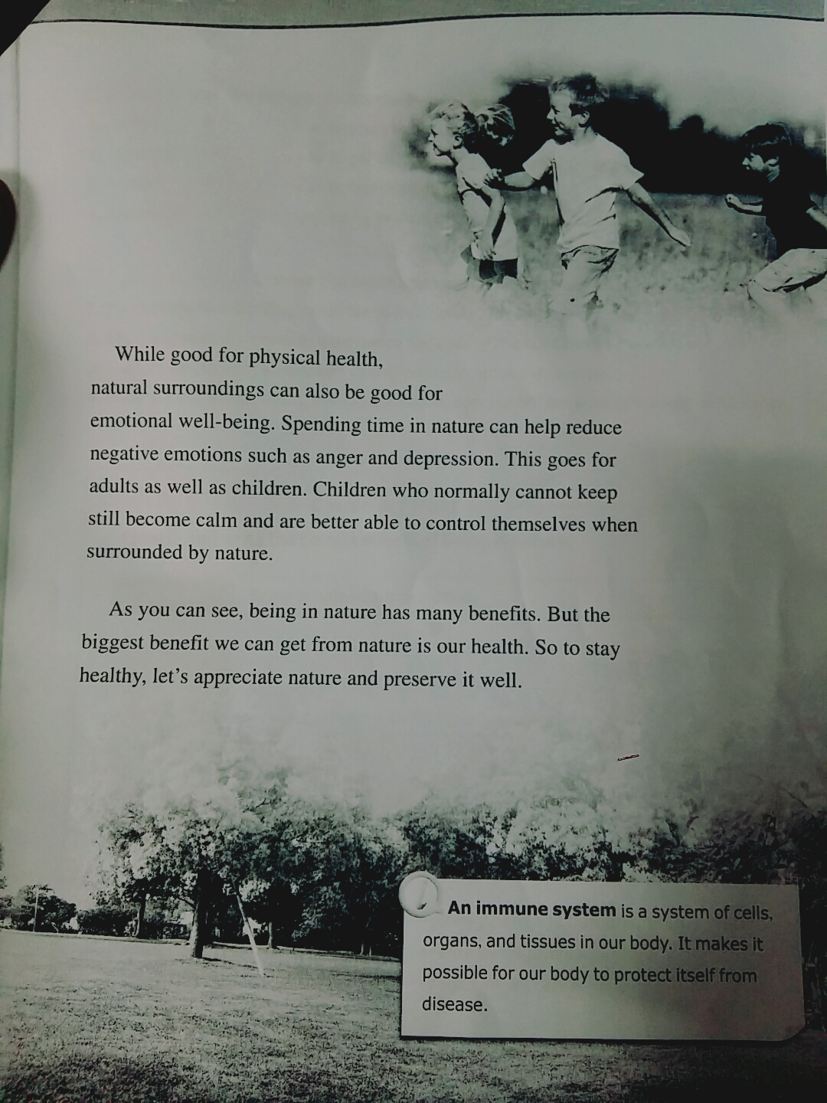

After Reading Work sheet

- Main idea choose the main idea of the passage.

- People who like spending time in nature are healthy.
- We have to preserve the forests to keep our natural surroundings.
- There are no parks in the city because of city developments.
- Being in nature helps a person recover from a disease.

- Check T(True) or F (False).
- Being in a natural environment increases one’s blood pressure. T F
- It is harder to find trees and forest in the city. T F
- Nature is beneficial only to children;s emotional health. T F
- Natural surroundings can affect the level of our stress hormones. T F

- Choose the correct answers.
- Which is NOT mentioned as benefits of nature?
- Healthy minds
- Healthy bodies
- Healthy religions
- Healthy emotions

- Which is mentioned about natural surroundings?
- They can be found very easily in the city.
- People don’t appreciate nature any more.
- They are only beneficial for our physical health.
- They have a positive effect on our body and mind.

- Natural surroundings are becoming rare because .
- people don’t enjoy outdoor activities
- more cities are growing
- developing a natural area costs too much
- the weather changes too much

