Listening Speaking Reading Grammar Writing
Topic: Show Me Your Abilities?
(Language Target: Can, Could)

Instructor:  Babette | Students Competency Level: Intermediate | Number of Students: 13 | Lesson Length:  50min
Materials: (List the Names of all materials used in the lesson. Materials must be shown at the end of this document)

- White Board & Marker
- Past vs Present Work Sheet
- The Guessing Work Sheet
- Speed Quiz Work Sheet

Aims: (What students will be able to achieve by participating in the activities of the lesson. (Ss gain or get by doing…)
- Improve Ss listening skill by listening to T’s story, questions and partner’s talk.
- Improve Ss speaking skills by speaking one’s idea, discussing in groups and responding to T questions.
- Improve Ss grammar skills by T using can, could and completing Past & Present Work Sheet and Speed Quiz Work Sheet.

Language Skills: (Lists what activities language skills students will be using by participating in the activities of the lesson.)
- Reading: (Where did reading occur in the lesson?)
Worksheet, Quiz
- Listening: (Where did listening occur in the lesson?)
T instruction and explanation, discussion
- Speaking: (Where did speaking occur in the lesson?)
Responding to T, Questions, discussion
- Writing: (Where did writing occur in the lesson?)
Writing Worksheet and Quiz
Language Systems: (Lists what language systems students will be using by participating in the activities of the lesson.)
- Phonology: (sound)
Discussion, T talk, Ss talk
- Lexis: (meaning)
Can, Could use Worksheet and Quiz
- Grammar: (language structure)
Can, Could
- Discourse: (communication)
Discussion, sharing stories, and playing a game
Assumptions: (What students must already be able to do and what concepts must already be mastered before the lesson in order to achieve the aims of the lesson.)

- All Ss will enjoy discussion and sharing their opinions.
- All Ss enjoy completing their own work sheets.

Anticipated Errors and Solutions: (What things might go wrong in the lesson and what the solution will be. An SOS activity should also be included)

If Ss may not understand clear the meaning.
→ Provide more examples.
- If some of the Ss are too shy to participate during the group discussion.
→ Encourage Ss to participate and give positive feedback.
- If some Ss don’t give their opinion during the group discussion.
→ T gives her/him opinion first.
- If activity takes too long.
→ Give time warning.
- If activity finishes too soon.
→ Give Ss more time for the discussion.

References:

Lead-In or Pre-Task Part (Warm-Up Part to activate and create interest in the lesson.)
Materials: (List the Names of all materials used in the Lead-In or Pre-Task Part of the lesson. Materials must be shown at the end of this document)

Time: | Classroom Set Up: | Student Activity and Goals: | Teacher Procedure & Instructions:
1min  5min | Whole  Whole | Greeting T.  Ss listen T’s talk and think about their special abilities.  Share Ss’s unusual abilities with others. | <Greeting>  Greeting Ss.  T talks her Special Ability to ss.  (I can eat bread for 1 week without rice)  Ask Ss to describe their Special abilities.  (Ex: I can play computer games more than 5 hours without any break/ I can sleep for 14hours a day/ I can play 3 different instruments)

Pre-Activity or Task Familiarization Part (Presentation Part Presenting the language structure to be covered in the lesson. Prepares students for the communication activity.)
Materials: (List the Names of all materials used in the Pre-Activity or Task Familiarization Part of the lesson. Materials must be shown at the end of this document)

White Board & Marker.

Past vs Present Work Sheet.

Time: | Classroom Set Up: | Student Activity and Goals: | Teacher Procedure & Instructions:
7min  13min | Whole  Group | Ss read, listen and speak to learn and become familiar with the structures.  Ss move into their groups.  Ss listen carefully T’s talk to understand the usage of target languages.  Get the Work Sheet and describe the changes of each items between past and present.  Show their item and share his(her) idea to the class. | (T writes grammar structures of ‘Can, Could, Can not, Could not’ on the white board.)  Do practice with ss. Accuracy is important.  Divide the class into 4 groups.  Explain the considerable changes about past vs present cellphone by using target languages.  Hands the Work Sheet out and ask Ss to describe the changes.  Ask Ss to present their ideas to the class.

Main Activity or Task Realization Part (Practice to Production Part Teacher lead practice of the language presented and move to communication based more student centered activity)
Materials: (List the Names of all materials used in the Main Activity or Task Realization Part of the lesson. Materials must be shown at the end of this document)

The Guessing Work Sheet.

Time: | Classroom Set Up: | Student Activity and Goals: | Teacher Procedure & Instructions:
2min  8min  8min | Group  Pairs  Whole | Ss get the Work Sheet  and listen T’s talk.  Ss Sequentially do the activity  Ss present partner’s ability. | Hands the Work Sheet out and explains the process.  1. Put Ss into pairs.  2. Each s writes his or her partner’s name in the space at the Work Sheet.  3. Ss work individually and try to guess if their partner can or can’t do the activities listed on the Work Sheet.  4. Ss can underline or circle can or can’t in each sentence without talking to their partners.  5. When Ss have finished, Ss take it in turns to ask their partner if they can do the activities on the Work Sheet.  6. If a S has guessed correctly, they put a tick in the second column.  7. If a S has guessed wrong, Ss  put a cross in the send column.  8. Ss should ask their partner to  demonstrate their ability.  1. Ask each group to present about what their partner can do to the class.

Post Activity or Post Task Part (Wrap-Up Part Close the Lesson on a high note to and consolidate language learned in a communication based activity new situation.)
Materials: (List the Names of all materials used in the Post Activity or Post Task Part of the lesson. Materials must be shown at the end of this document)

Speed Quiz Work Sheet

Time: | Classroom Set Up: | Student Activity and Goals: | Teacher Procedure Instructions:
2min  4min | Whole  Whole | Ss get it and listen T’s talk.  Ss read and write the right answer on the Quiz. | T hands the Quiz out.  Ask Ss to read it and fill in the blanks. After finishing, T and Ss scoring the answer sheet.  Thank everyone for participation and close the class.
Past vs Present Work Sheet

Pls talk about big changes between Past vs Present using Can(Can’t) or Could(Couldn’t) about each item.

 | <Past> | <Present>
① | 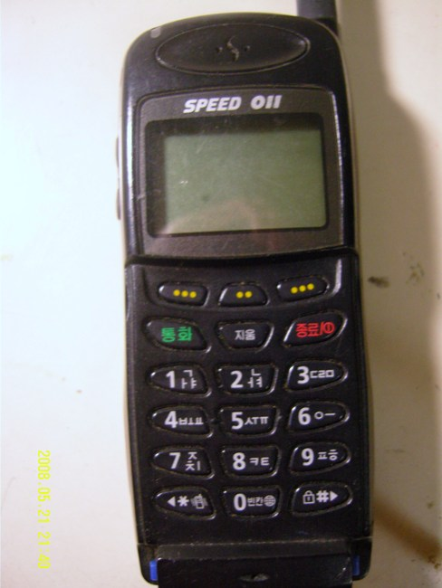
$②$
③
④

The Guessing Work Sheet

Work Sheet A

Partner’s name : | Right  Or Wrong
- My partner can/can’t spin around ten times and then walk in a straight line.
- My partner can/can’t pat his(her) head and rub his(her) stomach at the same time.
- My partner can/can’t wiggle his(her) ears.
- My partner can/can’t stand up and touch his(her) toes.
- My partner can/can’t draw a squre and a circle at the same time.
- My partner can/can’t write his(her) father’s name in chinese characters.
- My partner can/can’t ride a motobike.
- My partner can/can’t sing a song loudly in the class.
- My partner can/can’t dance in the class.
- My partner can/can’t walk like a model in the center of the class.

---------------------------------------------------------------------------------------------------------------------

Work Sheet B

Partner’s name : | Right  Or Wrong
- My partner can/can’t use the nose to touch his/her elbow.
- My partner can/can’t whistle.
- My partner can/can’t say the months of the year backwards in English without making a mistake.
- My partner can/can’t say ‘good-bye’ in five languages within 5 seconds.
- My partner can/can’t remember the teacher’s full name.
- My partner can/can’t type without looking at the keyboard.
- My partner can/can’t 12 push-ups in 10 seconds.
- My partner can/can’t say “Yaho” to the people in the street through the window.
- My partner can/can’t twist their arms to touch their navel.
- My partner can/can’t make 3 animal sound in English.

Speed Quiz Work Sheet

Pls use ‘can(can’t)/could(couldn’t)’ to fill the blanks for 4 min.

1. he understand what you were talking about?

2. My sister play tennis now.

3. I walk when I was less than a year old.

4. I speak foreign languages, when I was a kid.

5. Can you help me? I never understand this.

6. We eat in a restaurant, if you like

7. In those days, a pacific voyage be dangerous.

8. I use your phone, please?

9. He have slept through all that noise.

10. I was so surprised that I move an inch!

11. We _________________ get to the meeting on time yesterday because the train
was delayed by one hour.

12. I drive a car until I was 34, then I moved to the countryside so I had to learn.

13. Unfortunately, I really sing at all! No-one in my family is musical either.

14. Julian could play excellent golf when he was only ten.

15. She’s 7 years old but she read yet – her parents are getting her extra lessons.

16. James speak Japanese when he lived in Japan, but he’s forgotten most of it now.

