Listening Speaking Reading Grammar Writing
Topic: 10 Years Ago
(Language Target: Used To)

Instructor:  Miri | Students Competency Level  Pre-intermediate | Number of Students:  12 | Lesson Length:  75min
Materials: (List the Names of all materials used in the lesson. Materials must be shown at the end of this document)
Board and Markers
Teacher’s Picture
Activity Pictures
-Sechs Kies
-Finkl
-Lee Hyo-ri
Drilling Wall Chart I – Subject + used to + Base Verb.

Aims: (What students will be able to achieve by participating in the activities of the lesson. (Ss gain or get by doing…)
-Improve Ss listening skills by listening to T’s story, Ss sentences, drilling, playing a game and presentations.
-Improve Ss speaking skills by Ss presentations, sharing opinions, drilling, and playing a game.
-Improve Ss grammar skills about “Used To” by T using “Used To”, T responding and rephrasing Ss Thoughts, drilling, writing, playing a game.

Language Skills: (Lists what activities language skills students will be using by participating in the activities of the lesson.)
- Reading: (Where did reading occur in the lesson?)
Drilling wall chart, writing sentences
- Listening: (Where did listening occur in the lesson?)
Teacher talk, Ss talk, game
- Speaking: (Where did speaking occur in the lesson?)
Sharing Ss opinions about the Activity Pictures, answering T, playing a game
- Writing: (Where did writing occur in the lesson?)
Writing sentences about pictures in activities
Language Systems: (Lists what language systems students will be using by participating in the activities of the lesson.)
- Phonology: (sound)
Drilling, T and Ss talk.
- Function: (situation)
Describing about past
- Lexis: (meaning)
“Used To” use about the past
- Grammar: (language structure)
“Used To”
- Discourse: (communication)
- T-S-T, Ss presentations, sharing opinions, drilling, and playing a game.

Assumptions: (What students must already be able to do and what concepts must already be mastered before the lesson in order to achieve the aims of the lesson.)
-All Ss can talk about their past conditions, hobbies, habits.
Anticipated Errors and Solutions: (What things might go wrong in the lesson and what the solution will be. An SOS activity should also be included)
-If Ss cannot think of sentences: show Ss some examples.
-If Ss take short time to make sentences: give them more situations.
References:

Lead-In or Pre-Task Part (Warm-Up Part to activate and create interest in the lesson.)
Materials: (List the Names of all materials used in the Lead-In or Pre-Task Part of the lesson. Materials must be shown at the end of this document)
Teacher’s Picture
Time: | Classroom Set Up: | Student Activity and Goals: | Teacher Procedure & Instructions:
1 min  4min  7min | Whole  Whole  Ss | Greet T.  Listen to T, become aware of the target language structure.  Share Ss’s story | Greet Ss  Talk about ’10 Years Ago’ showing Teacher’s Picture by using ‘used to’  Ask Ss to share their story about their 10-year-ago habits, hobbies and condition that they don’t have now.

Pre-Activity or Task Familiarization Part (Presentation Part Presenting the language structure to be covered in the lesson. Prepares students for the communication activity.)
Materials: (List the Names of all materials used in the Pre-Activity or Task Familiarization Part of the lesson. Materials must be shown at the end of this document)
White Board and Markers
Drilling Wall Chart I – Subject + used to + Base Verb.

Time: | Classroom Set Up: | Student Activity and Goals: | Teacher Procedure & Instructions:
5min  3min  5min  10min | W-Ss  Whole  Whole  Whole-S | Ss read, listen, speak and drill to learn and become familiar with conditionals.  Listen to T.  Ss think.  Ss speak. | Put drilling wall charts on the white board.  Do drilling with student. Accuracy important.  T introduces activity by describing pictures and making ‘used to’ sentence.  Ask Ss to think about themselves 10 years ago using ‘used to’  Ask Ss to share their experience with the class.

Main Activity or Task Realization Part (Practice to Production Part Teacher lead practice of the language presented and move to communication based more student centered activity)
Materials: (List the Names of all materials used in the Main Activity or Task Realization Part of the lesson. Materials must be shown at the end of this document)
Activity Pictures:
-Sechs Kies
-Finkl
-Lee Hyo-ri
Time: | Classroom Set Up: | Student Activity and Goals: | Teacher Procedure & Instructions:
4min  8min  8 min | W-Ss  Group  Group-W | Listen to T and responses about the pictures. Thinks about the pictures.  Ss work in groups to share their opinions about the pictures using ‘used to’.  Ss present. | T shows Activity pictures and ask for Ss comment. Introduces “Describing Activity” about the pictures using ‘used to’ sentences based on picture, and teach others.  Put Ss in groups to write sentences about the pictures using ‘used to’  Ask Groups to come to front of class and present what they wrote. Teacher facilitates class response and feedback.

Post Activity or Post Task Part (Wrap-Up Part Close the Lesson on a high note to and consolidate language learned in a communication based activity new situation.)
Materials: (List the Names of all materials used in the Post Activity or Post Task Part of the lesson. Materials must be shown at the end of this document)

Time: | Classroom Set Up: | Student Activity and Goals: | Teacher Procedure Instructions:
4min  10min  1min | Whole  Whole  Whole | Listen to T instructions and prepare to play game  Ss play the game with teacher  Thank teacher and say good-bye | Introduce “Describing Myself After 10 Years Game” using “used to”. Give time to present what they wrote.  Ask all Ss to come to front and play the game. Each Ss must use “used to” sentences in the game and state what they wrote. Close the game when there is one student who wrote the most sentences. That student is winner.  Congratulate the winner and thank all students for actively participating in the lesson. Close by giving feedback about their work.

Activity Pictures

Sechs Kies
Finkl
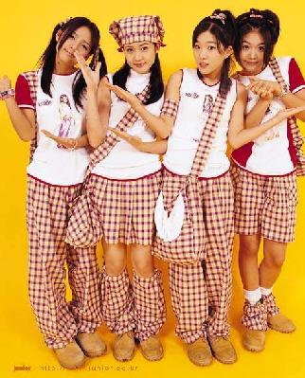
Lee Hyo-ri

Teacher’s Picture
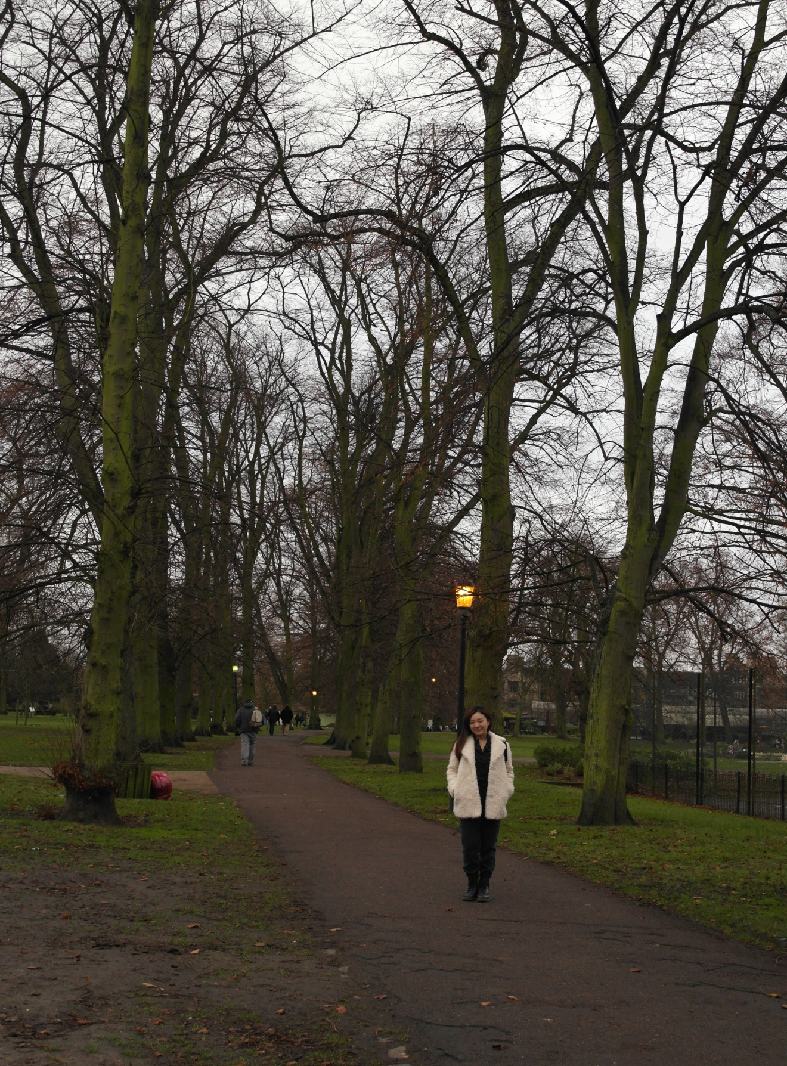

Drilling Wall Chart I – Subject + Used to + Base verb.

I used to listen to the music.

She used to wear glasses.

