Listening Speaking Reading Grammar Writing
Topic: Home Dressing

Instructor:  Julia | Students Competency Level  Pre-Intermediate | Number of Students:  14 | Lesson Length:  60minutes
Materials:(List the Names of all materials used in the lesson. Materials must be shown at the end of this document)
- White Board & Markers,
- Computer, Projector, Screen
- ‘Home Dressing’ Site
- Family Situation Cards:
- Parents, Two Students 4 Family Members
- Parents, Two Children, Grandparents 2Family Members
- Newlywed Couple 2 Family Members
- ‘House Ground Plan Worksheet Template’ A
- ‘House Ground Plan Worksheet Template’ B
- ‘House Ground Plan Worksheet Template’ C
- ‘House Ground Plan Worksheet Template’ D
- ‘House Ground Plan (Floor Plan) With Furniture Arrangement’ Sample
- ‘Vocabulary for House’

Aims:(What students will be able to achieve by participating in the activities of the lesson. (Ss gain or get by doing…)
- Improve speaking skills by group activity and discussion with a group and answering teacher
- Improve listening skills by group activity and discussion with a group, responding to teacher
- Improve writing skills by planning for buying house stuffs and arrangement
- Improve interaction and communication skills by having discussion in a group
- Activate, increase interest, and participate with fun in an English communication

Language Skills:(Lists what activities language skills students will be using by participating in the activities of the lesson.)
- Reading: (Where did reading occur in the lesson?)
Group activity, note taking
- Listening :(Where did listening occur in the lesson?)
Teacher talk, during the group activity, discussion
- Speaking: (Where did speaking occur in the lesson?)
Small group discussion, answering a teacher, presentation
- Writing: (Where did writing occur in the lesson?)
Note, Planning

Language Systems: (Lists what language systems students will be using by participating in the activities of the lesson.)
- Phonology: (sound)
Group activity, discussion, teacher talk
- Function:(situation)
Buying furniture and domestic appliances
Planning furniture arrangements and decoration for house
- Lexis: (meaning)
Vocabulary about house¹⁾, furniture²⁾, domestic appliances and other house stuffs 1) living room, bedroom, dining room, etc 2) bunker bed and so on
- Grammar:(language structure)
Description for arrangement, There is, there are
- Discourse: (communication)
Discussion, responding the teacher, group activity-buying/planning furniture

Assumptions :(What students must already be able to do and what concepts must already be mastered before the lesson in order to achieve the aims of the lesson.)
- All Ss probably know the key vocabulary about house, furniture, and domestic electronic
- All Ss probably have some dreams about ideal house and ground floor
- All Ss probably have some wishes to make special room for their interests
- All Ss probably have some wishes for home styling
- All Ss understand the concept of home styling and will enjoy planning home decoration
- All Ss have opinions about their ideal plan of furniture arrangement.

Anticipated Errors and Solutions:
(What things might go wrong in the lesson and what the solution will be. An SOS activity should also be included)
- If Ss may not have many ideasSolution : T gives them little examples
- If activity lasts too long Solution : T cuts the unnecessary parts
- If activity finished too soonSolution : T makes suggestion and shared ideas
- If Ss may not understandsSolution : T shows demonstration
- If certain Ss are shy Solution : T encourages them and gives positive feedback for them
References:
- www.homedressing.com.au (for showing Ss the concept of home dressing)

Lead-Inor Pre-Task Part (Warm-Up Part to activate and create interest in the lesson.)
Materials: (List the Names of all materials used in the Lead-Inor Pre-Task Partof the lesson. Materials must be shown at the end of this document)

Time: | Classroom Set Up: | Student Activity and Goals: | Teacher Procedure &Instructions:
1min  5min | Whole  Whole | Ss greet the teacher  Ss listen to teacher | Greeting  Tell T’s stories about the experience for home styling and share T’s ideal house  (buy furniture, change the colors of  imagination about T’s ideal house
5min | Ss | Ss talk their stories. | Elicit the stories from Ss  by asking something to want to change or buy if they have enough money.  And write it down on the board  (new sofa, new King bed, Sofa bed, Desk  Changing dining room..etc)  Let’s imagine about your home if you got the lottery

Pre-Activity or Task Familiarization Part (Presentation PartPresenting the language structure to be covered in the lesson. Prepares students for the communication activity.)
Materials: (List the Names of all materials used in the Pre-Activity or Task Familiarization Part of the lesson. Materials must be shown at the end of this document)
- White Board & Markers
- Computer, Projector, Screen
- ‘Home Dressing’ Site
- Family Situation Cards:
- Parents, Two Students 4 Family Members
- Parents, Two Children, Grandparents 2 Family Members
- Newlywed Couple 2 Family Members
- ‘House Ground Plan Worksheet Template’ A
- ‘House Ground Plan Worksheet Template’ B
- ‘House Ground Plan Worksheet Template’ C
- ‘House Ground Plan Worksheet Template’ D
- ‘House Ground Plan (Floor Plan) With Furniture Arrangement’ Sample
- ‘Vocabulary for House’

Time: | Classroom Set Up: | Student Activity and Goals: | Teacher Procedure &Instructions:
4min  2min  4min | Whole  Group  Group | Ss listen what T says  Ss move into group  Ss read the cards which describe family members.  & share with group members | Instruction  Show ‘Home Dressing’ Site  Introduce the meaning of home dressing.  Introduce the group activity for ‘Home dressing’ and describe setting.  Divide Ss into 3 groups  Hand out the situation cards which describe family members.  Let each groups pick up one ground plan template among 4 templates(A,B,C,D)  each group can be choose one which they want.
11min | Whole | Ss prepare for group activity  Ss see the pictures for home styling, home dressing | Ask Ss discuss ‘home dressing’ for family members which each group has  T facilitates. Make notes to help plan new furniture arrangement.  Transition  Now time to present their plans for home dressing

Main Activity or Task Realization Part(Practice to Production PartTeacher lead practice of the language presented and move to communication based more student centered activity)
Materials: (List the Names of all materials used in the Main Activity or Task Realization Partof the lesson. Materials must be shown at the end of this document)
- White Board & Markers, Colored pens and pencils for 3 group
- Family Situation Cards:
- Parents, Two Students 4 Family Members
- Parents, Two Children, Grandparents 2Family Members
- Newlywed Couple 2 Family Members
- ‘House Ground Plan Worksheet Template’ A
- ‘House Ground Plan Worksheet Template’ B
- ‘House Ground Plan Worksheet Template’ C
- ‘House Ground Plan Worksheet Template’ D
- ‘House Ground Plan (Floor Plan) With Furniture Arrangement’ Sample

Time: | Classroom Set Up: | Student Activity and Goals: | Teacher Procedure &Instructions:
1min  X3 | Whole  Groups | Ss get ready for presenting ideas on home dressing  But don’t use  situation cards  Everything below happens triple | T gives instruction for each group to come to front and present  And starts presenting their idea on home dressing for family situation  Everything below happens triple
5min  5min | Groups  Whole | Ss present their ideas of home dressing for each family while showing ground plan.  One group at a time  Other group watches listens and enjoys  Ss listen what T says  Ss applaud other students | T monitors presentation  Gives encouragement to each group  & facilitates class feedback to group presentation.  Give Ss positive feedback, and comments,  Facilitates class members’ feedback

Post Activity or Post Task Part (Wrap-Up PartClose the Lesson on a high note to and consolidate language learned in a communication based activity new situation.)
Materials: (List the Names of all materials used in the Post Activity or Post Task Part of the lesson. Materials must be shown at the end of this document)
- White Board & Markers
- Family Situation Cards:
- Parents, Two Students 4 Family Members
- Parents, Two Children, Grandparents 2Family Members
- Newlywed Couple 2 Family Members
- ‘House Ground Plan Worksheet Template’ A
- ‘House Ground Plan Worksheet Template’ B
- ‘House Ground Plan Worksheet Template’ C
- ‘House Ground Plan Worksheet Template’ D
- ‘House Ground Plan (Floor Plan) With Furniture Arrangement’ Sample

Time: | Classroom Set Up: | Student Activity and Goals: | Teacher Procedure Instructions:
5min  2min | Whole  Whole | Ss discuss differences of home dressing according to family’s characteristics  Ss listen | T discusses possible differences of home dressing according to family’s characteristics  Closing by giving Ss feedback about their accomplishment and improvement

Family Situation Cards
⬧ Parents, two students 4 Family Members

My husband always hopes to have his own study (library).

My Son and daughter needs to study hard.

I really like buying clothes, and drawing paintings

Yesterday, I won the lottery.

‘

Parents, grandparents, two children 6Family members-

My family really loves barbecue.

My grandmother loves the plants and flowers.

My two daughters need place to play.

Yesterday, I won the lottery.

Newlywed Couple 2 Family Members

We just got married.

We love watching movies.

My wife likes playing piano, listening to music.

I enjoy cooking for my new bride.

Yesterday, I won the lottery

‘House Ground Plan (Floor Plan) Worksheet Template’ A

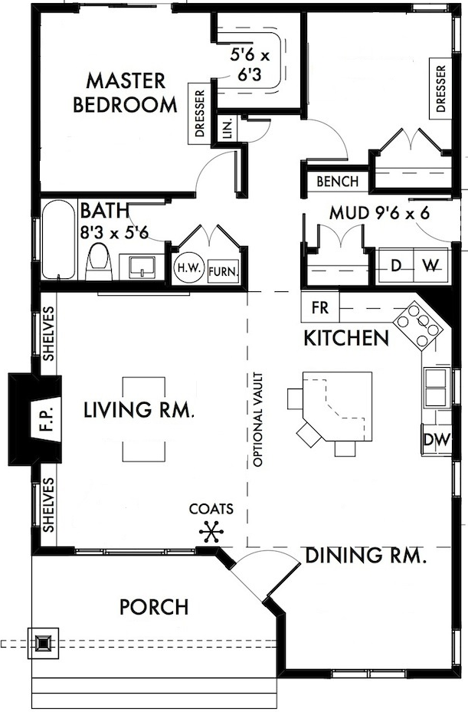
‘House Ground Plan Worksheet - Template’ B

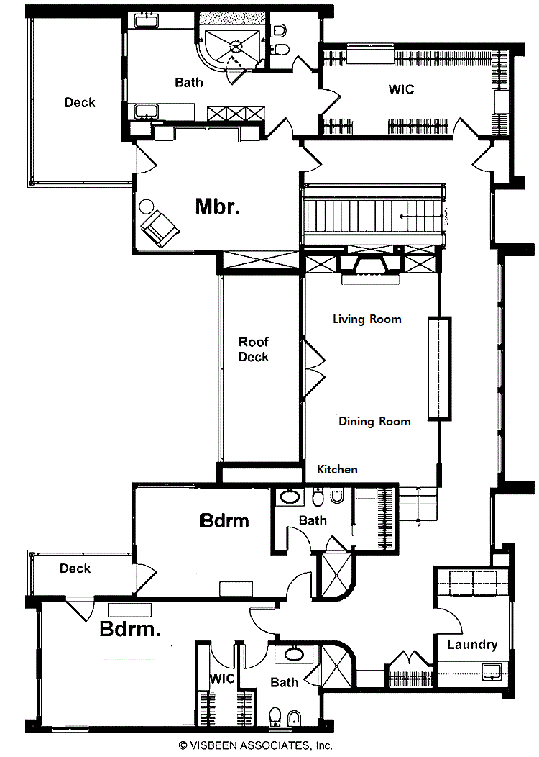

‘House Ground Plan Worksheet - Template’ C

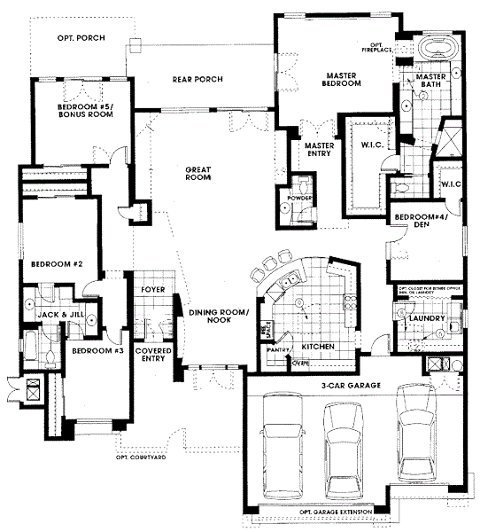

‘House Ground Plan Worksheet - Template’ D

4Bedroom, Family room, Porch

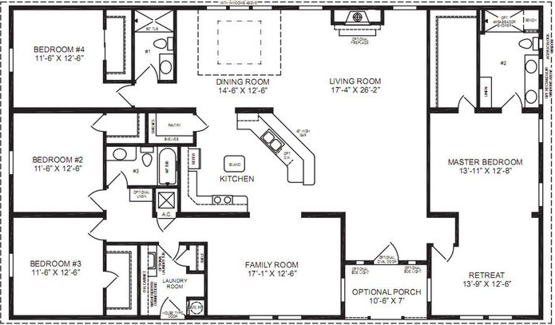

- ‘House Ground Plan (Floor Plan) With Furniture Arrangement’ Sample

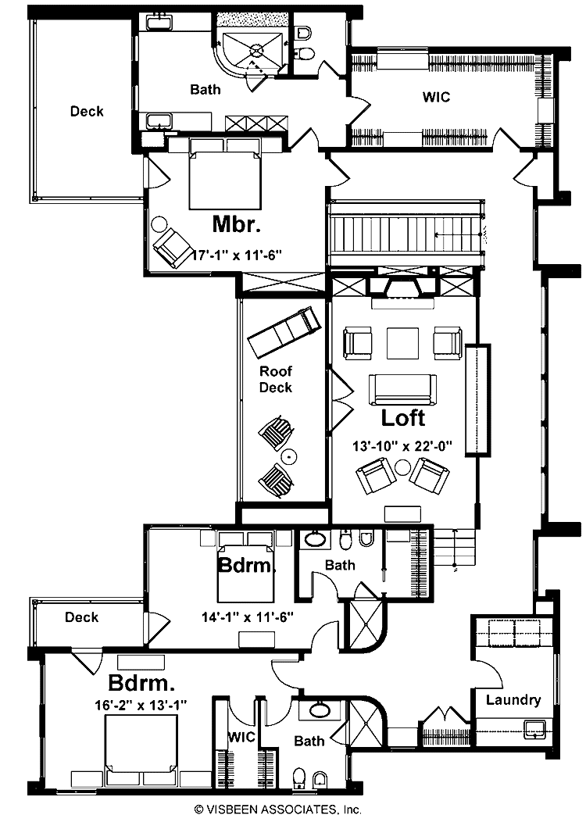
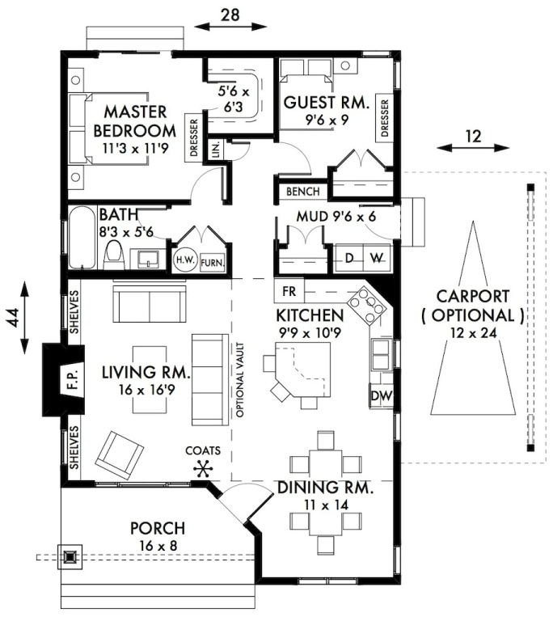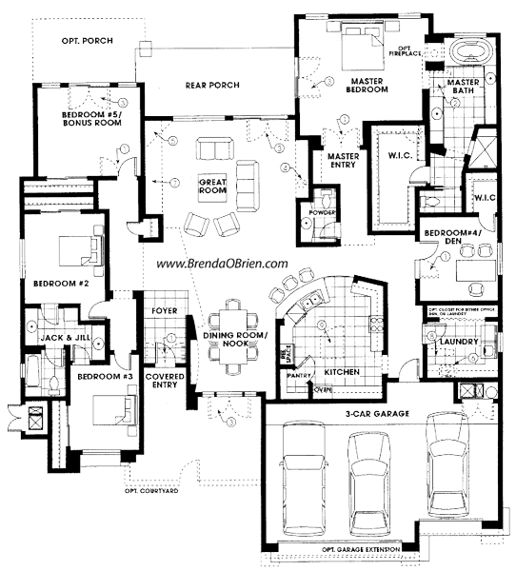

‘Vocabulary for House’

