Listening Speaking Reading Grammar Writing
Topic: Color Me Happy

Instructor:  Julia | Students Competency Level  Intermediate | Number of Students:  12 | Lesson Length:  50minutes
Materials:(List the Names of all materials used in the lesson. Materials must be shown at the end of this document)

Computer, Projector, Screen
White Board & Markers
‘Color Me Happy!’ Reading Text
Brainstorming The Word ‘Color’ Work Sheet
Pictures of Rainbows
- Rainbow Landscape
- The Rainbow
After Reading Work Sheet
Reading Summary
Bedrooms Picture

Aims:(What students will be able to achieve by participating in the activities of the lesson. (Ss gain or get by doing…)
- Improve Ss Reading Skills by reading the screen, board and work sheet
- Improve Ss listening skills by listening to T introduction, questions, and ICQ-CCQs and listening to other Ss statements during pair activity and group activity and discussion with a group
- Improve Ss speaking skills by reading text, group activity and discussion with a group and answering teacher
- Improve writing skills by completing work sheet of ‘Before reading’, and ‘After reading’, taking notes during discussion

Language Skills:(Lists what activities language skills students will be using by participating in the activities of the lesson.)
- Reading: (Where did reading occur in the lesson?)
Text and Work sheets
- Listening :(Where did listening occur in the lesson?)
T instruction and explanation, discussion, during the group activity
- Speaking: (Where did speaking occur in the lesson?)
Small group discussion, Repeat after T, responding to teacher,
Answering teacher, CCQ Questions, presentation and discussion
- Writing: (Where did writing occur in the lesson?)
Writing work sheets of ‘After reading’

Language Systems: (Lists what language systems students will be using by participating in the activities of the lesson.)
- Phonology: (sound)
Discussion, Ss talk, Teacher talk
- Function:(situation)
Sharing opinions about different colors
- Lexis: (meaning)
Vocabulary related to color
- Grammar:(language structure)

- Discourse: (communication)
Discussion, responding the teacher, answering ‘After Reading Work Sheet’,
group activity
Assumptions:(What students must already be able to do and what concepts must already be mastered before the lesson in order to achieve the aims of the lesson.)
- All Ss have feeling and opinion about color
- All Ss probably have experience to pick up the color when they need
- All Ss have opinion about color choice
- All Ss have opinions about recommending color according to the mood.

Anticipated Errors and Solutions:(What things might go wrong in the lesson and what the solution will be. An SOS activity should also be included)
- If Ss may not understand clear the meaning Provide more examples
- If some Ss are too shy to participate during the group discussion
Solution T encourages them to participate and gives positive feedback
- If some Ss don’t give their opinion during the group discussion
- Solution T give T’s opinion first and encourages them, gives positive feedback,
- If activity lasts too long give time warning and cuts the unnecessary parts
- If activity finished too soongive Ss more time for discussion

References:
Reading Highlights 3, WorldCom ELT

Lead-In or Pre-Task Part (Warm-Up Part to activate and create interest in the lesson.)
Materials: (List the Names of all materials used in the Lead-In or Pre-Task Part of the lesson. Materials must be shown at the end of this document)

Time: | Classroom Set Up: | Student Activity and Goals: | Teacher Procedure &Instructions:
4min | Whole | Ss greet the teacher  Ss listen to teacher. | Greeting  Tell T’s stories about experiences of picking up the color.  Tell T’s stories about favorite color and reason and background.
4min | S-W | Ss answer teacher’s questions. | Eliciting from Ss.  By asking Ss’ favorite color and reason.  (What’ your favorite color? Why)  Now let’s look at the color in more detail.

Pre-Activity or Task Familiarization Part (Presentation Part Presenting the language structure to be covered in the lesson. Prepares students for the communication activity.)
Materials: (List the Names of all materials used in the Pre-Activity or Task Familiarization Part of the lesson. Materials must be shown at the end of this document)
Computer, Projector, Screen
White Board & Markers
Pictures of Rainbows
- Rainbow Landscape
- The Rainbow
Brainstorming the Word ‘Color’ Work Sheet

Time: | Classroom Set Up: | Student Activity and Goals: | Teacher Procedure &Instructions:
1min | Whole | Ss look at the screen. | Show ‘Pictures of Rainbow’ by PowerPoint.
2min | Whole | Ss look at the board.  Ss answer teacher’s questions. | Introduce brainstorming activity.  Show an example on the board.  Ask Ss to brainstorm.  -“Let’s think about the color red.  What words occur to your mind?”
3min | Group | Ss complete the work sheet. | Set groups.  Hand out work sheet and  let Ss complete work sheet
2min | Whole | Ss share thoughts with other groups. | Ask each group to share their thoughts with other groups.  Transition  ‘Let’s look at t the color in detail’

Main Activity or Task Realization Part (Practice to Production Part Teacher lead practice of the language presented and move to communication based more student centered activity)
Materials: (List the Names of all materials used in the Main Activity or Task Realization Part of the lesson. Materials must be shown at the end of this document)
‘Color Me Happy!’ Reading Text
After Reading Work Sheet

Time: | Classroom Set Up: | Student Activity and Goals: | Teacher Procedure &Instructions:
6min | Whole  Whole | Listen to teacher. Receive text and read it carefully.  Ask questions as needed. | Introduce ‘Color Me Happy!’Text  and hand out text.  Ask students to read the text carefully and use questions to increase interest in the text.
6min | S-W | Ss share their thoughts with class. | Ask Ss to share their thoughts about the text and facilitate classroom discussion and feedback.  - What do color therapists think colors can do?  - How do scientists feel about color therapy?
1min | Individual | Ss get the work sheet. | Hand out ‘After reading’ work sheet  Put Ss in pairs to complete work sheet together
4min | Pair | Read and complete the work sheet. Ss ask some questions if they don’t know some words and can’t understand meaning. | Let Ss read and complete the work sheet in pairs.  Facilitate S-T, S-S interactions.
3min | S-W | Listen to T and  check the answers. | Check Ss answers of the worksheet and tell the right answers.  Give positive feedback.
Transition :
Let’s go over the color.

Post Activity or Post Task Part (Wrap-Up Part Close the Lesson on a high note to and consolidate language learned in a communication based activity new situation.)
Materials: (List the Names of all materials used in the Post Activity or Post Task Part of the lesson. Materials must be shown at the end of this document)
Computer, Projector, Screen
Reading Summary
Bedrooms Picture
White Board & Markers

Time: | Classroom Set Up: | Student Activity and Goals: | Teacher Procedure Instructions:
2min | Whole | Ss look at the screen  Ss Read together. | Show the power point for ‘After reading 2’ (Synthesize: Pick Your Color!)  Let’s sum up the color’s effect.  Read together.
2min | Individual | Ss respond. | Elicit answers on blank in power point from Ss  Facilitate class answer
4min | Whole | Ss listen. | Let Ss have time to pick your color.
 |  | Ss look at the screen. | Show ‘Bedrooms Picture’ by PowerPoint.
 | S-W | Ss answer teacher’s questions  and share their thoughts. | Eliciting from Ss  eg.  - How do the different pictures make you feel?”  - Which room would you want to sleep in? Why do you choose it?”
2min | Whole | Ss listen what T says, respond to teacher. | Ask 'Which color would you paint your bedroom?  Elicit response in class discussion.
3min | Group | Ss share their opinions about the color in group. | Set groups  Ask Ss to share their opinions about the color.  Encourage Ss and give positive feedback about their opinions.
1min | Whole | Ss say good bye. | Thank Ss for their active participation.

Pictures of Rainbows

Rainbow Landscape

The Rainbow

Brainstorming the Word ‘Color’ Work Sheet

List below what you feel and imagine when you think of each color.

Yellow

Green

Blue

Red

‘Color Me Happy!’ Reading Text

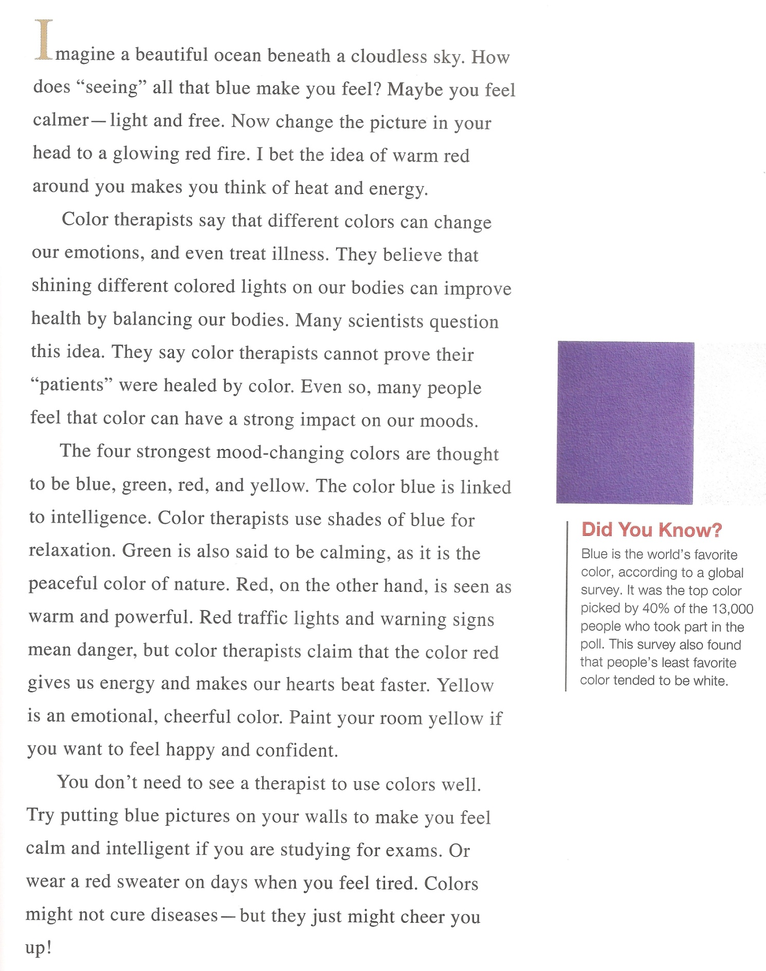
After Reading Work Sheet

Main Ideas and Inference

Circle the correct answer for each question.

1. What to color therapists think colors can do?

- Improve your health and your emotions.

- Impact your mood and make you intelligent.

2. How do scientists feel about color therapy?

- They don’t believe that colors can change moods.

- They are doubtful that it can heal disease.

Choose the best way to complete statement

3. Color therapists can’t prove that _______________

- Color can heal

- People think that colors can change their moods

Details

Write True or False or Not Given after each statement

- Many People have been healed by color therapy. __________

- Blue is supposed to make people feel relaxed __________

- Green is calming and red is exiting __________

- Yellow is linked to intelligence __________

Reading Summary

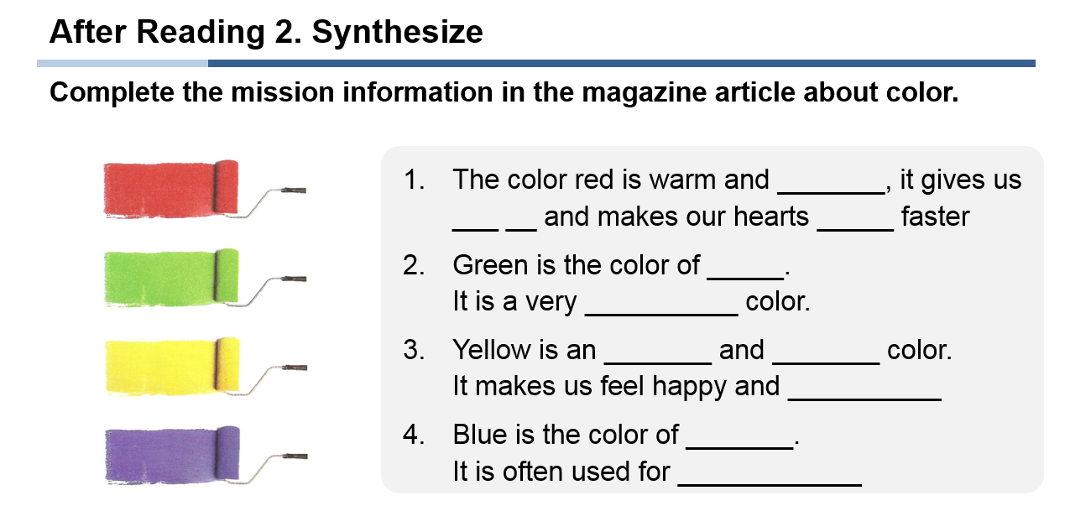

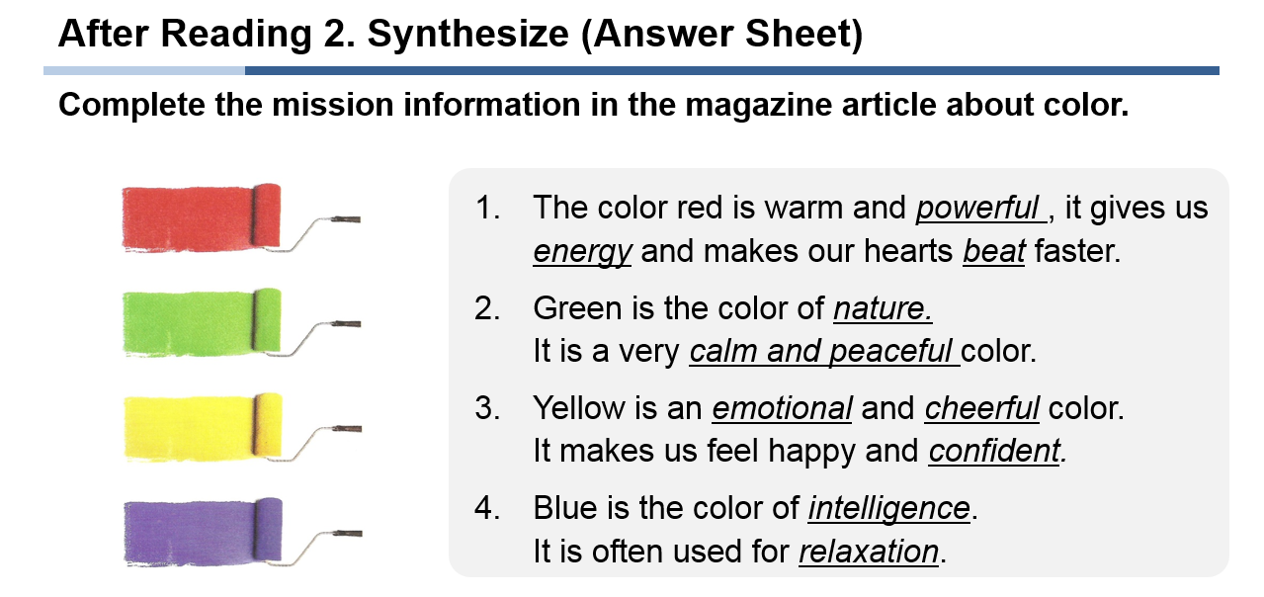

Bedrooms Picture

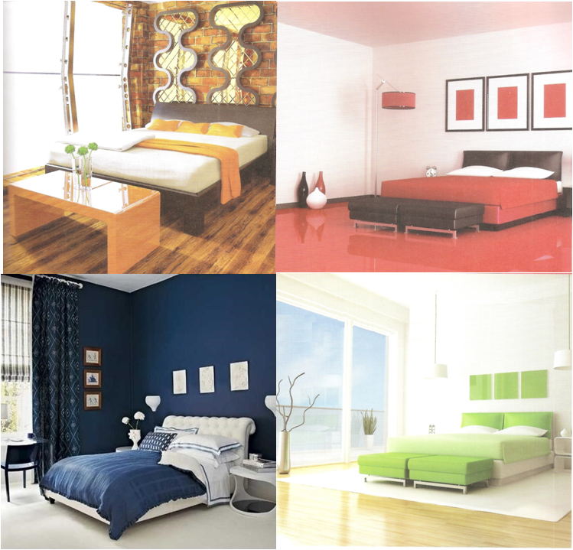

- How do you feel about each room?
- Which room would you want to seep in?
- Which color would you paint your bedroom?

