Listening Speaking Reading Grammar Writing
Topic:Private Investigator Mr. Po
(Language Target: Preposition)

Instructor:  Sunny | Students Competency  Pre-Intermediate | Number of Students:  13 | Lesson Length:  55 min
Materials:(List the Names of all materials used in the lesson. Materials must be shown at the end of this document)

Board and Markers
Preposition PPT Picture #1 to #7
Private Investigator Mr.Po Activity Worksheet
Picasso Activity Worksheet 1
Picasso Activity Worksheet 2

Aims:(What students will be able to achieve by participating in the activities of the lesson. (Ss gain or get by doing…)
- Improve Ss listening skills by listening to T’s story and Ss stories.
- Improve Ss speaking skills by discussing, drilling, and sharing ideas.
- Improve Ss grammar skills about preposition by T using different preposition and rephrasing Ss thoughts,

Language Skills:(Lists what activities language skills students will be using by participating in the activities of the lesson.)
- Reading: (Where did reading occur in the lesson?)
Drilling wall chart
- Listening:(Where did listening occur in the lesson?)
T’s instruction and story, Ss talk
- Speaking: (Where did speaking occur in the lesson?)
Sharing ideas in a group, discussion
- Writing: (Where did writing occur in the lesson?)
Writing sentences about an important event

Language Systems: (Lists what language systems students will be using by participating in the activities of the lesson.)
- Phonology: (sound)
Drilling, T and Ss talk
- Function:(situation)
Different types of phobias
- Lexis: (meaning)
Preposition use an important event
- Grammar:(language structure)
Prepositions of place & time
- Discourse: (communication)
Drilling, T-S-T communication, sharing ideas

Assumptions:(What students must already be able to do and what concepts must already be mastered before the lesson in order to achieve the aims of the lesson.)
Ss are used to working individually and in groups of 3~4.
Ss can explain where things are through drawing.
Ss know time, date and days.
Anticipated Errors and Solutions:(What things might go wrong in the lesson and what the solution will be. An SOS activity should also be included)
- If Ss may not understand preposition☞ Solution: T explains more
- There may not be enough time to complete the lesson ☞ Solution: Assign the post activity task as a homework assignment or do it next class
- If Ss finish the main tasks earlier ☞ Solution: Ss make more drilling wall chart and practice
References:

Lead-Inor Pre-Task Part (Warm-Up Part to activate and create interest in the lesson.)
Materials: (List the Names of all materials used in the Lead-Inor Pre-Task Partof the lesson. Materials must be shown at the end of this document) 8 minutes

Time: | Classroom Set Up: | Student Activity and Goals: | Teacher Procedure &Instructions:
1 min  7 min | Wh  Wh | Greet T  Listen to T  Ss share their own experiences.  Ss look at the screen. | Greet Ss  T tells Sswhat happened few days ago.  - T couldn’t find the car key  - Looked everywhere (under the sofa, on the desk, in the bag, between the shelf and tv, etc)  - Found it  Eliciting: T asks Ss if they have similar experiences  - Have you lost something and looked everywhere to find it?  T rephrases and respond using preposition.  T shows Ss PPT file to practice preposition.

Pre-Activity or Task Familiarization Part (Presentation PartPresenting the language structure to be covered in the lesson. Prepares students for the communication activity.) 10 minutes
Materials: (List the Names of all materials used in the Pre-Activity or Task Familiarization Part of the lesson. Materials must be shown at the end of this document)

Preposition PPT Picture 1
Preposition PPT Picture 2
Preposition PPT Picture 3
Preposition PPT Picture 4
Preposition PPT Picture 5
Preposition PPT Picture 6
Preposition PPT Picture 7

Time: | Classroom Set Up: | Student Activity and Goals: | Teacher Procedure &Instructions:
10 min | Wh  G | Sslooks at the screen and answer the questions.  Repeat after the teacher.  A student repeat after T  Ss listen and sit with their group members.  Each group gets a story handout. | T shows SsPPT pictures and ask them where each item or animal located.  - T: Where is the mouse?  Ss: behind the box  T: Yes, the mouse is behind the box. Listen. The mouse is behind the box. Repeat after me. Now, Lucy, it’s your turn.  Everything below happens 7 times.  T tells Ss they need to find a password. Divide Ss into 4 groups. Hand out the private investigator Mr. Poworksheet.

Main Activity or Task Realization Part(Practice to Production PartTeacher lead practice of the language presented and move to communication based more student centered activity)25 minutes
Materials: (List the Names of all materials used in the Main Activity or Task Realization Partof the lesson. Materials must be shown at the end of this document)

Private Investigator Mr.Po Activity Worksheet
Time: | Classroom Set Up: | Student Activity and Goals: | Teacher Procedure &Instructions:
2min  15 min  3min  5min | G  G  G | Ss look at the handout.  Ss decide which preposition they need for each blank with their group member.  Ss present their answer. | T tells Ss look at the handout. There are a picture and sentences with blanks.  Ss need to look at the picture and figure out what preposition they need to use for each sentence.  Then Ss need to break the code and find the missing item.  Ss present their answers.

Post Activity or Post Task Part (Wrap-Up PartClose the Lesson on a high note to and consolidate language learned in a communication based activity new situation.) 12 minutes
Materials: (List the Names of all materials used in the Post Activity or Post Task Part of the lesson. Materials must be shown at the end of this document)

Picasso Activity Worksheet 1
Picasso Activity Worksheet 2
Time: | Classroom Set Up: | Student Activity and Goals: | Teacher Procedure Instructions:
12min | Pair | Ss get the worksheet.  With his/her partner, read the instructions and draw the objects in the frame.  Compare the pictures and discuss differences. | T hands out Picasso activity worksheet.  Ss draw pictures in the upper frame according to the instructions on their worksheet.  Student A reads their instructions to Student B.  Student B draws the objects in the lower frame. Then, Ss swap roles.  After that they compare their pictures and discuss any differences.

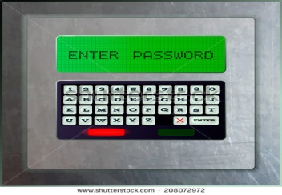
Private Investigator Mr.Po Activity Worksheet
Hi, I’m Po. Help me to open the safety box. Sarah forgot the password.
Put the correct preposition in the blanks. Put the letter in the box into the secret word to find the password.
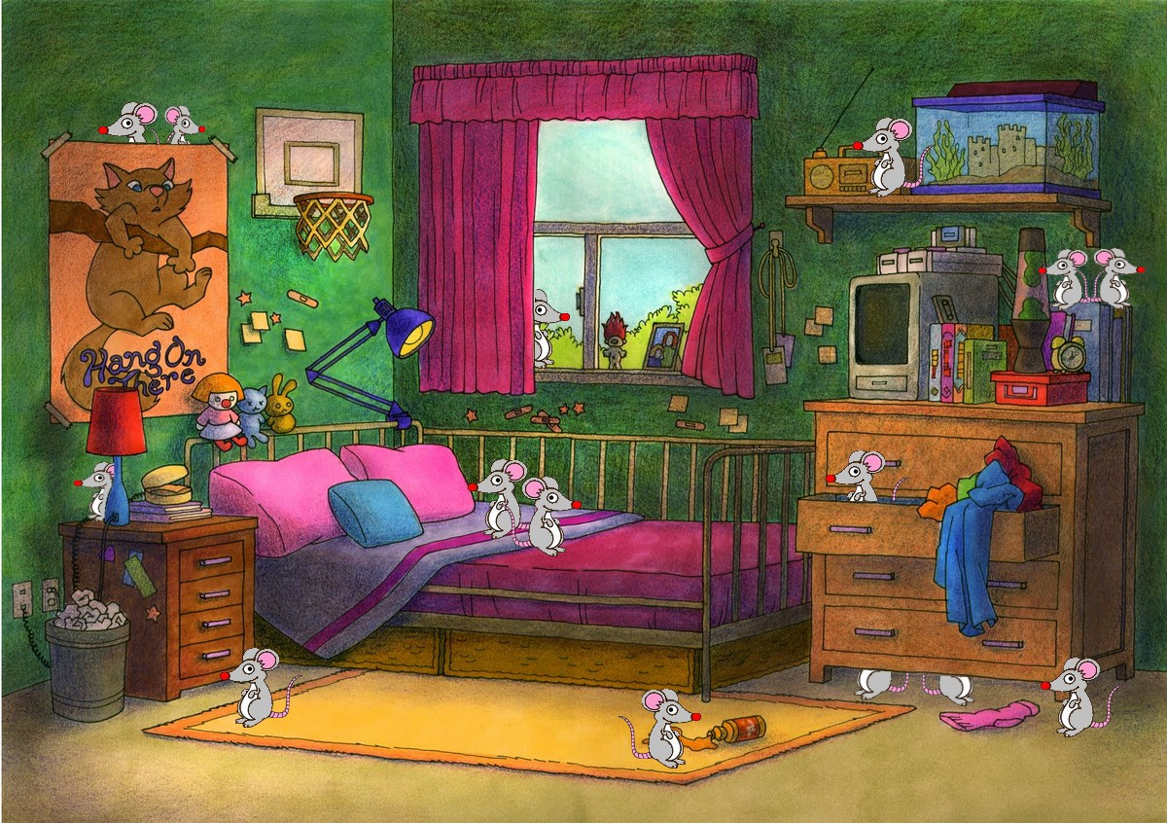
behind / under / in / across / on / from / between

- Two mice are ___ ___ ___ ___ ___ from each other.
- Two mice are ___ the bed.
- Two mice are __ __ __ __ __ the poster.
- One mouse is ___ the drawer.
- One mouse is across the room __ __ __ the lamp.
- One mouse is __ __ __ __ __ __ the radio and the fish tank.
- Two mice are __ __ __ __ the dresser.

Hint: 3415267 Secret password is ___________________________

Picasso Activity Worksheet 1

Picasso

- Student A reads their instructions to Student B.
- Student B draws the objects in the ‘B’ box.
- Then, the students swap roles.
- After that, compare pictures and discuss differences.

Student A reads the instructions for Student B.
- Draw a tree at the bottom on the left.
- Draw a cat behind the tree.
- Draw a table next to the tree.
- Draw a mouse under the table.
- Draw an airplane in the middle of the box.
- Draw a cloud above the airplane.
- Draw a cup of coffee on the table.
- Your sentence: ________________________________________
- Your sentence: ________________________________________

A

Picasso Activity Worksheet 2

Picasso

- Student B reads their instructions to Student A.
- Student A draws the objects in the ‘A’ box.
- Then, the students swap roles.
- After that, compare pictures and discuss differences.

Student B reads the instructions for Student A.
- Draw a car at the bottom on the right.
- Draw a girl at the bottom on the left.
- Draw a bird in the middle of the box.
- Draw a small ant under the car.
- Draw the sun at the top on the left.
- Draw a box between the car and the girl.
- Draw a dog on the box.
- Your sentence: ________________________________________
- Your sentence: ________________________________________

B

Preposition PPTPicture # 1 to 7
