Listening Speaking Reading Grammar Writing
Topic: If I Am Born Again
(Grammar Language Target: Using Adjectives)

Instructor:  Taylor | Students Competency Level : intermediate | Number of Students:14 | Lesson Length:  52 min
Materials:(List the Names of all materials used in the lesson. Materials must be shown at the end of this document)
Board and Markers
Teacher’s Story Pictures:
- Men
- Money
- Beauty
- House
- Computer
- Car
- Country
Diverse Kinds Of Adjectives
Adjectives With Be Verbs & Nouns
Handout About Adjective Questions

Aims:(What students will be able to achieve by participating in the activities of the lesson. (Ss gain or get by doing…)
- Improve Ss listening skills by listening to T’s story, Ss stories, drilling, playing a game and presentations.
- Improve Ss speaking skills by answering T, Ss presentations, sharing stories, drilling, and playing a game.
- Improve Ss grammar skills about adjectives by T using adjectives, T responding and rephrasing Ss thoughts, drilling, writing, and playing a game.

Language Skills:(Lists what activities language skills students will be using by participating in the activities of the lesson.)
- Reading: (Where did reading occur in the lesson?)
: teacher talk, Ss talk, game
- Listening:(Where did listening occur in the lesson?)
: sharing Ss stories about what they will do if they are born again
- Speaking: (Where did speaking occur in the lesson?)
: drilling adjectives with Be Verbs & Noun
- Writing: (Where did writing occur in the lesson?)
: writing sentences with adjectives in activities

Language Systems: (Lists what language systems students will be using by participating in the activities of the lesson.)
- Phonology: (sound)–Drilling, T and Ss talk.

- Function:(situation)–Supposing a situation that we are born again

- Lexis: (meaning)–Knowing about many adjectives’ meanings

- Grammar:(language structure) : Knowing various adjectives,
Adjectives with Be Verbs & Nouns

- Discourse: (communication): T-S-T, Ss presentations, sharing stories, drilling, and playing a game

Assumptions:(What students must already be able to do and what concepts must already be mastered before the lesson in order to achieve the aims of the lesson.)
- All Ss know about basic adjectives like ‘tall, short, pretty, etc.’
- All Ss can talk about their life when they are born again using adjectives

Anticipated Errors and Solutions:(What things might go wrong in the lesson and what the solution will be. An SOS activity should also be included)
- If Ss do not know some adjectives they want to express, T will let them know the words.
- If Ss take a long time to make sentences: never push students, give more time and encourage them.

References:
None

Lead-Inor Pre-Task Part (Warm-Up Part to activate and create interest in the lesson.)
Materials: (List the Names of all materials used in the Lead-Inor Pre-Task Partof the lesson. Materials must be shown at the end of this document)
Board and Markers
Teacher’s Story PPT:
- Men
- Money
- Beauty
- House
- Computer
- Car
- Country

Time: | Classroom Set Up: | Student Activity and Goals: | Teacher Procedure &Instructions:
1 min  4 min  4 min | Whole  Whole  Whole | Greet T.  Listen to T, become aware of the target language structure.  Share students’ story. | Greet Ss.  Talk about ‘If I born again’ story, with showing students Teacher’s story Pictures by using adjectives a lot.  Ask Ss to share their story about ‘If they are born again’. T rephrases and responds using Adjectives.

Pre-Activity or Task Familiarization Part (Presentation PartPresenting the language structure to be covered in the lesson. Prepares students for the communication activity.)
Materials: (List the Names of all materials used in the Pre-Activity or Task Familiarization Part of the lesson. Materials must be shown at the end of this document)
Board and Markers
Diverse Kinds Of Adjectives
Adjectives With Be Verbs & Nouns

Time: | Classroom Set Up: | Student Activity and Goals: | Teacher Procedure &Instructions:
5 min  5 min | W - Ss  Whole | Ss read, listen, speak and drill to learn and become familiar with adjectives  Ss answers T’s questions | T shows PPT of diverse kinds of adjectives. T also shows PPT of adjectives with Be Verbs & Nouns.  Accuracy is important.  T makes students change ‘Be Verb + Adjective’ forms to ‘Adjective + Nouns’ forms or vice versa.

Main Activity or Task Realization Part(Practice to Production PartTeacher lead practice of the language presented and move to communication based more student centered activity)
Materials: (List the Names of all materials used in the Main Activity or Task Realization Partof the lesson. Materials must be shown at the end of this document)
Board and Markers
Handout About Adjective Questions
Time: | Classroom Set Up: | Student Activity and Goals: | Teacher Procedure &Instructions:
1 min  1 min  1 min  1 min  1 min  2 min  1 min  5 min  10 min | Whole  Whole  Whole  Whole  Whole  Whole  Whole  Whole  Whole | Receive handouts from T  Solve some questions which complete some sentences with adjectives  Listen to T’s words and check the answers  Students put the words in the right order of a dialogue and practice it  Check the answers with T  Each student unscrambles the sentences and circle the adjectives  Check the answers with T  Introduce yourself to your partner by using adjectives  Introduce partners to other classmates by using adjectives and according to ‘be + adjective’ or ‘adjective + noun’ patterns. | T distribute some handouts related with adjective questions to students  T lets students solve the questions which students should complete sentences with adjectives  T tells students the answers of the questions  T lets students put the words in the right order of a dialogue and make them practice the dialogue  T tells students the answers of the questions  T lets students unscramble some sentences and make them circle the adjectives  T tells students the right answers of the unscrambling activities  T lets students introduce themselves to their partners by using adjectives  T directs students to introduce partners to other classmates by using adjectives and according to ‘be + adjective’ or ‘adjective + noun’ patterns.

Post Activity or Post Task Part (Wrap-Up PartClose the Lesson on a high note to and consolidate language learned in a communication based activity new situation.)
Materials: (List the Names of all materials used in the Post Activity or Post Task Part of the lesson. Materials must be shown at the end of this document)
Board and Markers
Handout About Adjective Questions
Time: | Classroom Set Up: | Student Activity and Goals: | Teacher Procedure Instructions:
5 min  5 min | Whole  Pair | Write about favorite holiday using the adjectives  Each pair talks about their favorite holiday using the adjectives | T makes students write about their favorite holiday using adjectives  T have students have a conversation about their favorite holiday using the adjectives

<Handout About Adjective Questions>

1. Complete the sentences with the proper adjectives.

Ex) The weather in Thailand is hot and humid.

- My sister’s hair is _________ and __________.
- The pumpkin pie is __________ and ___________.
- My cousins are __________ and _____________.

2. Put the words in the right order to complete the dialogue.

A: Look at Jason! Now, he’s bungee jumping.
B: Wow! He is a ________________________. (boy / brave / a)

A: What is he wearing?
B: He’s wearing _________________, ___________________ and _____________________.
(strong / a / harness) (helmet / red / a) (dangerous / is / it)

A :Is bungee jumping exciting?
B : Yes, but _______________________. (dangerous / is / it)

3. Unscramble the words to complete the letter.

Hi, Serena!

Thank you so much for your Christmas gift. _________________ looks really good on me.
(yellow / the / skirt)

It ____________________ here, in Australia. So, many people take ___________________
(is / summer / hot) (vacation / long / a)

these days. In Australia, people eat roast turkey on Christmas Day.

It is _________________________________________. Tomorrow is December 26th. It’s called
(yummy / food / a healthy food)

Boxing Day. It’s ________________ for shopping. Many shops have big sales.
( a / day / fun)

I will buy _________________ for you, ____________________ for Dad, and
(pretty / a / bag) (wallet / nice / a)

_________________________ for Mom. Happy Christmas, Serena!
(gloves / cozy and / warm)

Love always,
Your sister Gina

4. Introduce about yourself to your partners by using adjectives below.

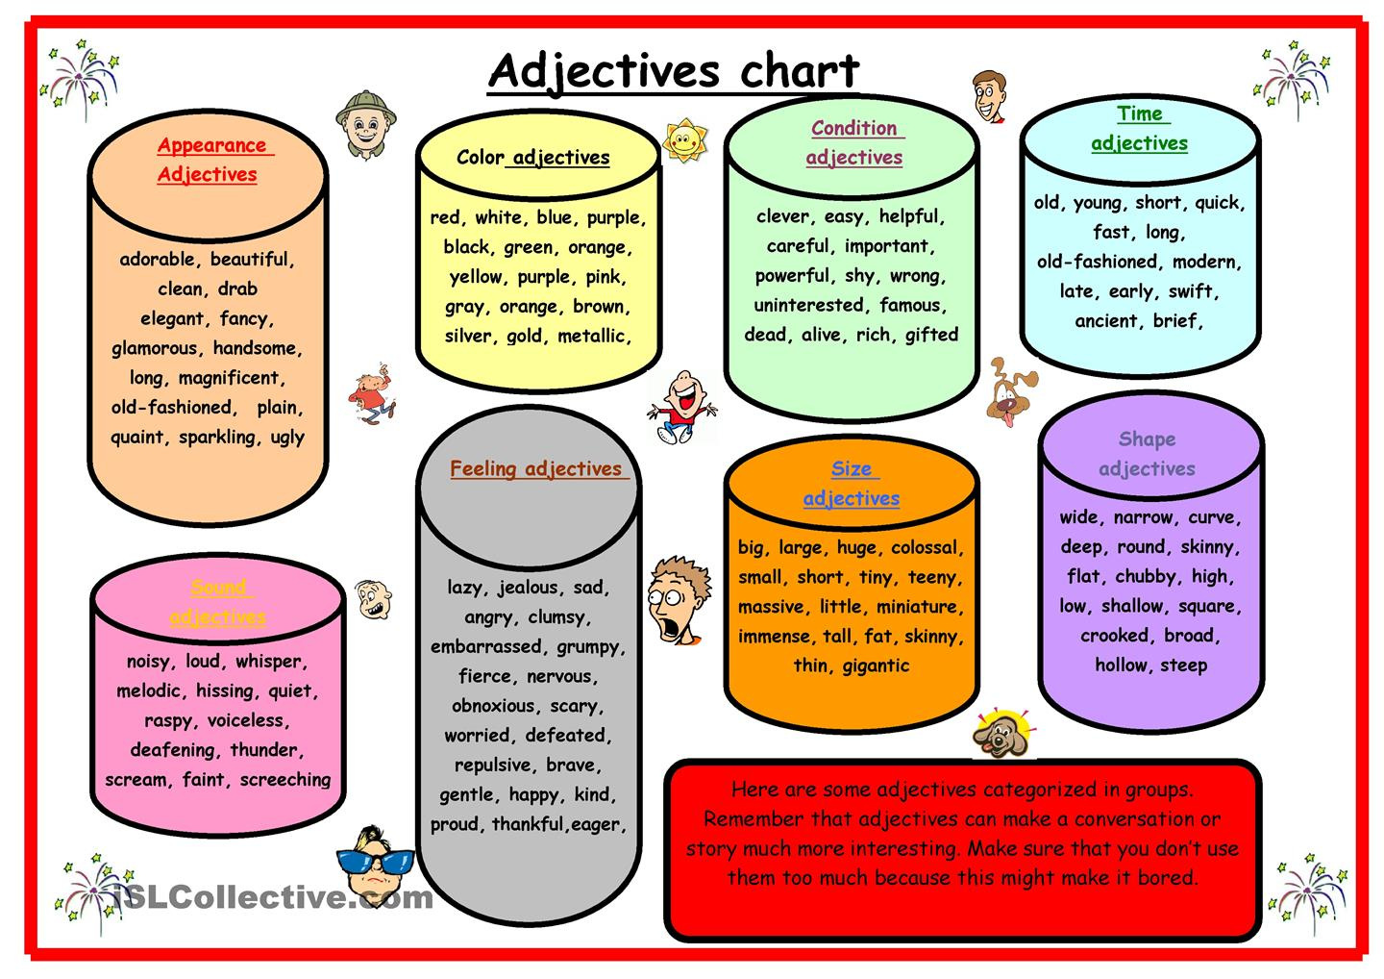

5. Introduce about your partners to other classmates by using adjectives above and according to the patterns below.

<Be Verb + Adjective>  - I am tall.  - The cats are cute and soft.  - My sister’s hair is long. | <Adjective + Noun>  - I am a tall boy.  - They are cute and soft cats.  - My sister has long hair.

6. Describe about your favorite holiday using the adjectives.

- Holiday : Chuseok / New Year’s day / Children’s day / Christmas / Budda’s day
Independence day / the Memorial Day

- Weather : warm / hot / cool / cold / sunny / chilly

- Food : spicy / sweet / sour / yummy / delicious

- Feeling : happy / excited / tired

Ex) My favorite holiday is ____Chuseok____.

It’s (on / in) ______September_______.

The weather is _______chilly_________.

We eat _______Songpyoen_________.

I __make some food__ on that day.
Pictures of Teacher's Story – If I Am Born Again>

<Diverse KInds of Adjectives>

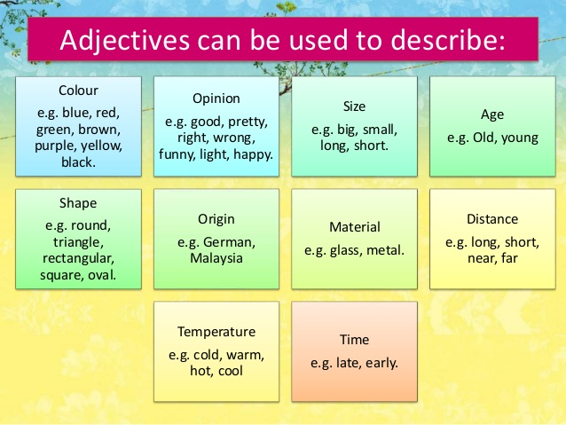

<Adjectives with Be Verbs & Nouns>

<Be Verb + Adjective>  - I am tall.  - The cats are cute and soft.  - My sister’s hair is long. | <Adjective + Noun>  - I am a tall boy.  - They are cute and soft cats.  - My sister has long hair.

