Listening Speaking Reading Grammar Writing
Topic: Modern Fencing and its History

Instructor:  Yeun | Students Competency Level  Upper Intermediate | Number of Students:  12 | Lesson Length:  65 Minutes
Materials: (List the Names of all materials used in the lesson. Materials must be shown at the end of this document)
‘Let’s Discuss’ Worksheet
‘Vocabularies Need To Know’ Worksheet
‘Fencing’ Reading Text
After Reading Worksheet

Aims: (What students will be able to achieve by participating in the activities of the lesson. (Ss gain or get by doing…)
- Improve Ss listening skill by listening to T instruction, questions and ICQ-CCQs, and listening to other Ss statements during activities.
- Improve Ss speaking skills by answering guiding questions, discussing in groups and responding to T questions
- Improve Ss reading skills by reading the text.
- Increase Ss basic knowledge on Fencing.

Language Skills: (Lists what activities language skills students will be using by participating in the activities of the lesson.)
- Reading: (Where did reading occur in the lesson?)
- Text and Worksheets
- Listening: (Where did listening occur in the lesson?)
- T instruction and explanation, Class discussion in activities.
- Speaking: (Where did speaking occur in the lesson?)
- Responding to T, Class discussion in activities.
- Writing: (Where did writing occur in the lesson?)
- Writing in worksheets

Language Systems: (Lists what language systems students will be using by participating in the activities of the lesson.)
- Phonology: (sound)
Class discussion, Ss Talk, T talk
- Function: (situation)
Discussing history of the sport Fencing
- Lexis: (meaning)
Vocabulary
- Grammar: (language structure)
Reading Text
- Discourse: (communication)
Class discussion

Assumptions: (What students must already be able to do and what concepts must already be mastered before the lesson in order to achieve the aims of the lesson.)
- All Ss know how to read.
- All Ss are willing to express their own thoughts and opinions.
- All Ss have basic knowledge on sports.
- All Ss have interests in the topic and enjoy the discussion.

Anticipated Errors and Solutions: (What things might go wrong in the lesson and what the solution will be. An SOS activity should also be included)
- If Ss don’t understand clearly
- Provide examples
- If Ss are not sure about what the text or vocabulary means
- T explains and gives examples
- If some students are too shy to participate in class discussion
- Encourage Ss to participate and give positive feedback
- If Ss have difficulty giving their opinion during the class discussion
- T gives his or her opinion first
- If activity takes too long
- T gives time warning
- If activity finishes too soon
- T gives Ss more time for the discussion

References:

Lead-In or Pre-Task Part (Warm-Up Part to activate and create interest in the lesson.)
Materials: (List the Names of all materials used in the Lead-In or Pre-Task Part of the lesson. Materials must be shown at the end of this document)

Time: | Classroom Set Up: | Student Activity and Goals: | Teacher Procedure & Instructions:
1 min  5min  5min  1min | W  W  G | Ss greet the teacher.  Ss listen to the T.  Ss talk their stories. | Greeting  Start with the story about funny and interesting introductions of experience on fencing.  Elicit the stories from Ss.  Transition: reading text.

Pre-Activity or Task Familiarization Part (Presentation Part Presenting the language structure to be covered in the lesson. Prepares students for the communication activity.)
Materials: (List the Names of all materials used in the Pre-Activity or Task Familiarization Part of the lesson. Materials must be shown at the end of this document)
‘Let’s Discuss’ Worksheet
‘Vocabularies Need To Know’ Worksheet

Time: | Classroom Set Up: | Student Activity and Goals: | Teacher Procedure & Instructions:
2 min  8 min  2 min | W  G  W | Ss get the worksheet  Ss read and complete the worksheet. Ss talk about their opinions each other and ask some questions. Groups share thoughts of members.  Ss get familiar with the key vocabularies. | Introduce worksheet and hand out the worksheet. Instruct and show example of how to complete.  T divides into 4 groups of 3 members. Let Ss read the questions and discuss in groups. Facilitate class feedback.  T explains about the vocabulary related to fencing.

Main Activity or Task Realization Part (Practice to Production Part Teacher lead practice of the language presented and move to communication based more student centered activity)
Materials: (List the Names of all materials used in the Main Activity or Task Realization Part of the lesson. Materials must be shown at the end of this document)
‘Fencing’ Reading Text
After Reading Worksheet

Time: | Classroom Set Up: | Student Activity and Goals: | Teacher Procedure & Instructions:
10 min  5 min  1 min  8 min  5 min  5 min | W  S-W  Individual  Pair  S-W | Listen to T. Receive the text and read it carefully. Ask questions as needed.  Share their thoughts with class.  Get the worksheet.  Read and complete the worksheet. Ask some questions if they don’t know some words or can’t understand meaning.  Check the answers each other. Groups share their ideas and respond feedback to other groups.  Share their answers with the rest of the classmates. | Introduce ‘Fencing’ text and hand out to Ss. Ask Ss to read the text carefully and to ask questions to increase interest in the text.  Ask Ss to share their thoughts about the text and facilitate classroom discussion and feedback.  Hand out after reading worksheet. Put Ss in pairs to complete worksheet together.  Give Ss time to read and complete the worksheet in pairs. Facilitate S-T, S-S interations.  Let Ss share what they have learned through the text in pairs. Observe Ss’ activity and give them some tips as needed.  Pick some pairs to speak out the answers they got for the class. Facilitate class feedback.

Post Activity or Post Task Part (Wrap-Up Part Close the Lesson on a high note to and consolidate language learned in a communication based activity new situation.)
Materials: (List the Names of all materials used in the Post Activity or Post Task Part of the lesson. Materials must be shown at the end of this document)

Time: | Classroom Set Up: | Student Activity and Goals: | Teacher Procedure Instructions:
2 min  2 min  2 min  1 min | W  I  W | Listen T’s feedback and respond to T.  Ss respond and have class discussion.  Listen and take notes.  Thank for the T. | Encourage Ss and give positive feedback about their opinion.  Let Ss have time to think of their favorite sports. Elicit response in class discussion. Facilitate class feedback.  Give Ss homework assignment:  “Know about my favorite sports”  Dismisses class and thank Ss for their active participation.

Let’s Discuss
- What is your favorite sport and why?
- Imagine a sport evolved from hundreds years ago.
- What do you know about Fencing?
- If you have watched any Fencing match, how was it? Was it fun?

Vocabularies Need to Know
Types of Fencing; depends on the types of weapon
- Foil:
- Épée:
- Saber:

Fencing
Fencing is a sport of dueling with foil, épée, and saber. The weapons and rules of modern fencing evolved from combat weapons and their usage. The foil—a light, flexible thrusting weapon with a blunted point—was originally a practice weapon. The épée is a straight, narrow, stiff thrusting weapon based upon the dueling weapons of European noblemen. The saber is derived from the 18th-century cavalry saber and the Middle Eastern scimitar and has a flexible triangular blade with scoring edges along the entire front and one third of the back edge.
International rules stipulate that fencers must attack and parry on a strip that is 14 m long and 2 m wide. The strip, or "piste," is marked off by two parallel lines, beyond which the fencer may not step without receiving a warning or a penalty. Protective clothing includes vests, breast protectors, heavy jackets, wire-mesh masks and leather gloves. A button blunts the weapon's tip, and points are scored by touching the opponent. In foil the torso is the target area; in épée it is the whole body; in saber it is the body above the hip. Winning touches are five in foil and saber, three in épée. Touches are scored electronically except in saber, where judges decide scoring. Although fencing matches are conducted between individuals, team scoring may result from a sum of individual scores.
The Fédération Internationale d'Escrime (founded 1913) serves as fencing's world governing body and oversees world championships. Prior to the 1960s, France and Italy dominated international competition in foil and épée, while Hungary dominated in saber. Since then Russia, Germany, Poland, Sweden, and others have joined the traditional powers.
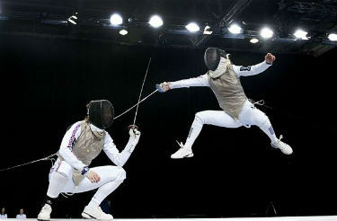
History
Swords have been in use since the Bronze Age, and nearly all people of antiquity practiced swordsmanship. Fencing as a contest has existed at least since 1190 BC, as shown in a relief carving in Upper Egypt from that time depicting adversaries with covered swordpoints and padded masks under the observation of spectators and judges. In the Middle Ages, swords were essential to civilians and soldiers. England's Henry VIII ordered fencing displays. Not until the 16th cent., however, when the light Italian rapier replaced the heavy German sword, did the sport become widespread and the subject of scientific theory. Fencing schools, frequented by young aristocrats, soon sprang up all over Europe, and fencing duels often settled matters of personal honor. In the late 19th cent., after many countries had outlawed the duel, fencing became an organized sport. Fencing has been a part of the Olympics since the first modern games in 1896, though women did not compete until 1924 and still compete in foil and épée only.
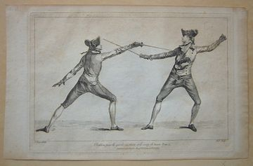
1763 Fencing

After Reading Work Sheet

Guess what type of Fencing they are
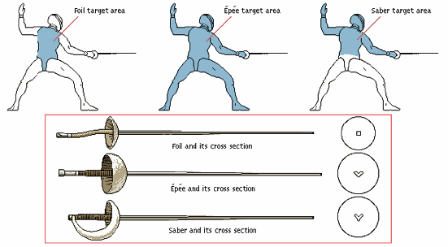

Get the Facts Right
Read the statements below. Are they true or false?
- The saber is a straight, narrow, stiff thrusting weapon based upon the dueling weapons of European noblemen.
- The fencer gets penalty when they step beyond the parallel lines of the piste.
- Judges decide scoring in Saber.
- Before 16th Century, the fencing was widespread and the subject of scientific theory.

Summarize and Analyze the text
Modern fencing
- Paragraph 1
- Paragraph 2
- Paragraph 3
History

Let’s Talk
- What do you know about Fencing now?
- Can you explain basic rules of Fencing to your partner?
- What do you think of Fencing as a sport?
- Do you want to fence? Why?

